Name: Dibajit Roy
ID: 22-48569-3
CT5
1. SELECT S_Name, (S_CGPA - 0.5) AS Updated_CGPA
FROM student_info;
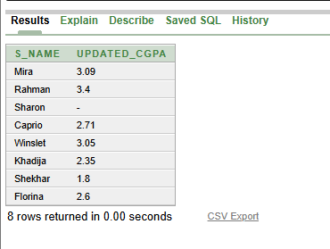
2. SELECT country || ' - ' || country_code AS Country_Info
FROM Address;
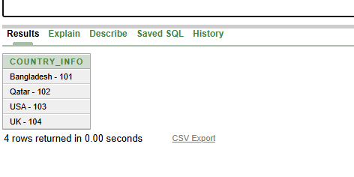
3. SELECT S_Name AS "Student Name",
S_BloodStatus AS "Student Blood Status"
FROM student_info;

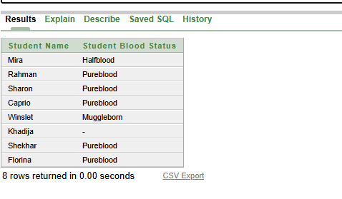

4. SELECT *
FROM student_info
WHERE LENGTH(S_Name) - LENGTH(REPLACE(LOWER(S_Name), 'o', '')) = 1;
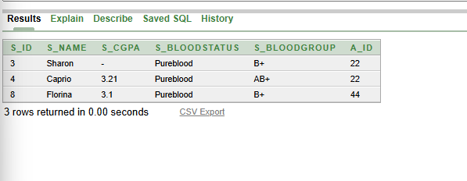
5. SELECT S_Name, S_CGPA
FROM student_info WHERE S_CGPA IS NULL;
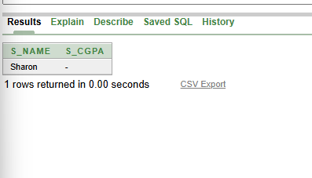

6. SELECT city, country, country_code
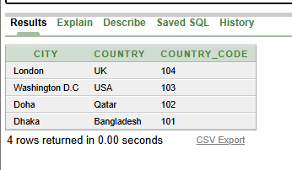
FROM Address ORDER BY country_code DESC;

7. SELECT S_Name, SUBSTR(S_CGPA, 1, 4) AS CGPA,
S_BloodStatus FROM student_info WHERE S_BloodStatus = 'Pureblood';
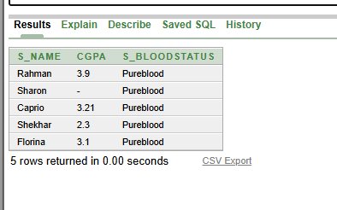
8. SELECT S_Name, NVL(TO_CHAR(S_CGPA), 'No CGPA') AS CGPA,
NVL(S_BloodStatus, 'Unknown') AS Blood_Status FROM student_info;
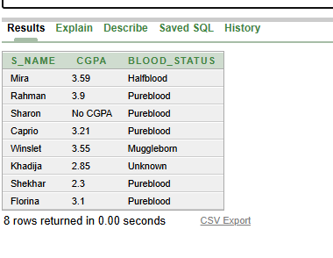

9. SELECT * FROM student_info
WHERE S_CGPA = (SELECT MAX(S_CGPA) FROM student_info);
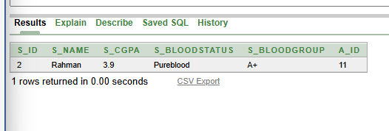
PLSQL:
1. DECLARE
v_name student_info.S_Name%TYPE;
v_cgpa student_info.S_CGPA%TYPE;
CURSOR c1 IS
SELECT S_Name, S_CGPA FROM student_info;
BEGIN
OPEN c1;
LOOP
FETCH c1 INTO v_name, v_cgpa;
EXIT WHEN c1%NOTFOUND;
DBMS_OUTPUT.PUT_LINE(v_name || ' -> ' || (v_cgpa - 0.5));
END LOOP;
CLOSE c1;
END;
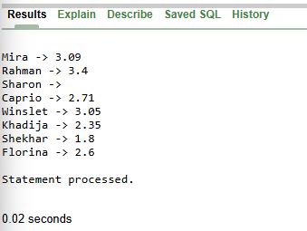
2. DECLARE
v_country Address.country%TYPE;
v_code Address.country_code%TYPE;
CURSOR c2 IS
SELECT country, country_code FROM Address;
BEGIN
FOR rec IN c2 LOOP
DBMS_OUTPUT.PUT_LINE(rec.country || ' - ' || rec.country_code);
END LOOP;
END;
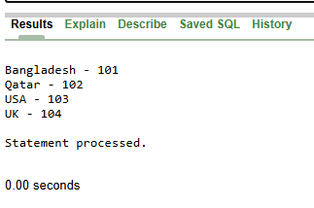

3. BEGIN
FOR rec IN (SELECT S_Name, S_BloodStatus FROM student_info) LOOP
DBMS_OUTPUT.PUT_LINE('Name: ' || rec.S_Name ||
', Status: ' || rec.S_BloodStatus);
END LOOP;
END;
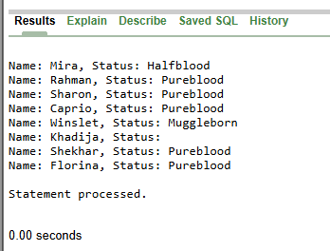
4. BEGIN
FOR rec IN (
SELECT S_Name FROM student_info
WHERE LENGTH(S_Name) - LENGTH(REPLACE(LOWER(S_Name),'o','')) = 1
) LOOP
DBMS_OUTPUT.PUT_LINE(rec.S_Name);
END LOOP;
END;
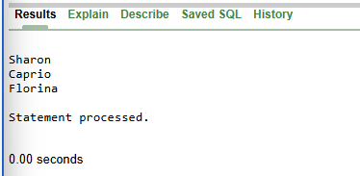
5. BEGIN
FOR rec IN (
SELECT S_Name, S_CGPA FROM student_info WHERE S_CGPA IS NULL
) LOOP
DBMS_OUTPUT.PUT_LINE(rec.S_Name || ' -> NULL CGPA');
END LOOP;
END;
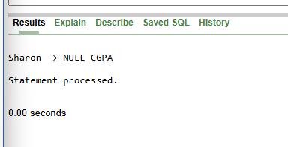
6. BEGIN
FOR rec IN (
SELECT city, country, country_code
FROM Address
ORDER BY country_code DESC
) LOOP
DBMS_OUTPUT.PUT_LINE(rec.city || ', ' || rec.country
|| ' -> ' || rec.country_code);
END LOOP;
END;
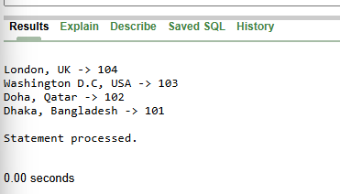
7. BEGIN
FOR rec IN (
SELECT S_Name, SUBSTR(S_CGPA,1,4) AS CGPA, S_BloodStatus
FROM student_info
WHERE S_BloodStatus = 'Pureblood'
) LOOP
DBMS_OUTPUT.PUT_LINE(rec.S_Name || ' -> ' || rec.CGPA);
END LOOP;
END;
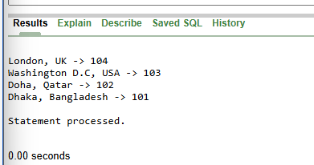

8. BEGIN
FOR rec IN (
SELECT S_Name,
NVL(TO_CHAR(S_CGPA),'No CGPA') AS CGPA,
NVL(S_BloodStatus,'Unknown') AS Status
FROM student_info
) LOOP
DBMS_OUTPUT.PUT_LINE(rec.S_Name || ' -> '
|| rec.CGPA || ', ' || rec.Status);
END LOOP;
END;
/
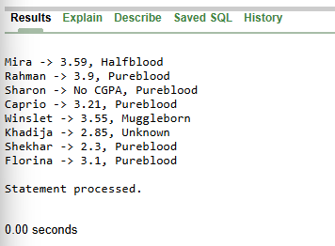
9. DECLARE
v_max NUMBER;
BEGIN
SELECT MAX(S_CGPA) INTO v_max FROM student_info;

FOR rec IN (
SELECT S_Name, S_CGPA FROM student_info
WHERE S_CGPA = v_max
) LOOP
DBMS_OUTPUT.PUT_LINE(rec.S_Name || ' -> ' || rec.S_CGPA);
END LOOP;
END;
