AroundYou

Technical Documentation

Version 1.0

AroundYou

Technical Document

Student: Mahmut Aksakalli

**Course:** Razvoj mobilnih aplikacija

Profesor: Josip Balen

**Asistent:** Bruno Zorić

**CONTENT**

1. DESCRIPTION OF PRODUCT 3

2. USER REQUIREMENTS 4

2.1 Request list 4

2.2 Usage cases 4

2.3 Details and Examples 7

2.4 Mock-up 10

3. LITERATURE 11

TECHNICAL DOCUMENTATION

1. **DESCRIPTION OF PRODUCT**

AroundYou is an Android mobile application that helps people find cafes around them. The app starts with login screen. A user can login using Google account. Login process is necessary to identify each user and give them opportunity to use all features of app. After login process, app wants to access location of device if this is first time that user opened the app. It uses location information to find places around the user. When the user gave access to location, app list cafes around the user. There are two different view mode to see cafes around you. One of them is list view which shows places name, address, distance and rating as a list. The other one is map view which shows user location and places on a map. On list view, the user can select place to see more details about place. After user selected a place from list view, it shows details of place, upcoming events that includes event date, a note to invite people and user who created that event. There is also opportunity to create new event in that place. If the user clicks create event button, it will show new activity to create an event. The user can select date and time of event and add a note to invite people.

1. **USER REQUIREMENTS**

**2.1. Request list**

|  |  |  |  |  |
| --- | --- | --- | --- | --- |
| ID | Status | Priority | Description | UC |
|  |  |  | General user requirements |  |
| 1 | A | 1 | There are different viewing options for places such as list view and map view | - |
| 2 | A | 1 | When user selected a particular place, all details belonging to that place are displayed. | UC5 |
| 3 | A | 1 | The user can see the details of each place. | UC5 |
| 4 | A | 1 | The user can see upcoming events on a place | UC5 |
| 5 | A | 1 | The user can add new event on a place | UC6 |
| 6 | A | 1 | While adding an event, the user can add an event note to invite other users | UC6 |
| 7 | A | 1 | While adding an event, the user can add event date and time. | UC6 |
| 8 | A | 1 | The user can login application | UC1 |
| 9 | A | 1 | The app needs access to location | UC2 |

**2.2. Usage cases**

|  |  |
| --- | --- |
| Case ID | UC1 |
| Name | Login to application |
| Description | The user sign in to identify himself |
| Precondition | Having a Google account |
| Main scenario | 1. The user click sign in with google button 2. Select an account or sign in with username and password 3. The user is redirected to list of places around him |
| Alternative scenatio | 1. The user entered invalid account   1. Login screen is shown again 2. A textview is shown with error message on login screen |
| Case ID | UC2 |
| Name | Location permission |
| Description | The app request to access location information of device |
| Precondition | - |
| Main scenario | 1. The app pops up a dialog window to ask permission 2. The user give access to location 3. A list of nearest cafes are shown |
| Alternative scenatio | 1. The user doen't give access to location  1. A textview is shown with error message that indicates app needs location permission to list cafes. |

|  |  |
| --- | --- |
| Case ID | UC3 |
| Name | Listing Cafes |
| Description | The app gets cafes around the user |
| Precondition | Access to location information |
| Main scenario | 1. The app takes location update from device 2. The app request nearby places from Google Places service 3. A list of nearest cafes are shown on list view |
| Alternative scenatio | - |

|  |  |
| --- | --- |
| Case ID | UC4 |
| Name | Listing Cafes on Map |
| Description | The app shows cafes around the user on map view |
| Precondition | Access to location information |
| Main scenario | 1. The app takes places list from repository 2. The app loads a Google map 3. The app marks your location on map 4. The app marks cafes around users' location |
| Alternative scenatio | - |

|  |  |
| --- | --- |
| Case ID | UC5 |
| Name | Details of a place |
| Description | The user sees details of a place |
| Precondition | - |
| Main scenario | 1. The user selects a place on place list. 2. The details of place is shown 3. The upcoming events on this place are shown |
| Alternative scenatio | - |

|  |  |
| --- | --- |
| Case ID | UC6 |
| Name | Create event |
| Description | The user creates an event on a place |
| Precondition | - |
| Main scenario | 1. The user clicks create event button 2. The user selects data of event 3. The user selects time of event 4. The user types an event note 5. When user clicked publish event button, app redirect the user to place details screen. |
| Alternative scenatio | 1. When one of the inputs is empty 2. The app shows a toast message that indicates there are empty inputs |

**2.3. Details and Examples**

**Table 1:** Required attributes for adding event

|  |  |  |
| --- | --- | --- |
| **Attribute** | **Necessary** | **Type** |
| Place ID | YES | String |
| Username | YES | String |
| Event Note | YES | String |
| Date | YES | Date |

The following pictures show an example of adding an event to a place around you. After logged in, list view of places is shown. The list view of places can be seen in Figure 2.1.

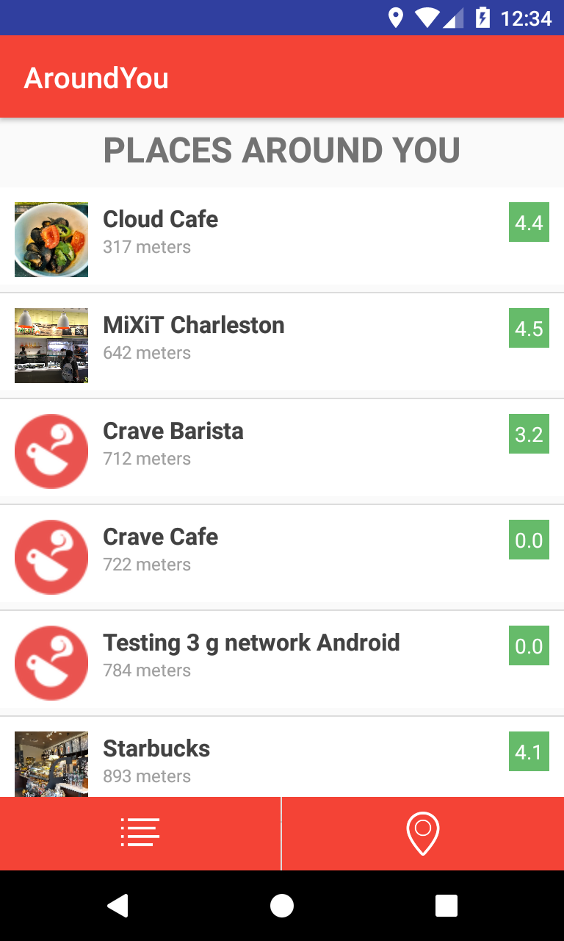

**Figure 2.1:** List view of places

Select a places from list to see details of places. This screen contains place name, address, rating and upcoming events. The details of place screen can be seen in Figure 2.2.

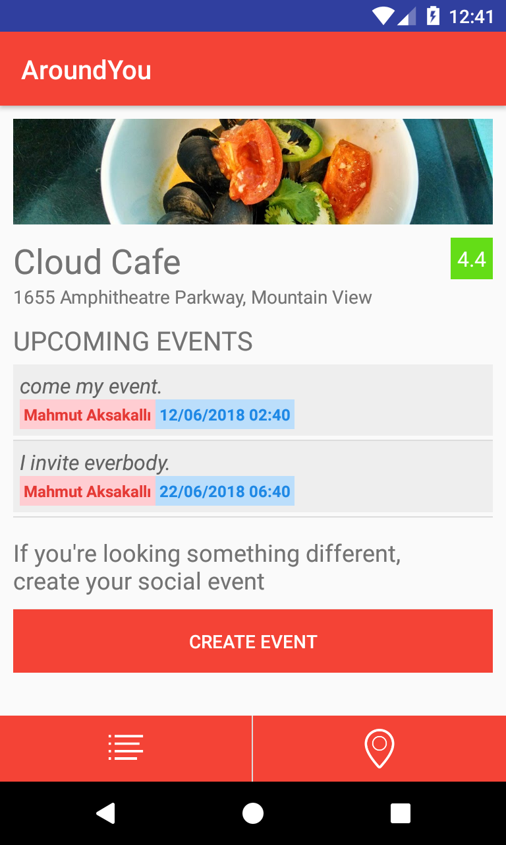

**Figure 2.2:** Details of a place

To create a new event on this place, click create event button. Application screen for creating an event is shown Figure 2.3.

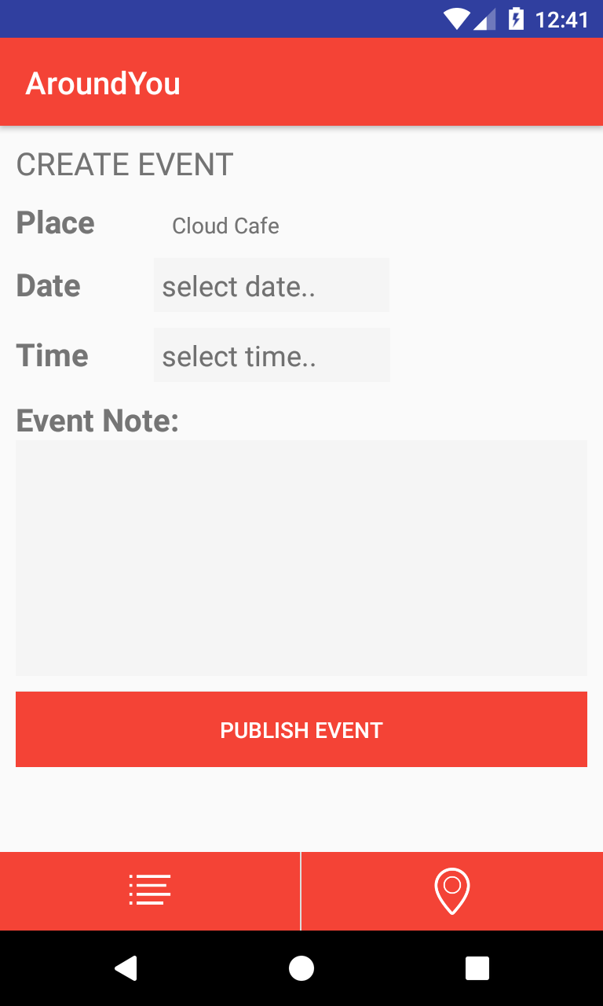

**Figure 2.3:** Create event screen

On create event screen, select date of event as shown below Figure 2.4.

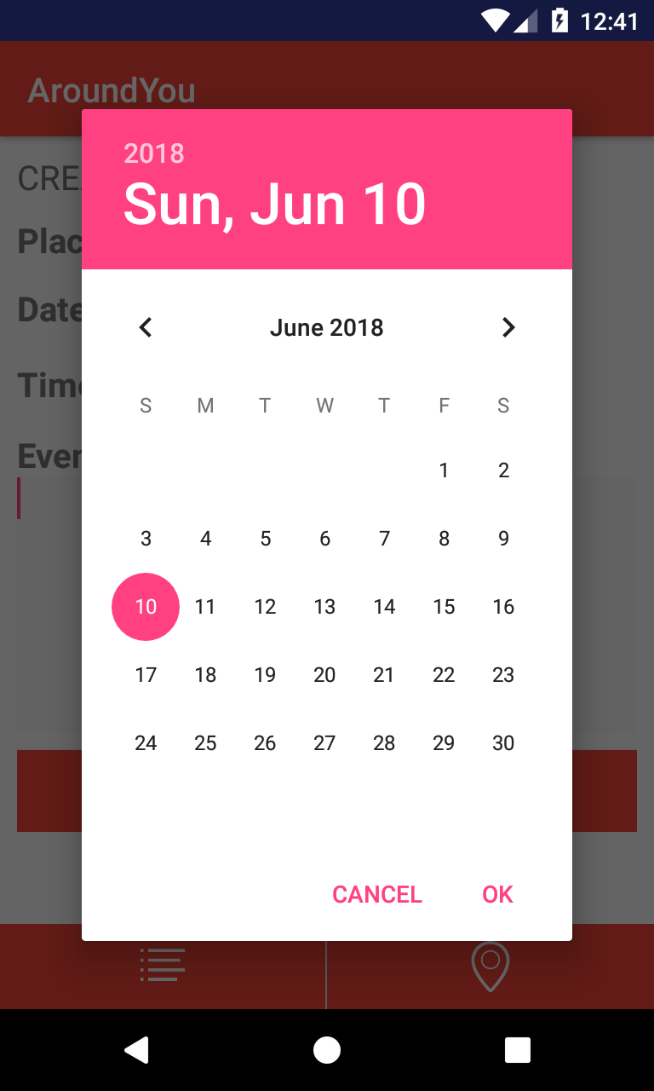

**Figure 2.4:** Select date of event

Then, select time of event as shown below Figure 2.5.

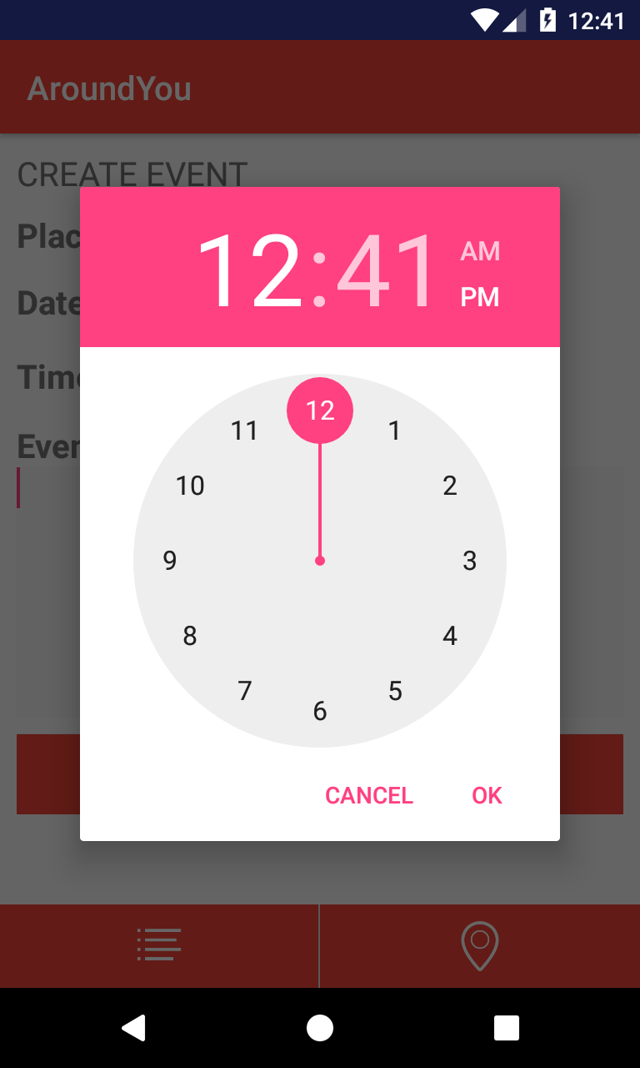

**Figure 2.5:** Select time of event

At last stage enter an event note to invite people to your event as shown below Figure 2.6.

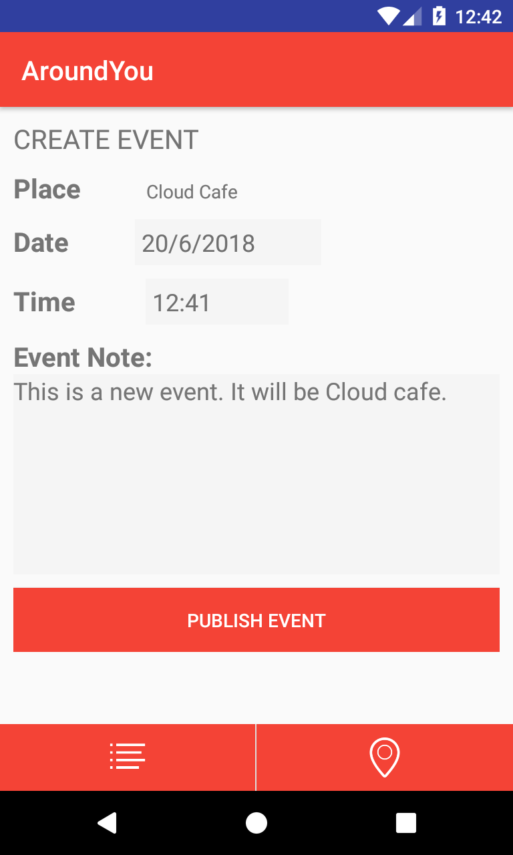

**Figure 2.6:** Enter an event note

**2.4. Mock-up**

Before you start making an app in Android Studio, you need to create a mock-up. Mock-up is made using the Fluid UI, a tool used to design a mobile interface. Figure 2.7. The mock-up application is displayed.

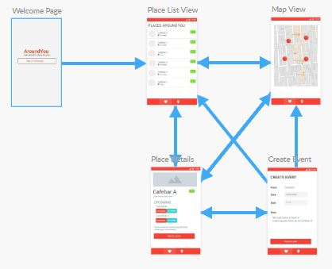

**Figure 2.7:** Mock-up of application

1. **LITERATURE**
2. <https://stackoverflow.com/>
3. <https://firebase.google.com/docs/android/setup>
4. <https://developers.google.com/identity/sign-in/android/start-integrating>
5. <https://medium.com/@jintin/mvp-architecture-in-android-1f98a74e7e1b>
6. <https://medium.com/mindorks/understanding-android-networking-library-retrofit-2-510d07dc5b1f>
7. <https://android.jlelse.eu/android-architecture-components-viewmodel-e74faddf5b94>