# Q1) Integral Slot Winding

In this part, 20 pole, 120 slot, 3-phase machines winding diagram is designed. Distribution factor, pitch factor, winding factor is calculated for fundamental, 3rd and 5th components.

Q(number of slots) = 120, p(pole pairs) = 10, m(number of phases) = 3;

slots per pole per phase slot angle

Double layer, short pitch winding diagram for one pole pair;

|  |  |  |  |  |  |  |  |  |  |  |  |  |
| --- | --- | --- | --- | --- | --- | --- | --- | --- | --- | --- | --- | --- |
| 120 | 1 | 2 | 3 | 4 | 5 | 6 | 7 | 8 | 9 | 10 | 11 | 12 |
|  | A1 | A2 | -C1 | -C2 | B1 | B2 | -A3 | -A4 | C3 | C4 | -B3 | -B4 |
| A3 | A4 | -C3 | -C4 | B3 | B4 | -A1 | -A2 | C1 | C2 | -B1 | -B2 |  |

λ (coil pitch) = 150°

* Fundamental component;

Distribution factor

Pitch factor

Winding factor

* 3rd harmonic component;

Distribution factor

Pitch factor

Winding factor

* 5th harmonic component;

Distribution factor

Pitch factor

Winding factor

As double layer and short pitch configuration is chosen, 5th harmonic component is found very small and induced voltage magnitude will be very small compared to 1st harmonic. 3rd harmonic component may be thought as high but according to connection type it can be eliminated.

# Q2) Fractional Slot Winding Design

In this part, [Emetor Winding Design](https://www.emetor.com/windings/) is used for initial design. According to program, maximum possible fundamental winding factor is achieved with 20 pole numbers and 24 slots which is 0.966. So, 20 pole numbers and 24 slots configuration is selected.

slots per pole per phase slot angle

|  |  |  |  |  |  |  |  |  |  |  |  |  |
| --- | --- | --- | --- | --- | --- | --- | --- | --- | --- | --- | --- | --- |
| Slot number | 1 | 2 | 3 | 4 | 5 | 6 | 7 | 8 | 9 | 10 | 11 | 12 |
| Electrical angle (degree) | 0 | 150 | 300 | 90 | 240 | 30 | 180 | 330 | 120 | 270 | 60 | 210 |
| 3rd harmonic angle | 0 | 90 | 180 | 270 | 0 | 90 | 180 | 270 | 0 | 90 | 180 | 270 |
| 5th harmonic angle | 0 | 30 | 60 | 90 | 120 | 150 | 180 | 210 | 240 | 270 | 300 | 330 |
| Coil distribution | A1 | -A2 | -B1 | B2 | C1 | -C2 | -A1 | A2 | B1 | -B2 | -C1 | C2 |

|  |  |  |  |  |  |  |  |  |  |  |  |  |
| --- | --- | --- | --- | --- | --- | --- | --- | --- | --- | --- | --- | --- |
| Slot number | 13 | 14 | 15 | 16 | 17 | 18 | 19 | 20 | 21 | 22 | 23 | 24 |
| Electrical angle (degree) | 0 | 150 | 300 | 90 | 240 | 30 | 180 | 330 | 120 | 270 | 60 | 210 |
| 3rd harmonic angle | 0 | 90 | 180 | 270 | 0 | 90 | 180 | 270 | 0 | 90 | 180 | 270 |
| 5th harmonic angle | 0 | 30 | 60 | 90 | 120 | 150 | 180 | 210 | 240 | 270 | 300 | 330 |
| Coil distribution | A3 | -A4 | -B3 | B4 | C3 | -C4 | -A3 | A4 | B3 | -B4 | -C3 | C4 |

20 pole numbers, 30 slots are chosen for another design.

slots per pole per phase slot angle

|  |  |  |  |  |  |  |  |  |  |  |
| --- | --- | --- | --- | --- | --- | --- | --- | --- | --- | --- |
| Slot number | 1 | 2 | 3 | 4 | 5 | 6 | 7 | 8 | 9 | 10 |
| Electrical angle (degree) | 0 | 120 | 240 | 0 | 120 | 240 | 0 | 120 | 240 | 0 |
| Coil distribution | A1 | -A2 | C1 | -C2 | B1 | -B |  |  |  |  |

### Q3) 2D FEA Modelling

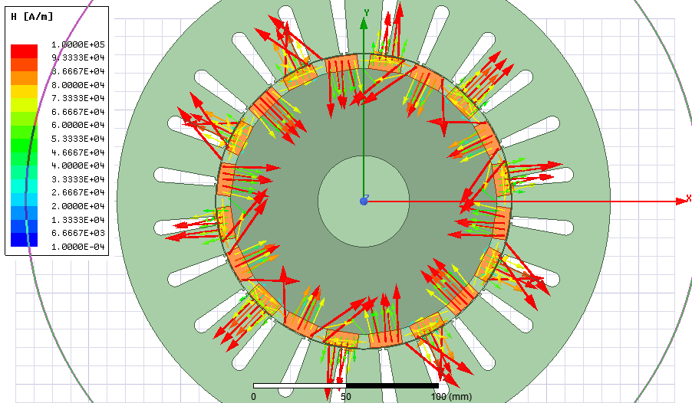

Figure 1: H_vector

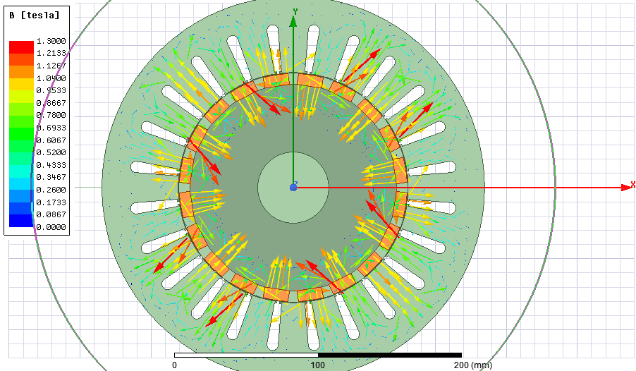

Figure 2: B_vector

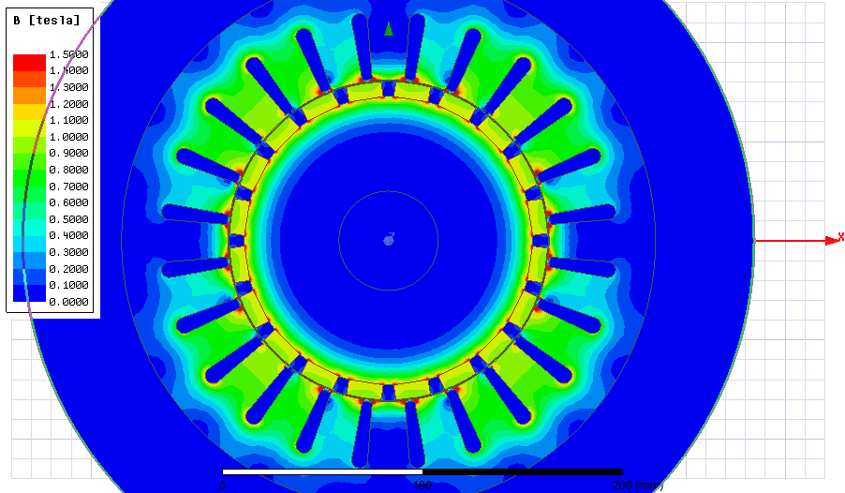

Figure 3: B magnitude