# Introduction

In this project, Surface Mount Permanent Magnet Synchronous Machines are going to be analysed with different design criteria. Throughout the project following parameters are kept constant;

* Number of phases: 3
* Number of poles: 4
* Motor Axial Length: 100 mm
* Air-gap clearance: 1 mm
* Magnet to Pole Pitch Ratio: 0.8

# Q1-Magnetic Loading

In this part, machine is constructed with NdFeB magnets with following parameters;

* Magnet Type: NdFeB N42 grade (ur=1.05), radial shaped
* Rotor Diameter: 100 mm
* Magnet Radial Thickness: 4 mm

Motor geometry can be seen in Figure 1.

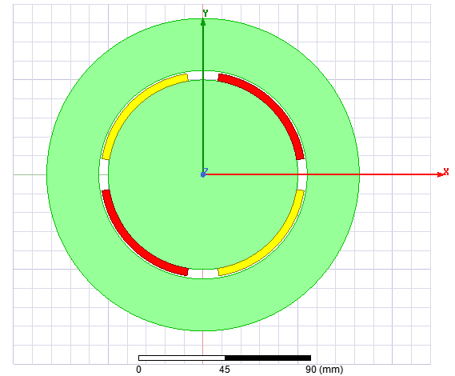

Figure 1: Geometry of constructed machine

## Part a)

Magnetic equivalent circuit for one pole pair can be seen in Figure 2. In this figure, MMF_M1 and MMF_M2 show permanent magnet sources whereas R_M1 and R_M2 show reluctances of permanent magnets.

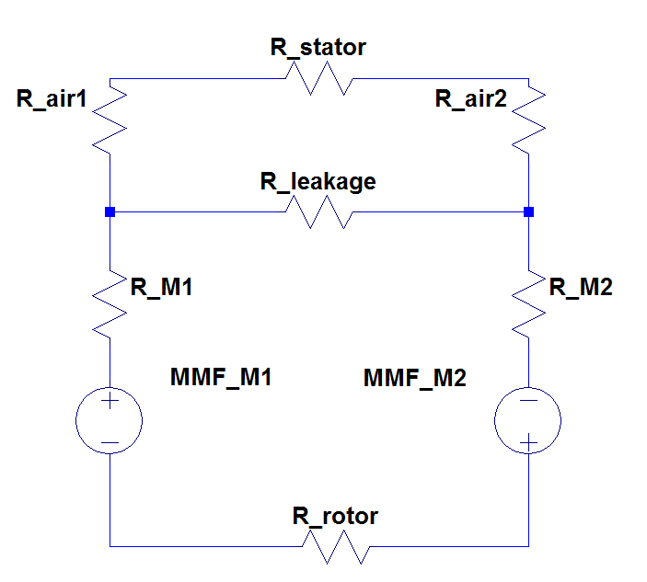

Figure 2: Magnetic equivalent circuit for one pole pair

Some assumptions are made for calculating operating point of the magnet. Stator and rotor reluctances are taken zero and leakage reluctance is taken infinite. Pole area can be calculated as;

Magnet to pole pitch ratio is 0.8 therefore magnet and air gap area can be calculated as;

Reluctances can be found as;

Permanent magnet MMFs can be calculated as;

By solving magnetic equivalent circuit, magnetic flux density can be found as;

By using magnet normal curve, operating point of the magnet can be calculated by load line as seen in Figure 3. Hm of the magnet is found as -198.5 kA/m.

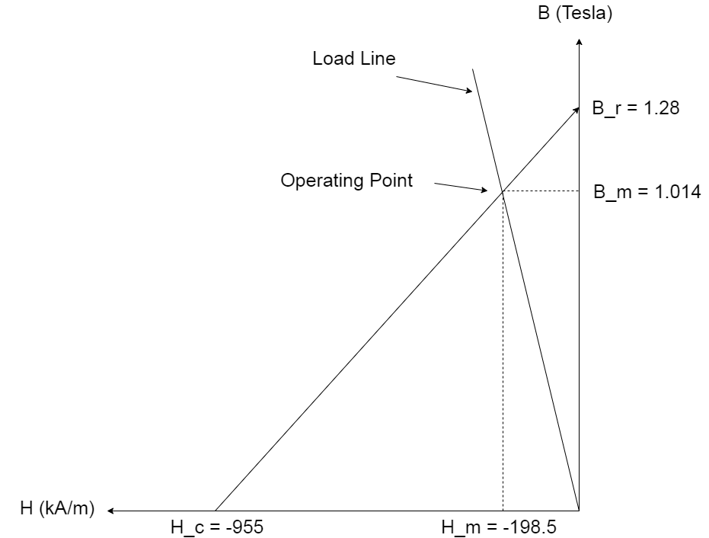

Figure 3: Normal line and load line of the magnet

## Part b)

Magnetic loading of the machine can be calculated as;

## Part c)

# Q2- Electrical Loading & Machine Sizing

In this part, electrical loading of the machine is investigated by determining slot numbers, types, current densities etc. Also force and power of the machine is found.

## Part a)

Slots per pole per phase are chosen as 2 for this design which gives 24 slots for the machine. By choosing 24 slots, MMF harmonics may not be critical. Construction of the machine may not be difficult because machine can be thought as small respectively. So, it seems that number of slots are chosen is reasonable. One of the stator tooth’s and slots thickness can be calculated as;

Note that this value is total total tooth and slot thickness. It is assumed that tooth and slot thickness are equal and slot thickness is found to be;

## Part b)

It is given that coil current is 2.5 A and maximum current density is 5 A/mm2. Also maximum fill factor should be 0.6. In order to not to exceed maximum current density, minimum area of the wire can be calculated as;

Therefore, AWG20 cable is chosen which has 0,518 mm2 area and 0,812 mm diameter. Note that AWG20 cable has 5 A ampacity which can handle given coil current.

## Part c)

In order to choose height of the slots, inner diameter to outer diameter ratio is taken as 0,6 for this design, therefore;

Height of the slot can be calculated as;

Turn number for each slot can be calculated by using slot height, slot thickness and fill factor as follows;

Number of turns is chosen as 300. Then, back core thickness can be calculated by following formula by taking back core flux density of 1 Tesla;

Therefore outer diameter of the machine can be calculated as;

## Part d)

Electrical loading of the machine can be calculated by following formula;

PMSM’s have typical electrical loading values between 35 and 65 kA/m, therefore the calculated electrical loading is reasonable.

## Part e)

Average tangential stress can be calculated by using electrical and magnetic loading and taking cosφ term 1 for PMSM’s, as follows ;

PMSM’s have typical average tangential stress between 21 and 48 kPa, therefore the calculated value is reasonable.

Then, total force and torque that machine can deliver can be calculated as;

## Part f)

Expected power output of the machine can be found as follow;