

**EE 568**

***Selected Topics on Electrical Machines***

***Project 4***

**PM Motor Comparison Analysis**

**Mahmut Enes KARA 2030898**

**Course Instructor: Ozan KEYSAN**

Table of Contents

Introduction 3

Literature Review 3

Analytical Calculation & Sizing 5

FEA Modelling 10

Comparison & Discussion 13

References 15

# Introduction

In this project, an electric machine for heavy duty electric vehicles is designed. The purpose of the designed machine is to use directly with heavy duty platforms without using any gear mechanism. The intended usage of the machine can be exemplified as 10-12 meter public buses, delivery trucks, work trucks like garbage trucks, shuttles etc. In order to meet the specifications of the heavy duty vehicles, 250 kW machine with 1500 rpm nominal speed and 3000 rpm maximum speed is going to be designed.

As the usage of the machine will be heavy duty vehicles, while deciding type of the machine, efficiency should be an important factor. Because power consumption of the heavy duty vehicles are very high and losses should be minimized. On the other hand, cost of the machine is an important factor but heavy duty machines are expensive itself, so cost of the machine can be handled by vehicle producers. Therefore Permanent Magnet Synchronous Machines can be used for these applications.

Although volumes of the electric machines are very critical in passenger vehicle applications, it can be considered that more volume can be reserved for electric machine in heavy duty vehicles by the help of nature of the vehicle. On the other hand, manufacturing of the machine can be ease by topology selection. Therefore Surface Mount PMSM is selected as topology of the machine.

# Literature Review

Radial flux Surface Mount PMSM’s are one of the most common type of the PM machines and it can be said that maturity level is very high compared to other machines such as Interior PM, Synchronous Reluctance etc. SMPMSM’s have magnets placed on the cylindrical rotor surface resultant no saliency on the rotor which implies no reluctance torque cannot be utilized. They have nearly equal direct and quadrate axis inductances. In industry or automotive, SMPMSM’s are one of the evaluated machine type where application require high torque density, high power factor, easy manufacturing and not require very high speed. Although literature concentrates on the other machine types such as IPM, SRM etc. there are some studies about SMPMSM’s like magnet pole optimization, cogging torque reduction, saturation model developments etc.

Chen et all investigate effects of the magnet shape to some machine parameters. They deal with three different magnet type as seen in Figure 1. Beside classical magnet shape, outer arc eccentric pole shape, inner arc eccentric pole shape configurations of SMPMSM’s are analysed. Based on the results they found, hm which is height of the magnet one of the factor that determine flux density whereas it also changes size of the cogging torque and back EMF. On the other hand, parameter d whose illustration can be seen in Figure 1b and 1c changes dimensional variance of flux density. By increasing d, flux density variation will be better and back EMF waveforms will more likely sinusoidal. It can be concluded from this study that magnet pole shape directly changes machine performance criteria. [1]

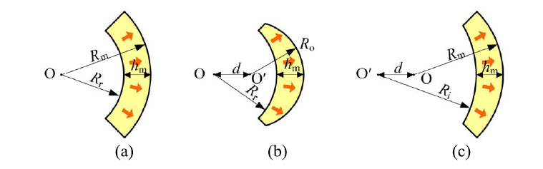

Figure 1: Different magnet shapes (a) Conventional pole shape (b) Outer arc eccentric pole shape (c) Inner arc eccentric pole shape [1]

Another study on optimization of the magnet shape was conducted by Li et all. They use also eccentric magnet shapes as seen in Figure 1. According to their results obtained in the FEA analysis, they argue that by changing d distance and shape of the magnet, total harmonic distortion of the back EMF waveforms can be reduced to 47%, cogging torque can be reduced to 72% and torque ripple of the machine can be enhanced by reduction of 29%. [2]

Hong et all conducted a study in order to show effects of notching groove on magnets. These grooves can be seen in Figure 2. They suggest a methodology to find groove effects on the cogging torque by using stored energy equation of the machine. They derived Fourier coefficients of the cogging torque with considering groove thickness and heights of the magnets. By verification of their suggestion on the FEA model, they concluded that with the help of the notching groove, cogging torque can be minimized with optimum groove number, thickness and height. [3]

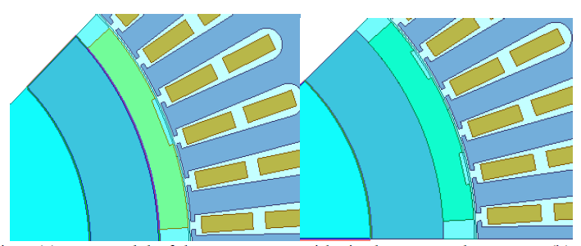

Figure 2: a) single rectangular groove on magnet b) double rectangular groove on magnet [3]

Beside magnet shape optimization, some research is done for analytical calculation of machine optimization. Berkani et all conducted a research by developing an analytical derivations in order to reveal out saturation effects on the iron parts of the machine. By doing so, they obtained set of equations and a flowchart to show saturation effect and results are verified with FEA. As a result of study, FEA dependency on the saturation effect is reduced and optimization can be made with less computational time. [4]

On the other hand, Zhang and Guo developed an analytical expressions for discover electromagnetic parameters and performances of a SMPMSM. Their research contains skewing effect of the magnets. With this perspective analytical model can be used for many SMPMSM designers. Based on their mathematical equations and expressions back EMF, cogging torque can be calculated analytically without using FEA software. [5]

To sum up literature review, although SMPMSM’s are very mature compared to IPM or SRM, magnets of the machine are subjected to optimization with their shapes. Also, there are researches end up with analytical models which reduces the computational time and necessity of FEA software.

# Analytical Calculation & Sizing

Some important design criteria for the machine can be stated as follows;

* 250 kW output power at 1500 rpm
* 1600Nm nominal torque at 1500 rpm
* Surface Mount PMSM topology
* Liquid cooling
* Inverter driven with 650V nominal DC-link voltage
* 750-550V DC-link range (1200V Power semiconductors used in inverter)
* Specific Machine Constant

Suggested electrical loading of liquid cooling PMSMs is 150-200 kA/m therefore, 175 kA/m is selected as electrical loading of the machine. On the other hand, magnetic loading of the machines can be obtained from average airgap flux density over a pole which is between 0.8-1.05 T in PMSM, so 0.8 T of magnetic loading is selected for the design. Also, winding factor of the fundamental component can be considered as 0.95 for initial design. Based on these numbers, specific machine constant can be calculated as follows;

* Rough Dimensions

Air gap of the machine can be defined according to following formula;

For heavy duty machines result of the formula can be increased up to 60%. Therefore, 1.045 mm can be raise up to 1.67 mm. It seems that air gap clearance of the machine can be selected as 1.5 mm for initial design of the machine.

As machine will be driven with inverter and maximum speed is about 3000rpm, by taken switching frequency as 12kHz and electrical frequency should be consider with at least 20 times of switching frequency, maximum electrical frequency can be considered as 600 Hz coincide with 3000 rpm. Therefore pole number of the machine can be chosen as;

Pole number of the machine is chosen as 24, polepair is 12.

Aspect ratio of the machine can be calculated as;

Aspect ratio is found as 0.23. Considering large synchronous machines like used in hydroelectric plants, it is logical to use the formula and applications show that aspect ratios are very small for these types of the machines. But for electric vehicle applications, reserved area for the machine may be considered as cubical. Therefore, overall length and outer diameter of the machine can be designed as close to each other. Therefore aspect ratio of 0.75 will be taken for calcuations.

Outer diameter of the rotor can be calculated as;

Axial length of the machine is 0.75 times of the outer diameter of the rotor and it is 0.239 m.

* Winding Configurations

In order to make winding configuration simple, slot per pole per phase will be taken as 1, and pole numbers was chosen as 24. Therefore number of slots is chosen as 72.

As slot per pole per phase is 1, phase sequence of the slots is chosen as A,-C,B,-A,C,-B which repeats for 12 times fulfilling 72 slots.

Determination of the number of coils, cable size etc, directly dependent of one phase current of the machine because one of the coil current should be determined. By assuming space vector modulation on the inverter side, maximum phase to phase voltage of the motor terminals at nominal 650Vdc can be obtained from following equation;

Maximum phase current which will be given to the machine can be obtained as follows;

Note that this current is too much for currents for one coil. In order to decrease the coil current, one coil can be made up with many strands which has no impact on turns number but it will help to choose reasonable and applicable cable size. On the other hand, current density of 10 A/mm2 can be taken as machine has liquid cooling infrastructure. Strands number can be selected as 15 in order to decrease area of the cable.

Based on the resultant wire area, AWG14 cable is chosen. Turns number will be calculated after obtaining slot dimensions.

* Other dimensions

Inner diameter of the stator can be calculated from outer diameter of the rotor, magnet thickness and air gap clearance. Magnet thickness is going to be taken as 4 mm whereas other dimensions were determined before.

Stator circumference can be calculated as;

For 72 slot configuration, stator slot length for one slot and one teeth can be calculated as;

Total slot and teeth length at the inner stator circumference is reasonable, therefore 72 slot configuration is feasible.

Assuming rectangular teeth shape, some dimension can be obtained. Outer stator slot diameter can be calculated as;

Height of the slot can be obtained as follows;

As rectangular teeth are chosen, slot dimension can be obtained at initial and final position;

Slot area can be obtained using height of the slot, initial and final thickness as follows;

Number of turns in a coil can be obtained by taking fill factor 0.55 as;

As pole number of the machine is high, outer diameter of the machine can be calculated as 1.3 times of inner diameter of the stator. Therefore, outer diameter is taken as 429 mm. Back core thickness can be obtained from outer diameter as follows;

Electrical loading of the machine was assumed 175 kA/m initially. Based on the obtained data, electrical loading can be calculated as follows;

Note that electrical loading is found a smaller than intended value. This situation is a result of selecting slot height as relatively smaller.

* Material Selection

In order to minimize core losses of the laminations, M250-35A is selected for rotor and stator laminations. This material has loss of 2.35 W/kg. Also relative permeability of the material is 660. [6]

NdFeB magnets are popular in electric vehicle applications. By taking magnet maximum temperature, N42UH grade NdFeB magnets are chosen whose intrinsic and normal curves for different temperatures can be seen in Figure 3.

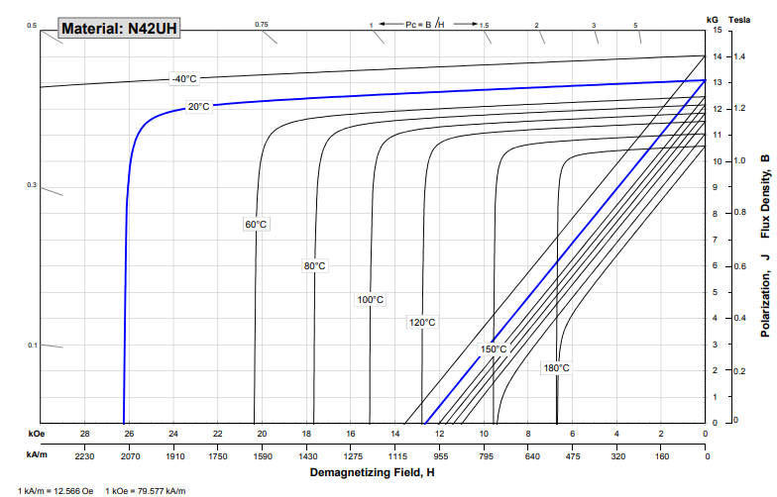

Figure 3: Intrinsic and normal curves of N42UH [7]

* Parameter estimation

Pole area of the machine can be calculated as;

Flux per pole can be calculated as;

Note that machine contain 12 equal segment which one of them has 2 pole and 6 slot. By considering all series configuration i.e. one phase has 12 series windings whose has 6 turns inside of themselves. Back EMF of the machine at 1500 rpm can be computed from well-known formula of;

Note that obtained value is too large considering battery voltage of the system. Therefore it should be reduced. As machine has perfect symmetry with 12 segments, back EMF can be decreased with parallel configuration. For 1500 rpm, it is logical to not apply field weakening because machine has 3000 rpm maximum speed and it is logical to apply field weakening after 1500 rpm up to 3000rpm. Therefore, peak of the phase to phase voltage should be decreased to nominal battery voltage of 650 Vdc. In order to provide this requirement, 12 winding can be connected as 4 parallel, 3 series configuration. Rearranged back EMF can be computed as;

Phase resistance of a segment can be calculated according to axial length which is 0.239 meter and taken into end windings which have 4 slot span. Average length of the end winding can be calculated from minimum length which coincide with inner stator diameter and maximum length which coincide with stator slot outer diameter.

Therefore length of one coil can be calculated from axial length and end winding length as follows;

AWG14 cable has 8.286 mΩ/m. So, one coil resistance can be calculated as;

One phase in one segment is made from 15 parallel AWG14 and 6 series turn and one phase is made from 4 parallel and 3 series of them. Therefore;

# FEA Modelling

Based on the dimensions obtained, machine model is constructed with Maxwell Ansys as seen in Figure 4. Note that machine has 24 pole and 72 slot as a result, machine can be divided into 12 equal segment. In order to reduce simulation time, model is reduced for one pole pair which has 2 magnet and 6 slot.

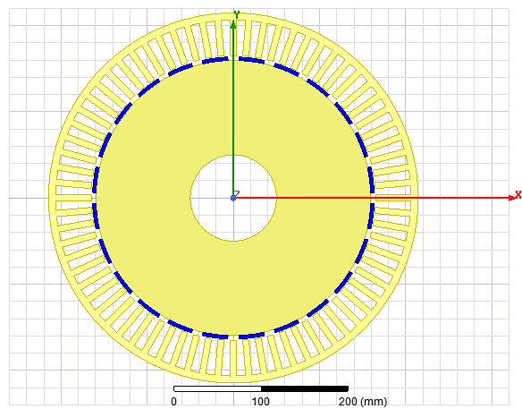

Figure 4: Constructed model

At no load, simulation is analyzed and magnetic field magnitudes can be seen in Figure 5. As seen from this figure, back core is highly saturated and output diameter of the machine should be increased.

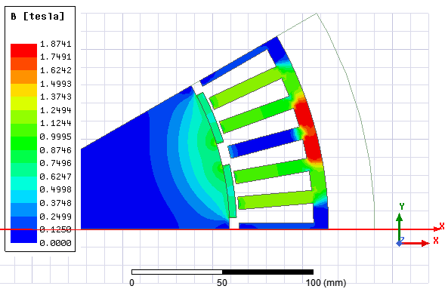

Figure 5: Bmag for initial design

Outer diameter of the machine is increased to 445 mm from 429 mm in order to prevent saturation of the back core. Resultant B_mag distribution can be seen in Figure 6. As seen from this figure, back core saturation problem is solved.

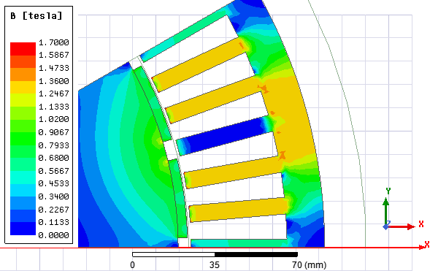

Figure 6: Bmag after output diameter increased

Air gap flux density over a pole is found as seen in Figure 7. Ideally, flux density should be same over a magnet but as seen from the graph, it has considerable decrease in magnitudes for both magnets. These decreases are originated from stator slot structure.

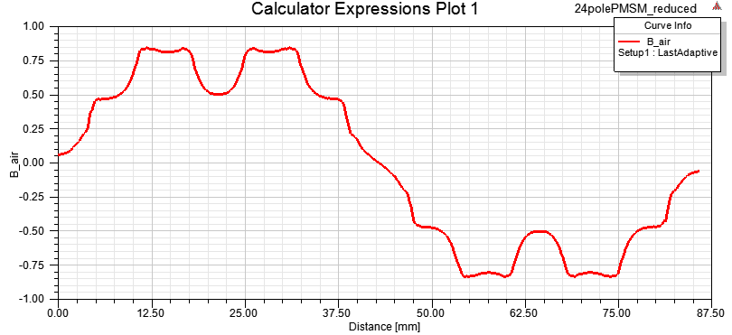

Figure 7: Air gap flux density

In order to eliminate these defects on the air gap flux density, stator structure opening are closed by arranging slot parameters as seen in Figure 8. Note that while construction of the machine these openings should be open but for simplicity, they can be used as Figure 8 in the simulations.

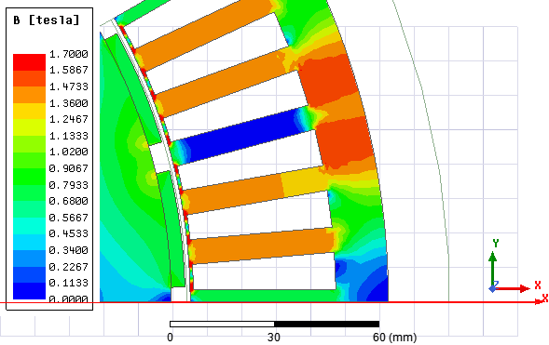

Figure 8: Bmag after closed slot openings

Air gap flux density over a pole after rearrangement of the stator slots can be seen in Figure 9. As seen from graph, defects on the waveform are significantly eliminated.

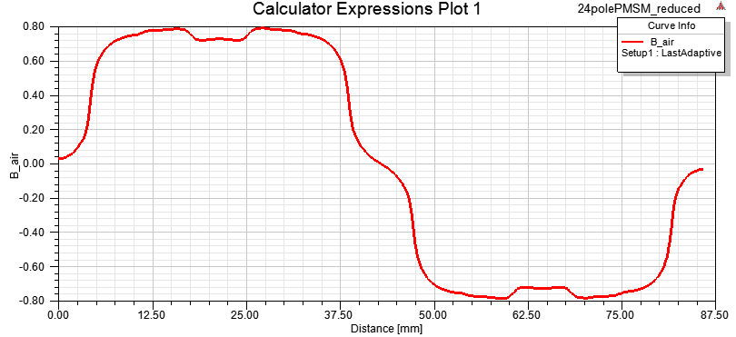

Figure 9: Air gap flux density with closed stator openings

Flux lines created by magnets and their distribution on stator and rotor can be seen in Figure 10. As seen from this figure, rotor laminations are solid and big enough for preventing saturation but stator back core and teeth may saturate if the design is not optimized.

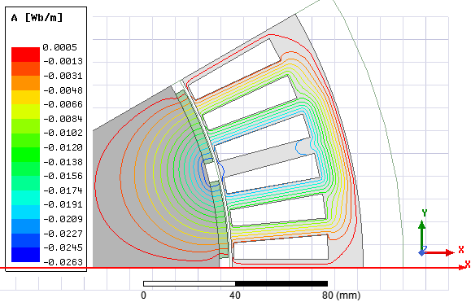

Figure 10: Flux lines of the design

Cogging torque over one polepair for one electrical cycle can be seen in Figure 11. As slot number of the machine is 72, one segment has 6 slots and cogging torque has 6 peaks for one electrical cycle. As machine has nominal torque of 1600 Nm, magnitude of the cogging torque can be considered as very low. So, design can be considered as feasible in terms of cogging torque.

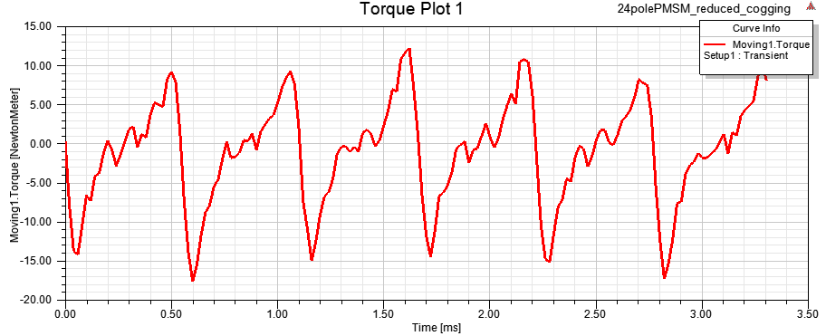

Figure 11: Cogging torque for one electrical cycle

# Comparison & Discussion

In this project, a 250 kW, 1500 rpm nominal speed Surface Mount PMSM is designed and analysed with some aspects. This machine is designed such that it can be used in heavy duty vehicle as main tractive component which converts electrical energy to mechanical energy.

Based on the analytical values, FEA model is constructed and it was seen that back core is highly saturated. So, Outer diameter of the machine is increased to 445 mm from 429 mm and saturation of the back core is eliminated. Moreover, air gap flux density was distorted due to parallel teeth configuration with open type slots. In order to make air gap flux density smoother, slot openings are closed. Although this will result manufacturing problems, for FEA analysis it fixed the problem. While manufacturing of the machine, semiclosed type stator slots configuration can be used for better air gap flux density distribution compared to open slots configuration.

Machine parameters can be listed as follows;

|  |  |  |  |
| --- | --- | --- | --- |
| **Nominal Power** | 250 kW | **Outer Diameter** | 445 mm |
| **Nominal Speed** | 1500 rpm | **Axial Length** | 239 mm |
| **Torque at Nominal Speed** | 1600 Nm | **Aspect Ratio** | 0.75 |
| **Maximum Speed** | 3000 rpm | **Rotor Outer Diameter** | 319 mm |
| **Pole number** | 24 | **Stator Inner Diameter** | 330 mm |
| **Slot Number** | 72 | **Slot Height** | 41.25 mm |
| **Magnet Type** | N42UH, NdFeB | **Magnet Volume** | 239*4*33.4 mm3 *24 |
| **Magnet Thickness** | 4 mm | **Turn number** | 6 |

In this part of the report, two commercial products will be investigated. One of the commercial products for heavy duty electric vehicle is TM4’s product of 9 phases Surface Mount PMSM. Key difference of TM4 product is that outer rotor configuration which results outer diameter of the rotor getting bigger and torque can be increased with same size inner rotor configuration. TM4’s machine parameters are listed below;

|  |  |  |  |
| --- | --- | --- | --- |
| **Nominal Power** | 235 kW | **Outer Diameter** | 488 mm |
| **Nominal Speed** | 1400 rpm | **Axial Length** | 252 mm |
| **Torque at Nominal Speed** | 1600 Nm | **Aspect Ratio** | 0.516 |
| **Maximum Speed** | 3375 rpm | **Stator Outer Diameter** | 450 mm |
| **Pole number** | 24 | **Stator Inner Diameter** | 392 mm |
| **Slot Number** | 144 | **Slot Height** | 18 mm |
| **Magnet Type** | NdFeB | **Turn number** | 5 |
| **Magnet Thickness** | 5.5 mm | **Air gap clearance** | 3 mm |

Although designed machine didn’t not perfectly validate with FEA, based on the analytical calculations, it has close dimensions with TM4’s machine.

Other commercial product is UQM’s 150 kW machine. Although power level of the machine is small, its parameters can be presented here as it is designed for electric vehicle application with liquid cooling infrastructure and SM type. UQM’s machine parameters are listed below;

|  |  |  |  |
| --- | --- | --- | --- |
| **Nominal Power** | 150 kW | **Outer Diameter** | 316 mm |
| **Nominal Speed** | 2000 rpm | **Axial Length** | 130 mm |
| **Torque at Nominal Speed** | 400 Nm | **Aspect Ratio** | 0.53 |
| **Maximum Speed** | 5500 rpm | **Rotor Outer Diameter** | 244 mm |
| **Pole number** | 24 | **Stator Inner Diameter** | 249 mm |
| **Slot Number** | 72 | **Slot Height** | 26 mm |
| **Magnet Type** | NdFeB | **Turn number** | 2 |
| **Magnet Thickness** | 4.5 mm | **Air gap clearance** | 2.5 mm |

As UQM’s has 150 kW nominal power, it seems that designed machines dimensions are logical and feasible.

One of the remarkable specifications of all machines is that all of them have very low turn numbers. By considering back EMF formula, it consist frequency which is larger in these machines (24 pole), flux per pole which is larger in these machines as pole area bigger compared to low power applications. Therefore turn numbers should be kept small for this type of machines.

# References

[1] Z. Chen, C. Xia, Q. Geng, Y. Yan “ Modeling and Analzing of Surface-Mounted Permanent-Magnet Synchronous Machines With Optimized Magnetic Pole Shape” *IEEE Transactions on Magnetics* vol 50. November 2014

[2] Z. Li, Z. Chen, H. Ma, Y. Guo “ Optimization and Analysis of Permanent-Magnet Synchronous Machine With Eccentric Magnetic Pole Shape” *18th International Conference on Electrical Machines and Systems (ICEMS),* October 2015

[3] T. Hong, X. Bao, W. Xu, J. Fang, Y. Xu “Reduction of Cogging Torque by Notching Groove on Magnets in SMPSPM” *22nd International Conference on Electrical Machines and Systems(ICEMS),* 2019

[4] M. S. Berkani, M. L. Sough, S. Giurgea, F. Dubas, B. Boualem, C. Espanet “A Simple Analytical Approach to Model Saturation in Surface Mounted Permanent Magnet Synchronous Motors *IEEE Energy Conversion Congress and Exposition,* September 2015

[5] S. Zhang, S. Guo “An Analytical Method for Electromagnetic Performance Calculation in Surface-Mounted Permanent-Magnet Machines with skewing *21st International Conference on Electrical Machines and Systems (ICEMS),* October 2018

[6] M250-35a lamination datasheet <https://cogent-power.com/cms-data/downloads/m250-35a.pdf>

[7] N42UH NdFeB magnet datasheet <https://www.arnoldmagnetics.com/wp-content/uploads/2017/11/N42UH-151021.pdf>