

**EE 568**

***Selected Topics on Electrical Machines***

***Project 1***

**Torque in a Variable Reluctance Machine**

**Mahmut Enes KARA 2030898**

**Course Instructor: Ozan KEYSAN**

Table of Contents

Introduction 3

Q1) Analytical Modelling 4

Part a) Reluctance and Inductance Calculation 4

Part b) Torque Derivation 6

Part c) Improvements 6

Q2) FEA Modelling (2D-Linear Materials) 7

Part a) Flux Density Vectors 7

Part b) Inductance and Stored Energy 8

Part c) Torque of the System 9

Q3) FEA Modelling (2D-Nonlinear Materials) 9

Part a) Flux Density Vectors of Nonlinear System 9

Part b) Inductance and Stored Energy of Nonlinear System 11

Part c) Torque of the Nonlinear System 12

Part d) Comparison 12

Q4) Control Method 12

Q5) Motion Analysis 12

Appendix 13

# Introduction

In this report, a variable reluctance machine is analysed in terms of system parameters by using both analytical modelling and Finite Element Analysis (FEA) modelling.

Analysed variable reluctance motor can be seen in Figure 1. Besides of the geometry, coils are wound within 30mm*100mm rectangle areas, each airgap clearance is 0.5 mm, depth of the core is 20mm. Number of turns is 250 mm whereas coil current is 3 A DC.

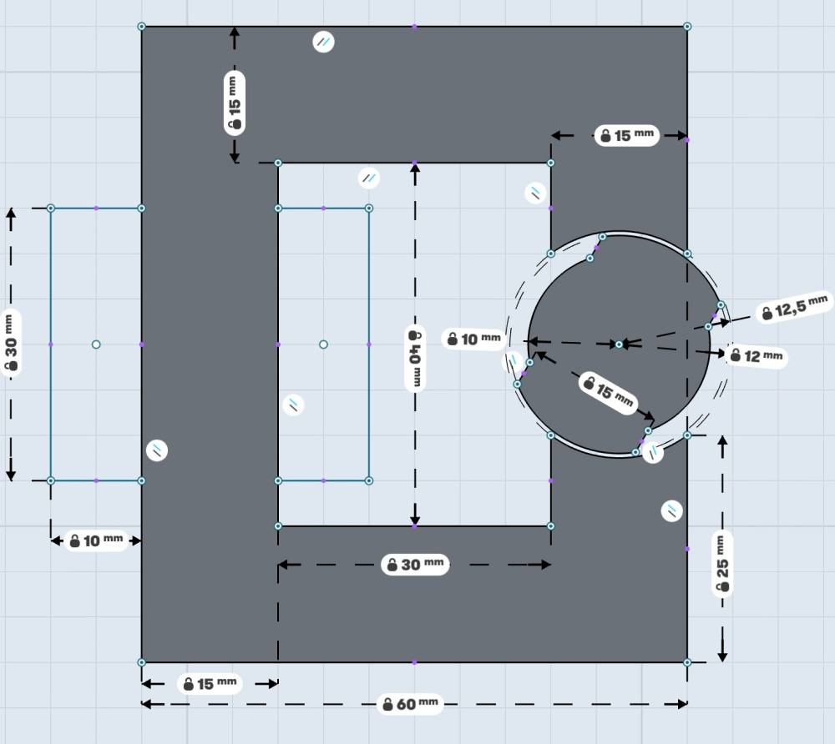

Figure 1: Geometry of the Variable Reluctance Machine

# Q1) Analytical Modelling

In this part, reluctance, inductance and torque of the system is calculated analytically and plotted by using MATLAB whose code can be found in Appendix. Also, improvements of the model by considering non-linear effects are discussed.

## Part a) Reluctance and Inductance Calculation

In order to model analytically, some assumptions are made;

* Core is infinitely permeable.
* No leakage flux and all flux lines are travelling through round shapes of the rotor. As rotor geometry has straight geometry between round shapes, these straight lines are ignored.
* 0 degree is set as rotor is aligned such that all airgap clearance is 0.5mm

Reluctance of the system is derived according to angle of the rotor.

For θ = 0 rad, equivalent reluctance can be calculated by just considering small airgap;

$$Req= \frac{2*air_gap_small}{µ_{0}*\frac{2*arcsin\left(\frac{7.5}{12}\right)}{2*π}*2*π*r_{large}*core_depth}$$

For θ > 0 and θ <2*arcsin(7.5/12), equivalent reluctance has two parts as small airgap and large airgap;

$$R1= \frac{2*air_gap_small}{µ_{0}*\frac{2*arcsin\left(\frac{7.5}{12}\right)-θ}{2*π}*2*π*r_{large}*core_depth}$$

$$R2= \frac{2*air_gap_large}{µ_{0}*\frac{θ}{2*π}*2*π*r_{small}*core_depth}$$

$$Req= \frac{R1*R2}{R1+R2}$$

For θ >2*arcsin(7.5/12) and θ <(π-2*arcsin(7.5/12)), equivalent reluctance can be calculated by just considering large airgap;

$$Req= \frac{2*air_gap_large}{µ_{0}*2*\frac{\arcsin\left(\frac{7.5}{12}\right)}{2*π}*2*π*r_{small}*core_depth}$$

For θ >(π-2*arcsin(7.5/12)), equivalent reluctance has two parts again as small airgap and large airgap;

$$R1= \frac{2*air_gap_small}{µ_{0}*\frac{2*arcsin\left(\frac{7.5}{12}\right)+θ-π}{2*π}*2*π*r_{large}*core_depth}$$

$$R2= \frac{2*air_gap_large}{µ_{0}*\frac{π-θ}{2*π}*2*π*r_{small}*core_depth}$$

$$Req= \frac{R1*R2}{R1+R2}$$

Inductances can be calculating according to reluctances by using following formula;

$$L= \frac{N^{2}}{Req}$$

Based on these formulas, reluctance and inductance of the system is calculated by using MATLAB and results can be seen in Figure 1 and 2 respectively.

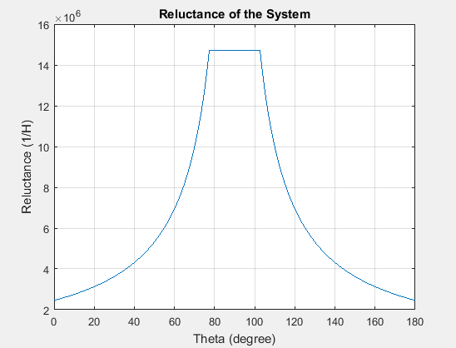

Figure 2: Reluctance of the system

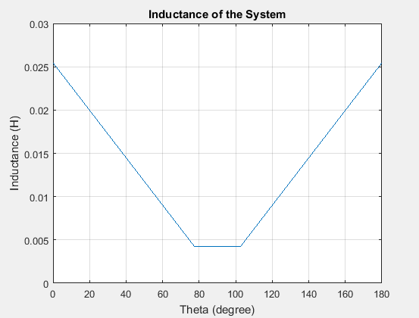

Figure 3: Inductance of the system

## Part b) Torque Derivation

Torque of the system can be calculated using following formula analytically and it can be seen in Figure 3.

$$T= -\frac{∂W_{magnetic}}{∂θ}=-\frac{1}{2}I^{2}\frac{dL}{dθ}$$

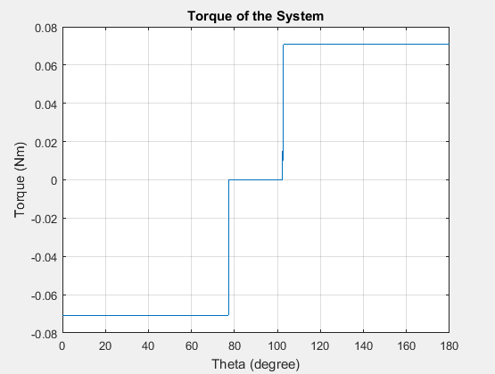

Figure 4: Torque of the system

## Part c) Improvements

In our analysis, it is assumed that all flux lines are going through on round shapes part. But in reality, there will be flux linkages between straight line part of the rotor and stator. If this effect considered analytically, torque curve of the analytical result will have smooth transition between negative and positive. Also permeability of the core should also be taken into account.

# Q2) FEA Modelling (2D-Linear Materials)

In this part, system is modelled in Ansys, Maxwell FEA program. As electric steel lamination iron is selected whose relative permeability is about 4000.

## Part a) Flux Density Vectors

Flux density vectors can be seen in Figure 5-7 which has rotor angles 0, 45, 90 degree respectively. As angle increasing, flux densities are decreasing. Therefore scaling of all three results are different.

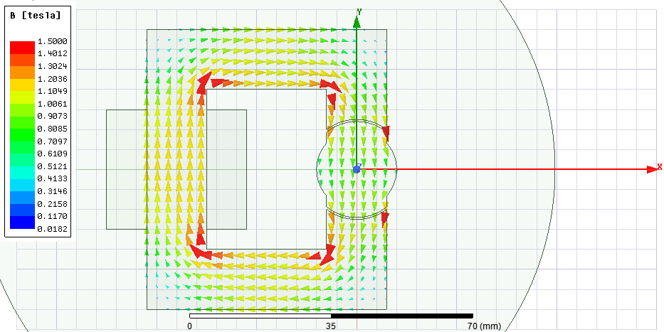

Figure 5: B vectors for θ=0 degree

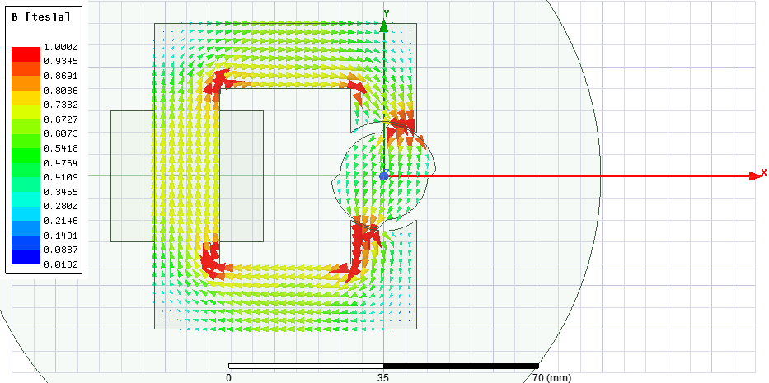

Figure 6: B vectors for θ=45 degree

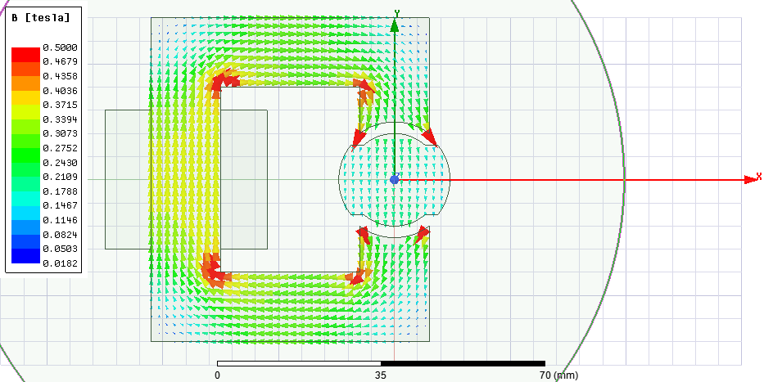

Figure 7: B vectors for θ=90 degree

## Part b) Inductance and Stored Energy

In order to calculate inductance of the system, Transient model is constructed in FEA and constant speed is given to the rotor. By doing so, a full rotation of the rotor is reached. Inductance is shown in Figure 8 according to this rotation.

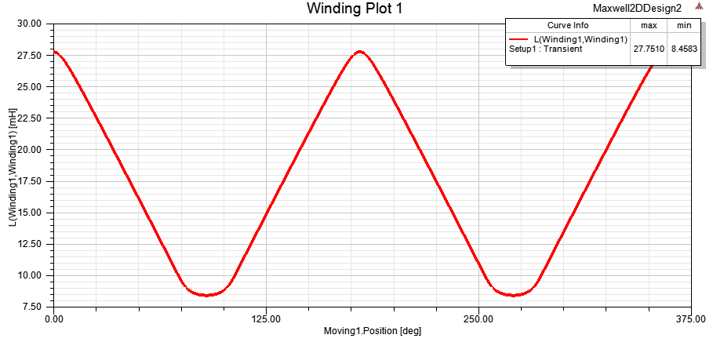

Figure 8: Inductance of the system

As Maxwell calculates energy in terms of Joule/m^3, this energy result is integrated for total energy. Stored energy in the system for 3 different points can be found in following table;

|  |  |
| --- | --- |
| Theta (Degree) | Stored Energy (mJoule) |
| 0 | 125,6 |
| 45 | 79,23 |
| 90 | 38,26 |

## Part c) Torque of the System

Torque of the system can be seen in Figure 9. Characteristic is similar with analytical results. But transition between maximum and minimum points are smooth compared to analytical whose transition made with step. This transition is also explained in improvements part of the analytical results.

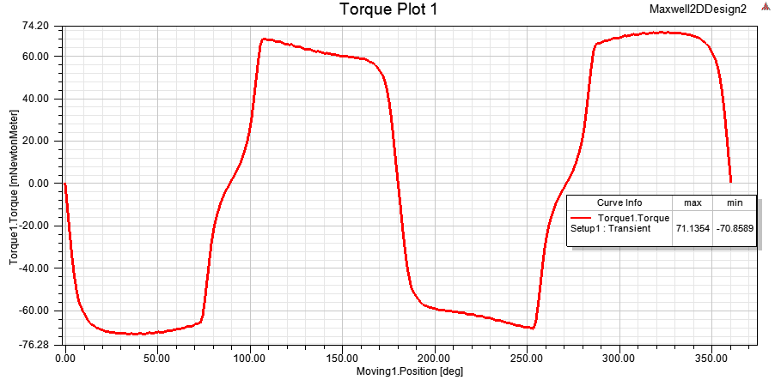

Figure 9: Torque generated in the system

# Q3) FEA Modelling (2D-Nonlinear Materials)

As nonlinear material M19_29G whose B-H curve can be seen in Figure 10 is selected. Material is starting to saturate around 1.5 Tesla.

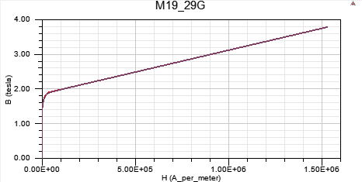

Figure 10: B-H curve of the chosen material

## Part a) Flux Density Vectors of Nonlinear System

For nonlinear material, flux density vectors can be seen in Figure 11-13. As seen in these figures, there is not much difference with linear material. This situation is resulting from low flux densities. If flux density magnitudes would much higher than 1.5 Tesla, saturation effect will be obvious.

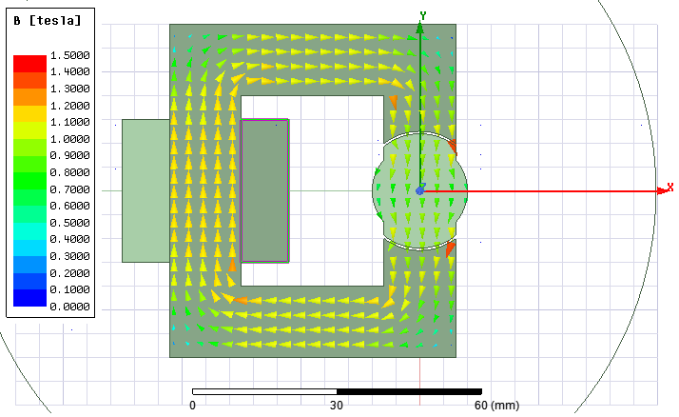

Figure 11: B vectors for θ=0 degree

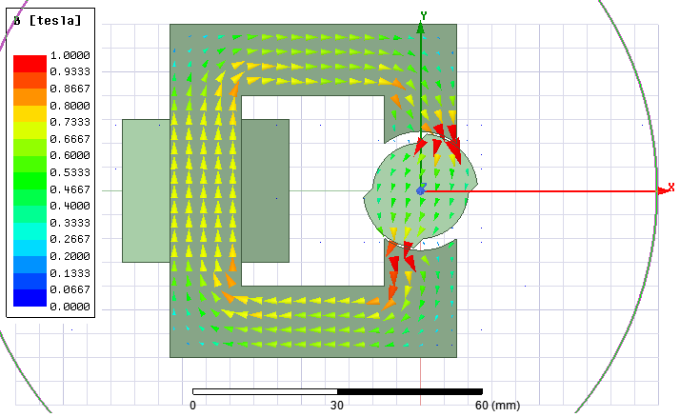

Figure 12: B vectors for θ=45 degree

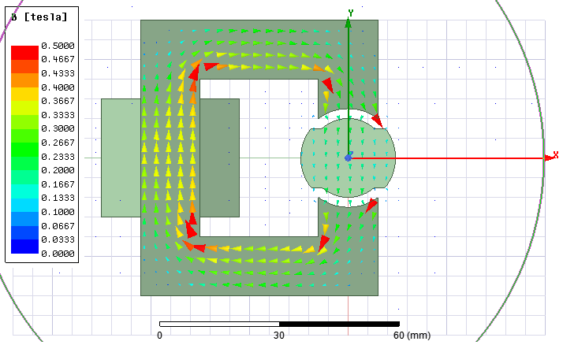

Figure 13: B vectors for θ=90 degree

## Part b) Inductance and Stored Energy of Nonlinear System

Inductance of the system with nonlinear material can be seen in Figure 14. Inductance characteristic is same with linear model.

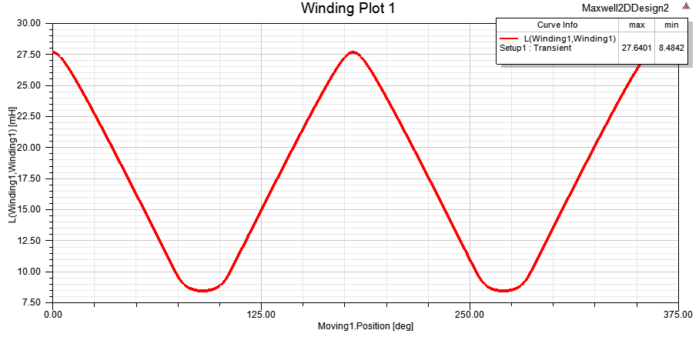

Figure 14: Inductance of the nonlinear system

Stored energy in the system for 3 different points can be found in following table. By comparing these results with linear model, maximum stored energy is decreased a bit which results from little saturation.

|  |  |
| --- | --- |
| Theta (Degree) | Stored Energy (mJoule) |
| 0 | 122,8 |
| 45 | 79,36 |
| 90 | 38,47 |

## Part c) Torque of the Nonlinear System

Torque of the nonlinear system can be seen in Figure 15. As expected, it is similar with linear system because of saturation of the system is very low.

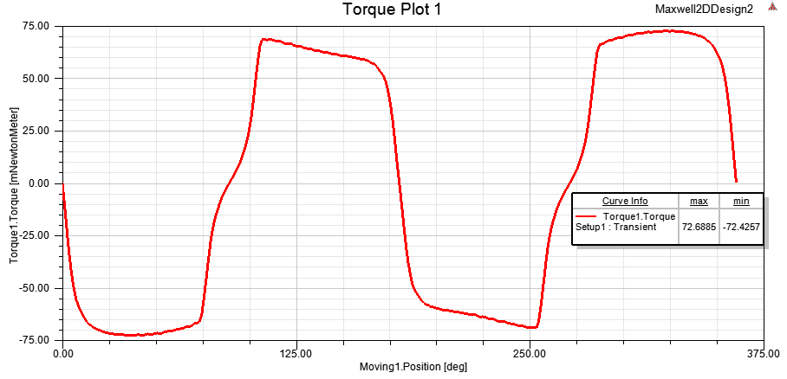

Figure 15: Torque generated in the nonlinear system

## Part d) Comparison

As flux density magnitudes are generally below 1.5 T, nonlinear material doesn’t saturate much and all results are almost same with linear part. Effect of the saturation can be easily seen if current value of 3 A made larger.

# Q4) Control Method

All of the torque results show that in the interval of 0-90 degree negative torque is generated with applied current. Also, in the interval of 90-180 degree positive torque is generated with applied current. Note that, polarity of the current does not change torque polarity. Therefore, rotation in negative direction can be obtained by applying excitation for 0-90 and 180-270 degrees. No current should be applied for other intervals. On the other hand, rotation in positive direction can be obtained by applying excitation for 90-180 and 270-360 degrees. No current should be applied for other intervals.

# Q5) Motion Analysis

Physical motion of the model is added to repository of the project.

# Appendix

Analytical Derivation Code

air_gap_small = 0.5*1e-3;

air_gap_large = 2.5*1e-3;

perm_air = 4*pi*1e-7;

core_depth = 20*1e-3;

theta_diff = asin(7.5/12);

r_large = 12*1e-3;

r_small = 10*1e-3;

turn_ratio = 250;

current = 3;

Req = zeros (1,1801);

R1 = zeros (1,1801);

R2 = zeros (1,1801);

L = zeros (1,1801);

Torque = zeros (1,1801);

theta = linspace(0,180,1801);

% Theta = 0

% R1 = 2*air_gap_small/(perm_air*((2*theta_diff)/(2*pi))*2*pi*r_large*core_depth);

% L1 = turn_ratio^2/R1;

%

% % 102.64>Theta>38.68*2

% R2 = 2*air_gap_large/(perm_air*((2*theta_diff)/(2*pi))*2*pi*r_small*core_depth);

% L2 = turn_ratio^2/R2;

for i=0:1:1800 %%0.1degree step

if i == 0 | i == 1800

Req(i+1) = 2*air_gap_small/(perm_air*((2*theta_diff)/(2*pi))*2*pi*r_large*core_depth);

L(i+1) = turn_ratio^2/Req(i+1);

elseif i > 0 & i < 774

R1(i+1) = 2*air_gap_small/(perm_air*((2*theta_diff-i*pi/1800)/(2*pi))*2*pi*r_large*core_depth);

R2(i+1) = 2*air_gap_large/(perm_air*((i*pi/1800)/(2*pi))*2*pi*r_small*core_depth);

Req(i+1)= R1(i+1)*R2(i+1)/(R1(i+1)+R2(i+1));

L(i+1) = turn_ratio^2/Req(i+1);

elseif i>=774 & i< 1026

Req(i+1) = 2*air_gap_large/(perm_air*((2*theta_diff)/(2*pi))*2*pi*r_small*core_depth);

L(i+1) = turn_ratio^2/Req(i+1);

elseif i< 1800

R1(i+1) = 2*air_gap_small/(perm_air*(abs(pi-2*theta_diff-i*pi/1800)/(2*pi))*2*pi*r_large*core_depth);

R2(i+1) = 2*air_gap_large/(perm_air*((pi-i*pi/1800)/(2*pi))*2*pi*r_small*core_depth);

Req(i+1)= R1(i+1)*R2(i+1)/(R1(i+1)+R2(i+1));

L(i+1) = turn_ratio^2/Req(i+1);

end

end

for i=0:1:1799

Torque(i+1)= current^2*(L(i+2)-L(i+1))/(pi*0.1/180)/2;

end

Torque(1801)= Torque(1800);

plot(theta,L);

grid on;

xlabel('Theta (degree)');

ylabel('Inductance (H)');

title('Inductance of the System');

figure;

plot(theta,Req);

grid on;

xlabel('Theta (degree)');

ylabel('Reluctance (1/H)');

title('Reluctance of the System');

figure;

plot(theta,Torque);

grid on;

xlabel('Theta (degree)');

ylabel('Torque (Nm)');

title('Torque of the System');