|  |  |
| --- | --- |
| StudentId | Total |
|  | 0 |
|  | 84 |
|  | 0 |
|  | 75 |
|  | 75 |
|  | 100 |
|  | 75 |
|  | 100 |
|  | 100 |
|  | 60 |
|  | 72 |
|  | 0 |
|  | 0 |
|  | 100 |
|  | 10 |
|  | 80 |
|  | 83 |
|  | 40 |
|  | 0 |
|  | 72 |
|  | 79 |
|  | 92 |
|  | 100 |
|  | 100 |
|  | 100 |
|  |  |
|  | 100 |
|  | 100 |
|  | 92 |
|  | 60 |
|  | 0 |
|  | 60 |
|  |  |
|  | 96 |
|  | 60 |
|  | 100 |
|  | 64 |
|  | 71 |
|  | 92 |
|  | 0 |
|  | 0 |
|  | 0 |
|  | 58 |
|  | 100 |
|  | 96 |
|  | 96 |
|  | 96 |
|  | 93 |
|  | 80 |
|  | 64 |
|  | 64 |
|  | 72 |
|  | 68 |
|  | 50 |
|  | 45 |
|  | 60 |
|  | 64 |
|  | 0 |
|  | 72 |
|  | 56 |
|  | 92 |
|  | 96 |
|  | 0 |
|  | 100 |
|  | 92 |
|  | 44 |
|  | 30 |
|  | 88 |
|  | 88 |
|  | 88 |
|  | 80 |
|  | 60 |
|  | 46 |
|  | 60 |
|  | 100 |
|  | 60 |
|  | 42 |
|  | 100 |
|  | 88 |
|  | 88 |
|  | 100 |
|  | 76 |
|  | 80 |
|  | 100 |
|  | 50 |
|  | 63 |
|  | 84 |
|  | 88 |
|  | 40 |
|  | 60 |
|  | 88 |
|  | 80 |
|  | 88 |
|  | 92 |
|  | 80 |
|  | 92 |
|  |  |
|  |  |
|  | 0 |
|  | 0 |
|  | 0 |
|  | 75 |
|  | 12 |
|  | 0 |
|  | 88 |
|  | 92 |
|  | 100 |
|  | 0 |
|  | 100 |
|  | 88 |
|  | 100 |
|  | 46 |
|  | 9 |
|  | 92 |
|  | 50 |
|  | 92 |
|  | 100 |
|  | 100 |
|  | 10 |
|  | 75 |
|  | 0 |

|  |  |
| --- | --- |
| Programming Outcomes | Question No |
| PO-4 | TÜMÜ |
| PO-5 | TÜMÜ |
| PO-6 | TÜMÜ |
| PO-7 | TÜMÜ |
| PO-8 | TÜMÜ |
| PO-9 | TÜMÜ |

Final Programming Outcomes Result

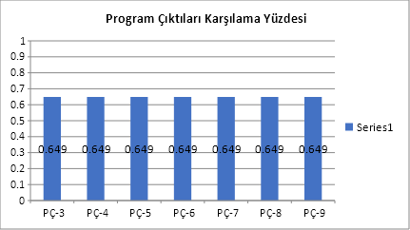

|  |  |
| --- | --- |
| Learning Outcomes | Question No |
| LO-4 | TÜMÜ |
| LO-5 | TÜMÜ |
| LO-6 | TÜMÜ |
| LO-7 | TÜMÜ |
| LO-8 | TÜMÜ |
| LO-9 | TÜMÜ |

Final Learning Outcomes Result

