|  |  |
| --- | --- |
| StudentId | Total |
|  |  |
|  |  |
|  |  |
|  |  |
|  |  |
|  | 148 |
|  |  |
|  |  |
|  |  |
|  | 112 |
|  |  |
|  |  |
|  |  |
|  | 74 |
|  |  |
|  |  |
|  | 64 |
|  |  |
|  |  |
|  |  |
|  | 74 |
|  | 134 |
|  |  |
|  | 148 |
|  |  |
|  |  |
|  | 74 |
|  | 74 |
|  | 138 |
|  | 128 |
|  |  |
|  |  |
|  |  |
|  |  |
|  |  |
|  |  |
|  |  |
|  |  |
|  |  |
|  |  |
|  |  |
|  |  |
|  |  |
|  |  |
|  |  |
|  |  |
|  |  |
|  |  |
|  |  |
|  |  |
|  |  |
|  |  |
|  | 56 |
|  |  |
|  |  |
|  |  |
|  |  |
|  |  |
|  |  |
|  |  |
|  |  |
|  |  |
|  |  |
|  | 148 |
|  |  |
|  |  |
|  |  |
|  |  |
|  |  |
|  |  |
|  | 120 |
|  | 53 |
|  |  |
|  |  |
|  | 148 |
|  |  |
|  | 63 |
|  | 146 |
|  | 62 |
|  |  |
|  | 146 |
|  | 146 |
|  |  |
|  | 72 |
|  |  |
|  | 63 |
|  |  |
|  |  |
|  |  |
|  | 134 |
|  |  |
|  | 60 |
|  | 67 |
|  | 70 |
|  | 68 |
|  | 70 |
|  |  |
|  |  |
|  |  |
|  |  |
|  |  |
|  |  |
|  |  |
|  |  |
|  | 67 |
|  | 144 |
|  |  |
|  |  |
|  | 148 |
|  | 24 |
|  | 150 |
|  | 68 |
|  |  |
|  |  |
|  |  |
|  | 144 |
|  | 148 |
|  | 75 |
|  |  |
|  |  |
|  |  |

|  |  |
| --- | --- |
| Programming Outcomes | Question No |
| PO-4 | TÜMÜ |
| PO-5 | TÜMÜ |
| PO-6 | TÜMÜ |
| PO-7 | TÜMÜ |
| PO-9 | TÜMÜ |
| PO-10 | TÜMÜ |

Quiz Programming Outcomes Result

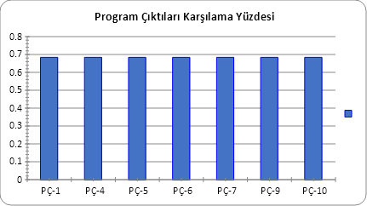

|  |  |
| --- | --- |
| Learning Outcomes | Question No |
| LO-4 | TÜMÜ |
| LO-5 | TÜMÜ |
| LO-6 | TÜMÜ |
| LO-7 | TÜMÜ |
| LO-9 | TÜMÜ |
| LO-10 | TÜMÜ |

Quiz Learning Outcomes Result

