Technical Analysis using R
  - Preliminary Stage
Assignment 2
Mahmoud Bakar
BDA400 Data Science Tools and Techniques
CDI College
10 November 2026

Purpose and completed analysis
This project establishes a reproducible stock-analysis workflow in R. It reads a five-symbol portfolio, imports historical data, calculates the required descriptive statistics and trailing moving averages, and produces tables and price-volume charts.
The completed run imported 250 daily observations for each of AAPL, MSFT, GOOGL, AMZN and TSLA. All 1,250 records cover 2 January through 31 December 2025. The numerical results passed independent R checks and a separate Python cross-check.

Submission contents
The Assignment2 directory contains this Word report, portfolio.txt, setup.R, stock_functions.R, display_analysis.R, a project file, verification code, source CSVs, calculated outputs and original screenshots.

Evidence and assistance
ChatGPT (GPT-6 Codex) assisted with implementation, documentation, execution and verification on 10 November 2026. Screenshots show real execution in an assistant-operated Linux workspace. They are not screenshots of installation on the student's Windows PC. The existing GitHub account and repository were reused.
Repository
https://github.com/mahmuudbakkar-pixel/TechnicalAnalysis
Assignment folder
https://github.com/mahmuudbakkar-pixel/TechnicalAnalysis/tree/main/Assignment2

1 GitHub account and repository
The GitHub account mahmuudbakkar-pixel already had a repository named TechnicalAnalysis. The existing account and repository were verified, and the Assignment2 subdirectory was added for this submission. Existing Assignment5 and Assignment6 content was preserved.
Reproduction steps: sign in to GitHub, open TechnicalAnalysis, create or open Assignment2, add the report and project files, then commit the changes. For a new account, first register through GitHub and create TechnicalAnalysis. Account registration was not repeated in this run.
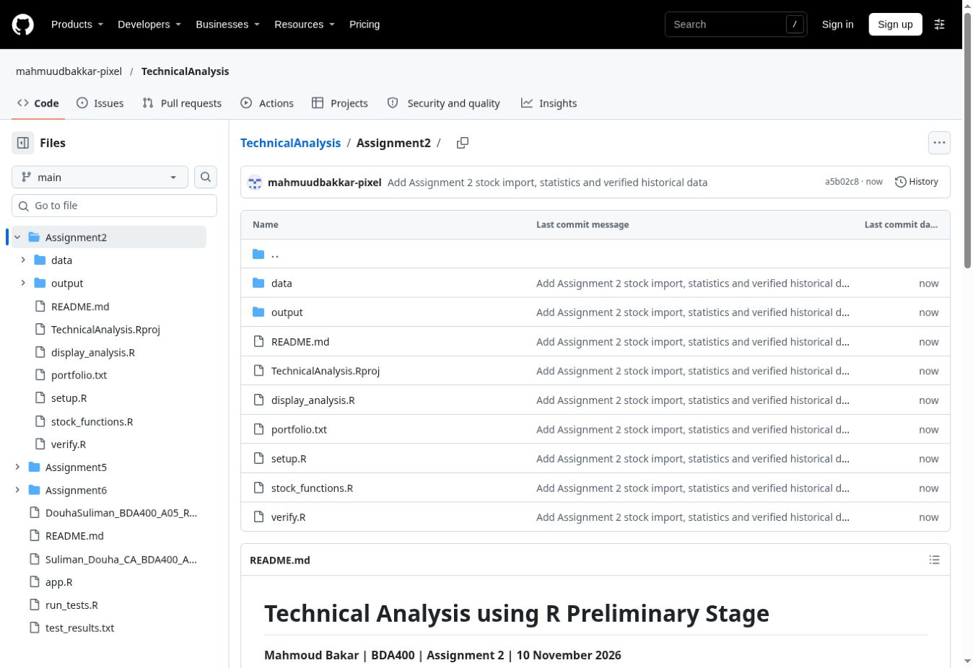
Figure 1. Actual GitHub Assignment2 folder after publication.
All source files, the five historical snapshots and outputs are stored in the assignment folder. A fresh download of that folder is sufficient to reproduce the cached analysis after installing the R packages.

2 R and RStudio installation
R 4.5.0 and its dependencies were downloaded from the official Debian repository and extracted into a writable workspace prefix. RStudio Desktop 2026.10.1+239 was downloaded from Posit as an official Ubuntu Jammy .deb package and extracted into the same workspace. This approach was used because system-wide package installation was unavailable.
The R launcher paths and RSTUDIO_WHICH_R were configured for the extracted R installation. The supplied TechnicalAnalysis.Rproj was then opened in RStudio. The console below confirms a running R session and the Assignment2 working directory.
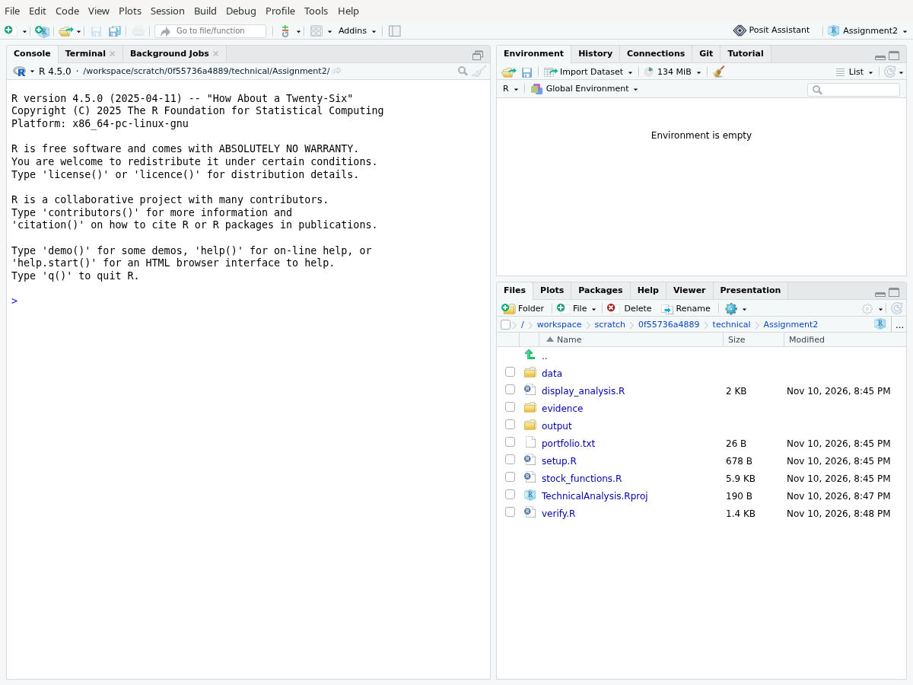
Figure 2. RStudio running R 4.5.0 with the project open in the Linux workspace.
On a personal Windows PC, install R from CRAN first, then RStudio Desktop from Posit, open the .Rproj file and run setup.R. Windows installer stages were not performed or photographed in this session; the evidence above documents the actual Linux setup.

3 Package installation and verification
The required packages were provisioned from Debian packages. quantmod 0.4.27 was also installed successfully from its official CRAN source archive through install.packages(..., repos=NULL, type="source") in RStudio after the online CRAN index was unavailable in the GUI session.
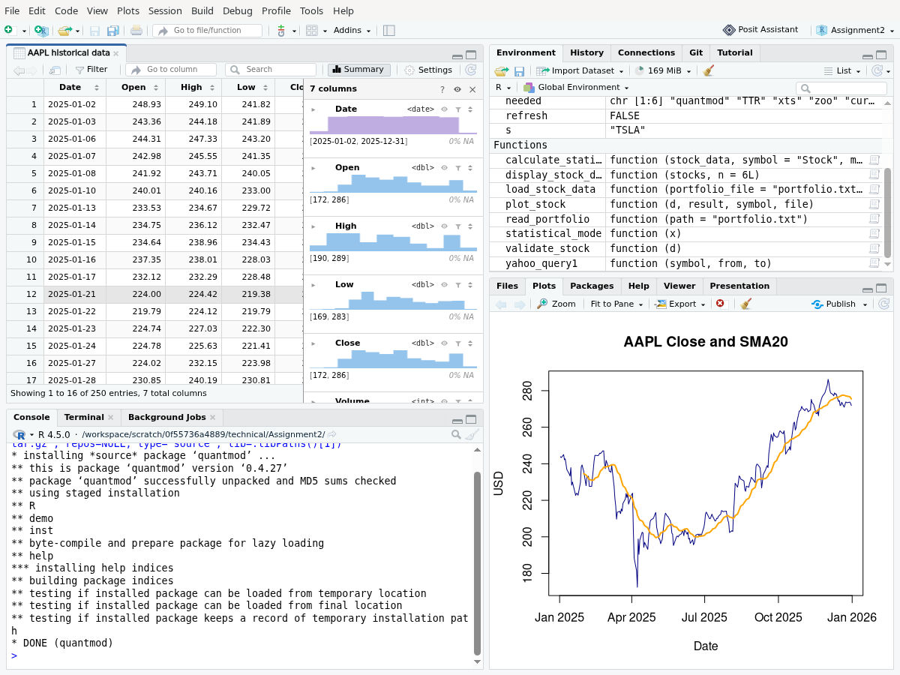
Figure 3. Actual RStudio installation output ending with DONE (quantmod).
Package | Version
quantmod | 0.4.27
TTR | 0.24.4
xts | 0.14.1
zoo | 1.8.14
curl | 6.2.1
jsonlite | 1.9.1

For a normal internet-connected setup, setup.R installs missing packages with install.packages() and then records package versions and sessionInfo(). The saved environment record identifies the versions used for the analysis.

4 Portfolio and data import
portfolio.txt contains AAPL, MSFT, GOOGL, AMZN and TSLA, one symbol per line. These are demonstration selections for the assignment, not a claim about personal holdings. read_portfolio() trims whitespace, removes empty and comment lines, de-duplicates symbols and validates symbol characters.
load_stock_data() requests each symbol with quantmod::getSymbols(src="yahoo", auto.assign=FALSE). The requested interval is 2025-01-01 inclusive to 2026-01-01 exclusive. Every original quantmod download succeeded. Each result is converted to a separate data frame in a named list, for example stocks$AAPL.
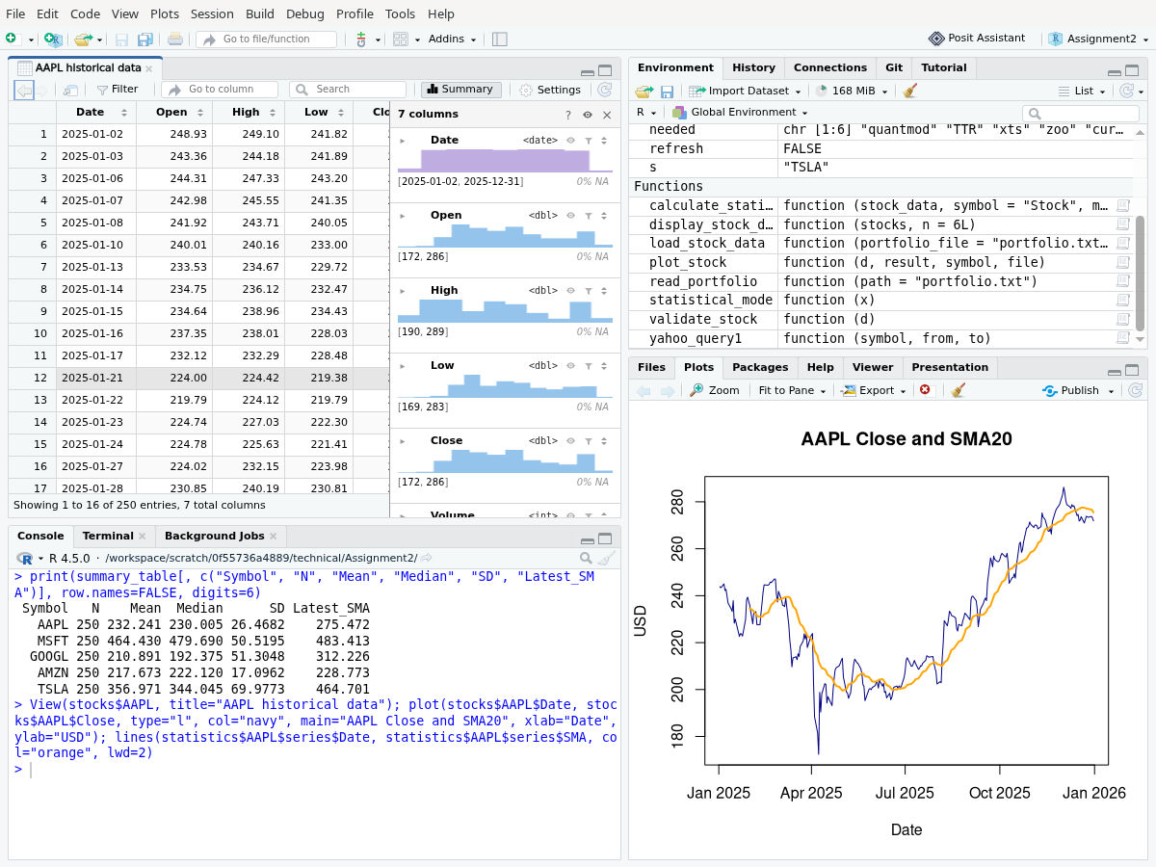
Figure 4. Imported AAPL observations in RStudio with a Close and SMA20 plot.
Columns are Date, Open, High, Low, Close, Volume and Adjusted. Validation checks unique dates, numeric finite values, positive Close and Adjusted prices, non-negative volume and consistent OHLC ranges. No interpolation or synthetic replacement data are used. Bundled CSV snapshots make later runs reproducible; TA_REFRESH=true requests the provider again.

5 Statistical methods and calculated results
calculate_statistics() uses the unrounded daily Close series consistently. Adjusted Close is preserved in the input but is not mixed into these calculations. Mean, median and sample standard deviation describe the complete annual price series; they are not return statistics.
Measure | Definition and treatment
Mean | sum(x) / n
Median | Middle sorted value; average of the two middle values when n is even.
Mode | All exact input values tied for highest frequency. No repeated value when every value is unique.
Sample SD | sqrt(sum((x - mean(x))^2) / (n - 1)); unavailable for one observation.
SMA 20 | Mean of the current and previous 19 trading observations; first 19 values are NA.

Symbol | N | Mean | Median | SD | Last SMA20
AAPL | 250 | 232.24 | 230.00 | 26.47 | 275.47
MSFT | 250 | 464.43 | 479.69 | 50.52 | 483.41
GOOGL | 250 | 210.89 | 192.38 | 51.30 | 312.23
AMZN | 250 | 217.67 | 222.12 | 17.10 | 228.77
TSLA | 250 | 356.97 | 344.04 | 69.98 | 464.70

All displayed prices are USD, rounded to two decimals for readability. Calculations and CSV outputs retain their original precision. The final SMA corresponds to 31 December 2025.

Mode results
AAPL: 201.00, 237.88, 254.43, 278.78 (tied modes)
MSFT: No repeated value
GOOGL: No repeated value
AMZN: 205.71, 222.54, 222.69, 232.38, 235.42 (tied modes)
TSLA: 329.65, 429.24 (tied modes)
The implementation deliberately does not use base R mode(), which reports storage type. It retains tied statistical modes rather than choosing one arbitrarily. Price rounding is not applied before counting frequencies.

6 Data displays and visualizations
display_stock_data() prints the first six and last observations for every symbol. display_analysis.R saves the complete summary, an aligned moving-average CSV for each stock and five PNG charts. Each chart combines daily Close with SMA20 and a separate daily-volume panel.
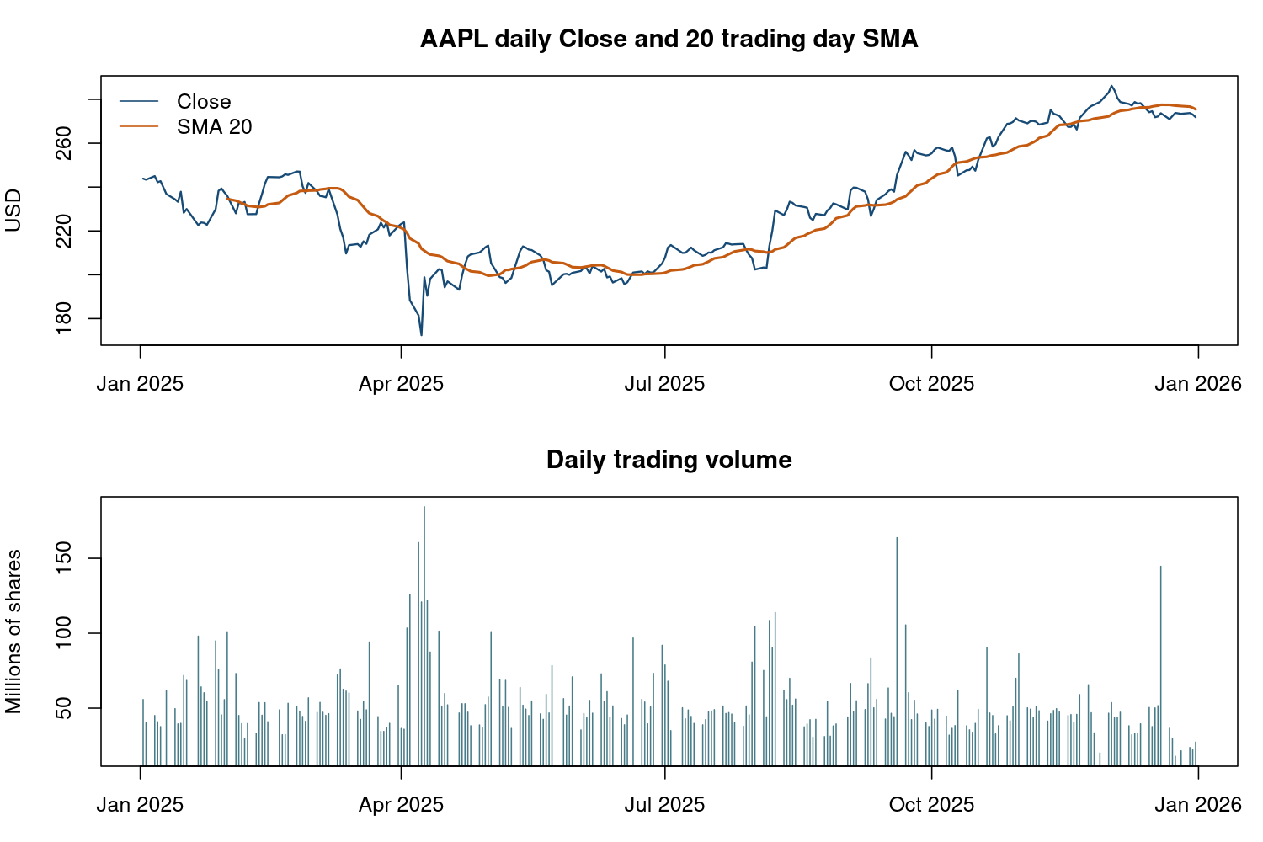
Figure 5. AAPL daily Close, SMA20 and trading volume for 2025.
The line chart makes changes through time visible, while the volume panel shows activity without sharing the price scale. A data table supports inspection of exact OHLCV values. Candlestick charts are another common presentation: they encode the Open, High, Low and Close of each interval, but are not necessary to satisfy this preliminary stage.
The same plotting function generated the MSFT, GOOGL, AMZN and TSLA figures in output/. All use trading dates from the input rather than inserting weekends or market holidays.

7 Execution and independent verification
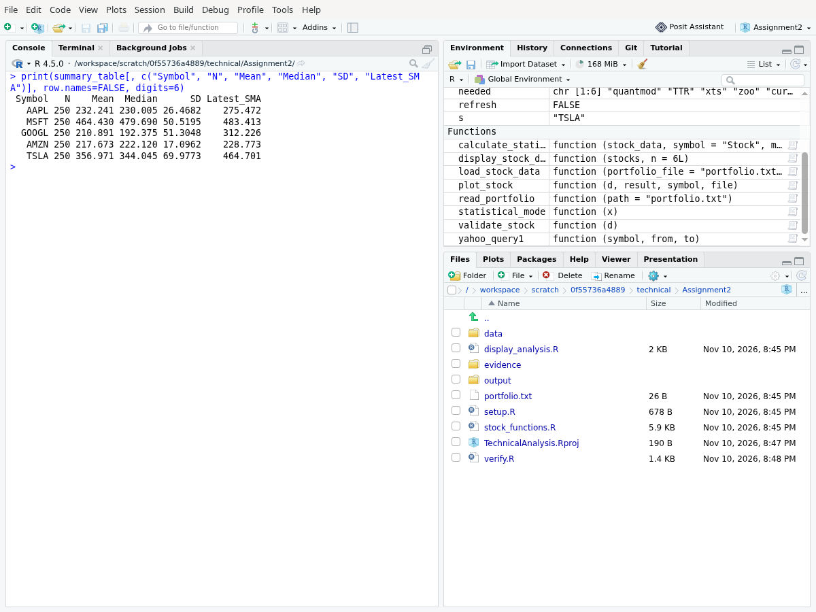
Figure 6. Actual RStudio summary output from the five-stock run.
verify.R independently recomputes each mean using sum/n, sample SD from squared deviations and every SMA using stats::filter(). It confirms 250 observations and 19 leading unavailable SMA values for each symbol. Tests also cover tied modes, unique values, short series, a single value and an invalid moving-average period.
A separate Python check reproduced mean, median, sample SD and final SMA20 for all five snapshots, matching the R outputs within numerical tolerance. output/verification.txt and output/execution_log.txt retain the test and original execution records.
To reproduce: open TechnicalAnalysis.Rproj; run source("setup.R"), source("display_analysis.R") and source("verify.R"). The default analysis reads the included snapshots. To retrieve data again, first run Sys.setenv(TA_REFRESH="true").

8 Sources and implementation notes
Market source: Yahoo Finance historical daily OHLCV through quantmod. Downloaded 10 November 2026; selected period 1 January 2025 to 1 January 2026 exclusive. The data/SOURCE.md file records provenance. Provider revisions may change results after a later download.
GitHub setup guide
https://docs.github.com/en/get-started/quickstart/set-up-git
CRAN R distributions
https://cran.r-project.org/
Posit RStudio downloads
https://docs.posit.co/ide/user/download.html
quantmod official reference
https://cran.r-project.org/web/packages/quantmod/refman/quantmod.html
TTR official reference
https://cran.r-project.org/web/packages/TTR/refman/TTR.html
Yahoo Finance display reference
https://finance.yahoo.com/
quantmod source archive used for installation
https://cran.r-project.org/src/contrib/Archive/quantmod/quantmod_0.4.27.tar.gz

Implementation boundaries
The cached run is intended to reproduce this report. Fresh retrieval can fail when the provider is unavailable or rate-limits access; such failures are logged, and a real Yahoo query1 fallback is attempted. If both fail, the script stops. It does not create replacement prices. Data with invalid or missing OHLCV fields are rejected rather than silently repaired.
The assignment requires installation screenshots on a local PC. This report documents the completed assistant-operated Linux installation and execution, with the platform stated explicitly. It does not claim that the student performed an installation or reviewed the code personally. The student should review the submission and confirm whether this platform evidence satisfies the instructor's local-PC requirement.
Assignment instructions: BDA400 Assignment 2 Technical Analysis using R Preliminary Stage, supplied six-page PDF. Report organization follows its setup, portfolio, import, statistics, display and documentation requirements.

