Testing

* 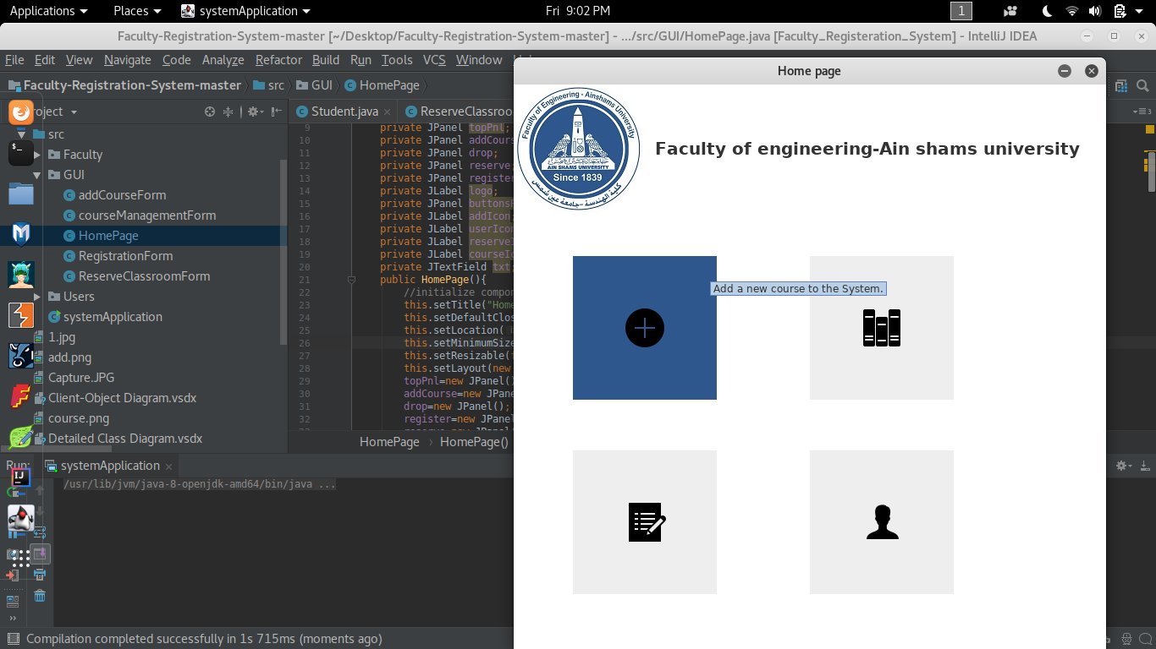The Program starts with four options

Figure [Add a new course to the system]

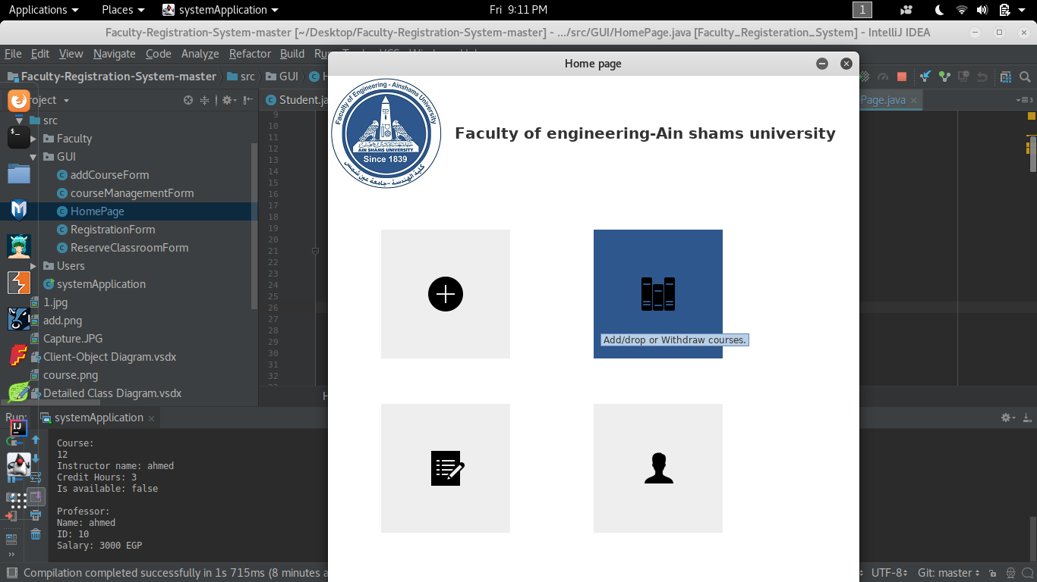

Figure [Add/Drop or Withdraw courses]

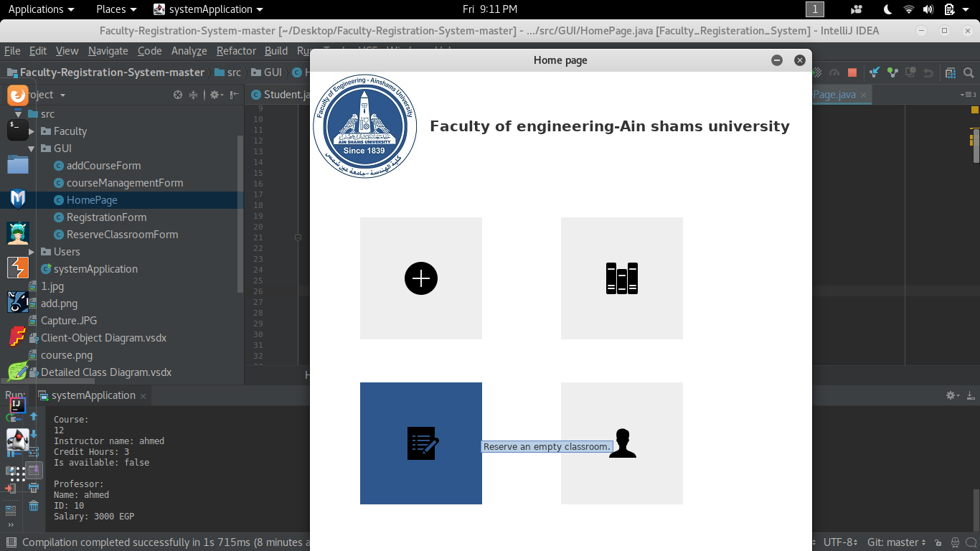

Figure [Reserve an empty classroom]

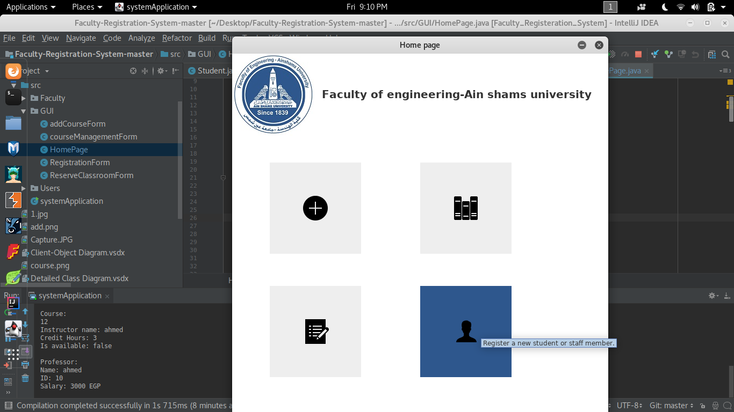

Figure [Register a new Student or staff member]

The program starts from Figure4 to add the students to our system or add staff members then, Figure1 is the next step to add a new course to the system then, Figure2 to add, drop or withdraw course for student finally, figure3 to reserve classroom.

* 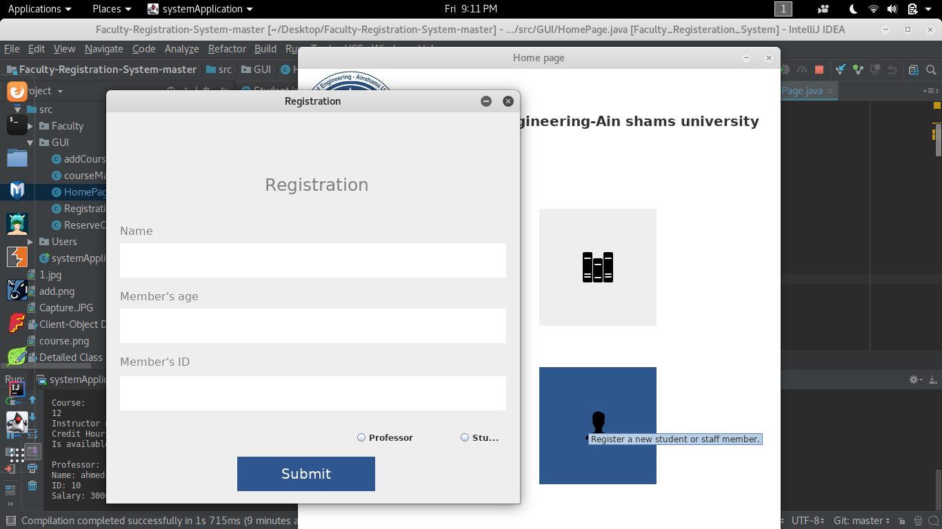Test case 1:

Figure [Inside Registration]

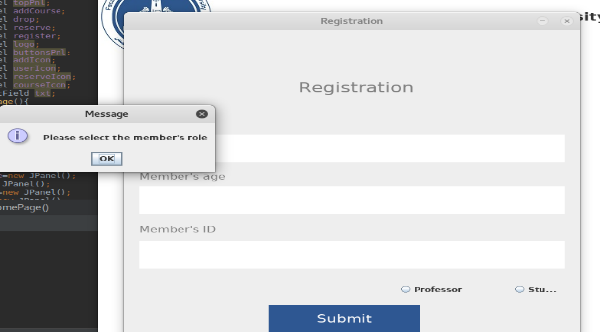The program successfully enters the Register a new student or staff member button as shown following figure5, when you press submit without typing any text or choosing a professor or a student the program sends you an Error message as shown as figure6, when we entered the information and choose professor or student as shown in figure7 it successfully saved it’s data

Figure [Error1]

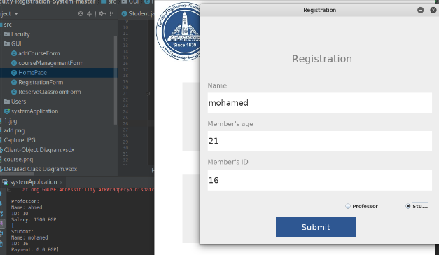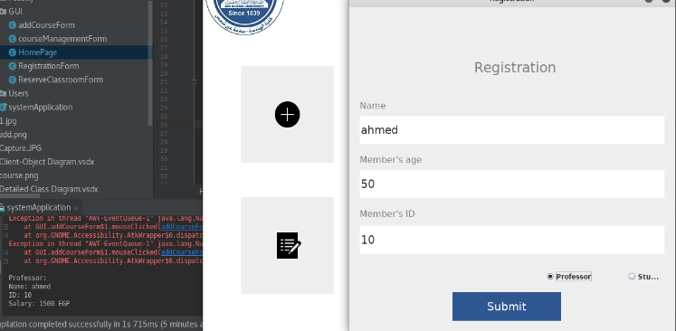

Figure 7[working]

* 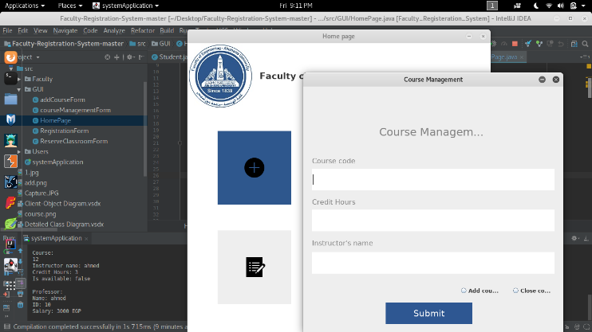Test case 2:  
  The program enter successfully when the add a new course as is shown as figure8, when you press submit without typing any text or choosing add or close course the sends an error message as shown in figure9,when you entered the right data in the fills and choose add or close course the program save it in the console as shown in figure10,

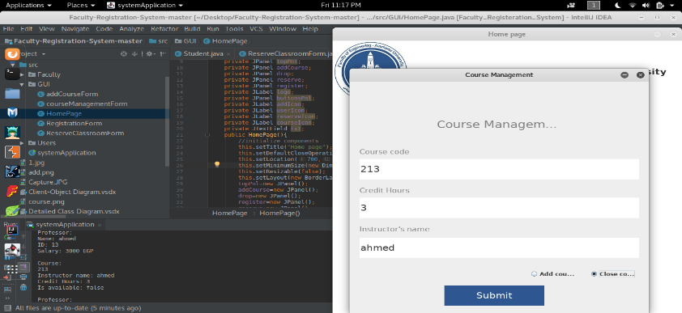

Figure 9

Figure 10

* 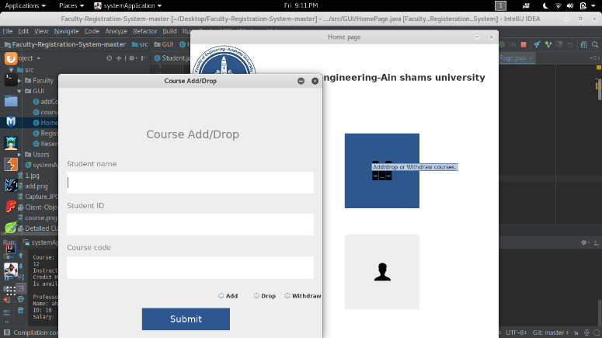Test case 3:

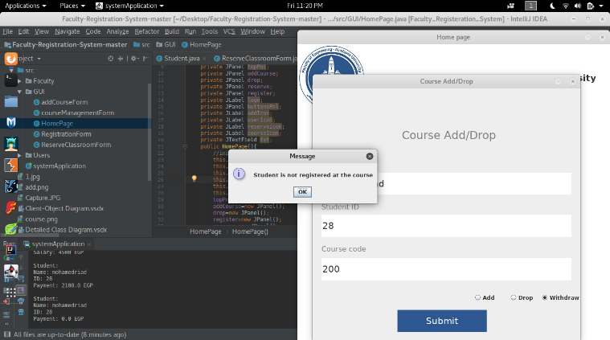The program enter successfully when the add a new course as is shown as figure11, when you press submit without typing any text or choosing add, drop, or withdraw the program pop an error message to fill the text fields, when the user fills the text fields with the correct data and choose add, drop or withdraw it save the data and print it on the console screen as shown in figure12, if the user want to drop or withdraw a course to student and the student doesn’t add this course before the program pop up an error message tells “Student is not registered at the course ” as shown as figure13

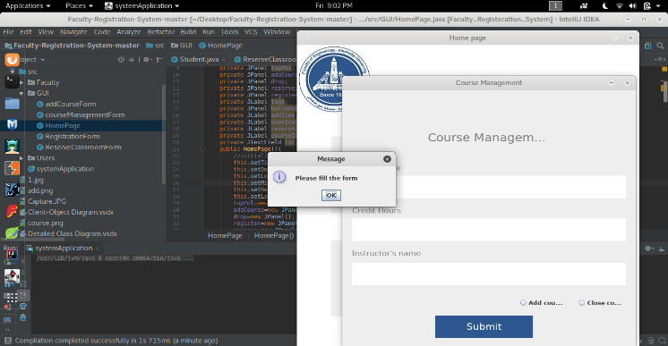

Figure 13

Figure 8

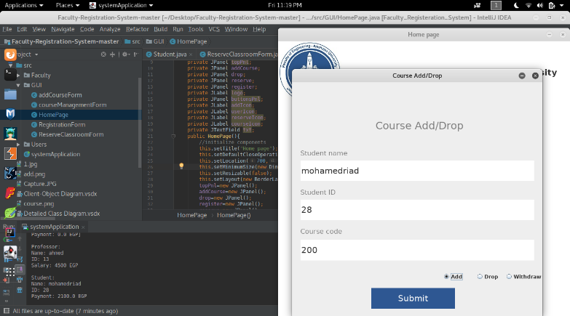

Figure 11

Figure 12

* 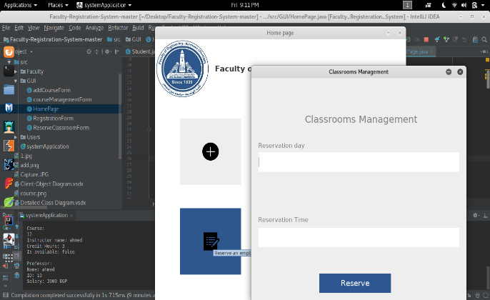Test case 4:  
  The program enter successfully when the add a new course as is shown as figure14, when you press submit without typing any text the program pops and error message to the user as shown as in figure 15,when the user fills the text fields with correct data it pops up a message tells him that the program has reserved to him a class room.

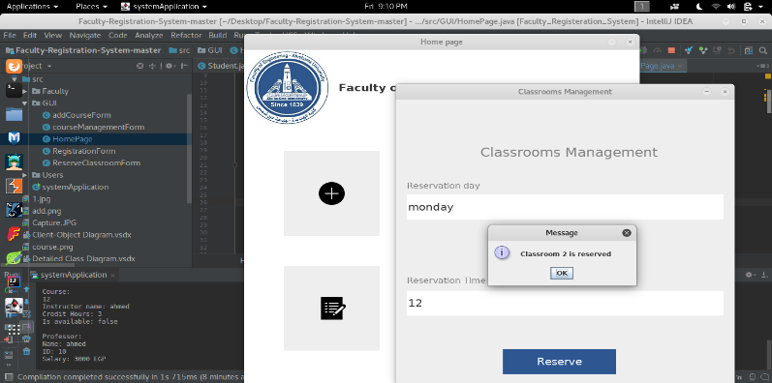

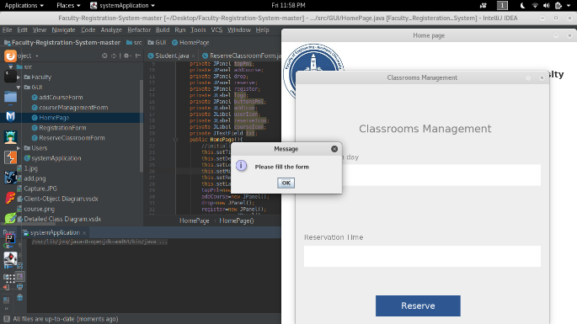

Figure 14

Figure 16

Figure 15