[Document title]

[Document subtitle]

mahmoud mohamed

[Year]

Table of content:

1. Description………………………………………………………………....3

1.1 Bonus Features…………………………………………………...…..3

1. User Guide………………………………………………………………....3
2. Work Split…………………………………………………………………..7
3. Additional Documentation………………………………………………...8

List of Figures:

Figure1: Sort menu…………………………………………………………..3

Figure2: Start menu………………………………………………………….4

Figure3: Player walking scene……………………………………………...4

Figure4: Shooting and attacking scene…………………………………....5

Figure5: Player hurt scene…………………………………………………..5

Figure6: Zombie hurt scene………………………………………………....6

Figure7: Player dead scene…………………………………………………7

Figure8: Zombie dead scene………………………………………………..7

Figure9: Zombie dead scene………………………………………………..7

1. Description:

Police-Vs-Zombies is a shooting game with various difficulties, in which a police man (the player) shoots zombies trying to survive till the end of the game, while each level more zombies are generated than the previous one, and each zombie needs several shots to be killed.

* 1. Bonus features:
* Hall of fame.
* Levels with various difficulties.

1. User Guide:

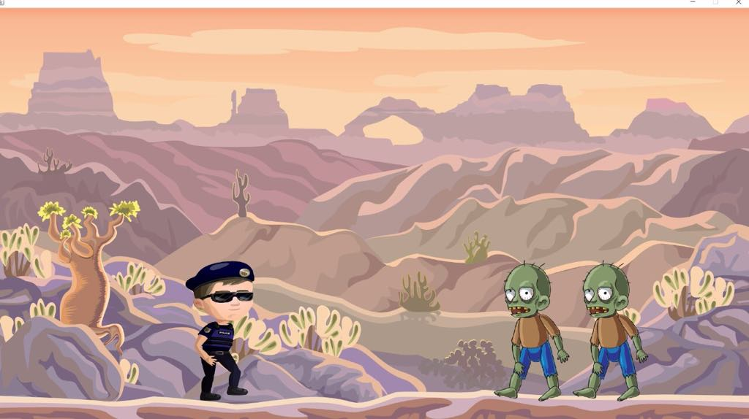

Figure 2: Start Scene.

* Walking using keyboard arrow keys.

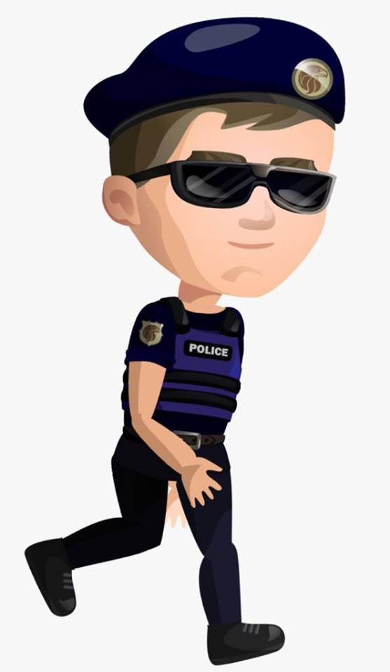

Figure 3: Player Walking Scene.

* Shooting using space bar key.

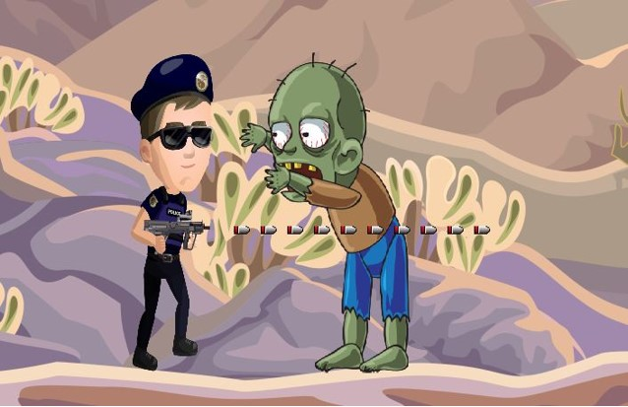

Figure 4: Shooting and zombie attacking scene.

* 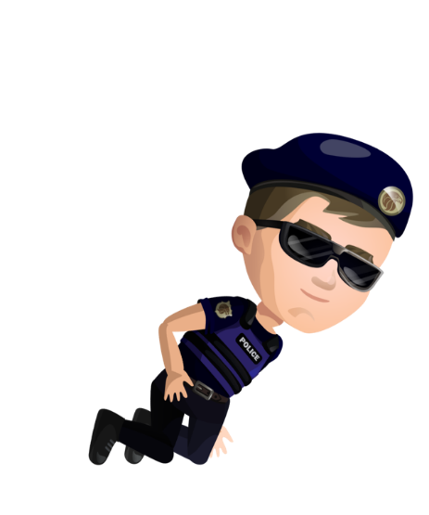Player hurt scene.

Figure 5: player hurt scene.

* Zombie hurt scene.

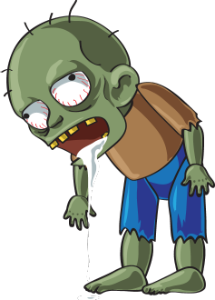

Figure 6: Zombie hurt scene.

* Player is dead.

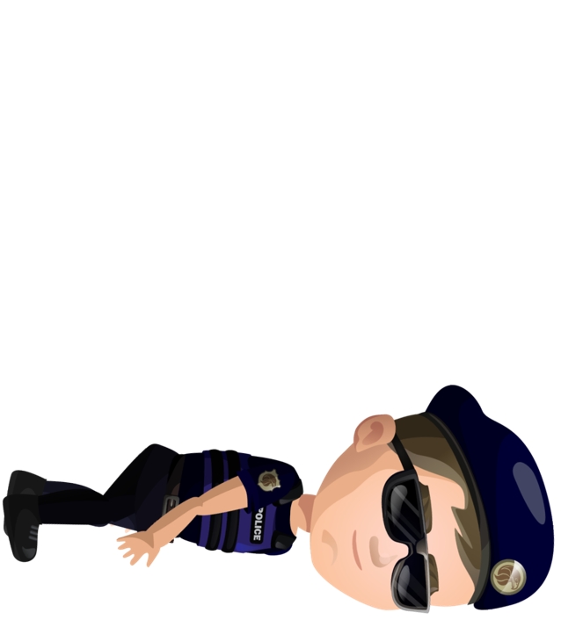

Figure 8: player dead scene.

Figure 7: Player dead scene.

* Zombie is dead.

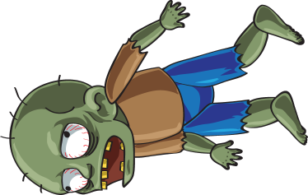

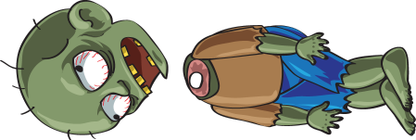

Figure 9: Zombie dead scene.

Figure 8: Zombie dead scene.

1. Work Split: (github link)
2. Additional Documentation:

* *Tricks:* Animation scenes for all the possible states of the player and the zombie and collision detection between the zombie and the player, also the bullet and the zombie.
* Also used git for version control.

Start scene

Player walking scene(using keyboard arrow keys)

Shooting scene and zombie attacking scene(shoot using space bar key)

Player hurt scene pending

Zombie hurt

Player dead

Zombie dead