**Michael Ahn**

**Homework 10**

1. **Problem 31**

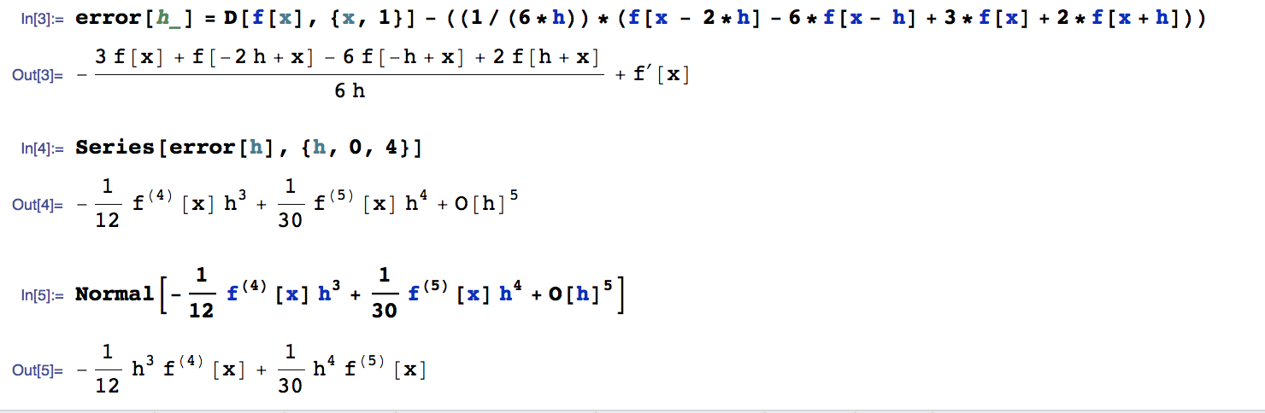

Order = 3 (lowest h exponent)

1. **Problem 32**

|  |  |
| --- | --- |
| n’(1.5) | 1.536000000000001e+01 |
| D1f(n, 1.5, 0.5) | 10 |
| D1b(n, 1.5, 0.5) | 28 |
| D1c(n, 1.5, 0.5) | 19 |
| D4.3af(x) | 3.583333333333333e+00 |
| D4.3bf(x) | 4.083333333333333e+00 |

1. **Problem 33**
2. **Newton-Cotes nodes and weights**

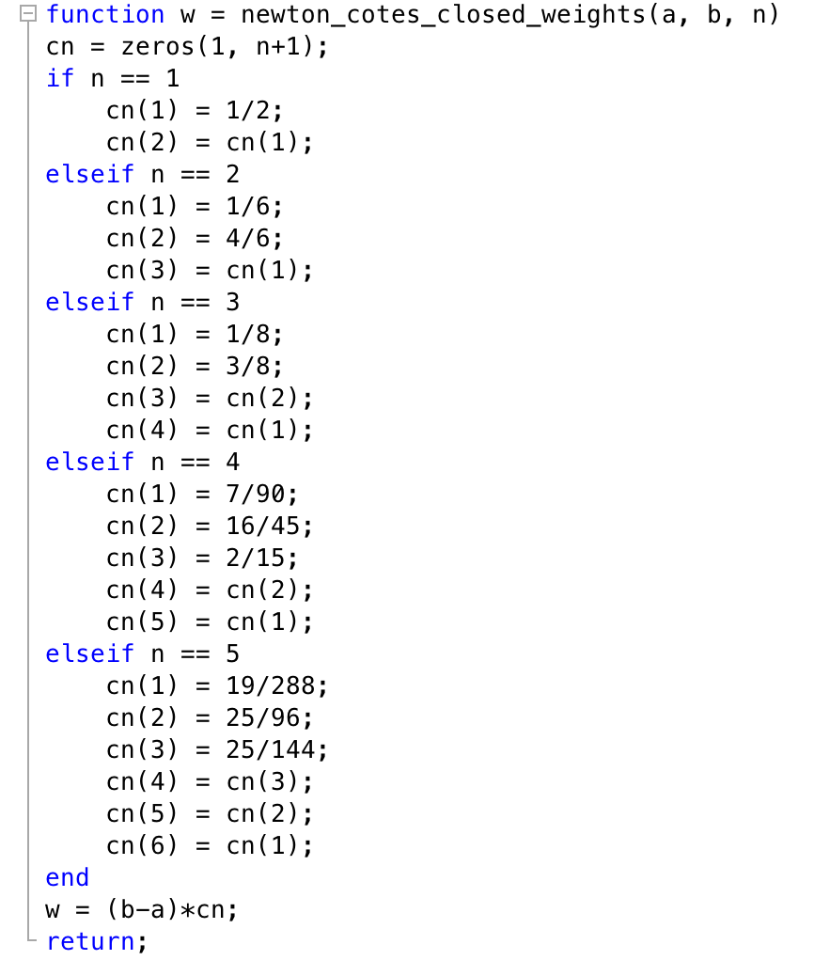

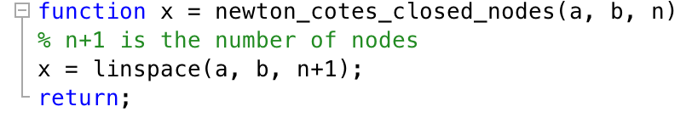

1. 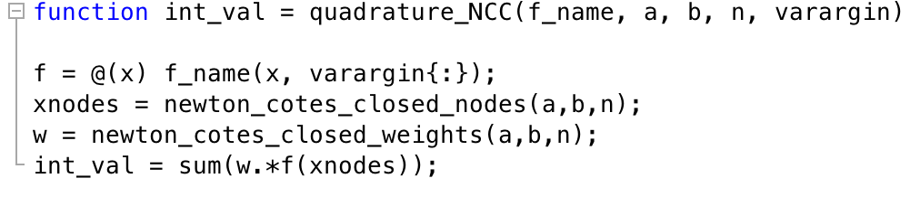**Newton-Cotes NCC**
2. **Use Newton-Cotes Formula**

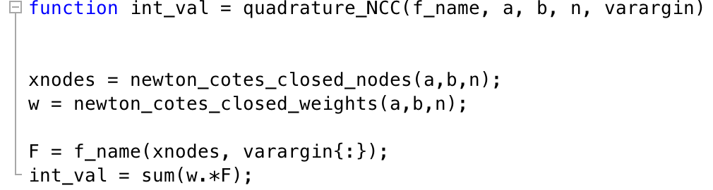

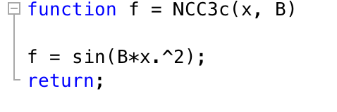

|  |  |
| --- | --- |
| B = sqrt(2) | B = pi |
|  |  |
| 5.840085377505808e-02 | 1.252405873458496e-01 |

1. **Problem 34**
2. **Implement Gaussian quadrature for nodes and weights**

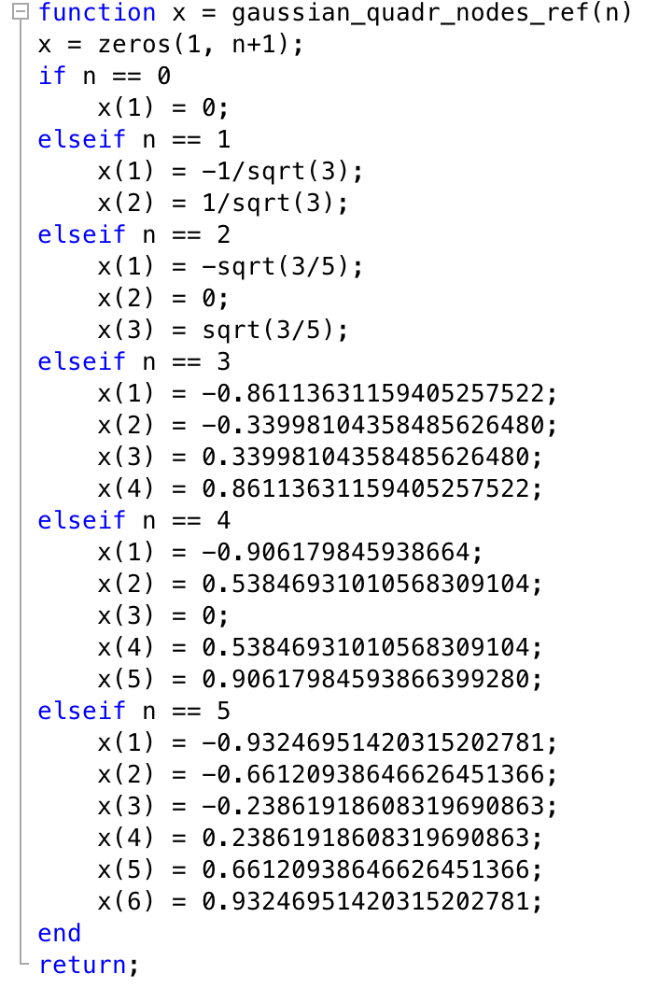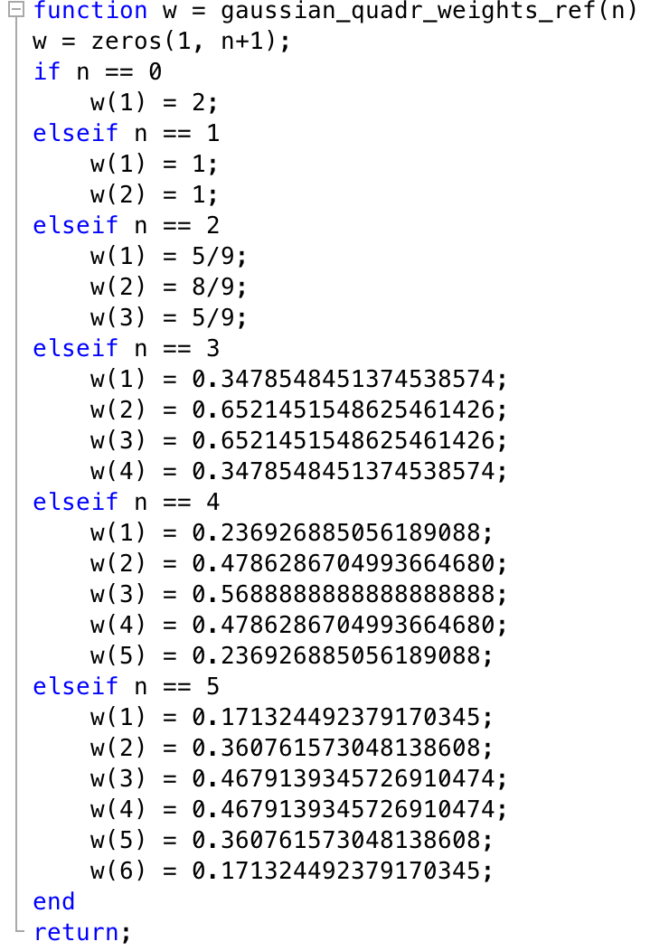

1. **Use Gauss-Legendre with n = 4**

|  |  |
| --- | --- |
| B = sqt(2) | B = pi |
| 4.937860648582195e-01 | 4.700258535072418e-01 |

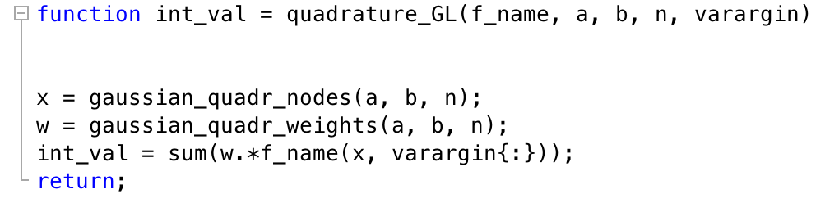

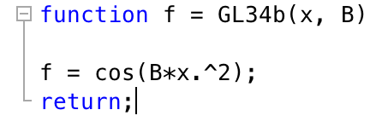

1. **Problem 35: NCC**

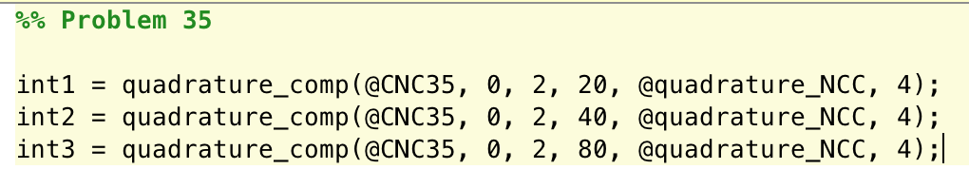

|  |  |
| --- | --- |
| Number of Subintervals | Integral … |
| 20 | -5.264076718361300e-02 |
| 40 | -5.264111247447470e-02 |
| 80 | -5.264111760359244e-02 |

1. **Problem 36: GL**

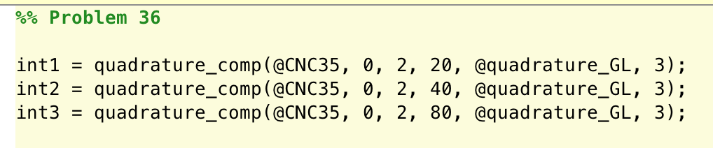

|  |  |
| --- | --- |
| Number of Subintervals | Integral … |
| 20 | 3.027473341759235e-01 |
| 40 | 3.027473334184856e-01 |
| 80 | 3.027473334154835e-01 |