**Michael Ahn**

**Homework 11**

1. **Problem 37**

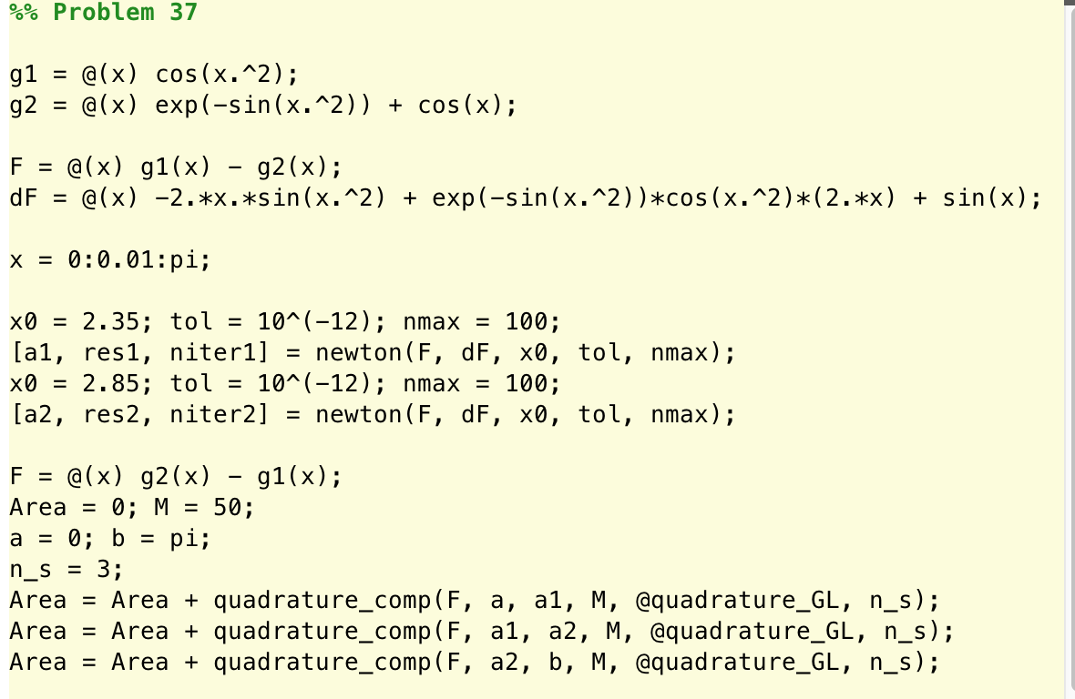Using plot to estimate the Newton x0 guess

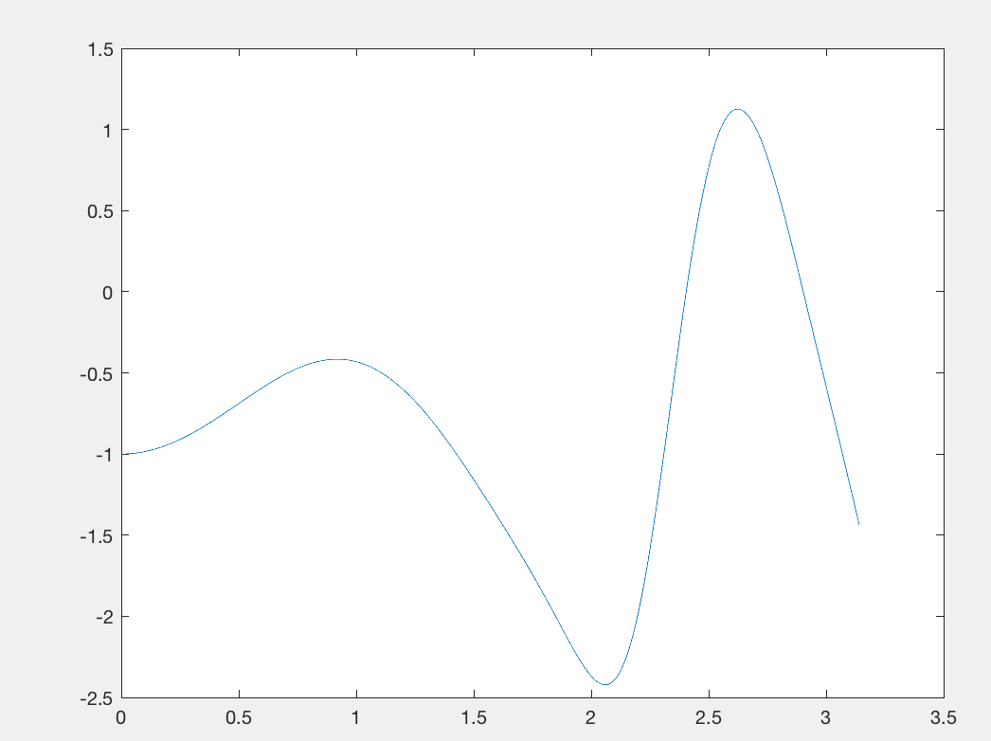

**Area = 2.420118842703918e+00**

1. 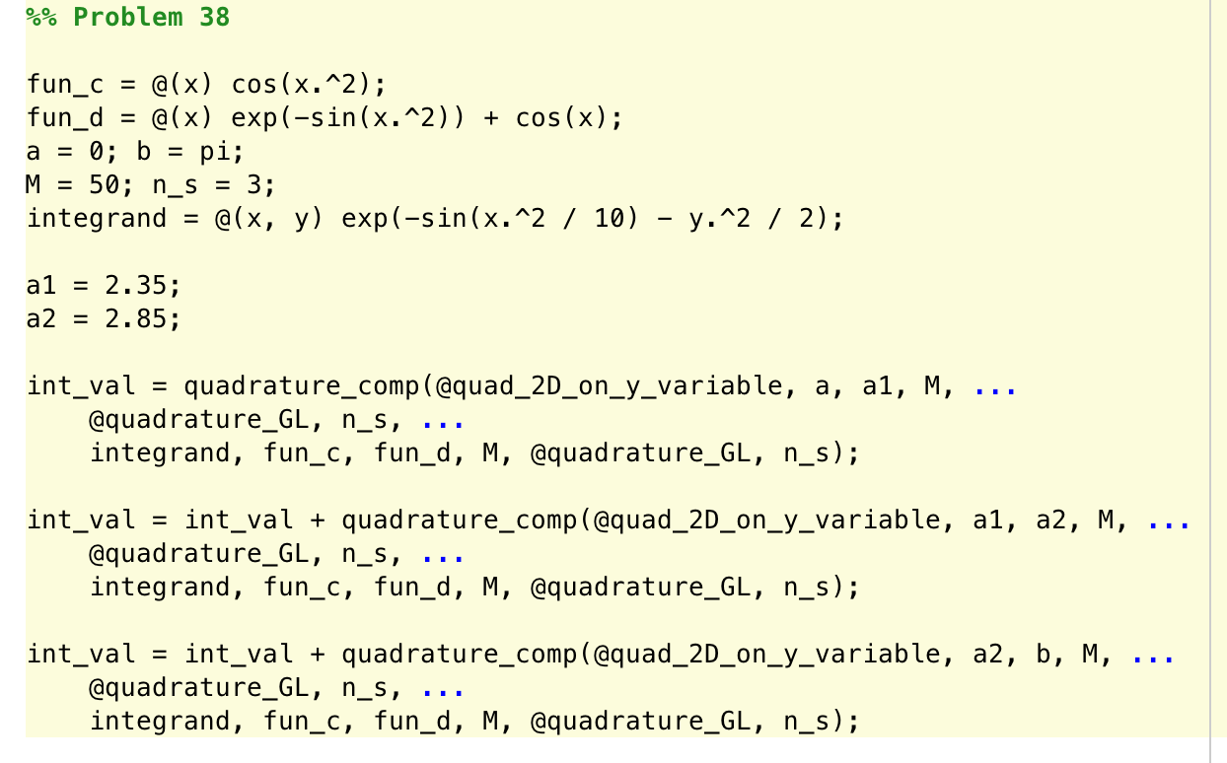**Problem 38**

**Area = 1.284323184489303e+00**

1. **Problem 39**

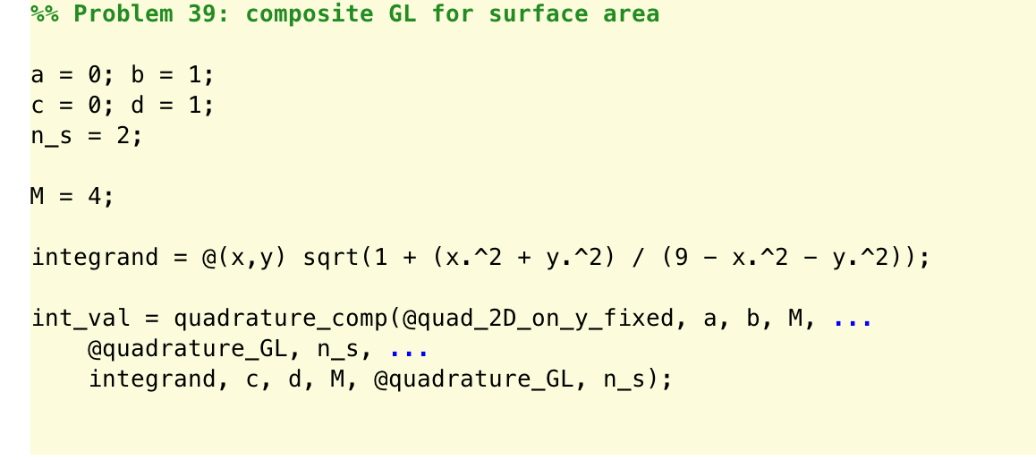

**Area = 1.040223777376140e+00**

1. **Problem 40**
2. 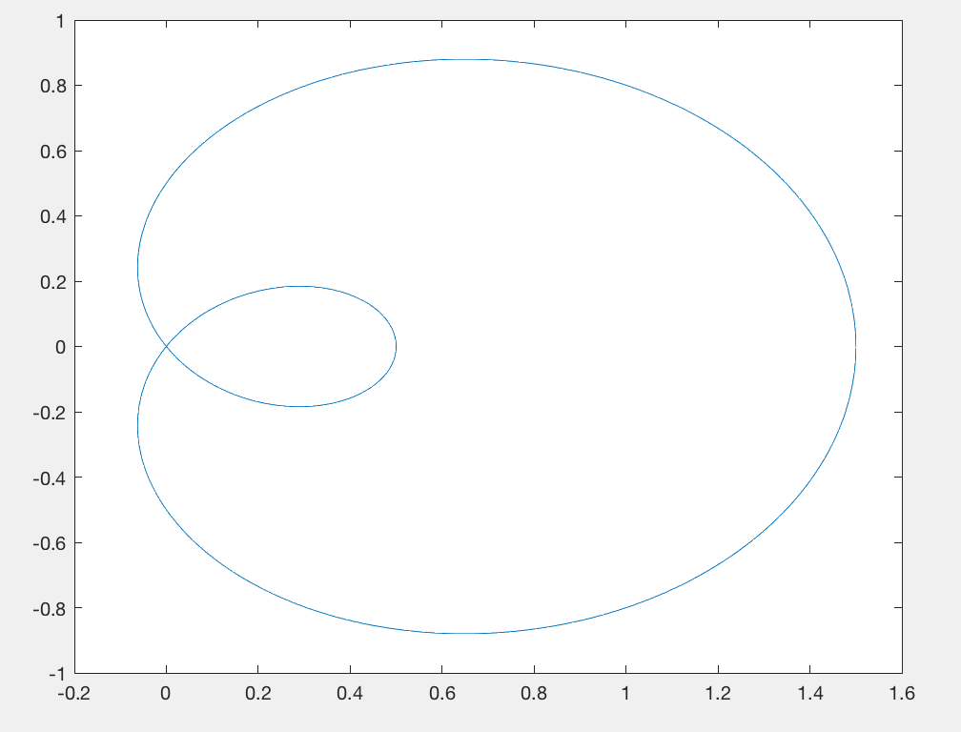**Plot the parametric curve**

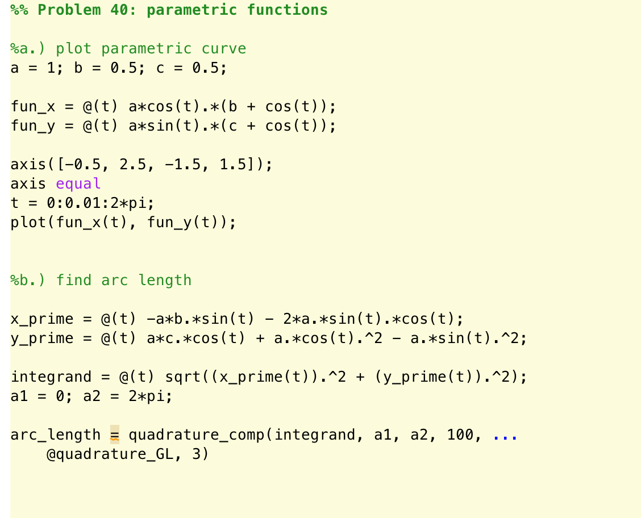

1. **Find arc length**

**L = 6.682446610277627e+00**