**Homework 12**

1. **Problem 41**
   1. **Implement the 4-stage Runge-Katta method**

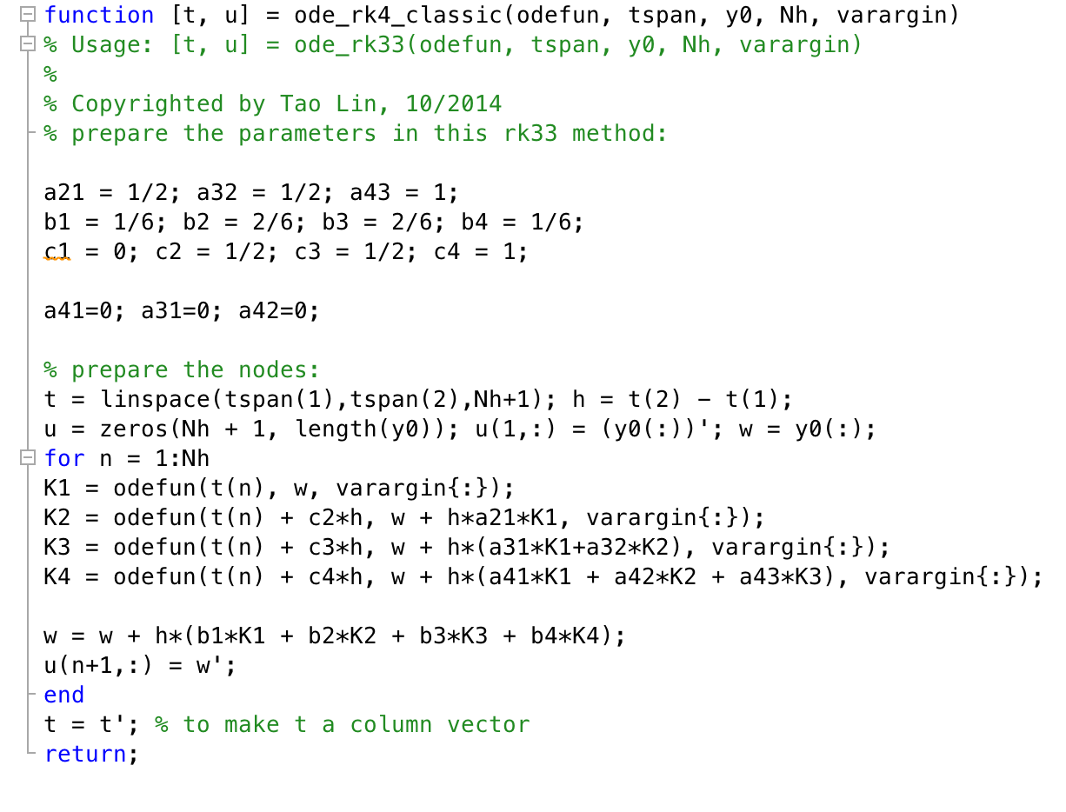

* 1. **Find values**

|  |  |  |
| --- | --- | --- |
| **T** | **3-stage** | **4-stage** |
| **0.28** | 1.524958587492407e+00 | 1.524958775061539e+00 |
| **0.76** | 2.330336005852792e+00 | 2.330334362097196e+00 |
| **1.00** | 2.630613661123128e+00 | 2.630611238981153e+00 |

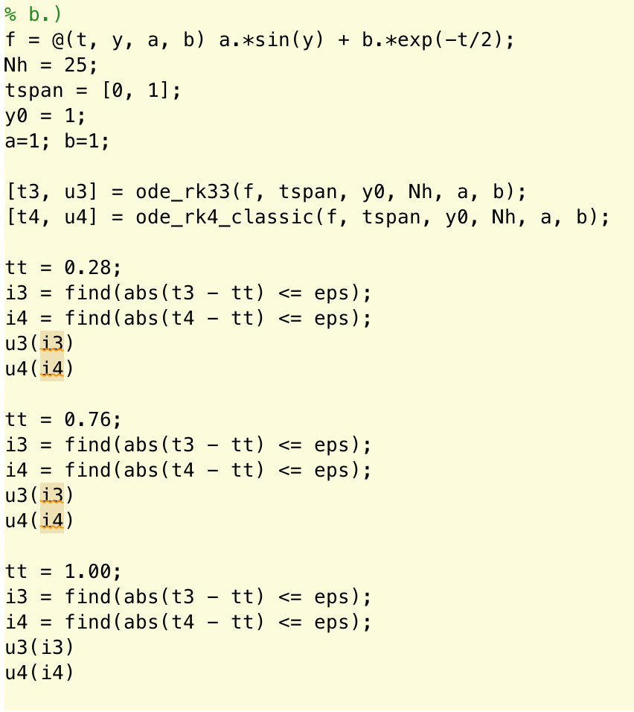

* 1. **Find values with new a, b**

|  |  |  |
| --- | --- | --- |
| **T** | **3-stage** | **4-stage** |
| **0.28** | 2.764281261509447e+00 | 2.764248015728158e+00 |
| **0.76** | 4.209029067717383e+00 | 4.209006359068695e+00 |
| **1.00** | 4.530293413067465e+00 | 4.530277028474328e+00 |

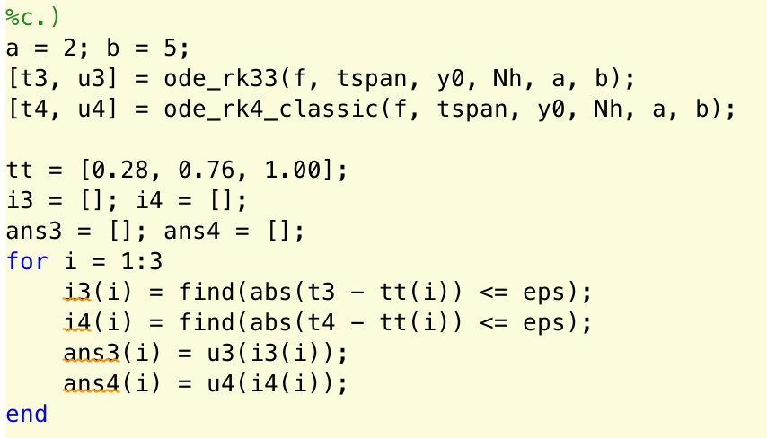

* 1. **Find values**

|  |  |
| --- | --- |
| **Y’(0) by RK3** | 6.682941969615793e+00 |
| **Y’(0) by RK4** | 6.682941969615793e+00 |
| **Y’(1) by RK3** | 1.065720569935482e+00 |
| **Y’(1) by RK4** | 1.065726504400589e+00 |

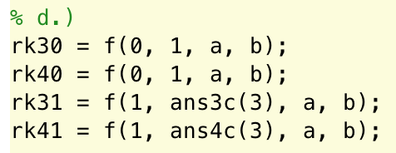

* 1. **Clamped Boundary Splines**

|  |  |  |
| --- | --- | --- |
| **t** | **y(t) by S3(t)** | **y(t) by S4(t)** |
| **0.55** | 3.768744313077694e+00 | 3.768710478640391e+00 |
| **0.91** | 4.426189221072285e+00 | 4.426171120797998e+00 |

* 1. **Composite GL Splines**

|  |  |
| --- | --- |
| **A by S3(t)** | **A by S4(t)** |
| 2.328065282759862e+00 | 2.328042560187849e+00 |

* 1. **Arc length**

|  |  |
| --- | --- |
| **S3** | **S4** |
| 3.493499554226488e+00 | 3.493499553453903e+00 |

1. **Problem 42**
   1. **Implement**

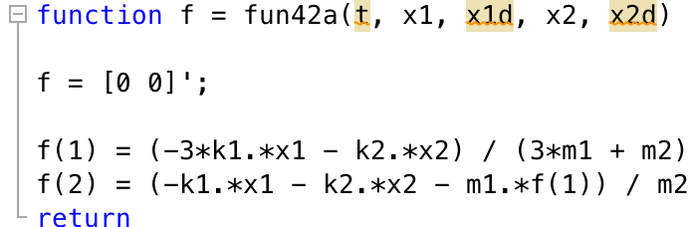

* 1. **Implement**

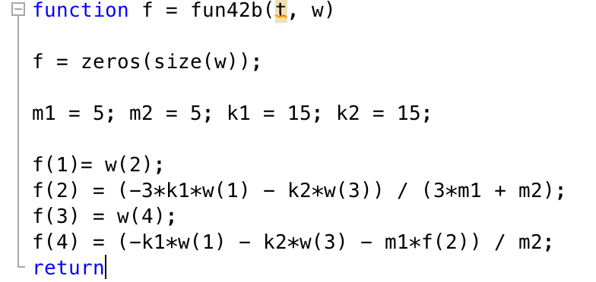

* 1. **Runge-Kutta**

|  |  |  |
| --- | --- | --- |
| **T** | **2** | **8** |
| **X1** | 1.499831253515625e+00 | 1.491739687302240e+00 |
| **X1’** | -3.374859375000000e-02 | -2.357679750827660e-01 |
| **X2** | -5.624789062500000e-05 | -2.751188278718372e-03 |
| **X2’** | -1.124915625000000e-02 | -7.846084172008884e-02 |

**d, e, f**

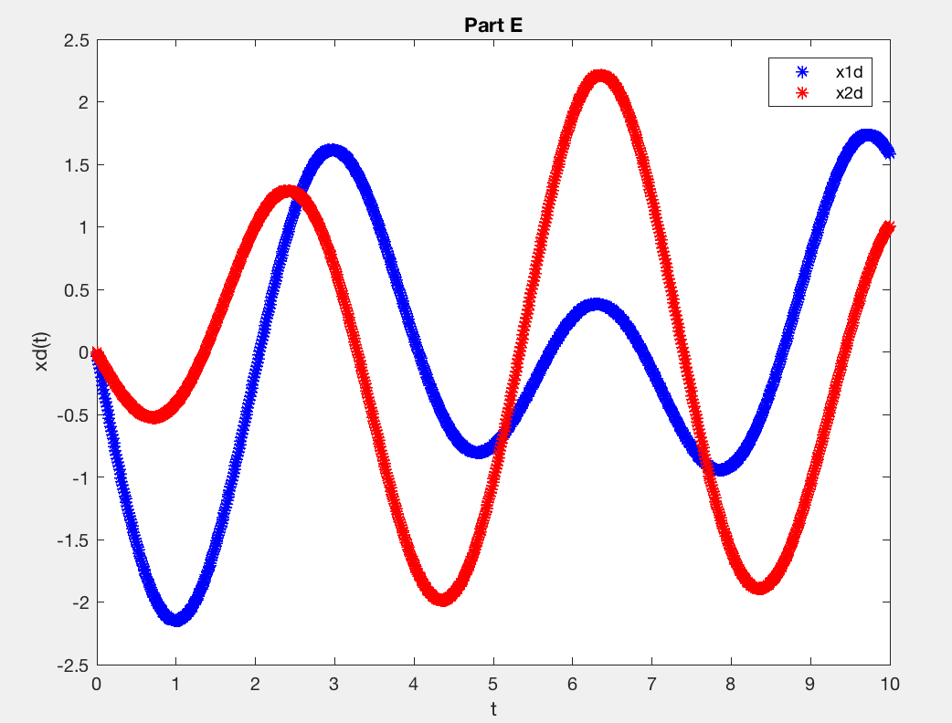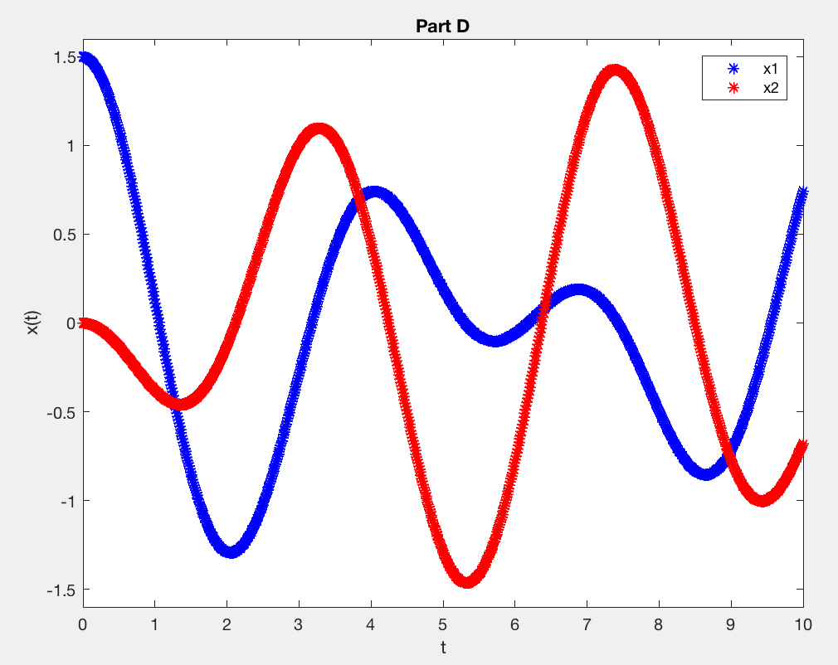

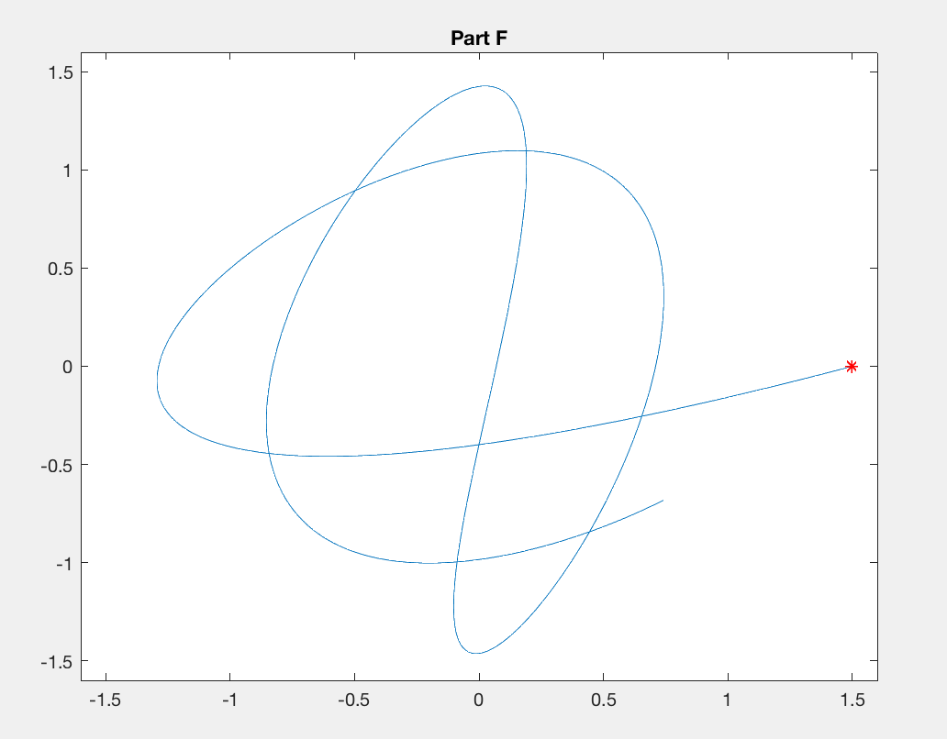

**g. Finding values**

|  |  |  |
| --- | --- | --- |
| **T** | **X1dd** | **X2dd** |
| **0** | **-**3.375000000000000e+00 | **-**1.125000000000000e+00 |
| **2** | 3.000141138051521e+00 | 1.267853246781804e+00 |
| **10** | -1.162177518101623e+00 | 9.743639812157202e-01 |

**h. Cubic Spline for Arc Length**

arc length = 1.529507872405552e+01