1. Use “help varargin” and read statements of page 45 of textbook- I did it!!!

2. Problem 14: Bisection Method

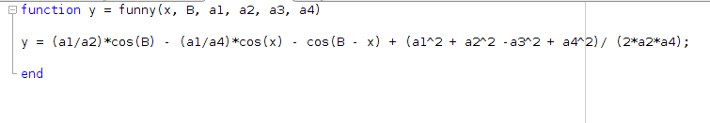 a.) Function Implementation

b.) Bisection Method

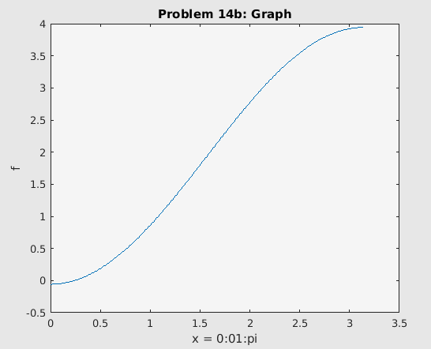

|  |  |
| --- | --- |
| *a* | 0 |
| b | 1 |
| Alpha | 2.407733958216340e-01 |
| Residual | 2.524647157997606e-13 |
| Iterations used | 39 |

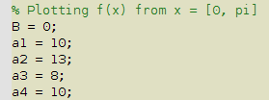

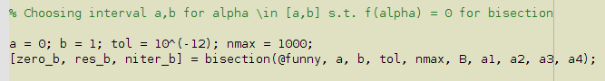

c.)

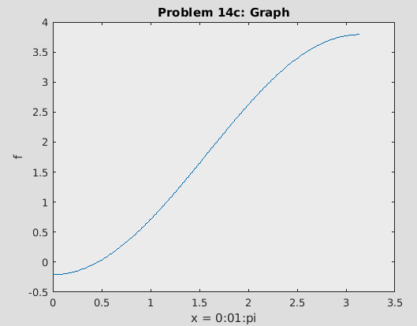

|  |  |
| --- | --- |
| *a* | 0 |
| b | 1 |
| Alpha | 4.604934250592123e-01 |
| Residual | 1.358912982141192e-13 |
| Iterations used | 39 |

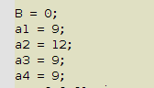



3. Problem 15: Newton’s Method

a.) Implement f’(x) from the f(x) in problem 14

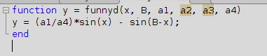

b.) Newton

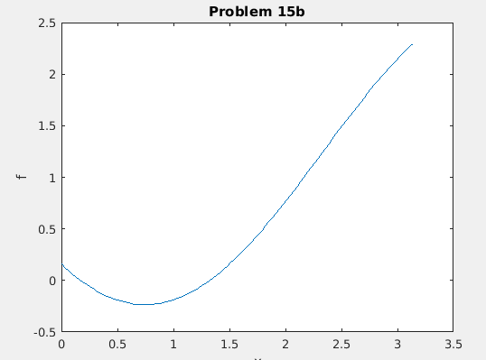

|  |  |
| --- | --- |
| X(0) | 1.2 |
| Alpha | 1.325709780438141e+00 |
| Residual | 0 |
| Iterations used | 6 |

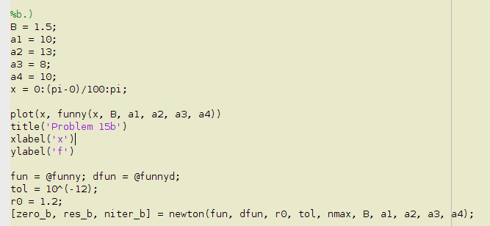

c.) Newton

|  |  |
| --- | --- |
|  | 0.8 |
|  | 2.017526570197690e+01 |
|  | 0 |
|  | 8 |

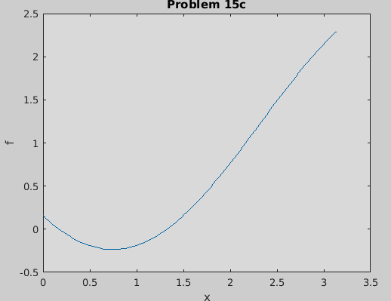

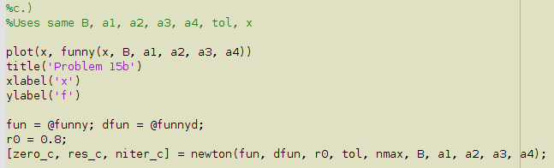

4. Problem 16: Secant Method

|  |  |  |
| --- | --- | --- |
| Zero found | Residual | Actual Iterations Used |
| 1.365230013414097e+00 | 0 | 5 |

5. Problem 17: Secant Method- compute negative zero

|  |  |
| --- | --- |
| x(0), x(1) | -1.5, -1.6 |
| Zero found | -1.857920829150198e+00 |
| Residual | 0 |
| Niter | 8 |

Found the x0 and x1 estimates by plotting function f(x) = cosh(x) + cos(x) – 3 against g(x) = 0 to visually guess close approximations, setting x1 to be closer to the negative zero than x0 by a small margin.

6. Problem 18: Nonlinear System of Equations

a.) Putting into vector form

b.) Derive Jacobian for f(x)

c.) Implement f(x) and J(x) in MATLAB

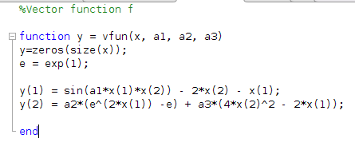

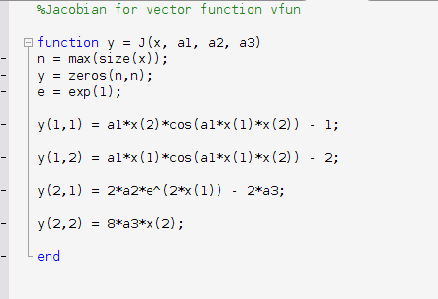

d.) Computing first two iterations

|  |  |  |
| --- | --- | --- |
| K | x1(k) | x2(k) |
| 1 | -3.747391355353402e-01 | 5.722929100123296e-02 |
| 2 | -3.737002516765929e-01 | 5.626787953179448e-02 |

e.) Solving for x(1), x(2)

|  |  |  |  |
| --- | --- | --- | --- |
| x1 | x2 | Residual | Actual Iterations |
| -3.736982167625410e-01 | 5.626648942888835e-02 | 5.551115123125783e-17 | 4 |

