Homework 1

1. Problem 1
a.) Fill out the table using the vector X from X.mat
dim(X1) | dim(X2) | k₁ | k₂
970 | 1030 | 817 | 188

b.) Strophoid Function
F(X₁(511)) | F(X₂(511))
1.459659638139902e-01 | 3.240932118522933e-01
function f = strophoids(x)
a = 0.5;
if x < 0.5
f = x*sqrt( (a - x) / (a + x) );
end
if x > 0.5
f = x*sqrt( (x - a) / (a + x) );
end

%(x - a) / (a + x)
%(x^2 - a^2) /(a^2 + 2*a*x + x*2)
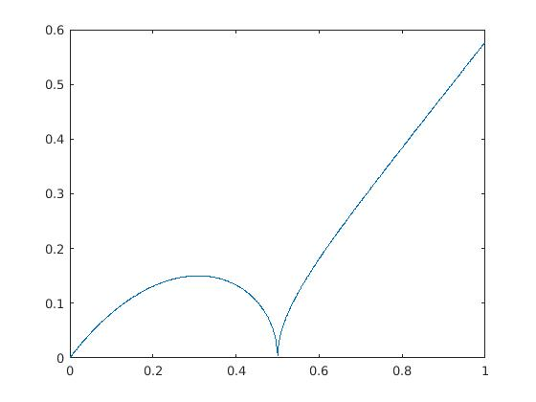
c.) Plot Strophoids

