1. Use “help varargin” and read statements of page 45 of textbook- I did it!!!

2. Problem 14: Bisection Method

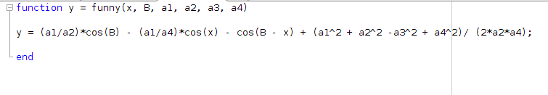
a.) Function Implementation
b.) Bisection Method

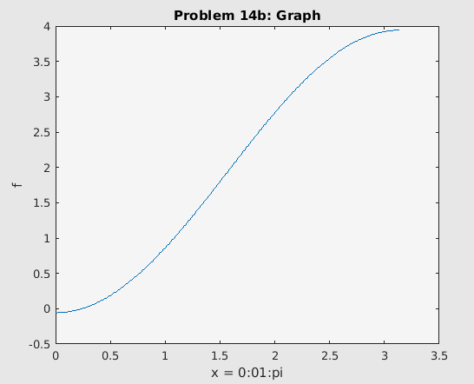

a | 0
b | 1
Alpha | 2.407733958216340e-01
Residual | 2.524647157997606e-13
Iterations used | 39
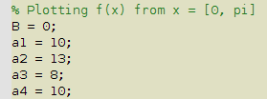

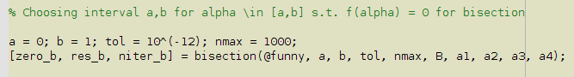

c.)
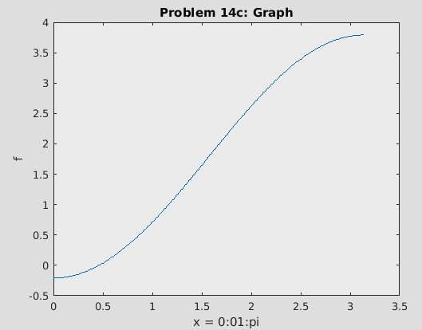

a | 0
b | 1
Alpha | 4.604934250592123e-01
Residual | 1.358912982141192e-13
Iterations used | 39
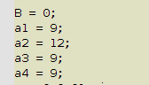

3. Problem 15: Newton’s Method

a.) Implement f’(x) from the f(x) in problem 14
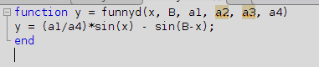

b.) Newton
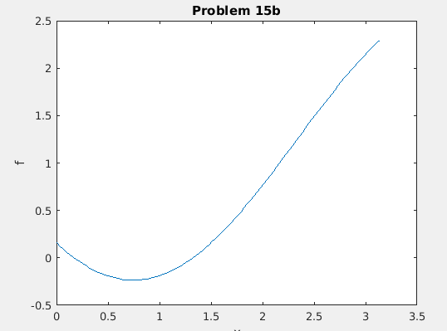

X⁽⁰⁾ | 1.2
Alpha | 1.325709780438141e+00
Residual | 0
Iterations used | 6
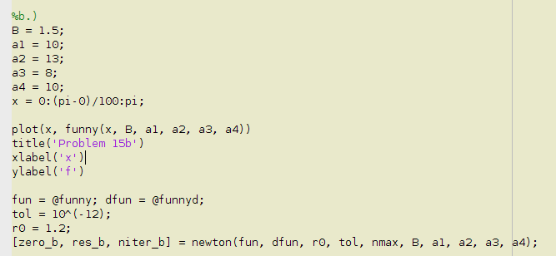

c.) Newton
0.8
2.017526570197690e+01
0
8
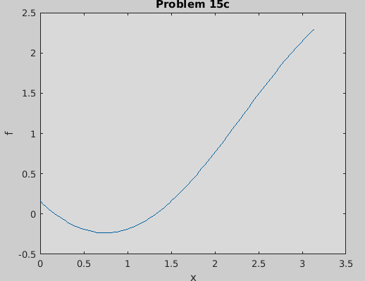
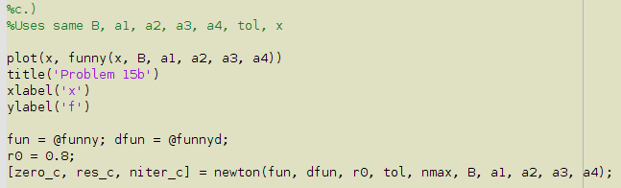

4. Problem 16: Secant Method

Zero found | Residual | Actual Iterations Used
1.365230013414097e+00 | 0 | 5

5. Problem 17: Secant Method- compute negative zero

x⁽⁰⁾, x⁽¹⁾ | -1.5, -1.6
Zero found | -1.857920829150198e+00
Residual | 0
Niter | 8

Found the x0 and x1 estimates by plotting function f(x) = cosh(x) + cos(x) – 3 against g(x) = 0 to visually guess close approximations, setting x1 to be closer to the negative zero than x0 by a small margin.

6. Problem 18: Nonlinear System of Equations

a.) Putting into vector form

b.) Derive Jacobian for f(x)

c.) Implement f(x) and J(x) in MATLAB

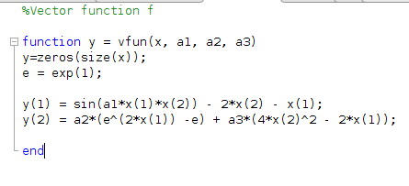

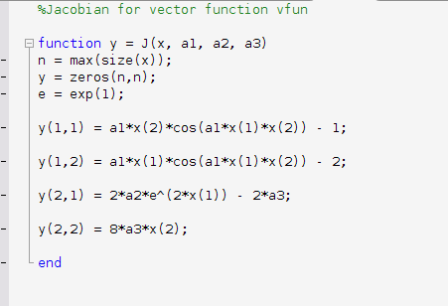

d.) Computing first two iterations
K | x₁^{(k)} | x₂^{(k)}
1 | -3.747391355353402e-01 | 5.722929100123296e-02
2 | -3.737002516765929e-01 | 5.626787953179448e-02

e.) Solving for x(1), x(2)
x¹ | x² | Residual | Actual Iterations
-3.736982167625410e-01 | 5.626648942888835e-02 | 5.551115123125783e-17 | 4
