Homework 6

1. Problem 19

a.) Approximate Jacobian with finite differences
J(1,1) | J(2,2)
-3.827471045703409e-01 | 1.077119999999716e+00

b.) Modified Newton Jacobian approximation
X1(2) | x2(2)
-3.732058376687573e-01 | 5.626232820955775e-02

2. Problem 20

a.)
J(1,2) | J(2,1)
-5.699987519708682e+00 | -4.429176102630938e+00

b.) Implement modified newton method

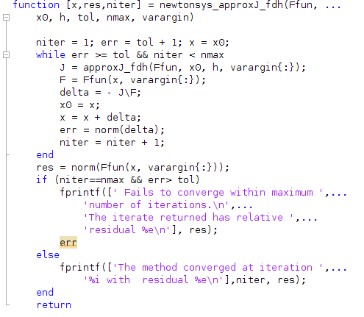

c.) Solve system of nonlinear equations from 20a
X1 | -3.732058376695438e-01
X2 | 5.626232820945344e-02
Res | 3.744555404993960e-12
Niter | 6

3. Problem 21

a.) Implement Jacobian approximation for complex variable method

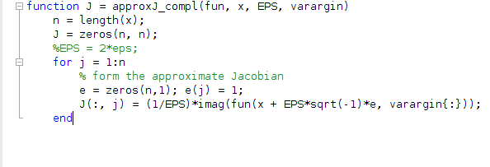

b.)
Jf(1,2) | J(2,1)
-5.791364443706561e+00 | -4.432905227626845e+00

c.) Implement newtonsys_approxJ_compl
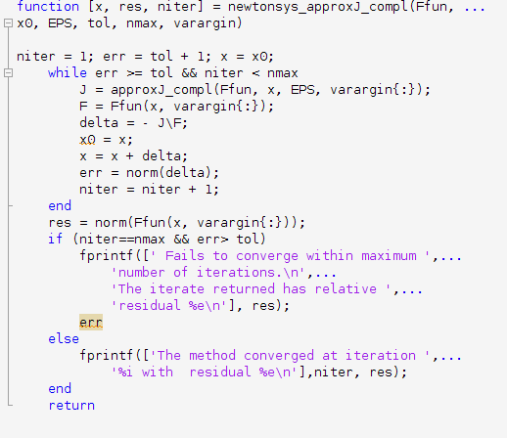
d.)
X1 | -3.735391208430725e-01
X2 | 5.625990747331381e-02
Res | 5.551115123125783e-17
niter | 5

4. Problem 22

a.) Implement Broyden’s method
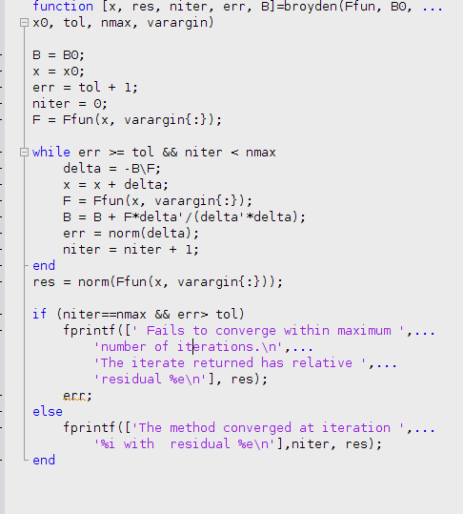

b.) Approximating x

K | x1(k) | x2(k)
1 | -3.135967032377301e-01 | 3.555231731285171e-01
2 | -2.393615167309388e-02 | 1.264580761861792e-01

c.) Use Bryoden to solve system
X1 | -3.667010034769886e-01
X2 | 5.612745145275295e-02
Res | 1.600627259928237e-12
Err | 2.745149447436020e-10
niter | 6

