Curriculum Vitae

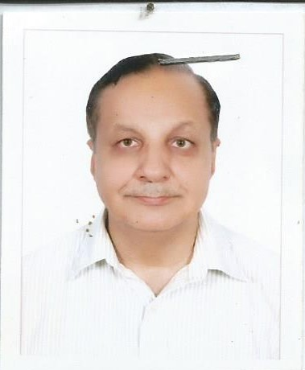

**Biographical Data**

Date of Birth: May 13, 1957.

Marital Status: Married

Cell Phone: 00923349892419

E-mail: ***asim_ali_malik@hotmail.com***

Permanent Address: 217-A, New Muslim Town, Lahore, Pakistan.

**Objective**.

To secure a position of a clinical dermatologist with a well reputed foreign organization after gaining qualification from prestigious instituitions.

**Education/Qualifications**

Membership-MRCPS (Glasg). Royal College of Physicians & Surgeons, Glasgow.

March 22nd 2019.

Diploma in Dermatology Royal College of Physicians & Surgeons, Glasgow.

Date of Award March 20,2012.

Diploma in dermatological Sciences Attended & got clinical training in University Hospital

Of Wales-- an attached teaching hospital with Cardiff

University—in 2003-4.

MBBS Allama Iqbal Medical College, affiliated with

University of the Punjab in 18-02-1988

**Professional Membership**

Society of Dermatologists Pakistan

Royal College of Physicians & Surgeons, Glasgow( Member).

**Professional Registration**

Pakistan Medical & Dental Council(Permanent Registration) as Member.

Saudi Commission of Health Specialities

Dermatology Continuing Professional Development Society, Cardiff University, UK.

**Current Work Experience**

Working as a Consultant Dermatologist at “ Lahore Lasers”. I rejoined it after Saudi Arabia.

**First Consultant Job**

I did my first consultant job at “Lahore Laser” starting from 21st March 2012 to 1st October,

2015.

**Second Consultant Job**

Presently, working as Visiting Consultant in Ittefaq Hospital(Trust), Lahore.

**Recent Work Experience**

Worked in Saudi Arabia as Specialist Dermatology, employed by Ministry of Health—

Subjective Operating Program, from Oct. 11,  2015 to Sept. 07, 2018 at King Fahad Hospital,

Al-Baha, Kingdom of Saudi Arabia.( Total three years)

Working as Visiting Consultant in Ittefaq Hospital(trust), Lahore from April 30, 2019 to date.

Worked in Sahara Medical College, Narrowal. Fom October 1, 2019 for 5-6 months.

**Research Work**

Worked as Referee in Peer-Review process with Inter national Journal of

Dermatology(American Journal).

Presented Dissertation in Cardiff University in 2003-4 to Professor Andrew Finlay as

Chairman of the Committee, gainig 7 out of 10. The Topic of Dissertation was

“Pathogenesis and Management of Dermatoses caused by Ticks.”

**Dermatosurgery and Dermatological Procedures**

I have done work with a renowned plastic surgeon, Dr. Abdul Hakeem Babar, Retd.

Professor of Mayo Hospital.

I am comfortable with the following procedures in dermatology clinic;

Laser therapy, Cryotherapy, Punch biopsy, Intradermal injections etc.

**Work Experience & Professional Training**

House job in General Medicine in Services Hospital from 2-2-1989 to 31-7-1989(Six Months).

House job in General Surgery in Services Hospital from 1-9-1988 to 28-2-1989 (Six Months).

**GP- Experience**

I have a long experience working as a GP in various rural and urban medical set-ups in

public sector organization—PESSI(Punjab Employee’s Social Security Institution), from 1989

to 2012. This long experience imparts me deep clinical insight into almost every specialty

of Medicine. Moreover, I have practical knowhow to deal with common ailments both at

a rural dispensary level and tertiary care hospital level.

**Community-based Clinic**

I have done community-based clinic maintained by the World-recognised Organisation

‘Rotary Club’ for 2-years in evening timings. I attended poor patients for their

Dermatological ailments.

**Short Courses/ Work Shops attended in UK and Pakistan**

1. Dermatology Teaching Day at Singleton hospital, Swansea, Wales, UK
2. Course in Oxford Radcliffe Hospital, UK on immunobulous diseases and learnt SALT Technique and ELECTROPHORESIS.
3. PHOTOTHERAPY AND PHOTOCHEMOTHERAPY for skin diseases day, it is the latest technique for vitiligo and psoriasis.
4. Practical Dermatology Surgery Day, UK. Learnt different Dermatosurgery techniques.
5. Lasers Day. A course in introduction to lasers in dermatology.
6. Attended First National Conference of PESSI.
7. Joined a course of Occupational Safety, Hygiene and Health under ILO regarding safety of workers at factories.

**LANGUAGES**

I can speak and write Urdu, English & Arabic easily and fluently,

**Medical Transcription & Computing Skills**

I have attended a course in medical transcription under Fauji Foundation organization &

know computing skills like operating Microsoft office and internet.

**Further Qualifications and Future Goals**

I have already passed four modules out of the six of European Board in 2016.

Moreover, I qualify to get FRCP(G) and applying for that.

**References**

Dr. Abdul H. Babar, MBBS, MD, DABPS, FACS.

Professor(R) and Consultant Plastic Surgeon

Address: 8/C MODEL TOWN, LAHORE-54700, PAKISTAN.

DR. Jameela Fareedi, Medical Director, Jameela Fareedi Hospital

Address: 34-B, Johar Town, Lahore.