

**TECHNOLOGY MANAGEMENT ASSIGNMENT 2**

**TEAM MEMBERS:**

**MAHNOOR 231-450813**

**ZAEEM NASIR 241545771**

**HAMZA AYUB 22-11085**

We looked for many different tools for service management system like hubspot, trello …… and we choose trello as it is less complicated when it comes to usage and if more reliable. Not only this but trello is more use friendly as its all about providing better services to make customer life easy so it is that kind of tool that is easy to use.

Here are some pictures with explanation of the steps that we took:

STEP FOR LOGGING IN:

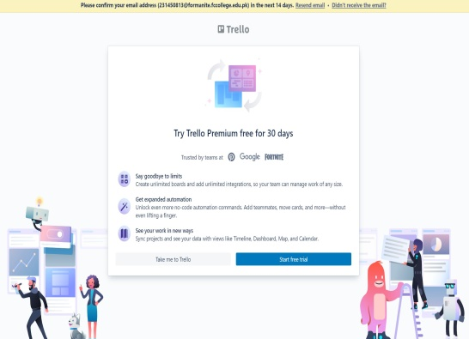

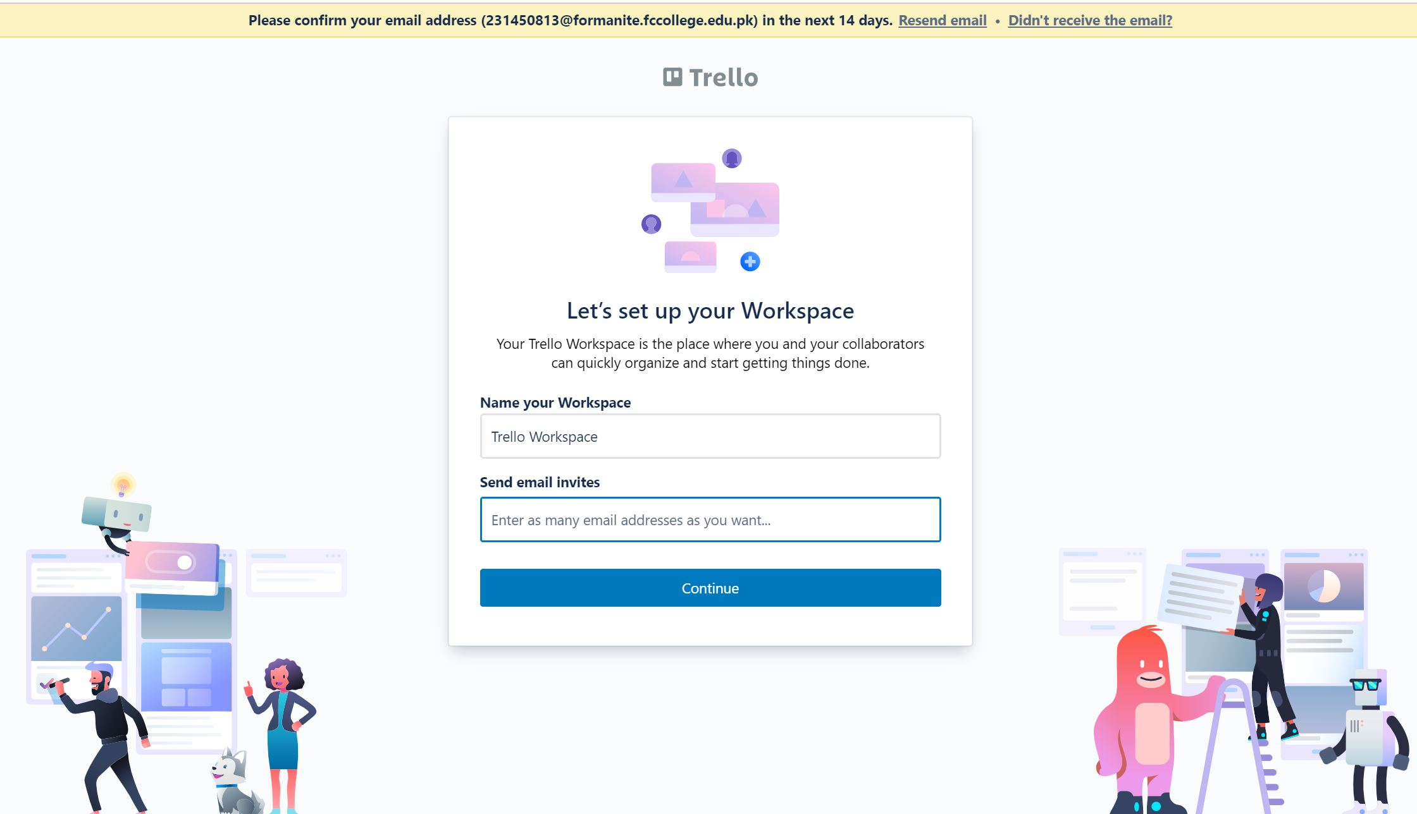

We entered our desired email and this page pops up where we are required to enter the name of our workspace and email of our team members so we can send them invites to join this workspace with us. As this app is paid but they offer free trial so we used that to gain experience of this service management tool.

FRONT PAGE:

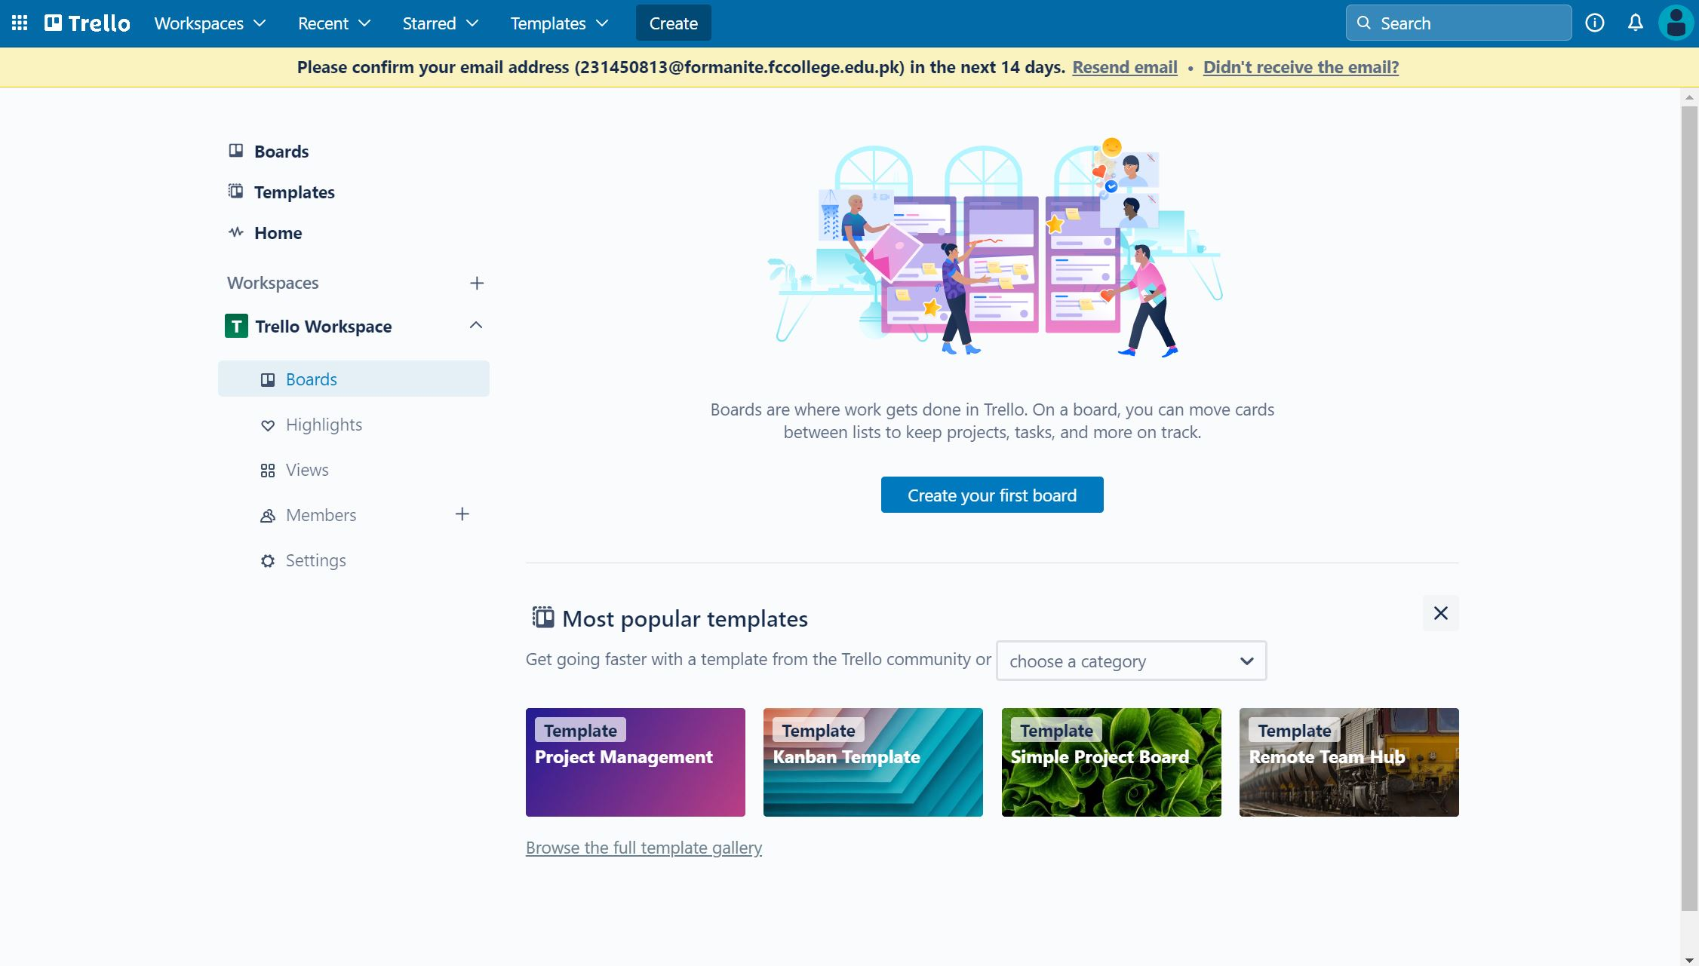

This is the main page of the trello where you can see many options like boards, template type which can be customized, can make different workspace for each department or different companies, we can see projects and tasks who need to be finished as soon as possible due to its due date and we can add members.

BOARDS:

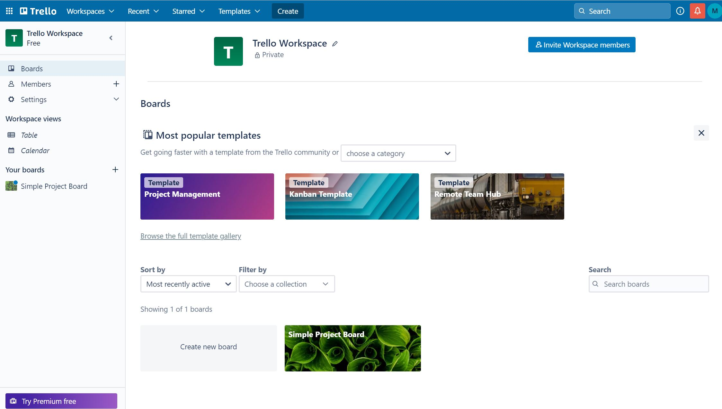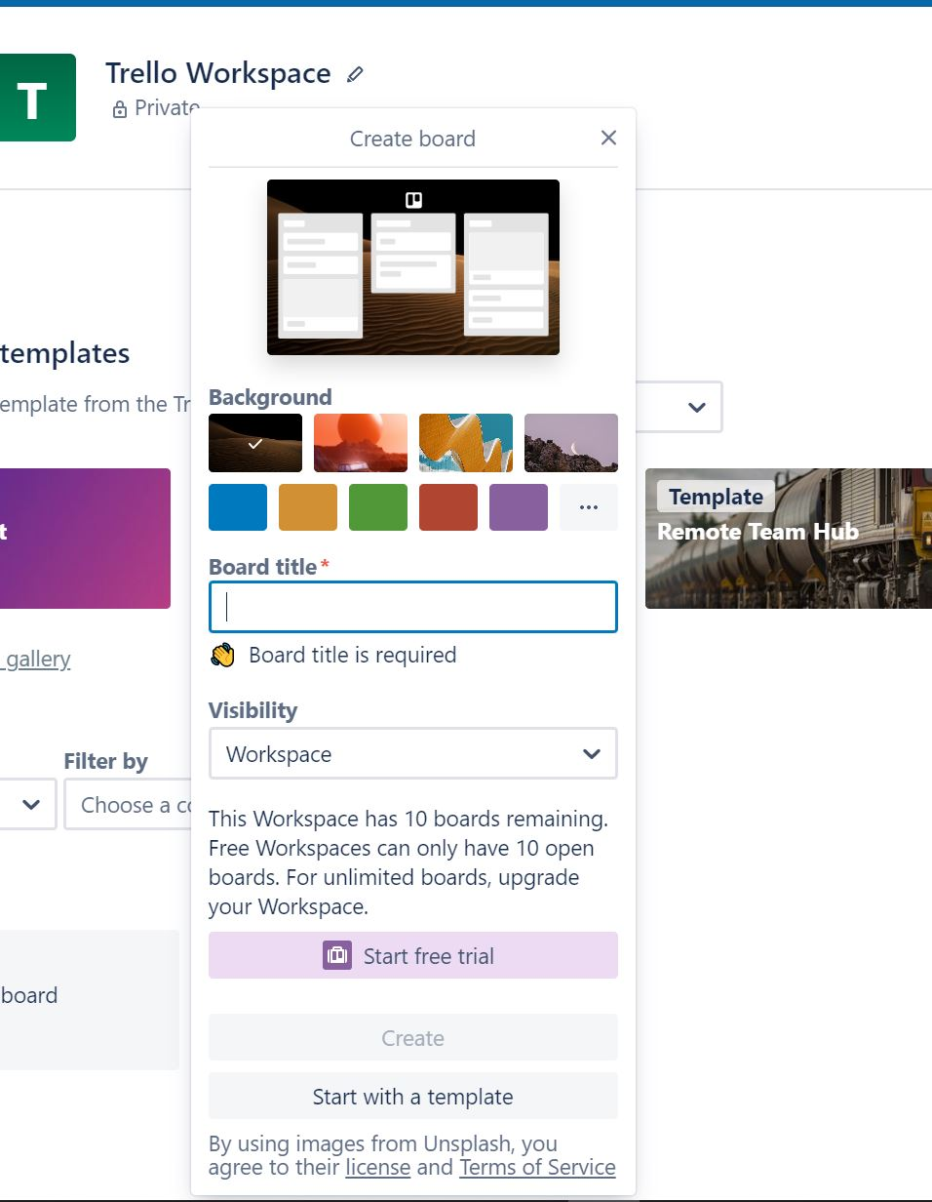

Here as you can see in board we have different options where you can select template according to your requirement, set its title and to whom you want it to be visible to all these options are to be selected according to the project description.

BOARD SETTING AND TASKS SETTING:

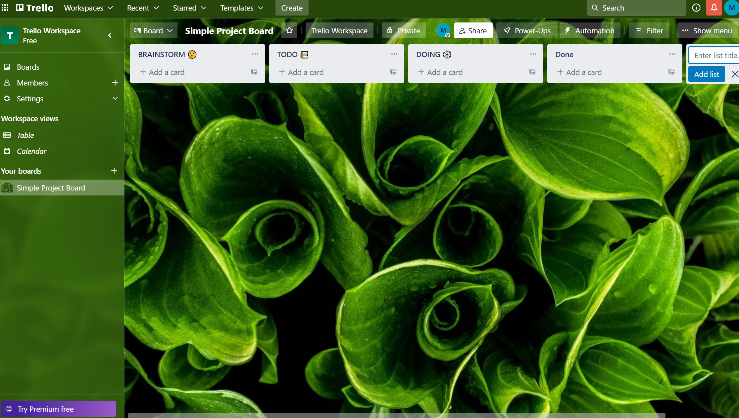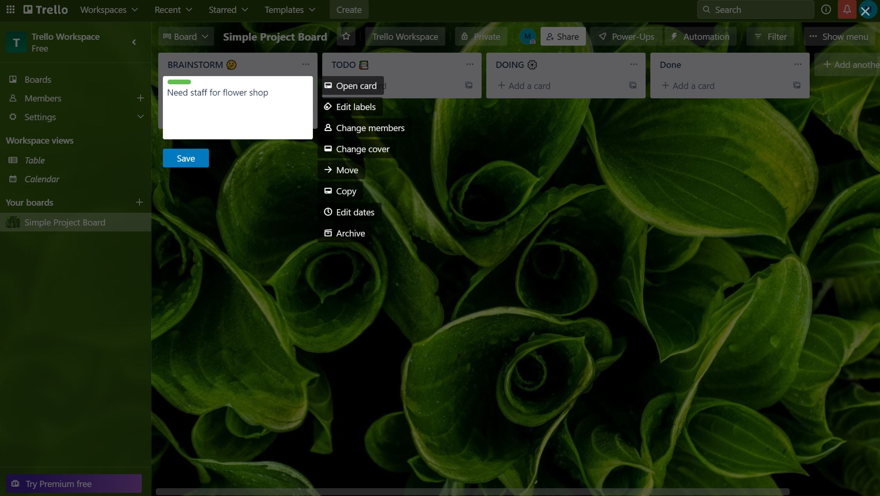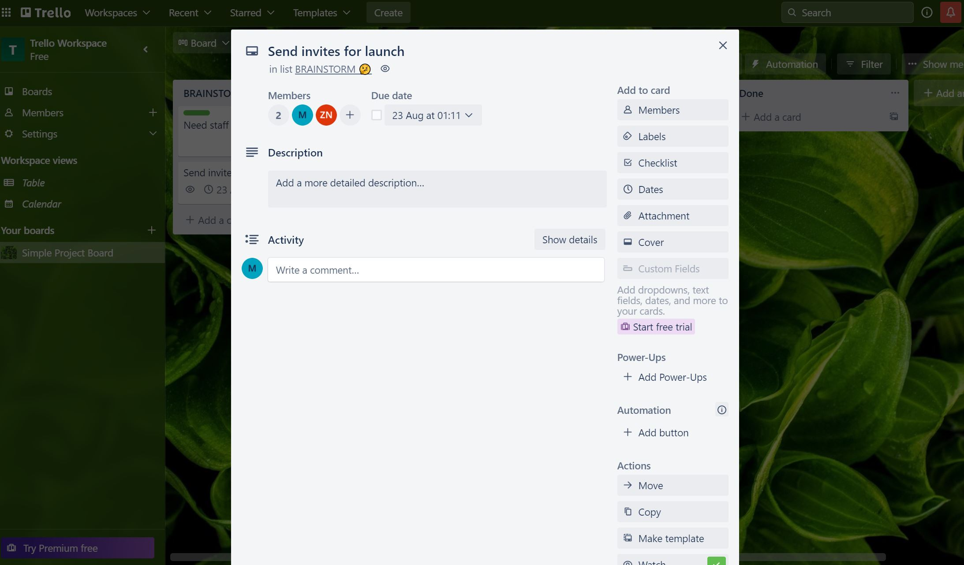

In this step you can make list title according to your convenience like the things that need to be done can be listed in TODO list and tasks in process can be under DOING list these titles can be customised and so are labels to make them more prominent to all members working on them. The members can be customised too.

THE TWO TASKS THAT WE DID ARE:

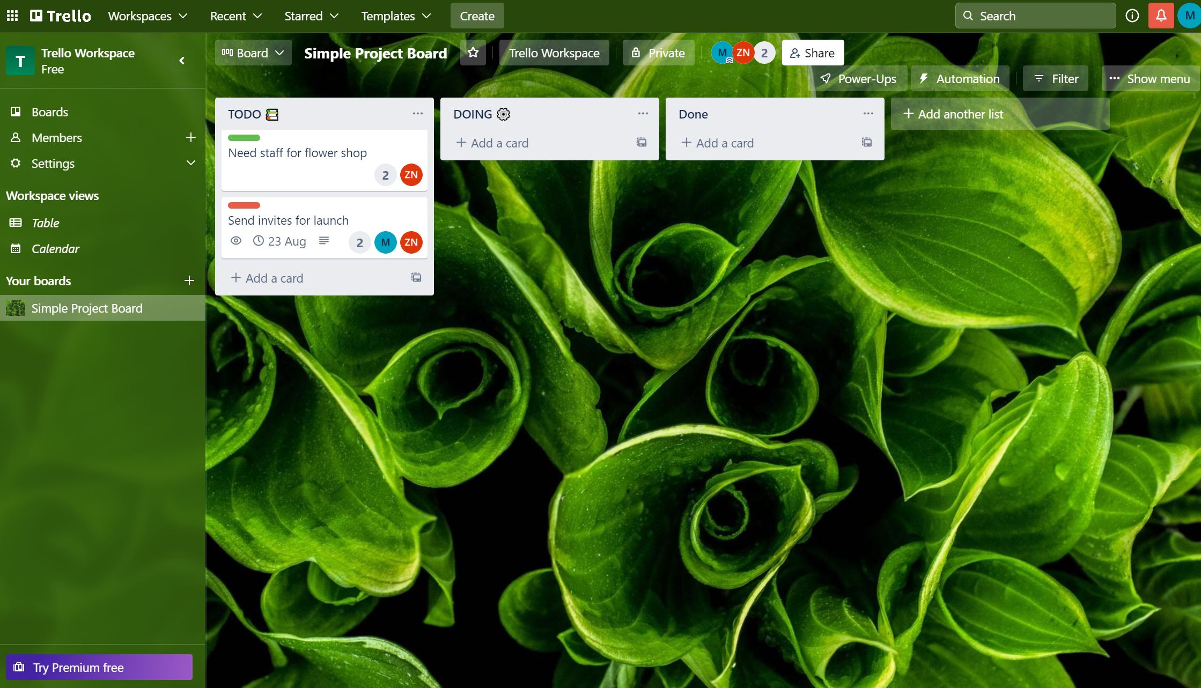

PROCESS DETAILS:

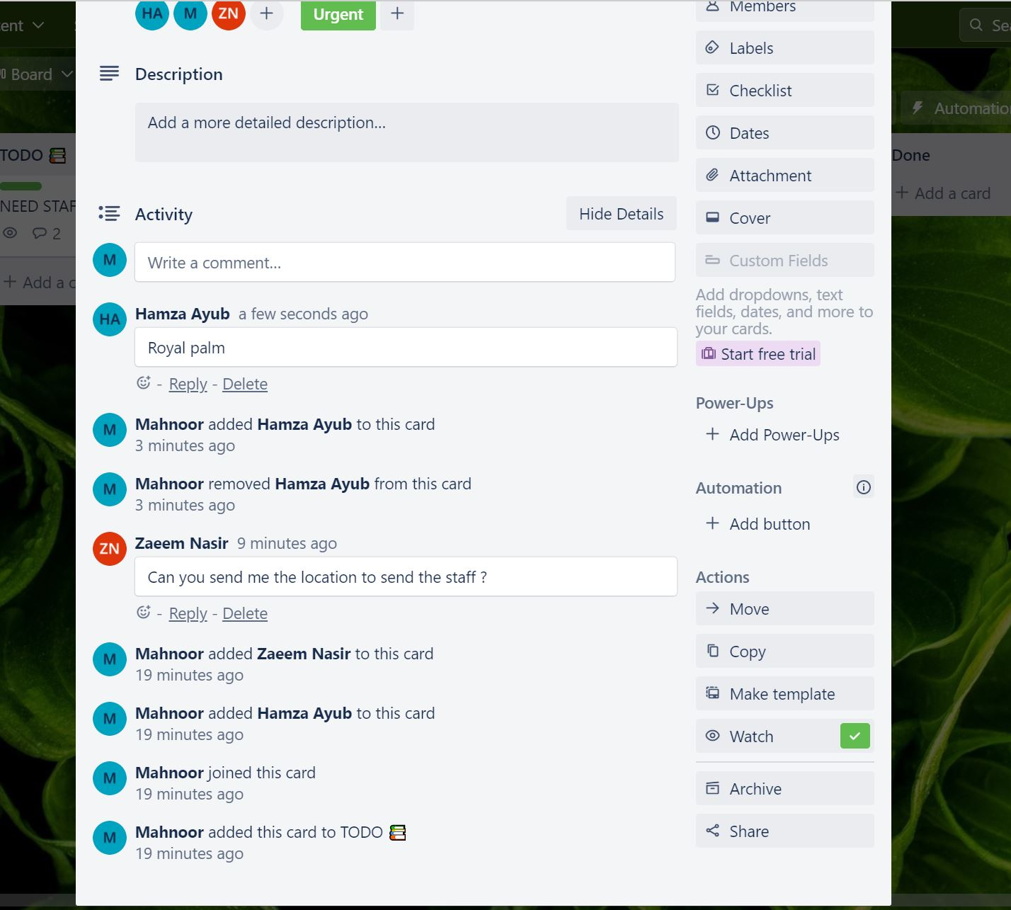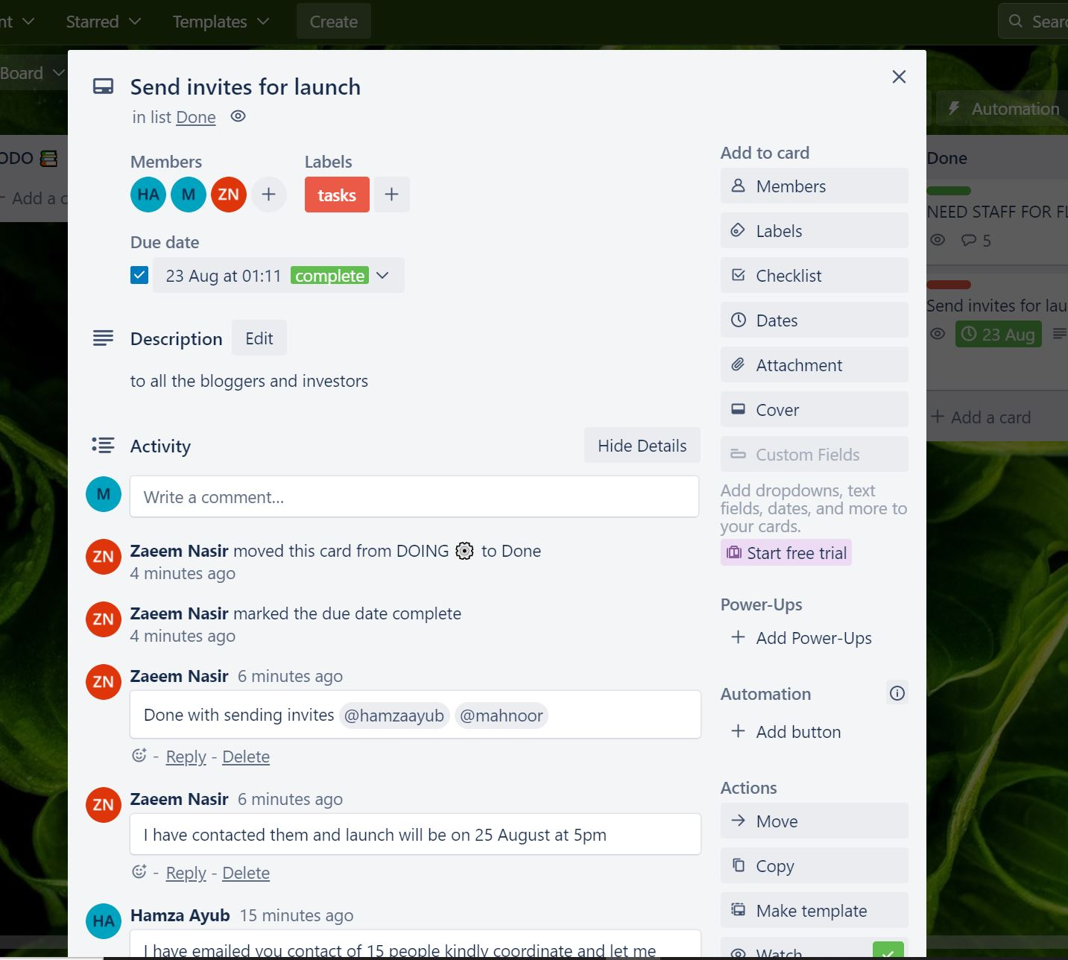

Once all tasks is assigned all the members will start working on it and will update each other and ask for if any query they have related to it. Not only this but they will move task to each list it suits like the requirement are processing or the task is done or they are still doing it.

Here we can see that all the activities that are done each and every moment is tracked and is displayed in the activity area for overview and helps each and every member to stay updates and they can review steps whenever they are in need.