

**TECHNOLOGY MANAGEMENT ASSIGNMENT 3**

**TEAM MEMBERS:**

**MAHNOOR 231-450813**

**ZAEEM NASIR 241545771**

**HAMZA AYUB 22-11085**

This is assignment of technology management we are required to learn Bitrix24 and show process of it. What is Bitrix24? Bitrix24 is collaboration software with complete tools for management, collaboration, and communication. Bitrix24 gives you a unified platform for your files, projects, messages, tasks, and contacts. You can immediately use the platform by simply registering for an account and then inviting your colleagues.

Here is the demonstration on how to use it with screenshots:

**Signing up:**

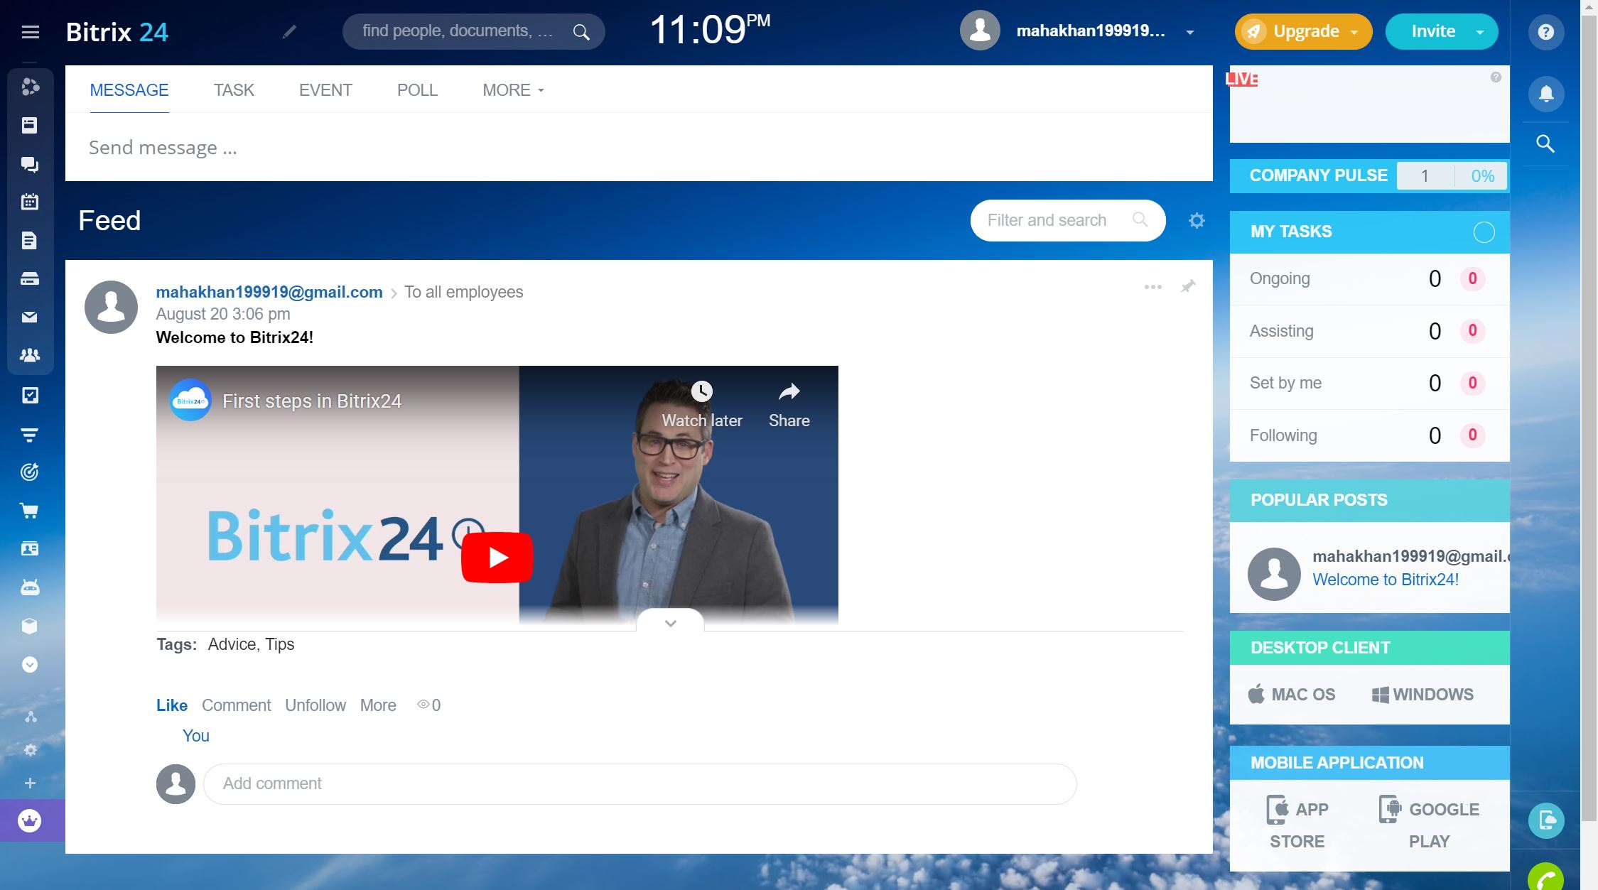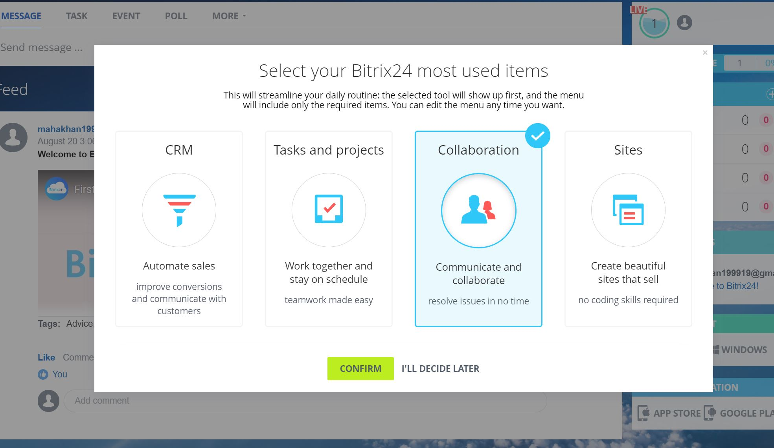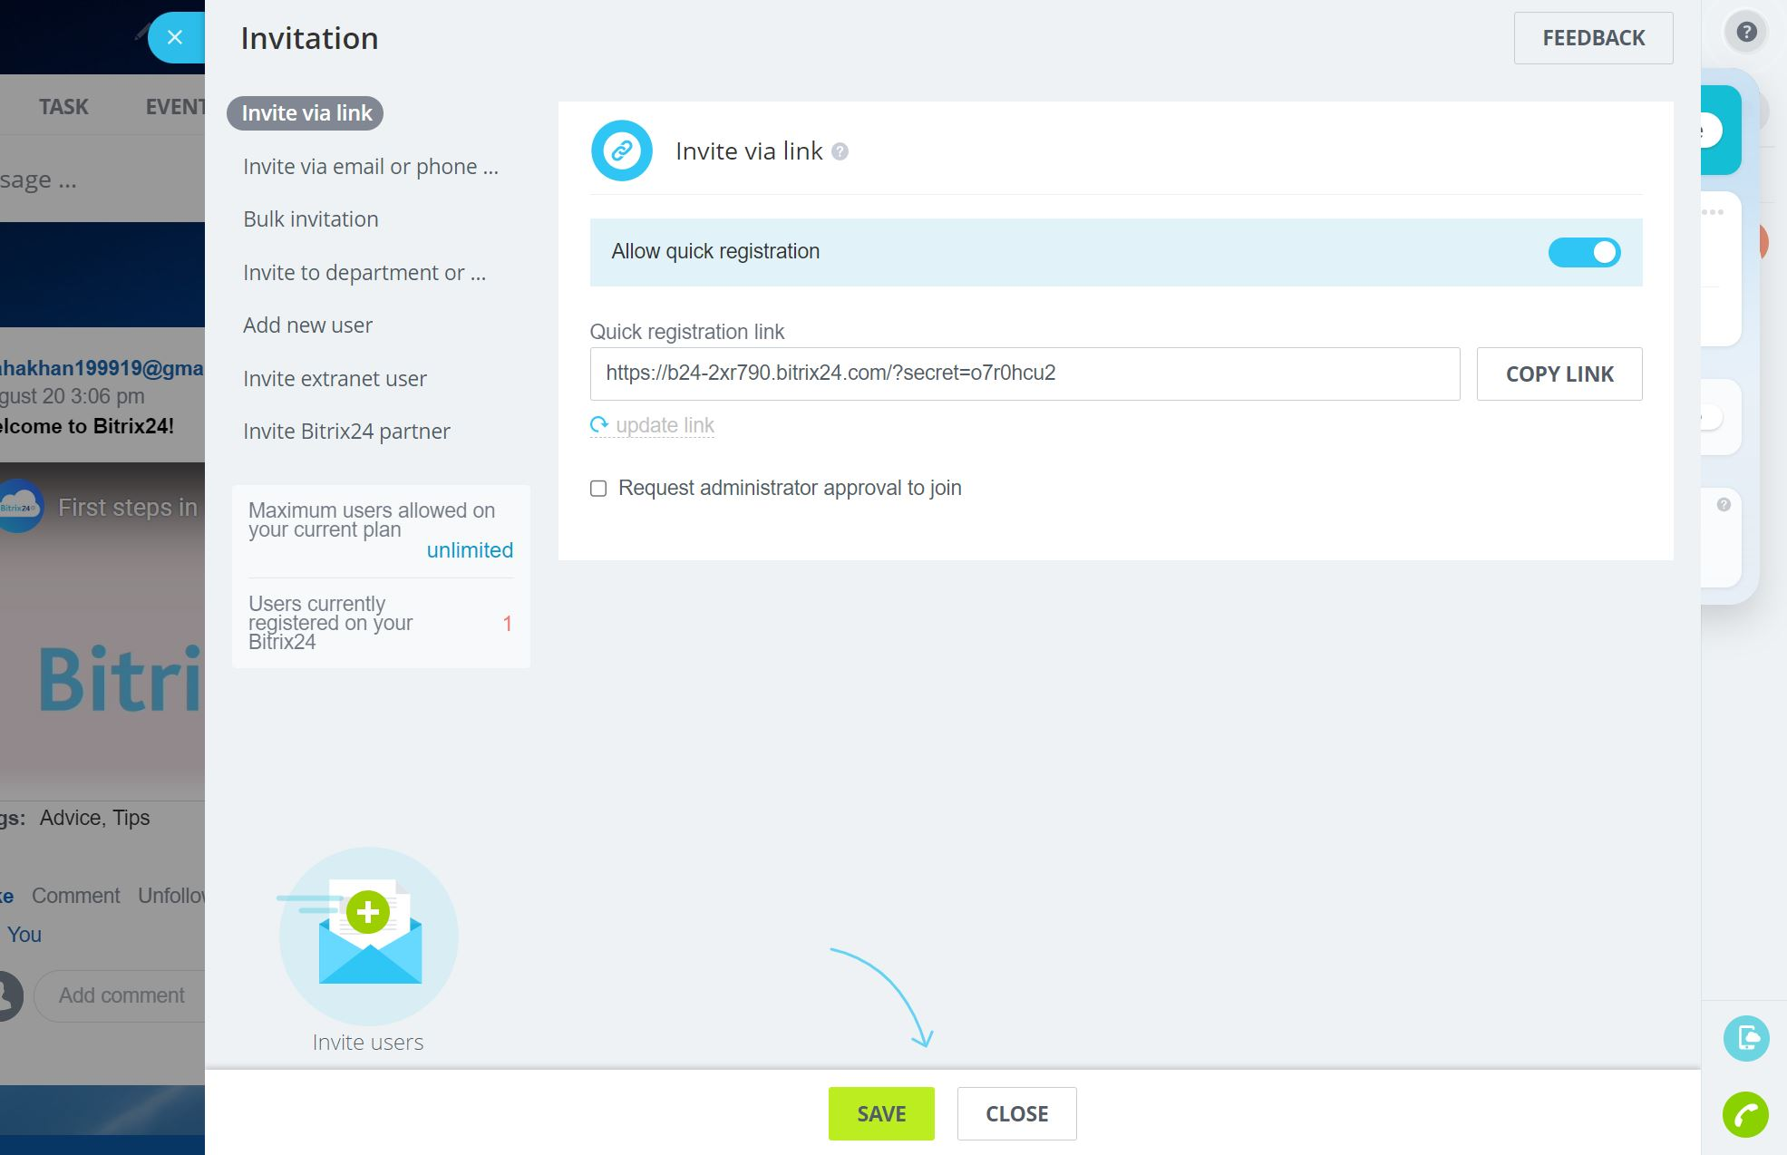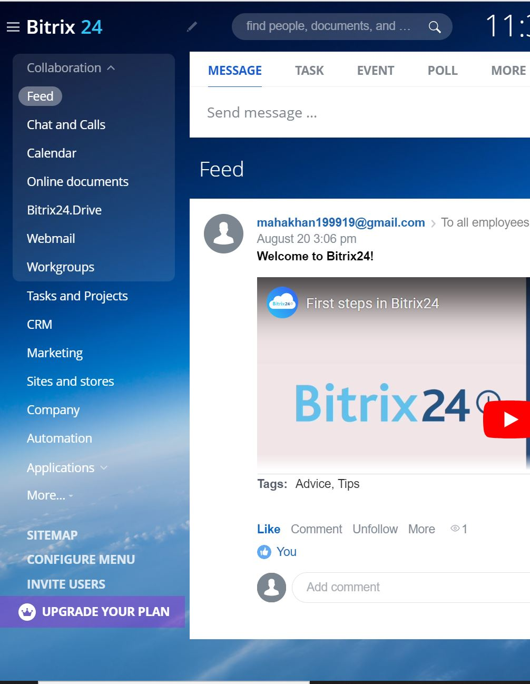

Here are some screenshots to help understand the sign up process. Firstly it will ask you to enter your email and then you will click on get free registration once you are done with that confirm you email through verification email on your account.

After this it will ask you to select your required streamline it can be edited later too. You can invite your group members as much as required for your certain project or task. You can see the menu too where there are various option that can be selected accordingly.

**Creation of project and tasks:**

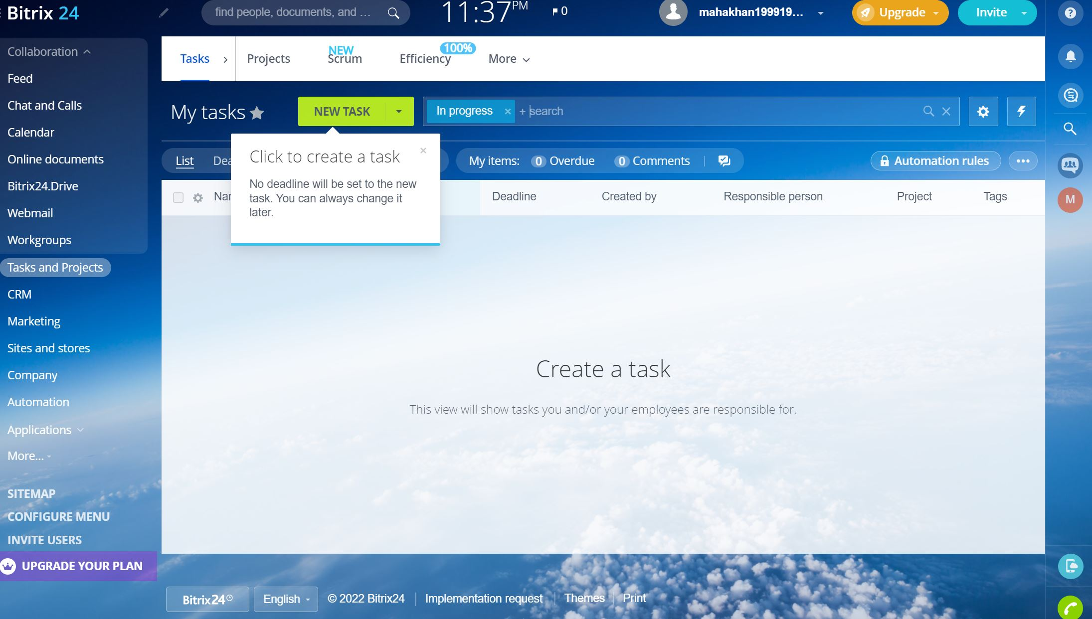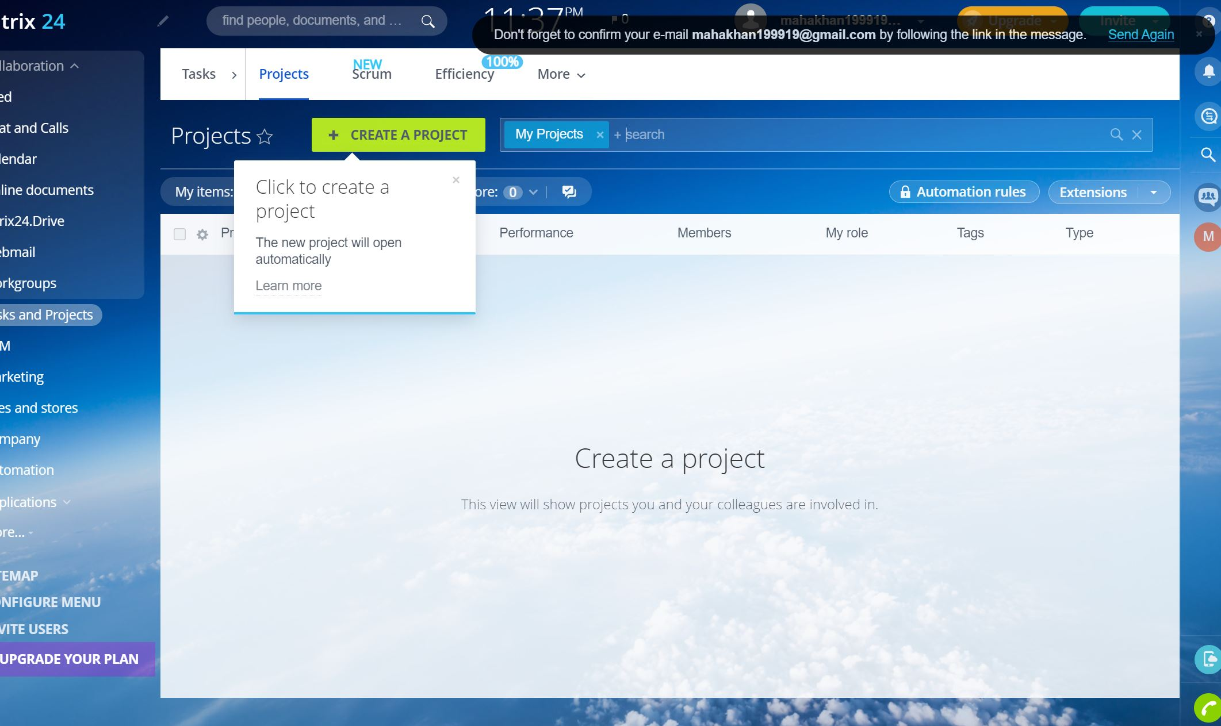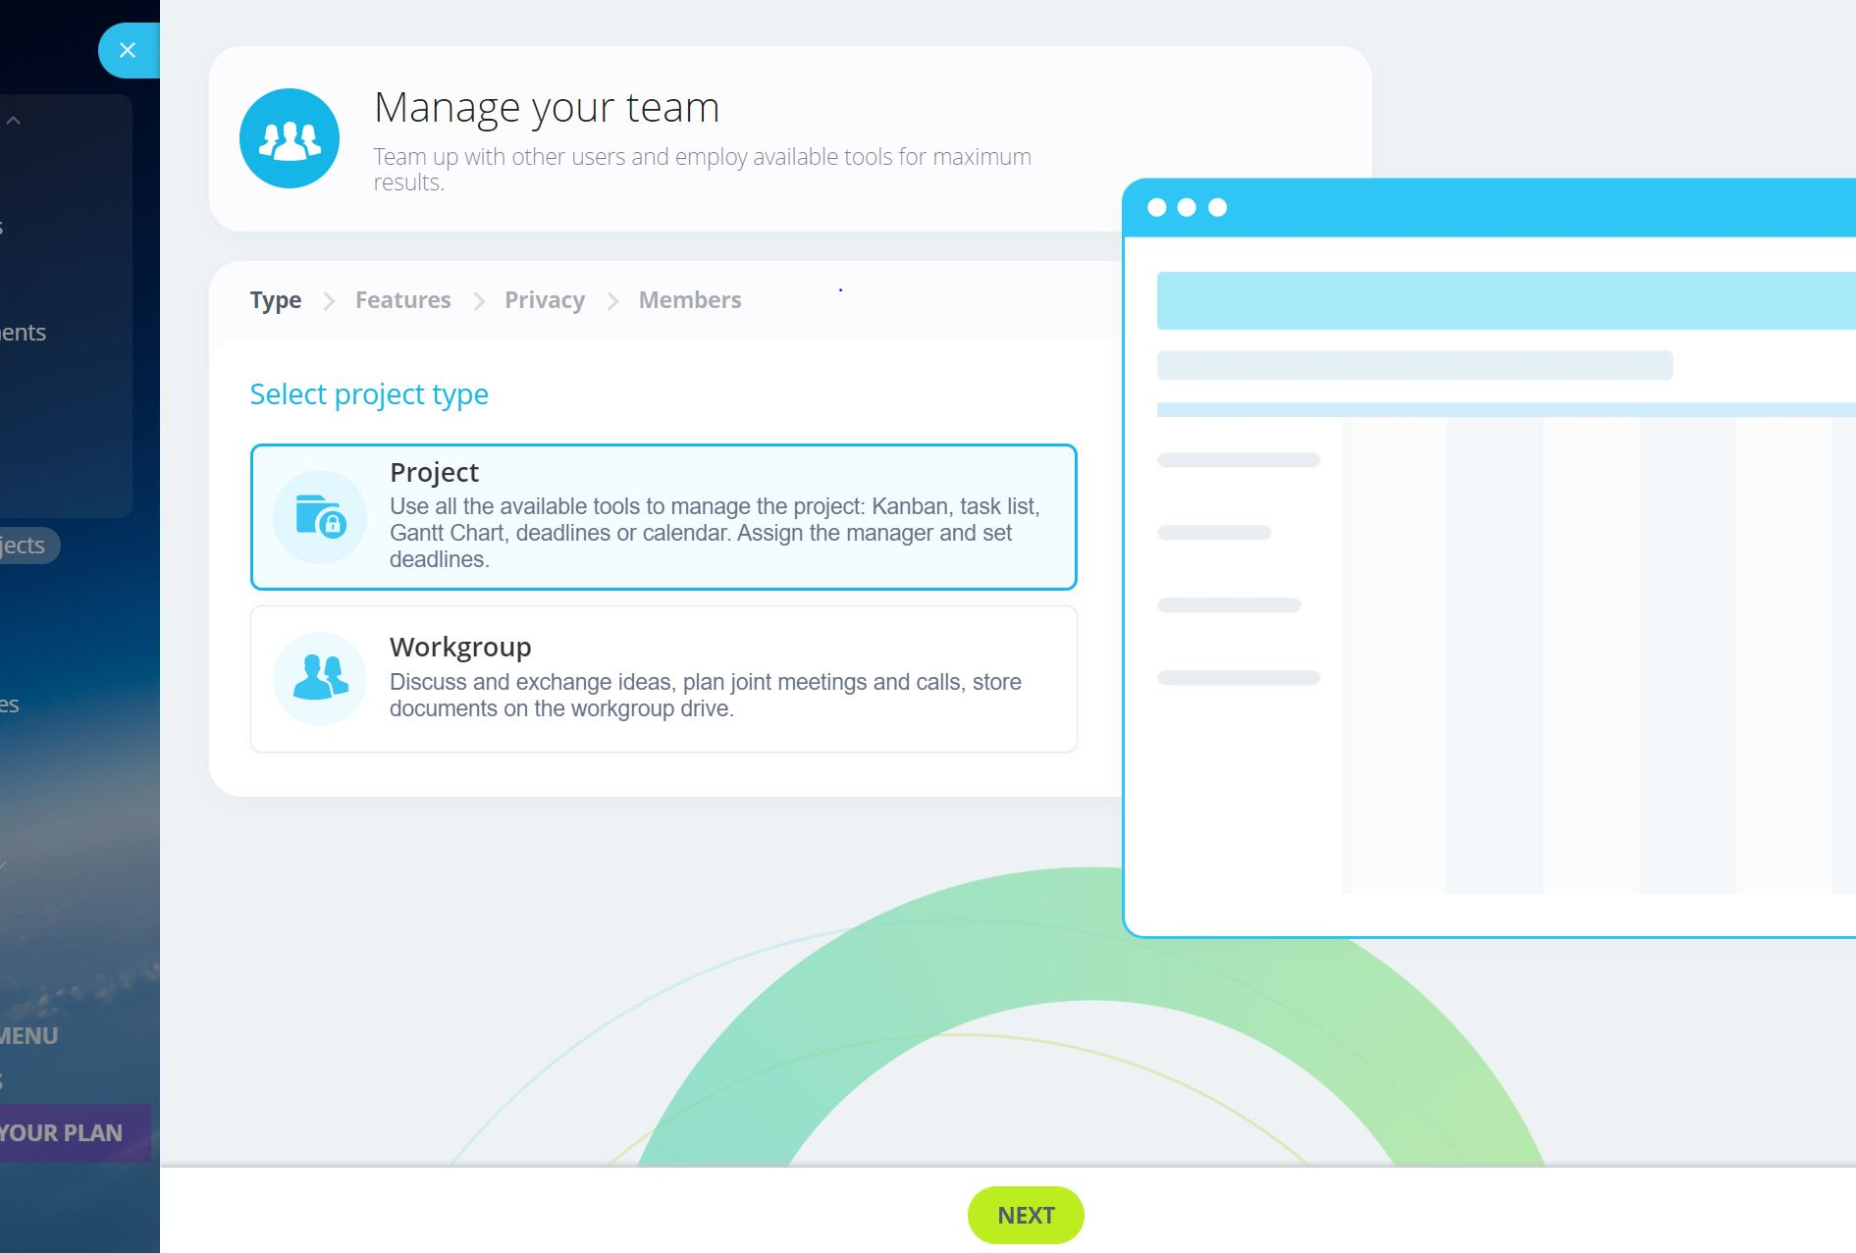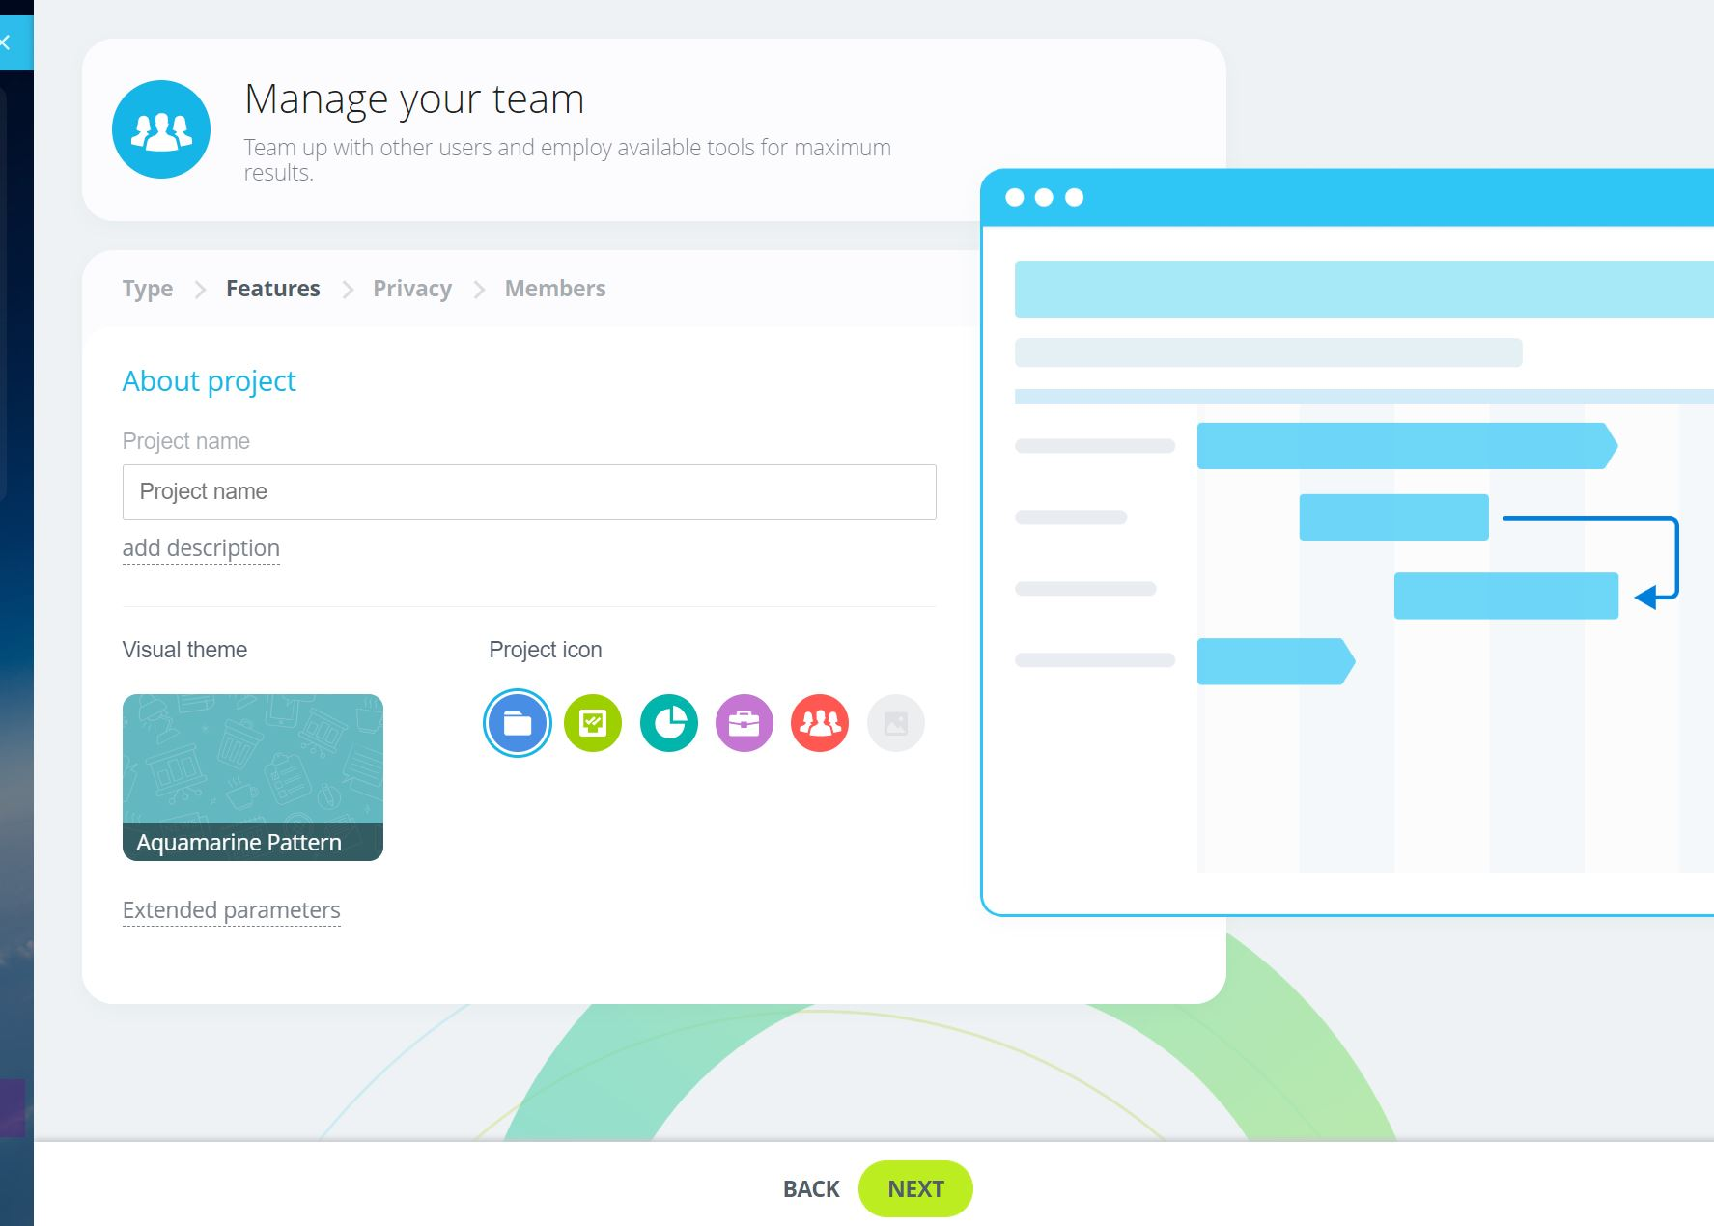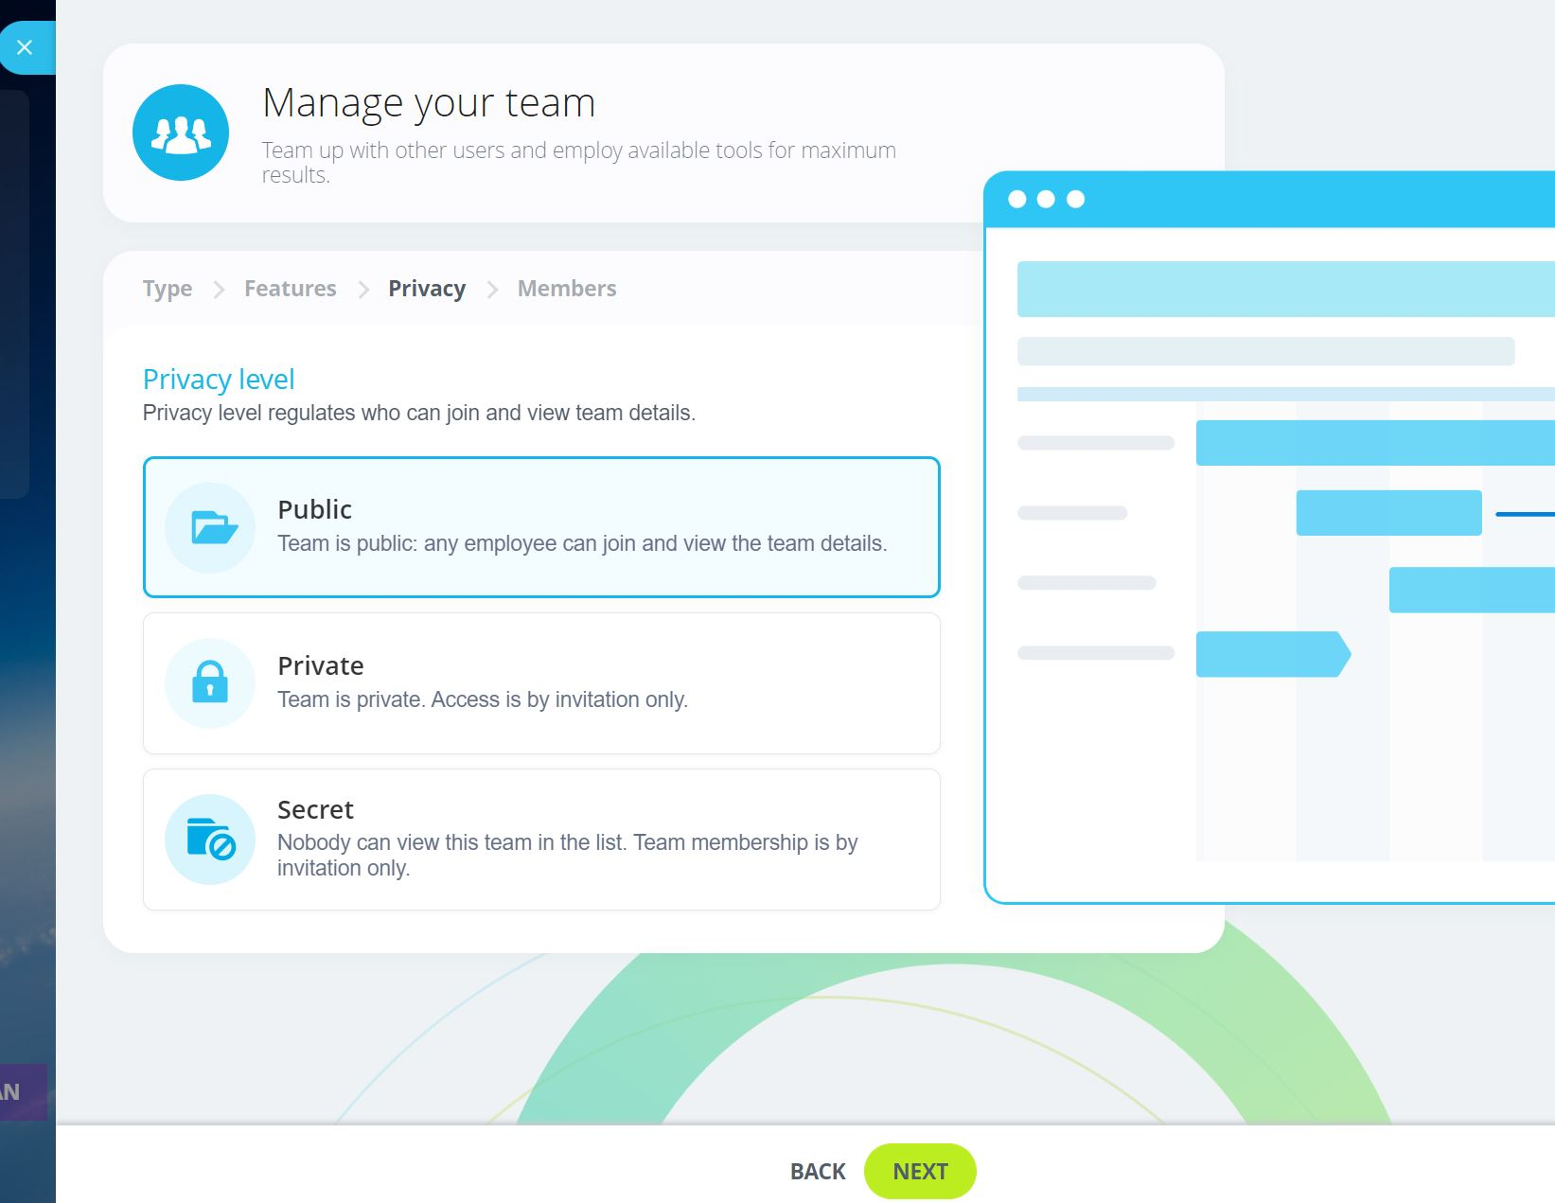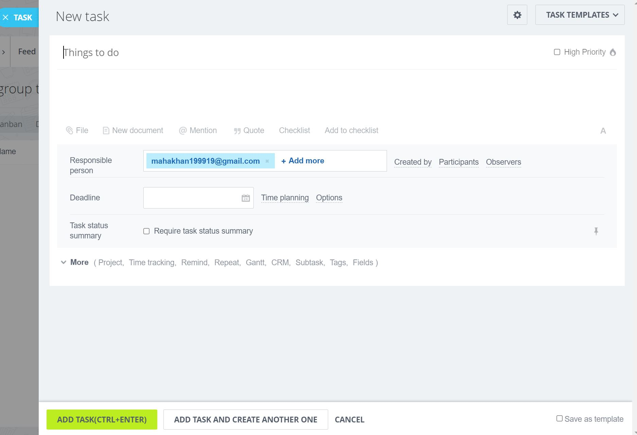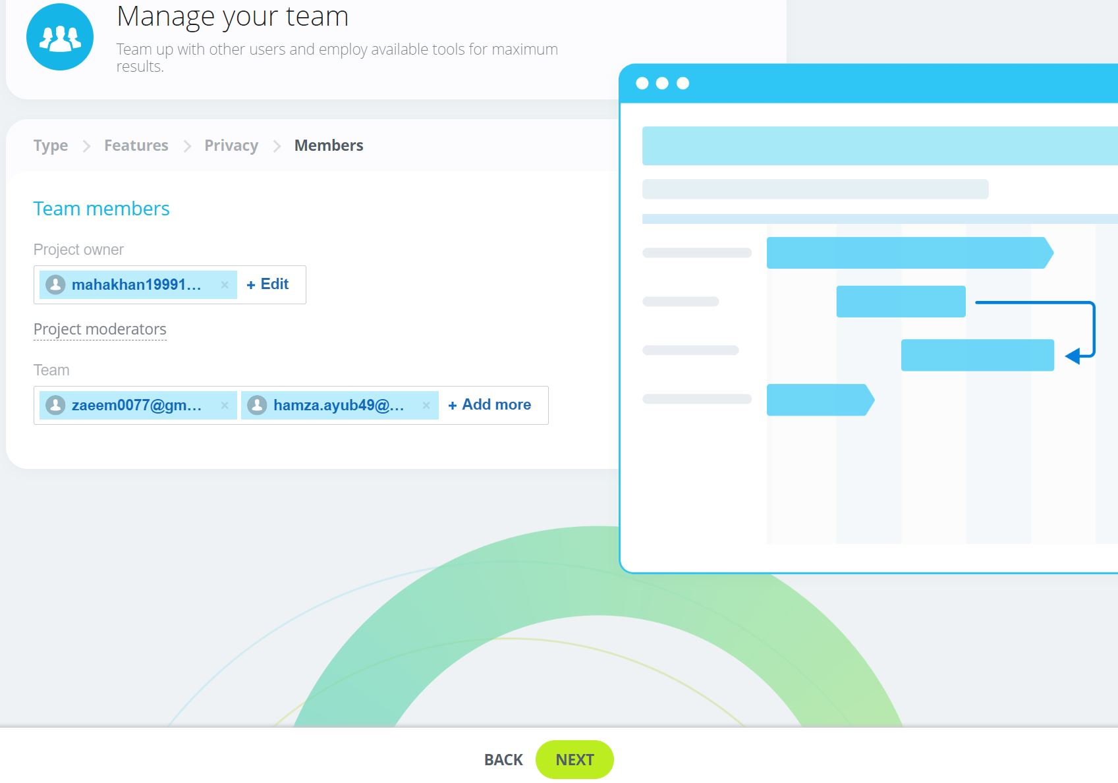

It is very easy to understand and implement. Firstly go to project and select create a project it ask you about the project where you can enter details according to the project you are working on like its name, its icon , any description if you want to add any and if you want your project to be private, public or secret. We choose private as we wanted invited members to access them. After entering all the required details about the project you can create any many task as you need inside it. In task section you can write title, add file, mention members and quote main things too. Later you can mention responsible member, the created of the task, any extra participant or observer you might want to add. Set deadlines or planning time that is required for other members to know how much time span they actually have.

**Two Projects and 5 tasks each we made:**

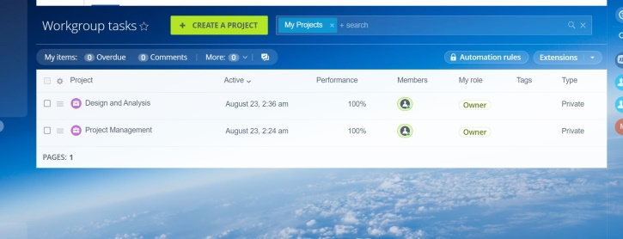

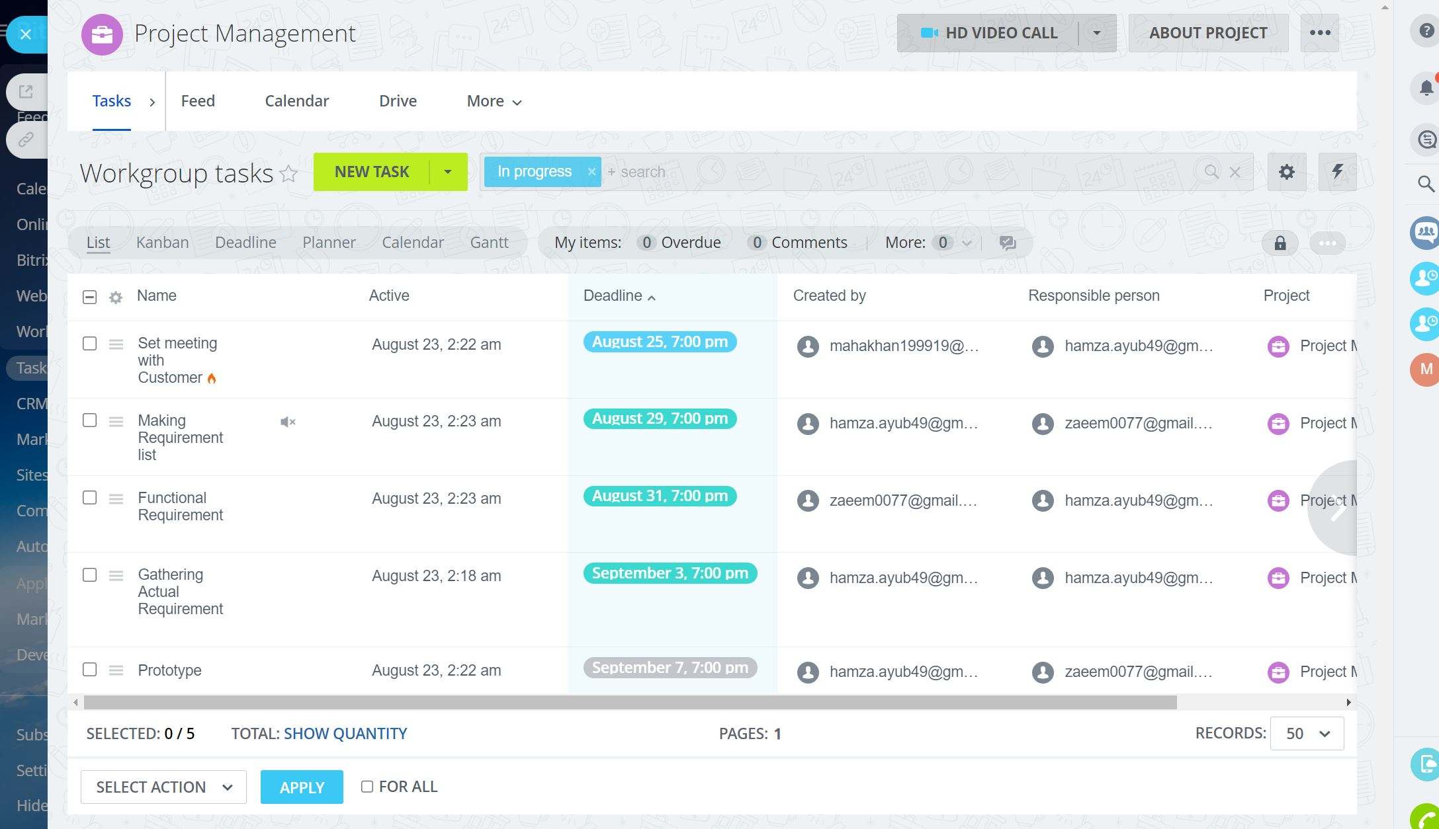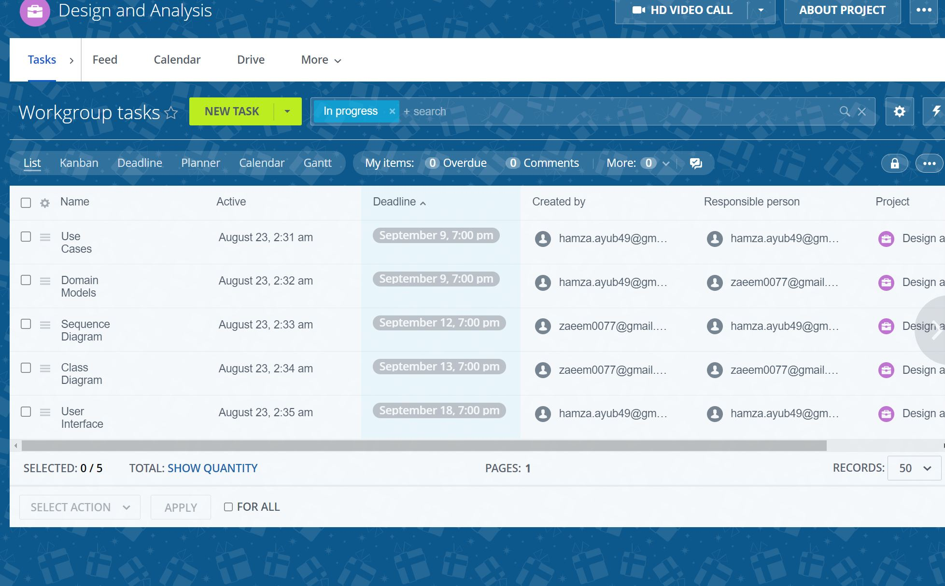

**Gantt chart and Scrum team report:**

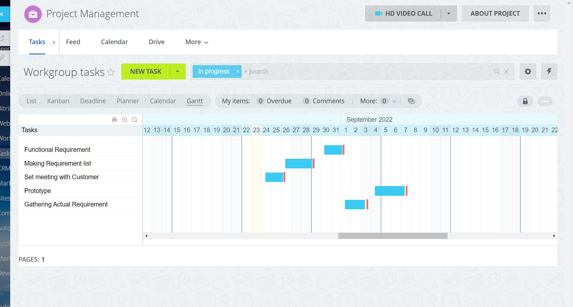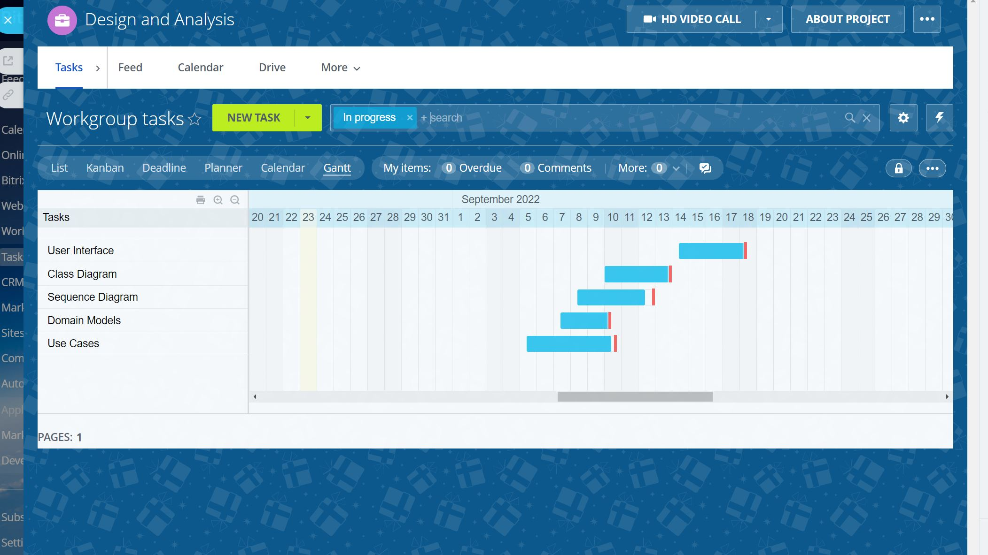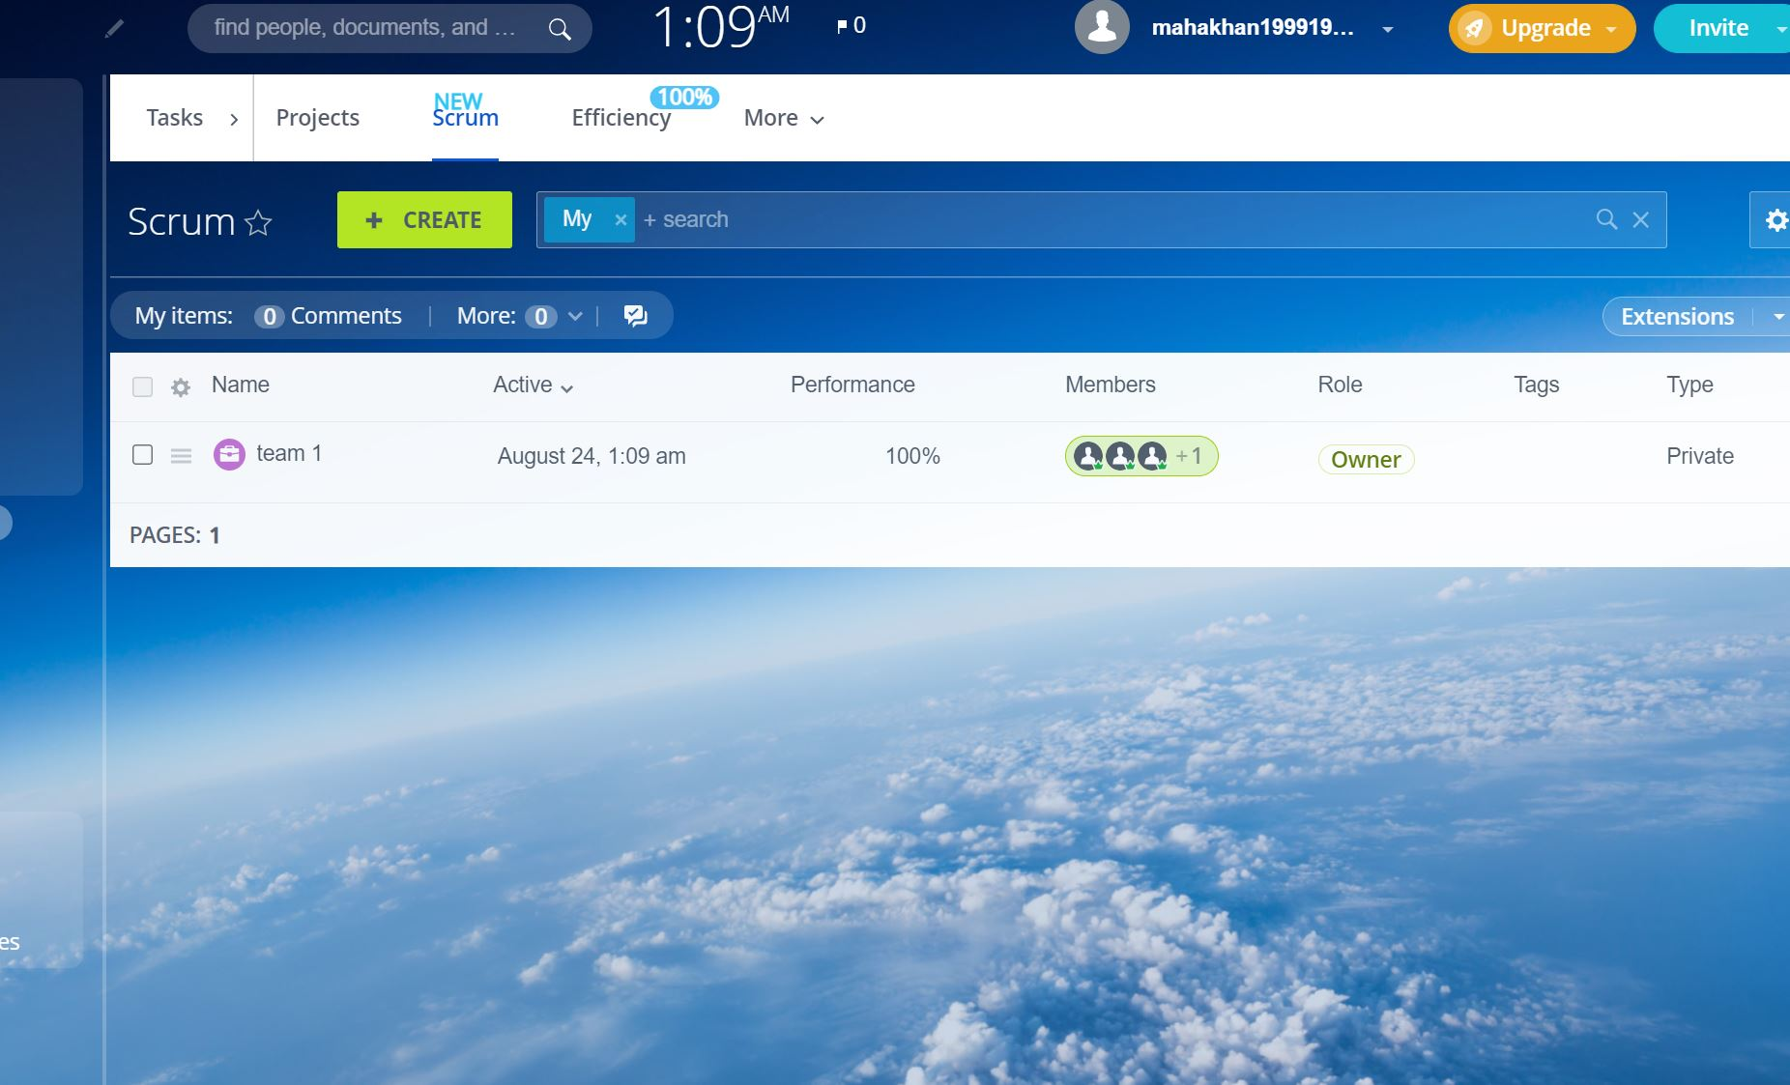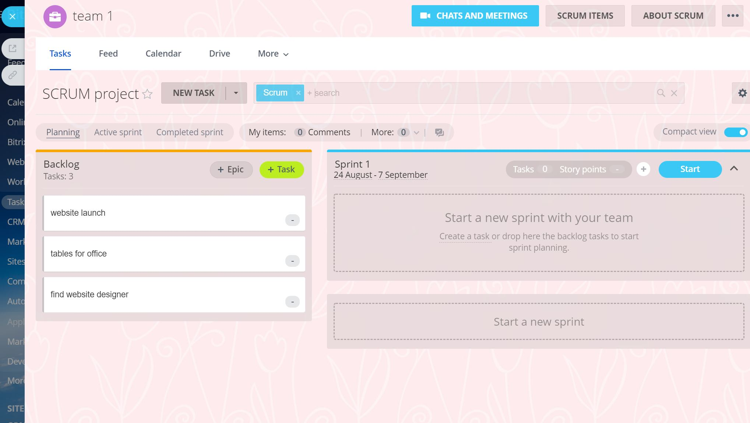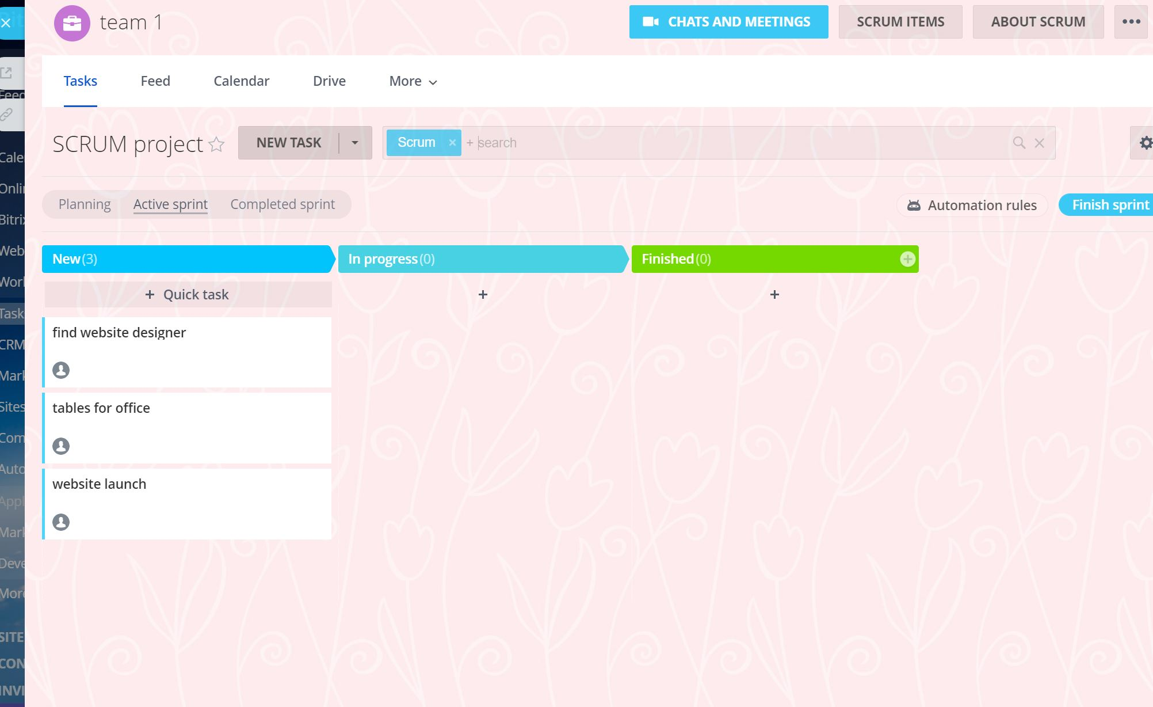

Here is the Gantt chart of our each project task these gantt charts helps manager and other team member to have a clear look at what tasks can be done simultaneously and when is the deadline of each task that is stated. Scrum is used mainly for the small tasks that are less complicated for tangible and predictable results. Firstly open scrum edit and prioritize your backlog like which tasks are more important once we are done with it more task to the sprint only the owner of the scrum have access to move task. There are many options available in setting for the customization in scrum. As soon as members start working they can change phases accordingly and can chat or call anytime they want to solve problems quickly. We can send tasks to next sprint or back to the backlog whenever we want in the kanban.

**Display of team member roles:**

|  |  |
| --- | --- |
| Mahnoor | Customer |
| Zaeem Nasir | Team member |
| Hamza Ayub | Project Manager |

**Kanban List:**

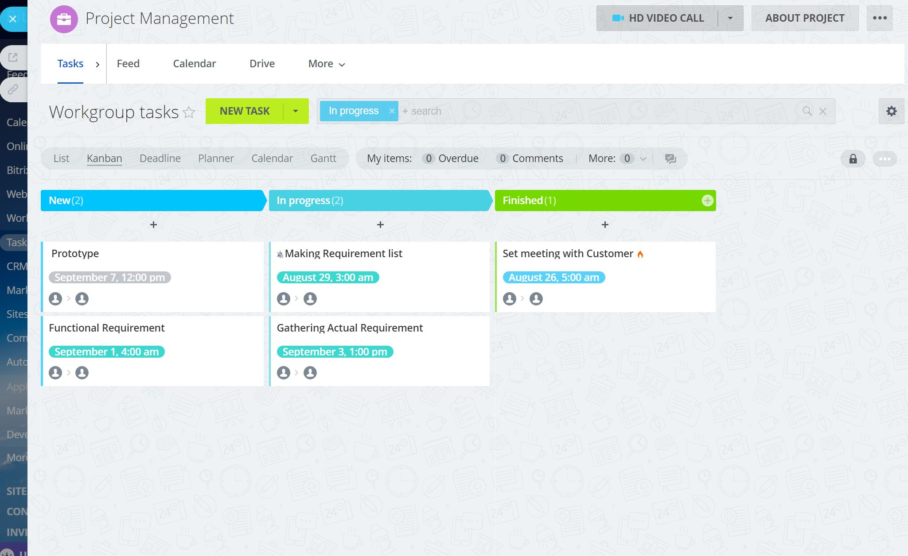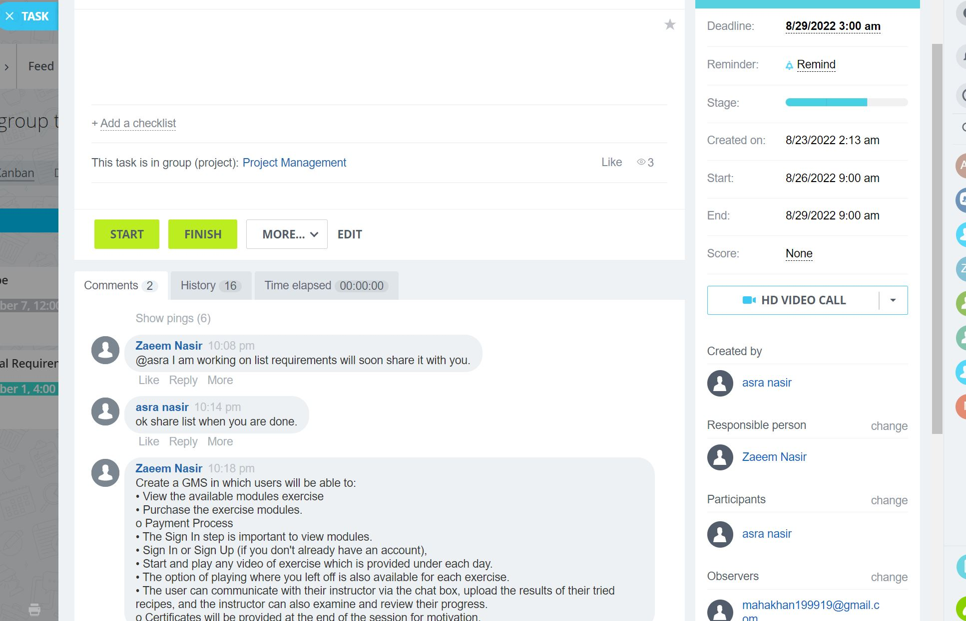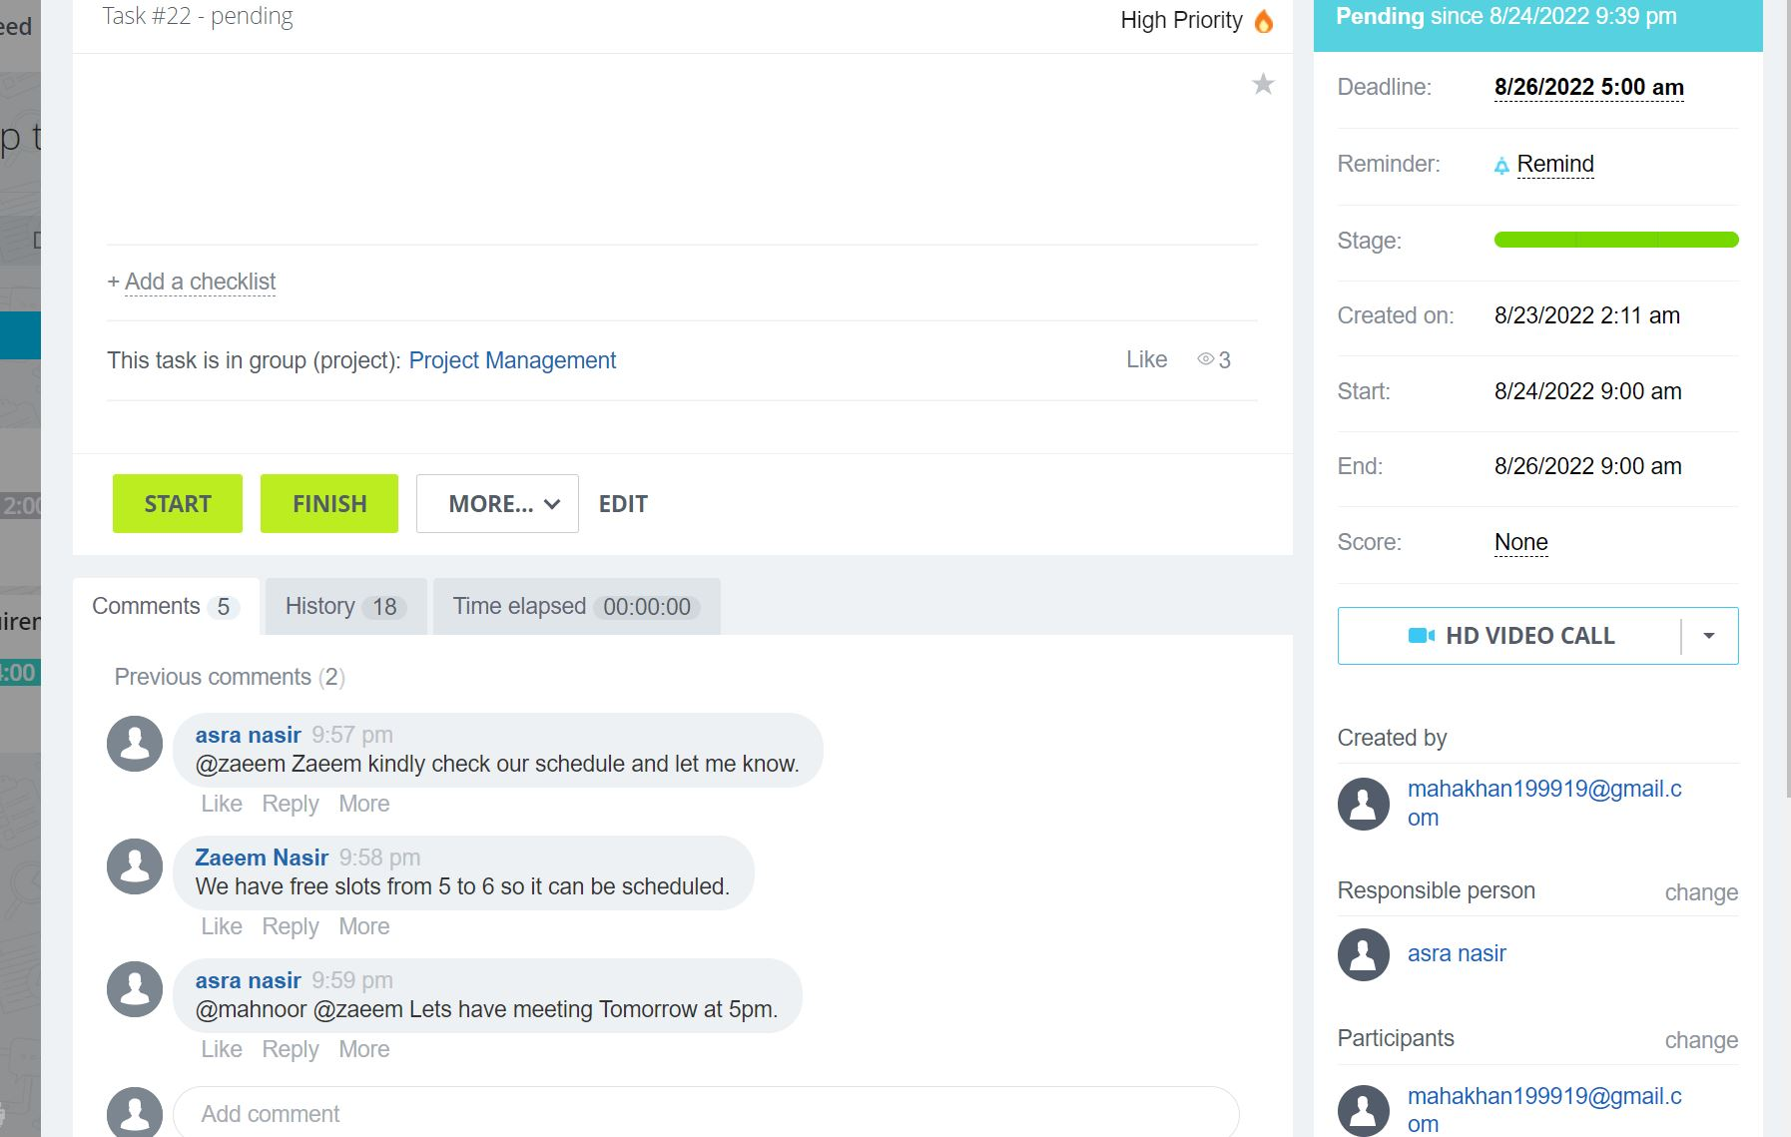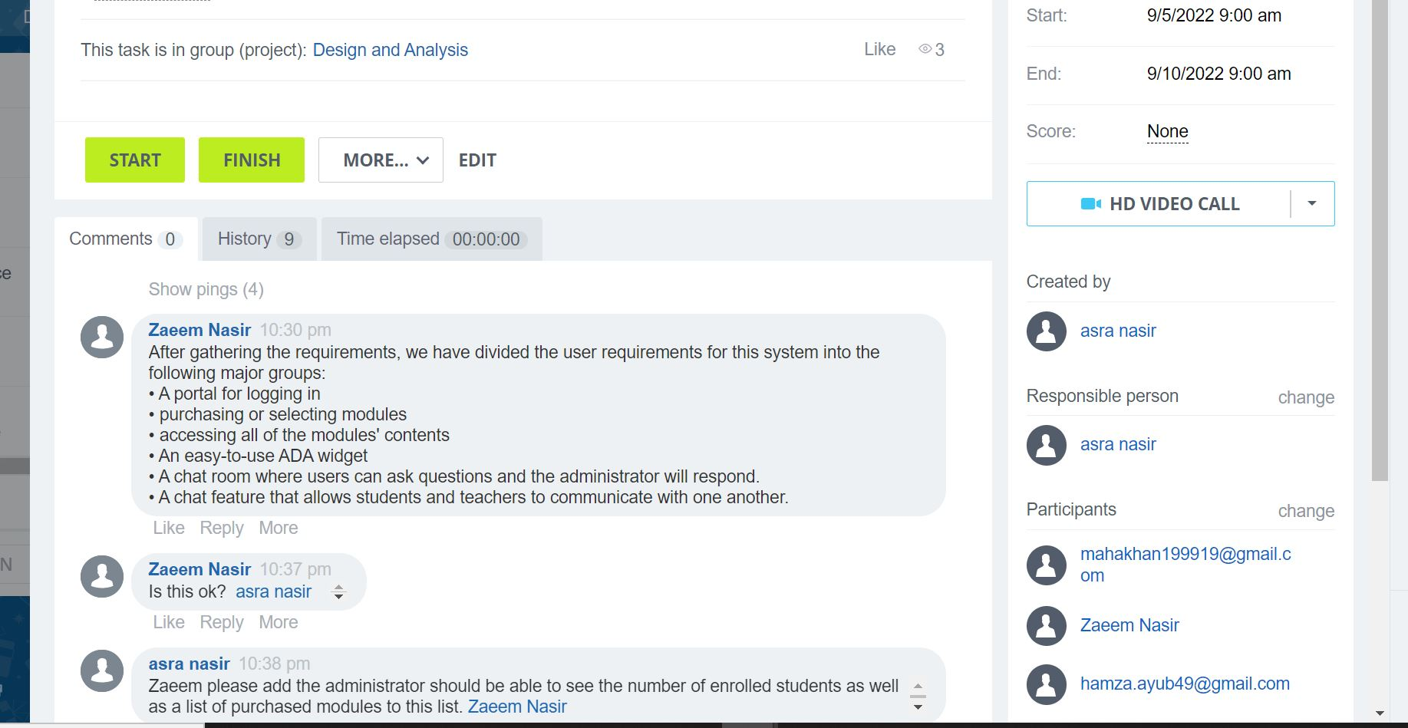

The Kanban list shows the way each task is taken in process and details when and how it is working it helps to evaluate will the task finish in the given amount of time or not. Members meet and discuss over comments and video calls on how to take things forward and clear their concerns. Here are the screenshots of how things work we can move one task from one stage to another. Mainly kanban is about coordination we can tag members share related documents and all other things to make work efficiently.