

**TECHNOLOGY MANAGEMENT ASSIGNMENT 2**

**TEAM MEMBERS:**

**MAHNOOR 231-450813**

**ZAEEM NASIR 241545771**

**HAMZA AYUB 22-11085**

In this assignment we will use jira service desk and jira service management and demonstrate how the tool is used.

What is exactly Jira? It is a tool source used for a variety of project templates to help teams gets set up quickly by creating projects tailored to a specific team or use. These templates include pre-configured request types, workflows, and other relevant features. Available templates include IT service management, general service, customer service, HR, facilities, and legal service management.

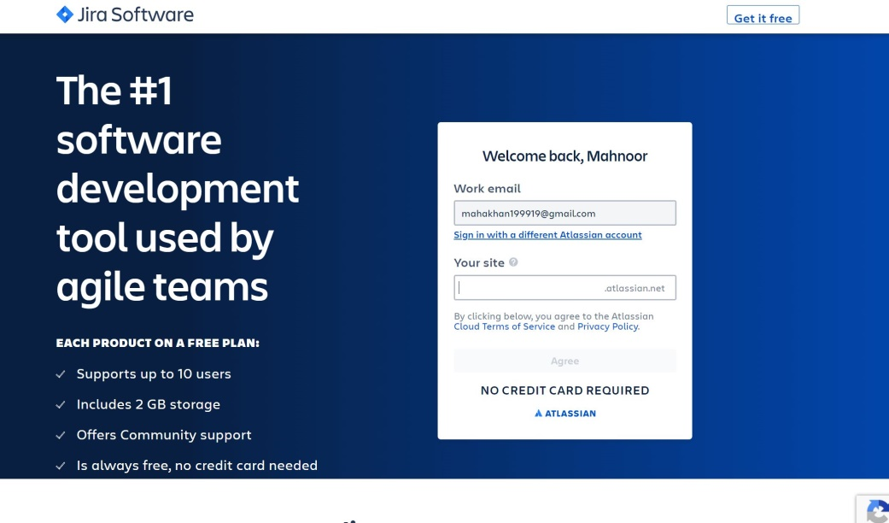

Firstly we will make account on Atlassian and then sign up to jira service desk as well as the management service once we have done that we can login to both of these areas using that same email and by entering our site name.

**Jira Service Management:**

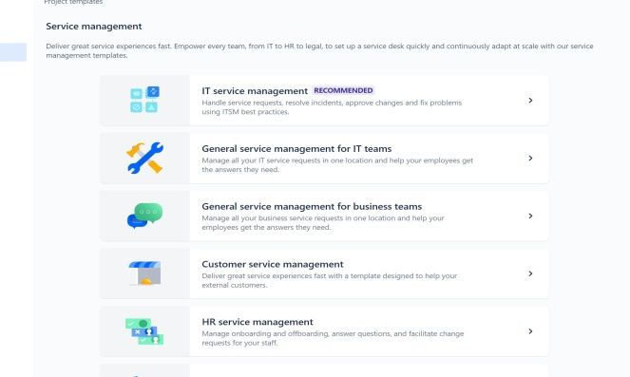 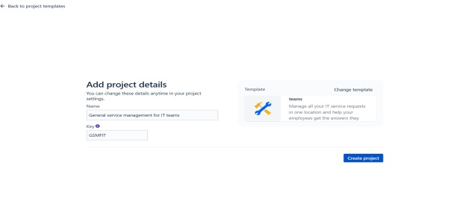

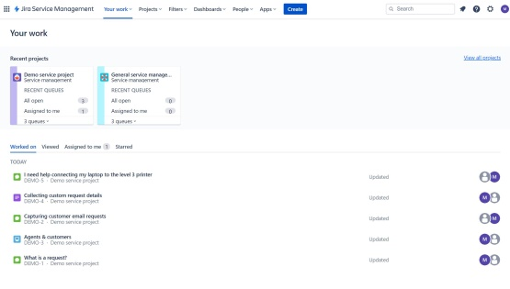

As we will login to service management it will go to project template where we need to select the desired template for our project. We choose general service management for IT team. After that we need to add project details like its name and its key. We can change the template type too if we want. Furthermore, we go to the page as shown in the screenshot where we can see demo if we are new to this tool. It has many opens like your work, projects, filters, documents, people and Apps.

**Jira Software:**

 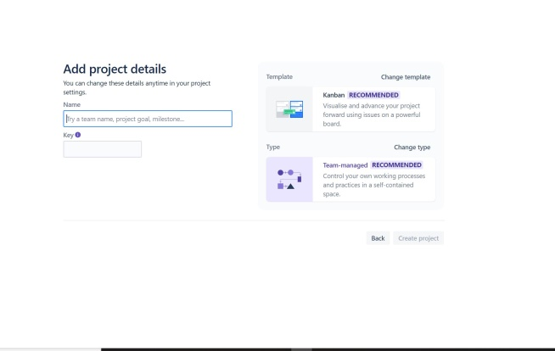

 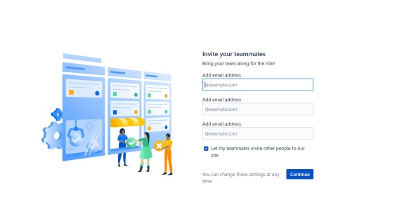

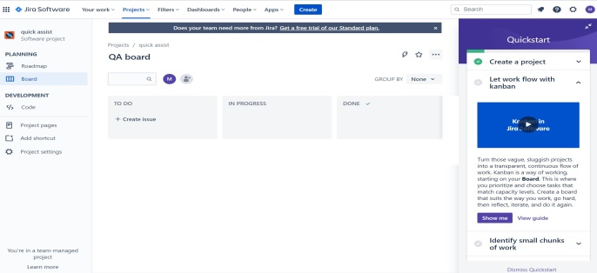

In Jira software as we sign in it ask for some knowledge to know if you are new to this tool or not. After that it will ask for project name and key and which sources can we use to ask our team members to connect and then enter there emails if we want to add more than 3 people we can invite them late too. We than comes to main page where we can access projects, filters, dashboard and many other options.

**Demonstration:**

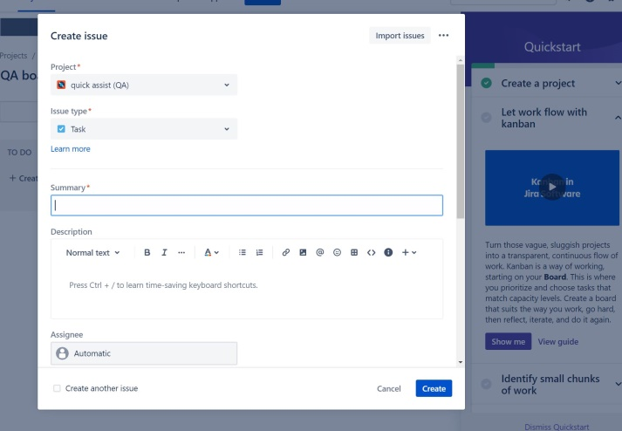 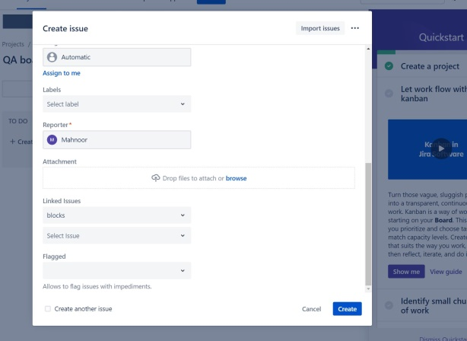

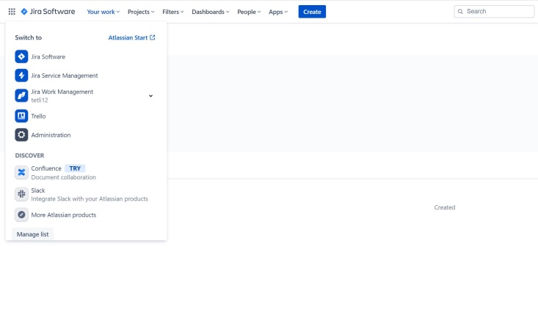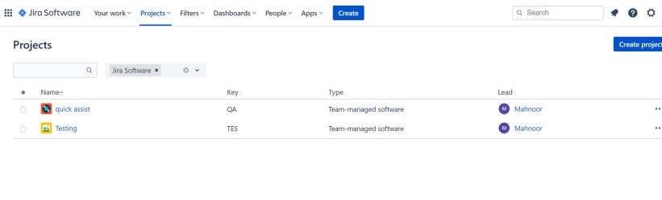

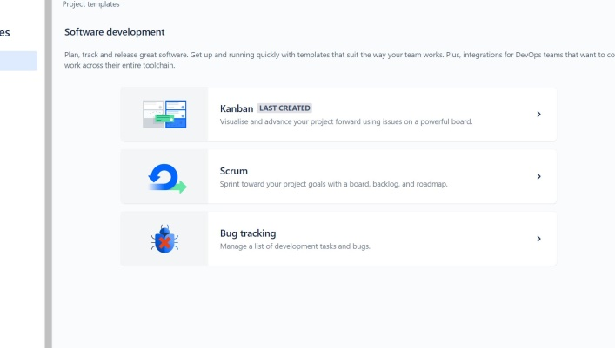 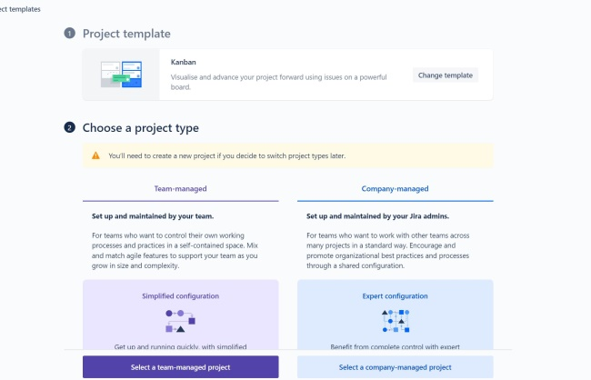

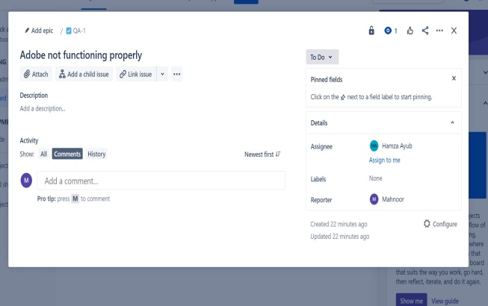

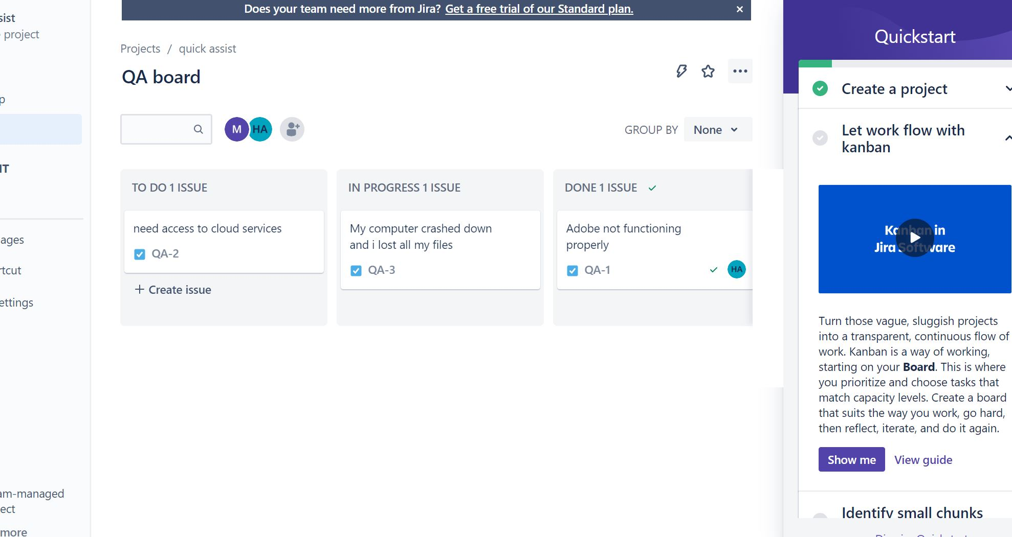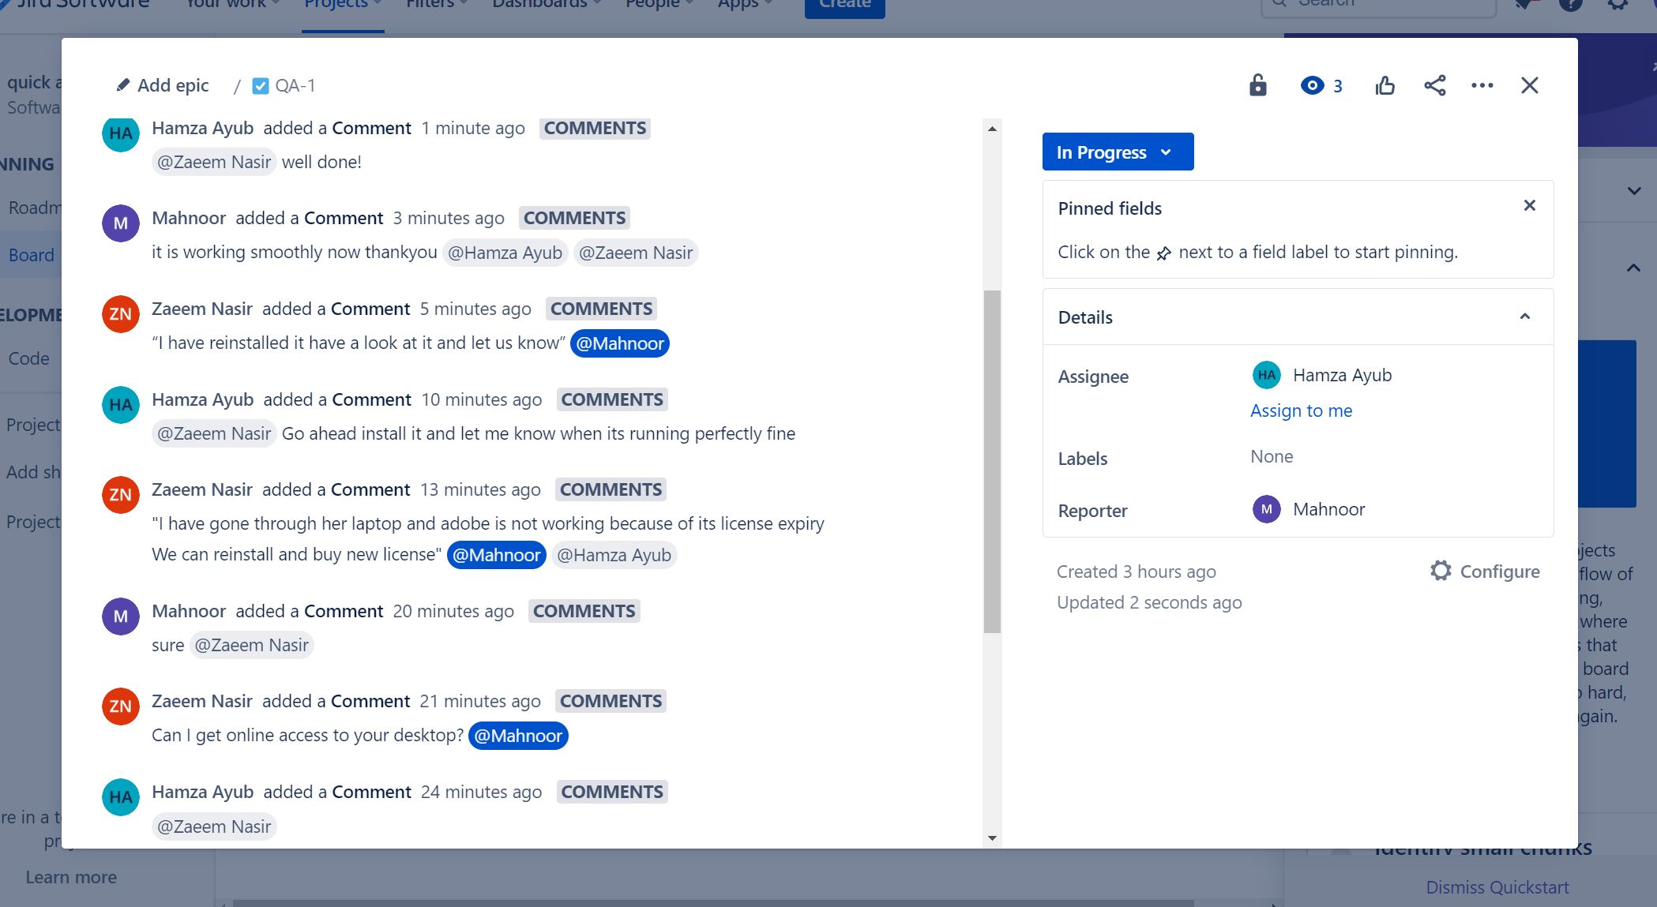

These screenshots shows how all this process will work. Once user will make project and assign certain task in Jira software tool it can be easily accessed in Jira service management. In the kanban members can see and ask for desired description of the task. Members can easily communicate in comments and attach files mention team members and later track activities that are going on.

**Team Members Contribution and Report:**

All team members Mahnoor, Zaeem and Hamza did all the work together by arranging meetings and discussing the process how jira works and how it can help us in different paths of our life. We decided not to divide the work but to do it collectively so we all know how each and every step is working and learn how to run Jira software and its service management tool.