

**NAME:** Mahnoor

**ROLL NO:** 231-450813

**INSTRUCTOR:** Saad bin Saleem

There are many different ways of unit testing the one I used is the “__main__” attribute one. When we execute a module as a standalone program, the attribute __name__ will be assigned the string ‘__main__’. If we imported the module from a python file in some other program then the __name__ attribute possesses the value of that python file.

Here are the screenshots of testing the programs.

**EVEN_ODD.PY**

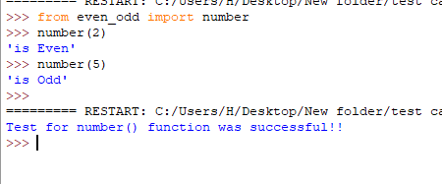

**LEAPYEARCAL.PY**

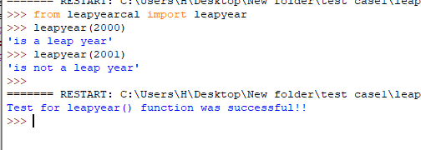

**LARGEST.PY**

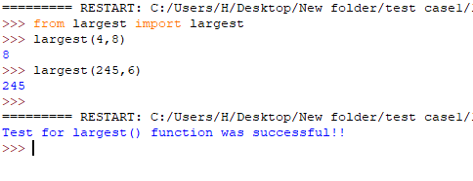

**NUMCHECKER.PY**

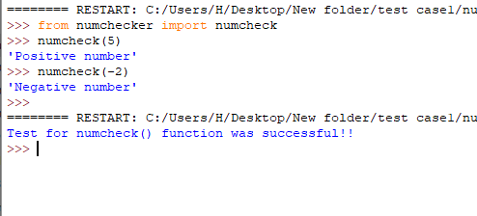

**PRIMENUMBER.PY**

