Konfydence Admin Panel — One-Page Specification
When an admin logs in, they should:
- Instantly understand the state of the business:
- How many B2C members?
- How many companies/schools?
- Are demos happening?
- Are leads coming in?
- Have obvious next steps:
- Add organization / Create package / Open leads / View demos.
- Never feel like the system is “broken”:
- Empty states always explain “why 0” and “what to do”.
- Use the sidebar as a clear map:
- Dashboard for overview
- Content for Cards + Packages
- Customers for Users + Organizations + Custom packages
- Sales & Analytics for revenue + demos
- CRM for Leads
- Settings for everything else
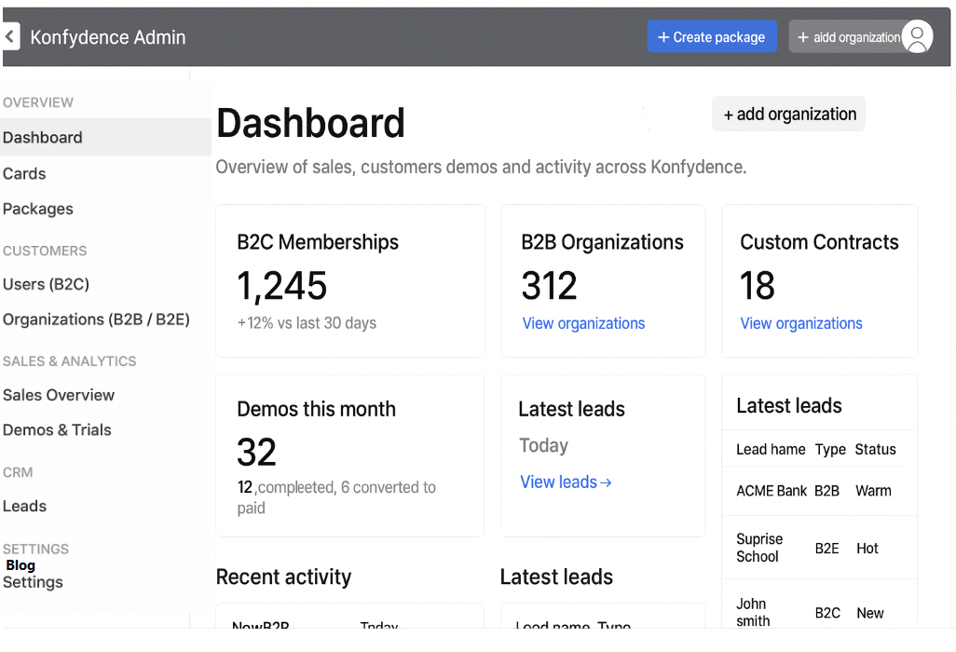
User roles should be defined
- Admin
- Editor
- Sales/CRM
- Read-only?

1. Information Architecture (Admin Menu)
Dashboard
Cards (Learning Content)
Packages (Standard & Custom)
Users (B2C)
Organizations (B2B & B2E)
↳ Custom Packages / Contracts
↳ Staff / Employees / Students
Sales & Memberships
Demos & Trials
Leads (B2B, B2E, Contact Forms)
Settings (Partner logos, integrations, branding)
2. Dashboard Requirements
The dashboard should summarize key metrics and link into deeper pages:
- B2C revenue / active memberships
- B2B revenue (companies)
- B2E revenue (schools)
- New leads (B2B / B2E)
- # of demos requested, started, completed
- Active custom contracts
- Latest activity (new signup, new lead, demo initiated, contract renewed)
Each metric displayed as a card with:
- Title
- Primary number
- Small trend indicator
- “View more” link
3. Cards (Learning Content)
Each “Card” = one learning unit / module.
Required Features
- Create / Edit / Delete / Replace
- Duplicate (clone)
- Toggle Draft / Published
- Tagging (skill, difficulty, customer type)
- Attach files (PDF, audio, video links content in different formats, because different clients (B2C, B2B, B2E) may require:
    - A short video
    - A PDF presentation
    - An audio commentary
    - A link to an external resource)
Data Fields
- Title
- Description
- Category
- Tags
- Target audiences (B2C / B2B / B2E)
- Visibility (public / internal / custom-only)
- Content attachments
4. Packages (Standard & Customizable)
4A. Standard Packages
These are what B2C buys or what B2B starts from.
Features
- Create / edit / archive
- Add/remove cards
- Pricing model (one-off, subscription, per-seat)
- Visibility control (public / hidden)
Fields
- Name
- Description
- Included cards
- Price or seat pricing
- Tags (e.g., “Compliance”, “Soft Skills”)
4B. Custom Packages (Per Organization)
Each organization (company, bank, school) can have its own custom package based on a standard one.
Features
- Clone from standard package
- Add/remove cards
- Custom pricing
- Contract term (start/end)
- Assign users
- Custom rules (e.g., “Completion = bonus eligibility”)

Fields
- Base package reference
- Custom modules added/removed
- Contract pricing
- Seat count
- Contract duration
- Assigned cohorts (employees, classes, etc.)
5. Users (B2C)
Features
- View profile
- Membership type
- Active packages
- Progress tracking
- Purchasing history
- Disable/enable account
Fields
- Name, email
- Membership type & expiry
- Completed cards/modules
- Engagement data
6. Organizations (B2B / B2E)
Features
- Create/edit organization entry
- Attach custom packages
- Manage staff/students
- Monitor progress & engagement
- Contract status tracking (active, expired)
Fields
- Organization name
- Sector (company, bank, school, government, etc.)
- Contact persons
- Seat limits
- Custom package(s)
- User list + progress
- Contract terms (price, seats, start/end)
7. Sales & Memberships
Central hub for viewing all transactions.
B2C
- Membership purchases
- Renewals
- Active/inactive status
- Customer value
B2B
- Company contracts
- Revenue per organization
- Seat usage
- Expiry reminders
B2E
- School contracts
- Class/teacher-level usage
- Enrollment metrics
8. Demos & Trials
Tracks demo usage across B2C, B2B, B2E.
Features
- Create demo types (which package/module is demoed)
- Track requests / uses / completions
- Identify “who used the demo”
- Conversion funnel
- Link demos to leads or users
Fields
- Demo type
- User or lead who requested
- Date started / completed
- Completion %
- Follow-up notes
9. Leads
Consolidate all lead types:
- B2B Leads
- B2E/SCHOOL Leads
- Contact Form Leads
Features:
- Add/edit leads
- Tagging (cold, warm, hot)
- Notes and internal discussion
- Convert lead → organization
- Integrate with demo requests
10. Settings
- Manage partner logos
- Admin users / roles
- Branding (logo, colors)
- Payment & subscription settings
- Optional: Integration keys (Stripe, CRM, LMS endpoints)

Definition: Hot / Warm / New Status
🔥 Hot Lead
A hot lead is a prospect who is very close to buying.
Indicators:
Requested a demo AND completed it
Asked for a quote or pricing
Engaged multiple times
Has an urgent need
Decision-maker is involved
Meaning:
You should follow up immediately — they are likely to convert soon.

🌤️ Warm Lead
A warm lead is interested, but not yet ready to purchase.
Indicators:
Filled out the contact form
Responded to initial outreach
Attended a webinar or partially used a demo
Expressed interest but has no set timeline
Meaning:
Nurture them — follow-up emails, share relevant packages, invite them to demos.

🟦 New Lead
A new lead is someone who has just entered your system and has not been contacted yet.
Indicators:
Just submitted a form
Added manually
Imported list
No follow-up has happened yet
Meaning:
They need to be contacted for the first time.

