**Mahnoor Hassan**

**SEO hands on exercise 1 batch 6**

**Task 1: Create an account on Google ads and go to keyword planner tool**

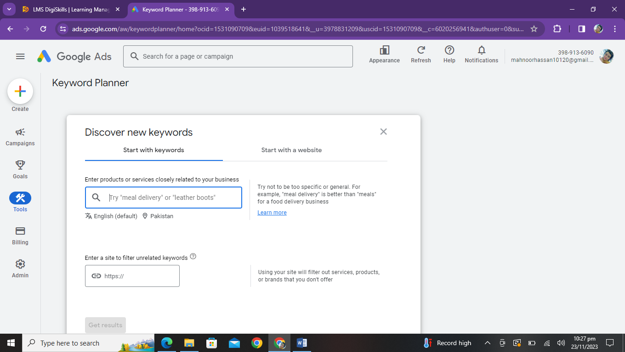

**Task 2 : Search keywords related to the above scenario.**

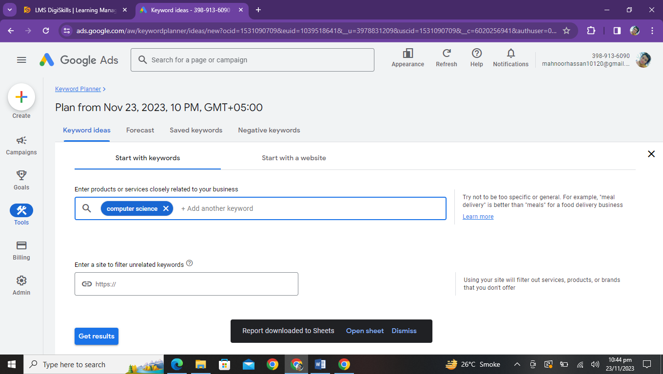

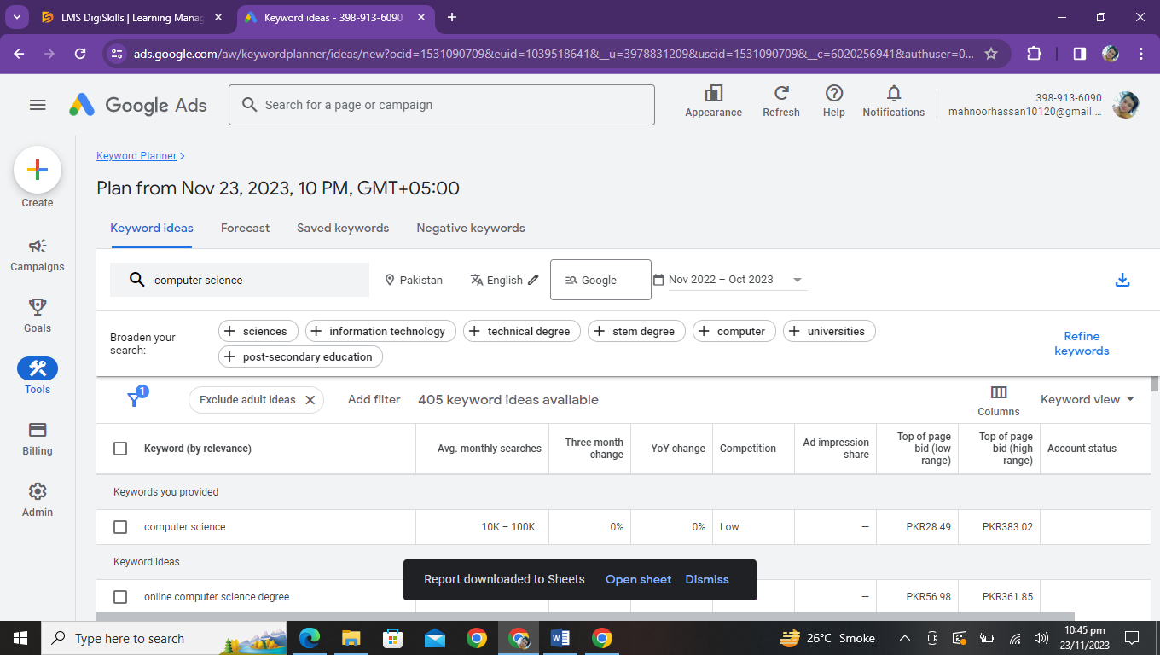

**Task 3: Apply the keyword filter of “Computer science degree**

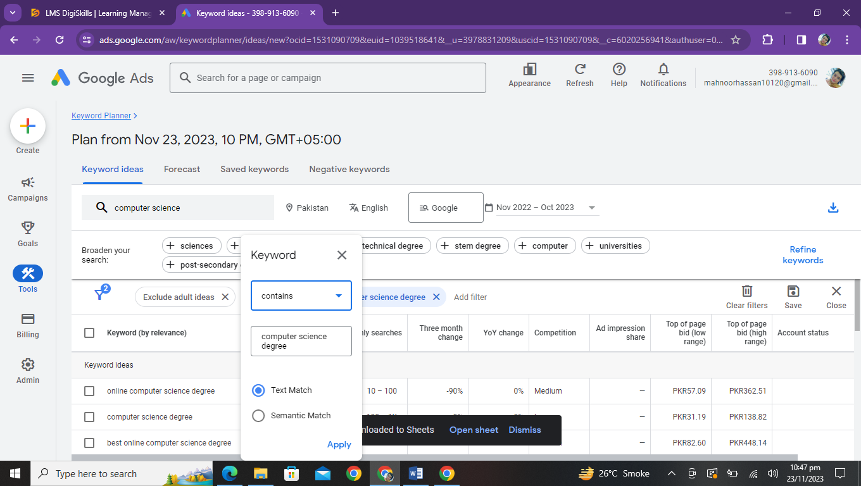

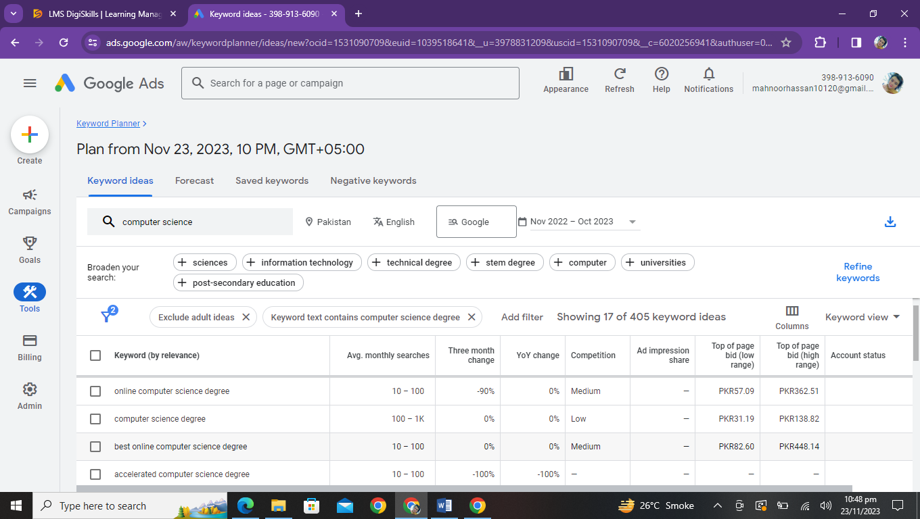

**Task 4: Refine the keywords with the option of “Universities”**

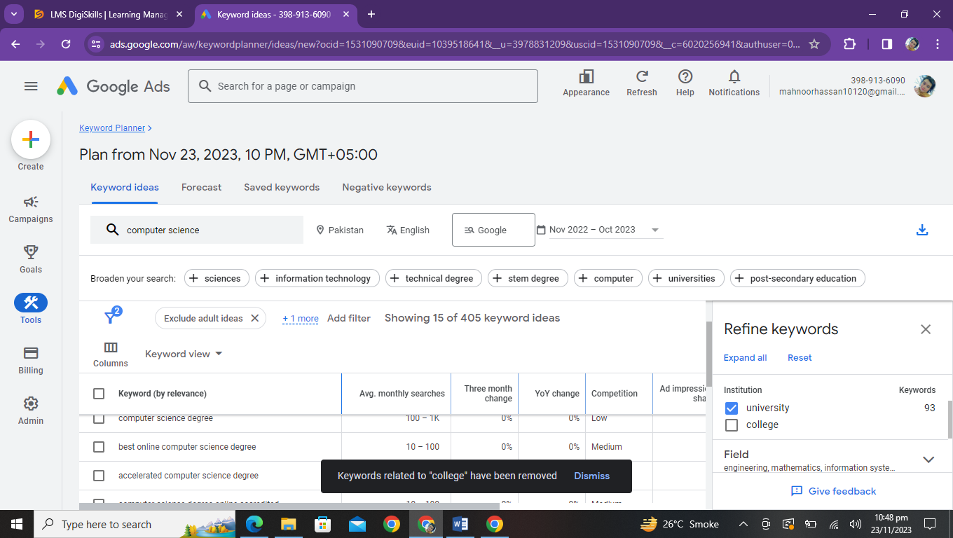

**Task 5: Highlight 5 keywords related to the computer science degree having minimum traffic of 100 per month.**

