University of Sialkot
Department of Software Engineering
Semester Project – Deliverable 1
(Client-Side Architecture)
Project Title: Academic CGPA Management Portal

Student Name: | Mah Noor Javed, Iqra Safdar
Student Roll Number: | 23010101-027, 23010101-020
Course: | Semester Project
Instructor: | Museb Khalid
Submission Date: | July 1, 2026

1. Introduction
The Academic CGPA Management Portal is a web-based utility application designed to simplify the process of tracking and calculating academic performance. In modern educational structures, managing and predicting Cumulative Grade Point Averages (CGPA) manually can be complex and prone to errors. This project addresses that challenge by providing a clean, responsive, and intuitive dashboard where students can seamlessly configure individual semester parameters, input their specific Grade Point Averages (GPA), and define credit hours to compute final statistics instantly.
2. Project Overview & Technology Stack
Project Overview
The core objective of this application is to deliver a real-time, lightweight dashboard for academic grade management. The user interface features a dual-navigation layout containing a Dashboard for live calculations and a Calculation History section for tracking past data. Users can dynamically add new semester rows, input their GPA along with the respective credits, or remove semesters using an interactive interface.
Technology Stack
Framework: Vue.js (v3) – Used as the primary progressive framework to build a component-based reactive user interface via the Composition API.
Build Tool: Vite – Employed as the local development server and build tool to achieve near-instant hot module replacement (HMR) during execution.
Styling Engine: Custom CSS3 – Written with structured flexbox alignments, smooth transitions, and a clean color palette (featuring an active orange branding hierarchy) for an aesthetic look.
Version Control: Git & GitHub – Used for tracking development changes, committing codebase milestones, and hosting the final repository online for version deployment.
3. System Architecture
Component Architecture Tree
This tree diagram illustrates the runtime relationship and layout connection between the functional frontend components and the overall folder configuration:
[ Root: App.vue ] (Main Entry Point & Shared Navbar)
│
├─── [ Component: Navbar / Header ] (Persistent Navigation)
│ ├── Dashboard Link (Routes to DashboardView)
│ └── Calculation History Link (Routes to HistoryView)
│
└─── [ Router View: <router-view> ] (Dynamic Content Window)
│
├───► [ View: DashboardView.vue ] (Active Calculation Engine)
│ │
│ ├─── [ Sub-Component: SemesterRow ] (Dynamic Input Rows)
│ │ ├── GPA Input Field
│ │ └── Credits Input Field
│ │
│ └─── [ Action Controls ]
│ ├── Add Semester Button
│ └── Calculate CGPA Button
│
└───► [ View: HistoryView.vue ] (Stored Calculation Module)
Description of Architecture Components
App.vue (Core Wrapper): This is the main parent element of the application. It hosts persistent UI items like the CGPA Management Portal Header (Navbar) which stays consistent across view switches.
Vue Router (<router-view>): Acts as the dynamic viewing center of the single-page layout. When an anchor tab is triggered, the router targets the current window partition and swaps components without forcing a manual page reload.
DashboardView.vue (Core UI Page): The core calculation workspace containing operational functions and dynamic array manipulation logic.
Input Sub-Components (SemesterRow.vue): Reusable structural units bound to dynamic loop cycles, allowing users to safely manage runtime key arrays across customizable value forms.
4. Single Page Application Routing
Navigation within the portal is managed client-side using Vue Router 4. This ensures instantaneous transition periods between the primary workspace configurations.
// src/router/index.js
import { createRouter, createWebHistory } from 'vue-router'
import DashboardView from '../views/DashboardView.vue'
import HistoryView from '../views/HistoryView.vue'
const routes = [
{ path: '/', name: 'dashboard', component: DashboardView },
{ path: '/history', name: 'history', component: HistoryView }
]
const router = createRouter({
history: createWebHistory(import.meta.env.BASE_URL),
routes
})
export default router
5. Inter-Component Communication (Props & Emits)
To implement clean, decoupled application logic, state changes and configurations pass tracking information down to nested sub-layers using structured Props, while reactive data upscales back to central repositories via custom Emits.
5.1 Props Implementation (SemesterRow.vue)
The child component below accepts contextual parameters from the dashboard wrapper view and registers custom modification triggers upon immediate user action:
<!-- src/components/SemesterRow.vue -->
<script setup>
import { defineProps, defineEmits } from 'vue'
const props = defineProps({
semester: { type: Object, required: true },
index: { type: Number, required: true }
})
const emit = defineEmits(['update-semester', 'remove-semester'])
const onInputChange = () => {
emit('update-semester', {
index: props.index,
gpa: props.semester.gpa,
credits: props.semester.credits
})
}
const deleteRow = () => { emit('remove-semester', props.index) }
</script>
<template>
<div class="semester-row">
<span class="semester-label">Semester {{ index + 1 }}</span>
<input type="number" v-model.number="semester.gpa" @input="onInputChange" placeholder="GPA" min="0" max="4" step="0.01"/>
<input type="number" v-model.number="semester.credits" @input="onInputChange" placeholder="Credits" min="1"/>
<button @click="deleteRow" class="delete-btn">Delete</button>
</div>
</template>
5.2 Emits & Central Computation (DashboardView.vue)
The container page captures structural lifecycle streams tracking values upward, keeping local records structured dynamically within the primary application engine:
<!-- src/views/DashboardView.vue -->
<script setup>
import { ref } from 'vue'
import SemesterRow from '../components/SemesterRow.vue'
const semesters = ref([{ gpa: null, credits: null }])
const cgpa = ref(null)
const addSemesterRow = () => { semesters.value.push({ gpa: null, credits: null }) }
const handleSemesterUpdate = (data) => {
semesters.value[data.index].gpa = data.gpa
semesters.value[data.index].credits = data.credits
}
const removeSemesterRow = (index) => {
if (semesters.value.length > 1) semesters.value.splice(index, 1)
}
const calculateCGPA = () => {
let totalPoints = 0, totalCredits = 0
semesters.value.forEach(sem => {
if (sem.gpa !== null && sem.credits !== null) {
totalPoints += (sem.gpa * sem.credits)
totalCredits += sem.credits
}
})
cgpa.value = totalCredits > 0 ? (totalPoints / totalCredits).toFixed(2) : 0
}
</script>
6. Application Screenshots
The following section reserves slots for visual verification fields tracking localized workspace containers. Please insert your component output frames directly under each figure description below.
Figure 1: Initialized application dashboard container screen view
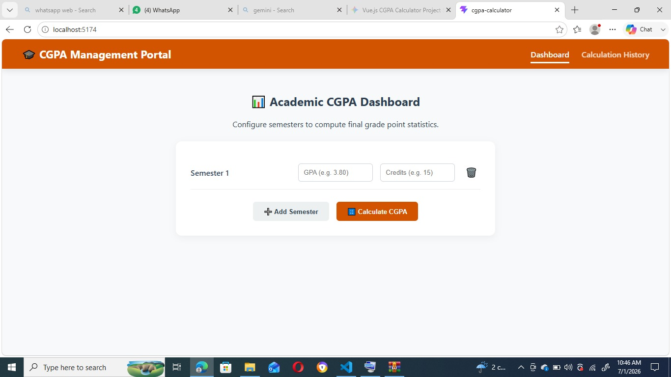

Figure 2: Active operational dashboard tracking multi-row calculations
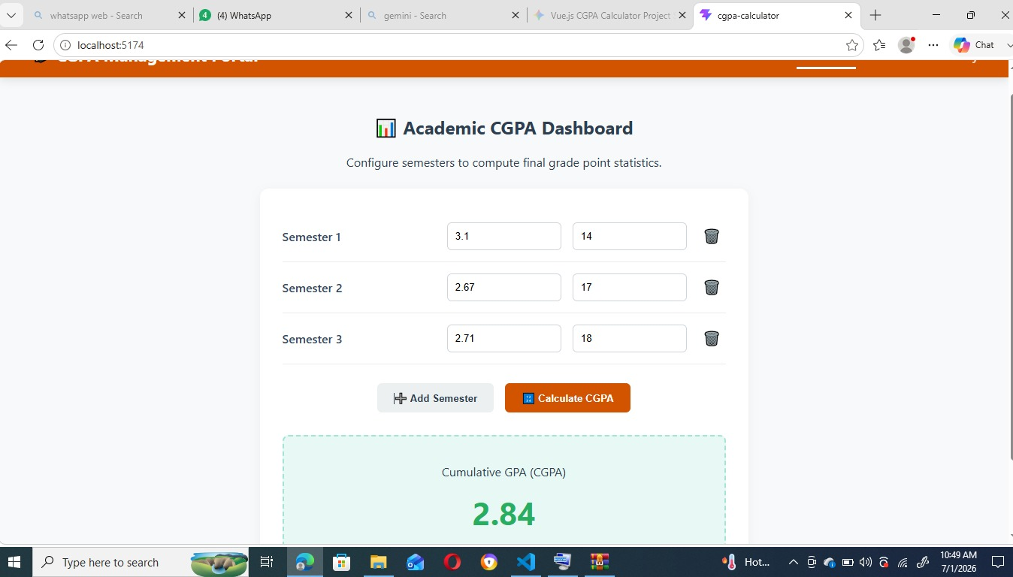

Figure 3: Core historical logging system overview screen
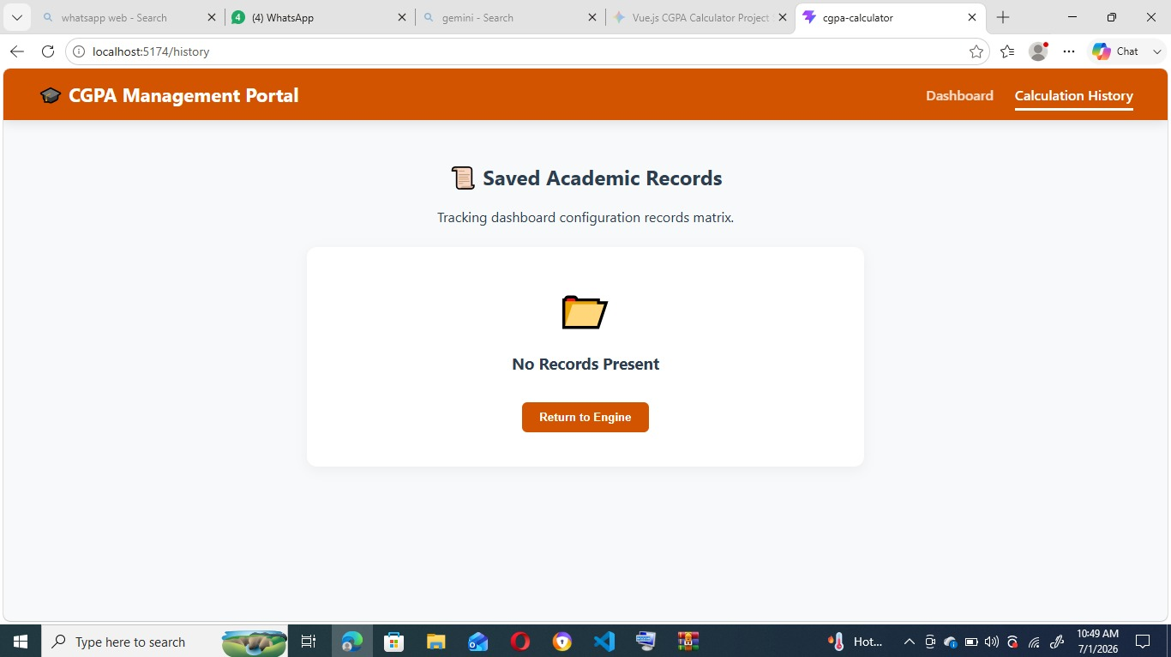
7. Conclusion
The Academic CGPA Management Portal successfully demonstrates the power of building modern, lightweight, and reactive Single Page Applications (SPAs) using Vue.js 3 and Vite. By utilizing core framework design patterns such as modular component separation, unified dynamic routing via Vue Router, and clean parent-child data syncing through Props and Emits, the system delivers a fast and fluid user interface.
The application successfully eliminates traditional page-reload lag, ensuring instant real-time CGPA calculations while keeping a completely tracking-ready interface layout. Hosted and managed efficiently using Git and GitHub, this project stands as a fully scalable baseline that can easily be expanded in the future with custom database integrations or permanent cloud storage solutions for worldwide student access.

