Table of Contents
1. Contract Deployment 2
2. Contract Deployment Shown On MetaMask 3
3. Contract Deployment Details on Remix 3
4. Contract Verification on Remix 4
5. Contract Verification Etherscan 5
6. Contract Verification Etherscan with Source Code Verified 5
7. MetaMask Connecting to UI 6
8. UI (1) 6
9. UI(2) 6
10. Interaction to Post Message 7
12. Interaction showing new message posted 8
13. Interaction to Like Message 8
14. Interaction after message is liked 9
15. All transaction on MetaMask 10
16. Transactions shown on Etherscan 11

1. Contract Deployment

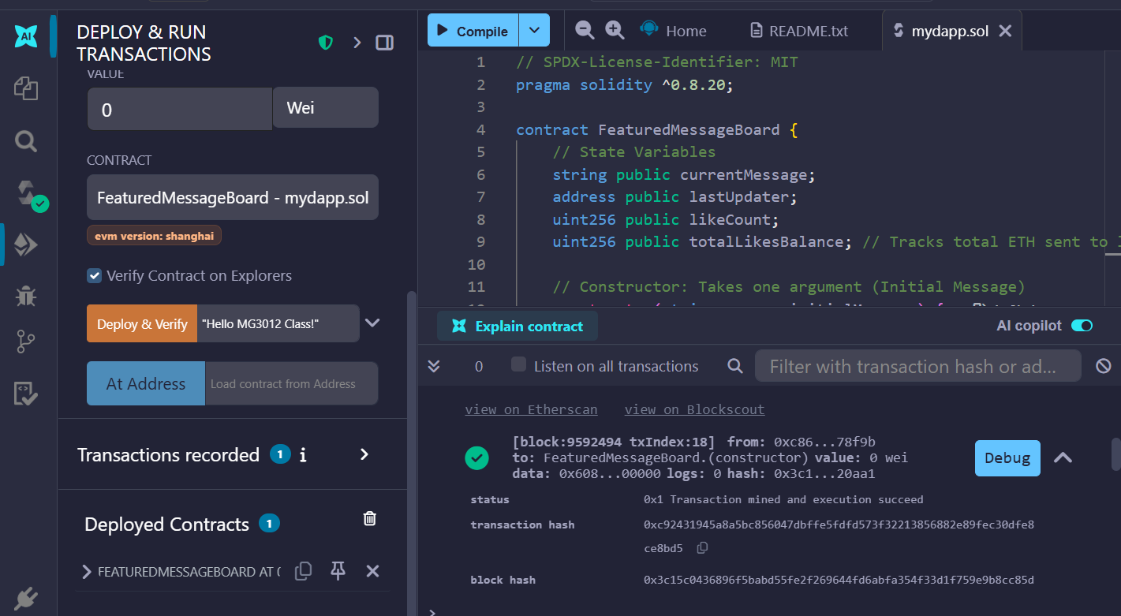

2. Contract Deployment Shown On MetaMask
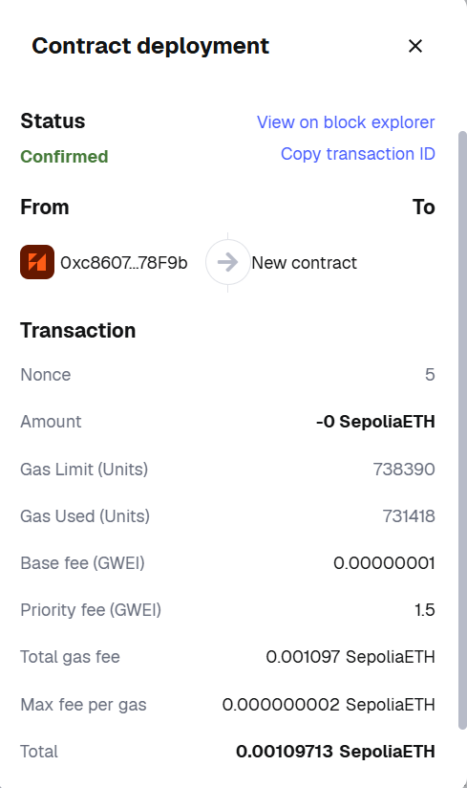

3. Contract Deployment Details on Remix
status | 0x1 Transaction mined and execution succeed
transaction hash | 0xc92431945a8a5bc856047dbffe5fdfd573f32213856882e89fec30dfe8ce8bd5
block hash | 0x3c15c0436896f5babd55fe2f269644fd6abfa354f33d1f759e9b8cc85df20aa1
block number | 9592494
contract address | 0x0e7770f45c15c9562362d9f8302c64d0f8ad8b1f
from | 0xc8607E772dDB4245CC94c5F65719E99977178F9b
to | FeaturedMessageBoard.(constructor)
gas | 738390 gas
transaction cost | 731418 gas
input | 0x608...00000
decoded input | { "string initialMessage": "Hello MG3012 Class!" }
decoded output | -
logs | []
raw logs | []

4. Contract Verification on Remix
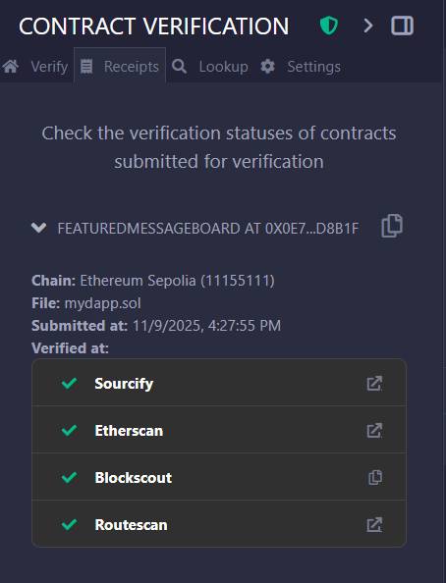

5. Contract Verification Etherscan
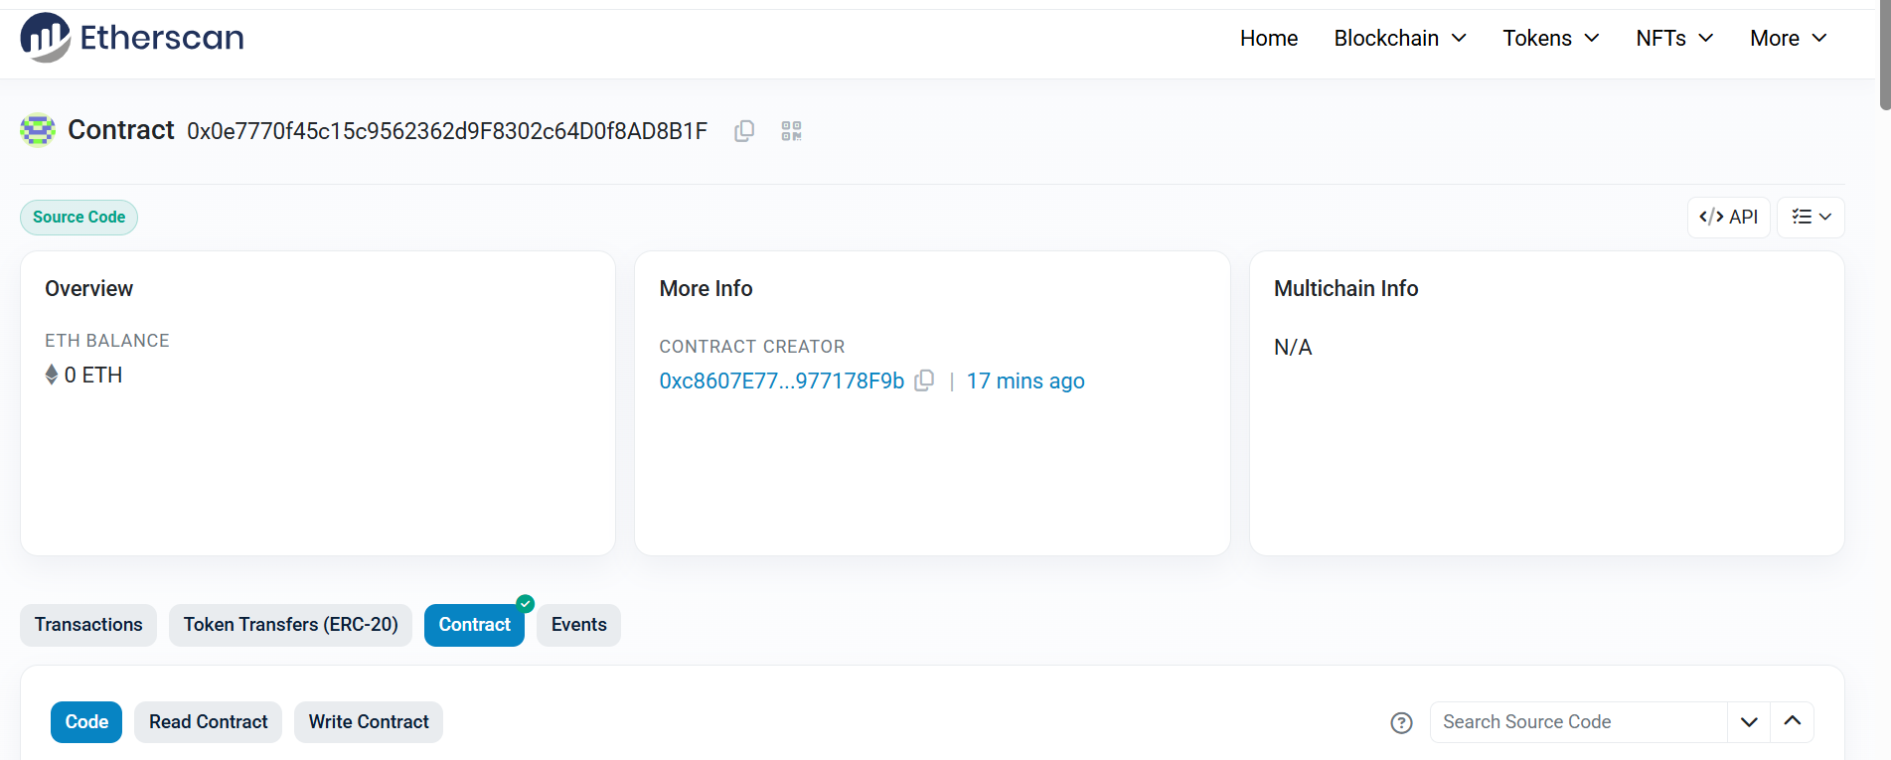

6. Contract Verification Etherscan with Source Code Verified
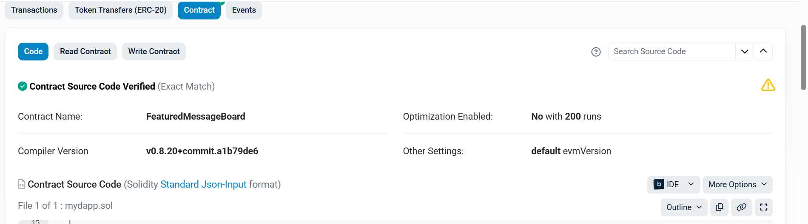

7. MetaMask Connecting to UI
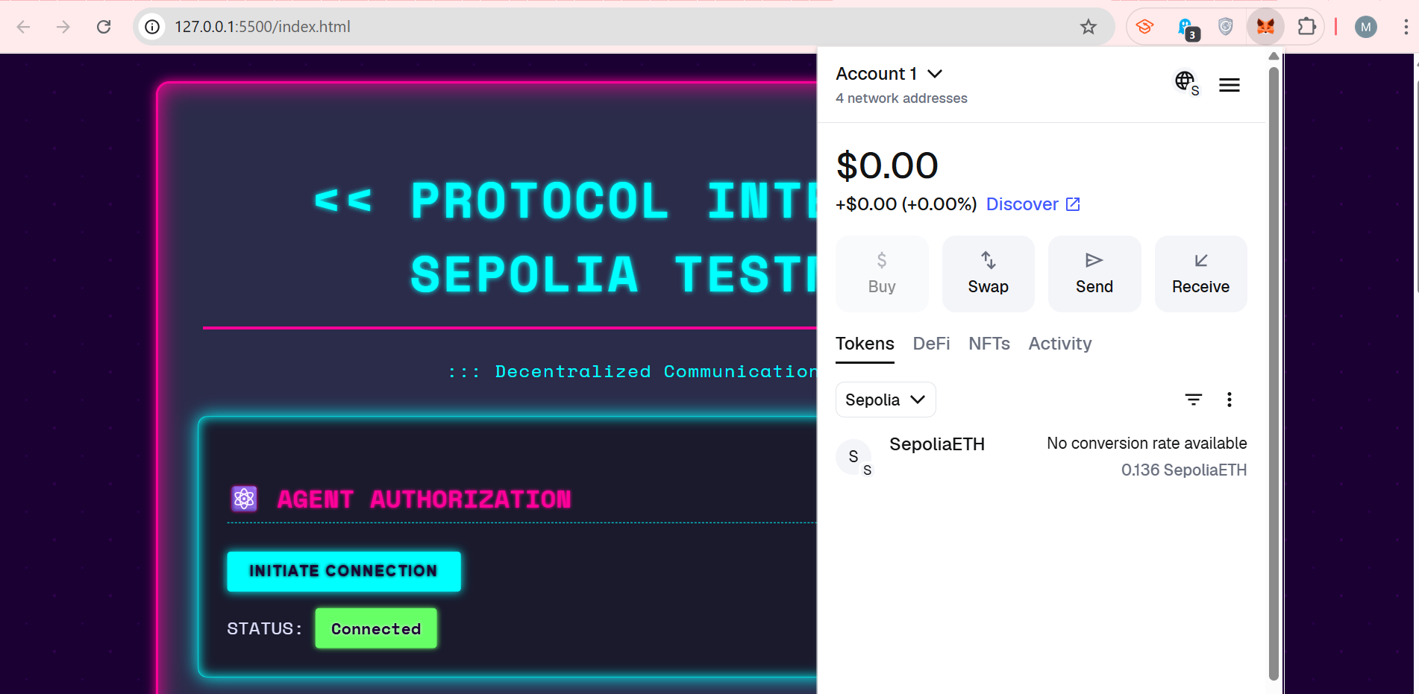

8. UI (1)
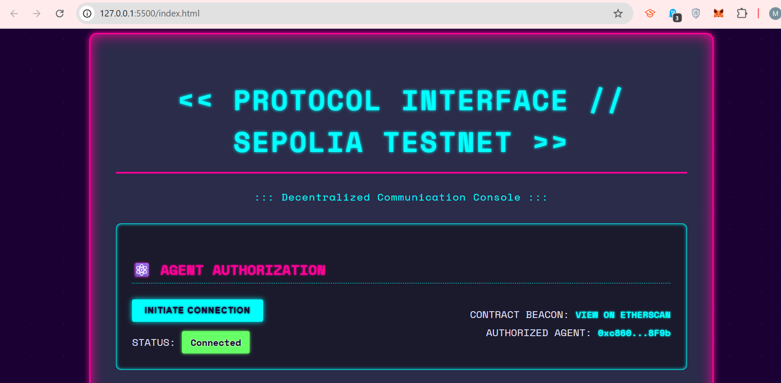

9. UI(2)

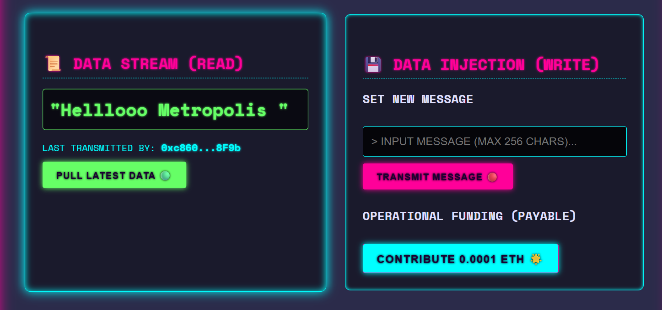

10. Interaction to Post Message
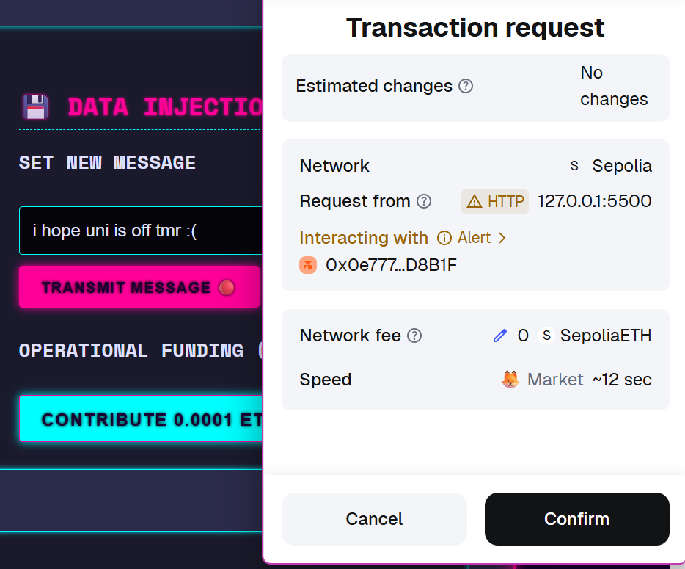

12. Interaction showing new message posted
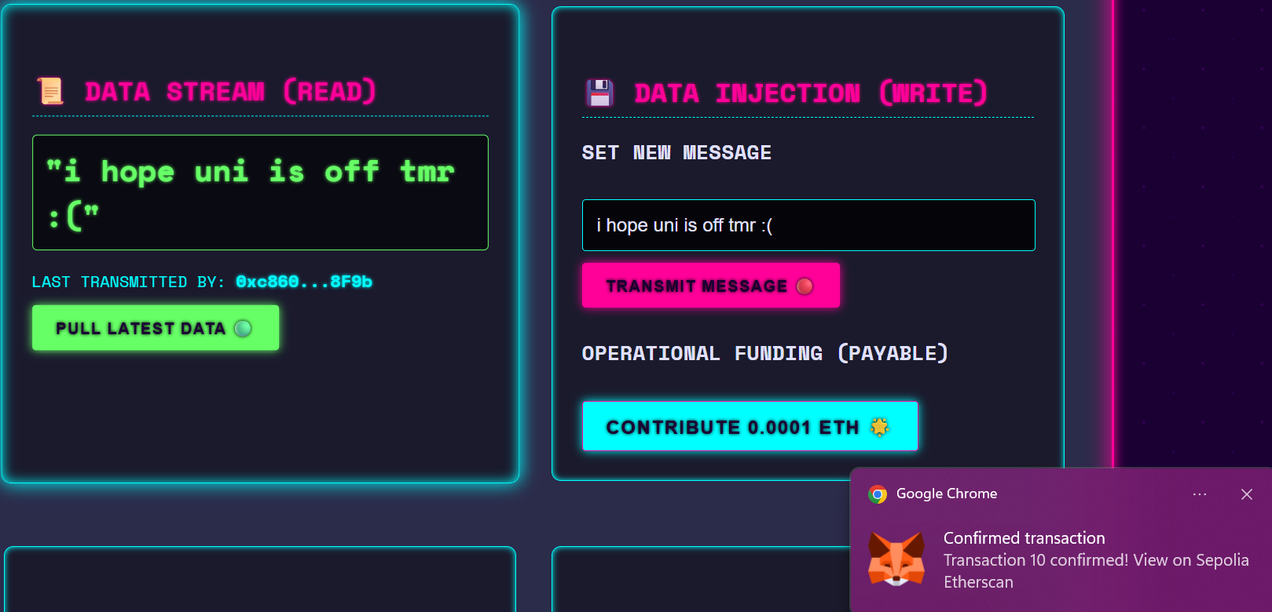

13. Interaction to Like Message
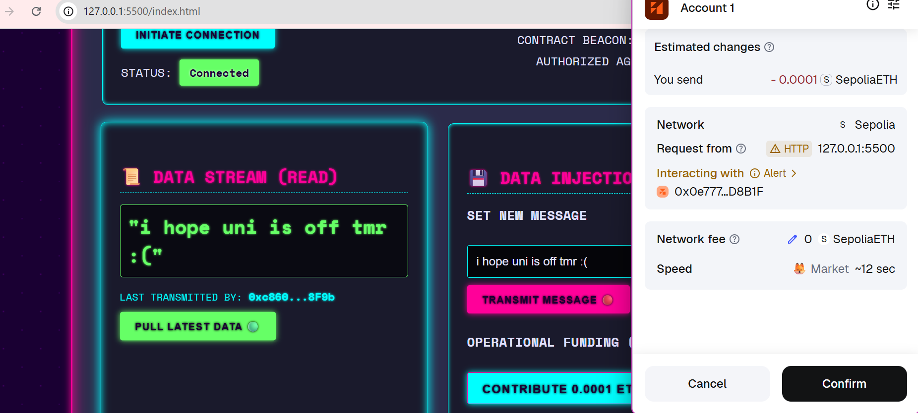

14. Interaction after message is liked

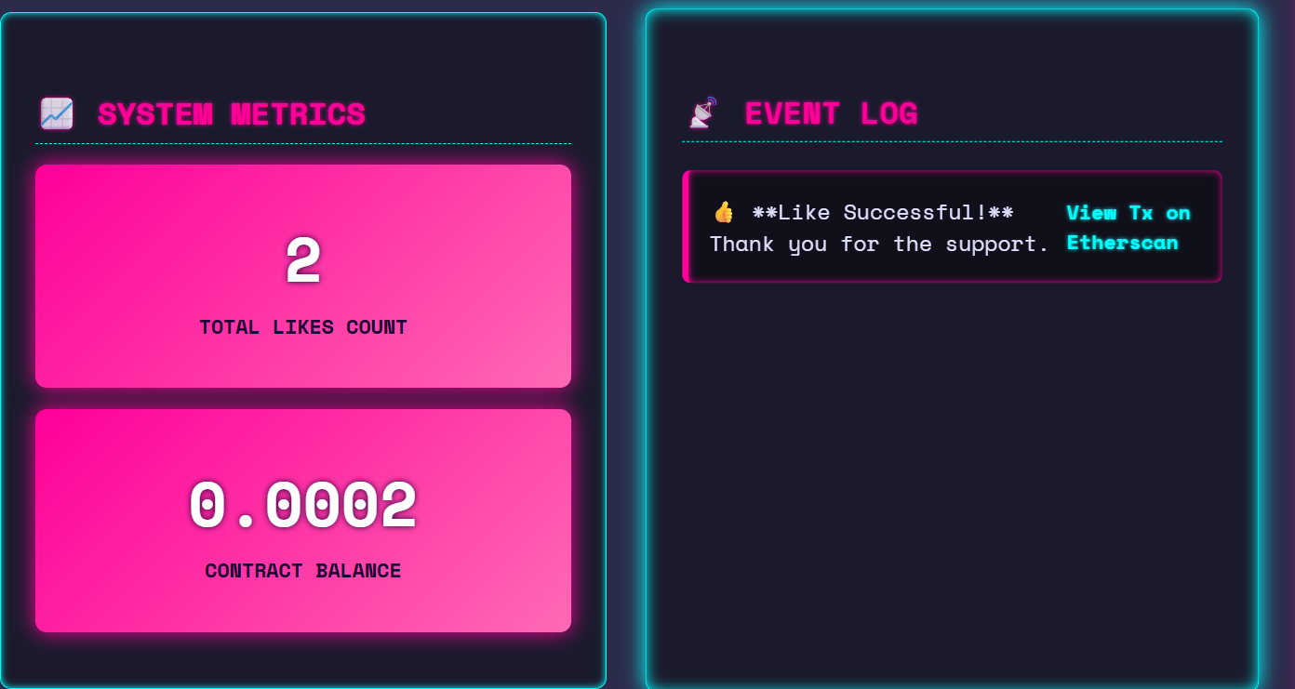

15. All transaction on MetaMask
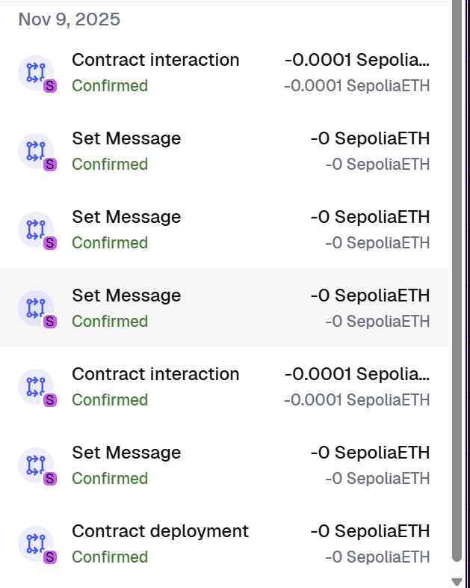

16. Transactions shown on Etherscan
