Comparing Data-Driven and Physics-Informed Neural Networks
Main finding: the physics-informed model had slightly lower test error. Both models have limited original-scale accuracy; this comparison does not isolate the physics penalty’s effect or validate the physical law.

1. Data and evaluation design
Item | What we did
Dataset | 1,865 observations; both prediction networks use all nine features, x1–x9. ID is only an identifier.
Data quality | No missing/nonfinite values or duplicate IDs. All observations, including extreme values, were retained.
Repeated inputs | Six matching-input pairs: two share y, four have different y. All rows were kept; each pair stays together in every split.
Holdout split | Seed 42; 1,493 training / 372 testing rows (80.05% / 19.95%). Grouping explains the small departure from 80/20.
Validation | The same five grouped folds for both models; validation sizes 298, 298, 300, 300, 297. Preprocessing is fitted on each fitting fold only; the test set is excluded from tuning.
Preparation: compare raw inputs with log10(x1, x2, x4, x5, x6), then standardize. These inputs are positive; zero-valued features are not logged. The target is log10(y), reflecting its wide range (about 0.000075–46.86). Outputs are converted back with 10^z, ensuring positive predictions. Invalid numerical outputs raise errors; nothing is silently clipped.

2. Search choices and selected models
Search choice | Candidate values | Reason
Prediction network | 1–3 layers; width 16/32/64; ReLU/tanh | Compare modest capacities for nine inputs.
Adam learning rate | 0.0003 / 0.001 / 0.003 | Explore slower and faster updates.
Batch size; L2 | 32/64/128; 0/1e−5/1e−4/1e−3 | Balance update frequency and overfitting.
Input representation | Selected logs off/on | Test compression, especially for x2 and x4.
Exponent network | Tanh: (8), (16), (16,8); inputs x1–x2/all | Limit flexibility; test additional inputs.
Physics weight λ | 0.01 / 0.1 / 1 / 10 | Compare weak and strong equation penalties.
Budget: seed-42 random sampling without replacement; 20/1,296 data-driven and 20/72 physics candidates, each over five folds (200 fits). Physics keeps the selected prediction backbone, batch size, L2, and input transform fixed. Choose the lowest mean validation RMSLE. Early stopping: at most 1,000 epochs; patience 50; minimum improvement 1e−5. Retain the lowest-score checkpoint. L2 penalizes weights, not biases; no separate weight decay is used.
Selected setting | Data-driven | Physics-informed
Prediction network | 16 → 16 → 16, ReLU | Same prediction backbone
Rate / batch / L2 | 0.003 / 64 / 0.001 | 0.003 / 64 / 0.001
Transforms | Selected logs + standardization; log10(y) | Same
Exponent / physics weight | Not applicable | One 16-neuron tanh layer; x1–x2; λ=0.01

3. How physics enters training
The equation is y_phys = x2² / [72.2 × x1^(−m)]. A second network learns a separate m for each sample, jointly with the prediction network. Softplus enforces m>0. At inference, m uses features alone, never observed y. Features x3–x9 influence the prediction branch.
Using original units: z_phys = 2 log10(x2) − log10(72.2) + m log10(x1), where z = log10(predicted y). Minimize data MSE in log10(y) + λ × mean[(z − z_phys)²] + L2. Equation equivalence and gradient flow to both networks and m were checked. Exponents are learned during training, not prescribed or fitted afterward.

4. Training and validation evidence
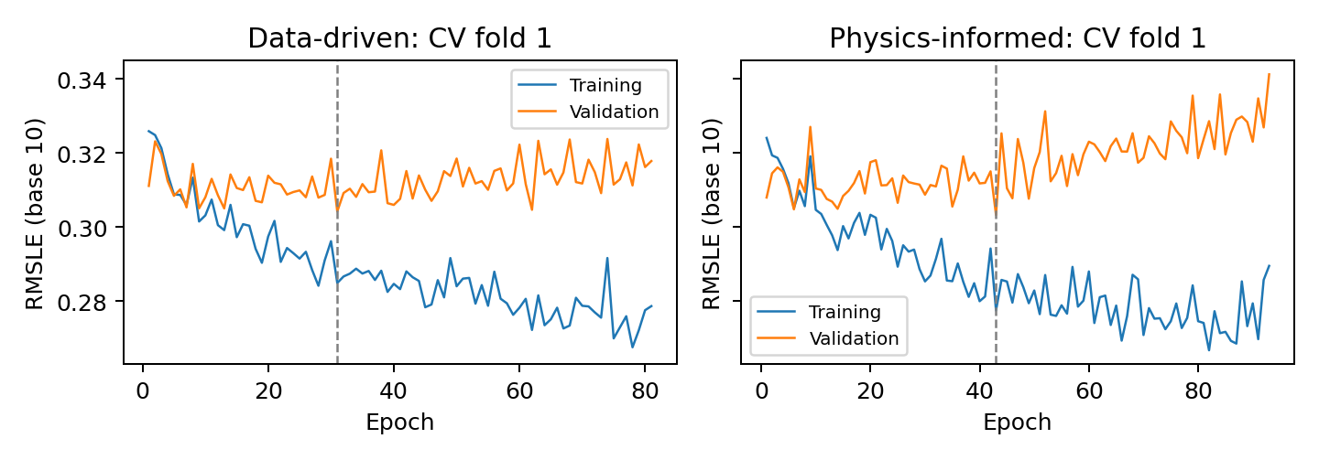
Figure 1. Training and validation RMSLE for preselected fold 1 of each selected model. Dashed lines mark retained epochs. Curves stop at actual early stopping. All five folds are included in supporting outputs; test error is never plotted against epoch.
Selected model | Validation RMSLE mean | Fold standard deviation
Data-driven | 0.299685 | 0.016474
Physics-informed | 0.298574 | 0.015089
Each summary uses five folds; SD uses ddof=1. These scores were used for selection and are not independent test estimates. Fold seeds are 42 + fold number.

5. What the exponent learned
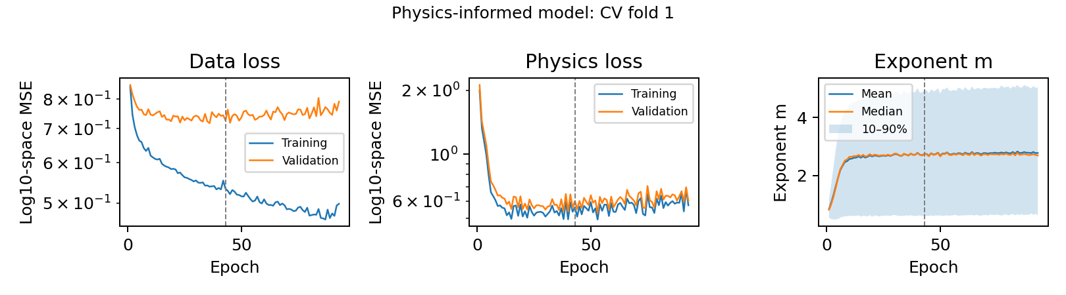
Figure 2. Physics-informed fold 1: separate data/physics losses and m evolution on fixed fitting-fold inputs. The shaded band is the sample 10th–90th percentile, not uncertainty. Dashed lines mark the retained epoch. Final-refit diagnostics are also saved.
Because m varies by sample, report its final distribution rather than one global value. Each sample’s learned m is saved with its ID; held-out values are generated from inputs alone.
Final model inputs | Mean m | Median m | SD | 10th–90th percentile
Training | 2.843 | 2.718 | 1.723 | 0.649–5.296
Testing | 2.959 | 2.958 | 1.652 | 0.768–5.419

6. Runtime and final refitting
Model | 100 CV fits | Full-training refit
Data-driven | 293.20 s | 78 epochs; 1.29 s
Physics-informed | 546.87 s | 116 epochs; 2.67 s
About 14 minutes of CV training on one CPU thread, using deterministic algorithms; installation and smoke tests excluded. One nonselected physics-informed fold reached 1,000 epochs; selected folds did not. Refit durations are the median selected CV best epochs. Fresh models and scalers use all 1,493 training rows, seed 42, with no validation/test monitoring. Both models were fixed before testing and were not adjusted afterward.

7. Final predictive results
Model | Training R² | Training RMSLE | Testing R² | Testing RMSLE
Data-driven | 0.0896 | 0.2808 | 0.1803 | 0.2855
Physics-informed | 0.1886 | 0.2725 | 0.2082 | 0.2810
Higher R² and lower RMSLE are better. R² = 1 − SSE/SST uses original-scale residuals, not squared correlation. Base-10 RMSLE = √mean[(log10(1+ŷ) − log10(1+y))²]. This +1 convention differs from the log-target training loss.
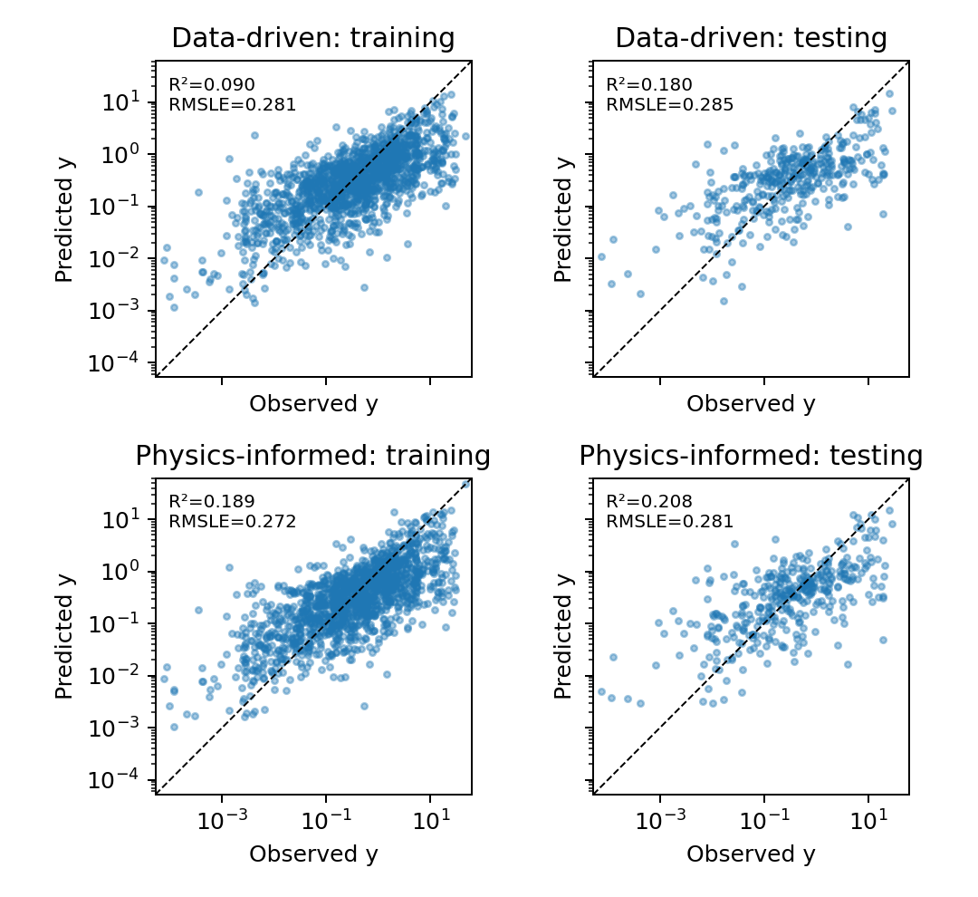
Figure 3. Final predictions: training and testing for both models. All panels use common logarithmic limits and a 1:1 line. Training predictions are in-sample; testing predictions are held out.

8. Interpretation and limitations
- Prediction limits: the physics-informed model has test RMSLE 0.2810 versus 0.2855, but both test R² values remain low. Small targets are often overpredicted and large targets underpredicted. The log(y) training loss and log(1+y) selection score emphasize errors differently; one split gives limited evidence.
- Approximate physics: agreement RMSE is 0.7838 (training) and 0.7075 (testing), in log10 units. The selected λ=0.01 is weak. Since x1<1 and m>0, the equation requires y_phys<x2²/72.2; 359/1,493 training observations exceed that bound and were retained.
- Evidence limits: m and the predictor can co-adapt; the added branch and optimization changes are not isolated, so a causal benefit of physics is not established. Twenty candidates and one seed per fold limit robustness; fold SD is not a confidence interval. Matched-λ studies, repeated seeds, and simple baselines remain future work.

Reproduction and disclosure
Reproduce with Database.xls, the notebook, README.md, and requirements.txt. Supporting files contain partitions, settings, fold records, final models, ID-linked predictions/m, and figures. Sources: supplied challenge/workbook and listed software libraries. OpenAI Codex assisted with code, execution, interpretation, figures, and writing. The author must verify and understand all submitted work.

