Assignment 01 — Solution
Gitea • Multiple Git Remotes • Git LFS • GitHub Pages
Student Name | Mahnoor Khan
Registration No. | FA24B1-SE-012
GitHub Username | mahnoorkhan5376
Assignment | Assignment01 — Gitea, Git Remotes, Git LFS & GitHub Pages
Deadline | 10 October 2026

Task 1: Install Gitea and Push a Repository from the Ubuntu Server

Step 1.1: Install and Run Gitea on the Ubuntu Server
Docker Engine, curl and the Docker Compose plug-in were installed on the Ubuntu server. The instructor's Gitea repository was cloned and Gitea with PostgreSQL was started using the unchanged compose.yaml.
cd ~/Gitea
docker compose up -d
docker compose ps
curl -sS -o /dev/null -w "Gitea HTTP status: %{http_code}\n" http://127.0.0.1:3000/
Result: both containers (gitea and gitea_db) are running and Gitea returned HTTP status 200.
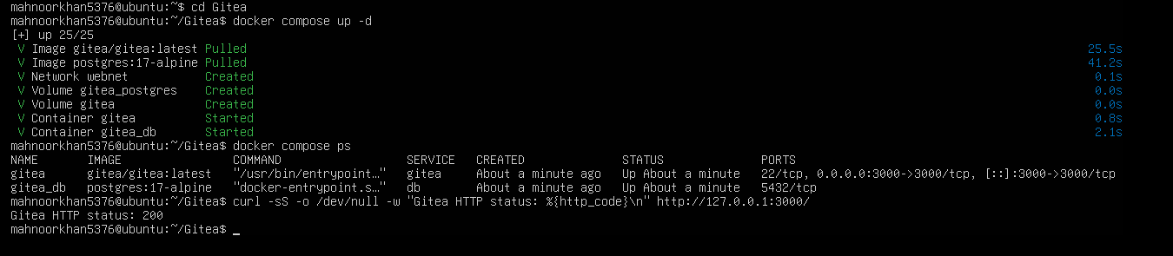
Screenshot: task1_gitea_running.png — Gitea and PostgreSQL running, HTTP status 200

Step 1.2: Create and Push the Initial Repository
An empty public repository named Assignment01 was created in Gitea. On the Ubuntu server a separate local repository was created with a README.md containing my name and registration number, committed, and pushed to Gitea using a personal access token entered at the password prompt (the token is not stored in the remote URL).
cd ~
mkdir Assignment01 && cd Assignment01
git init
git branch -M main
git add README.md
git commit -m "Add student information"
git remote add gitea http://mahnoorkhan5376@127.0.0.1:3000/mahnoorkhan5376/Assignment01.git
git remote -v
git push -u gitea main
Result: the push succeeded and branch 'main' is tracking 'gitea/main'.
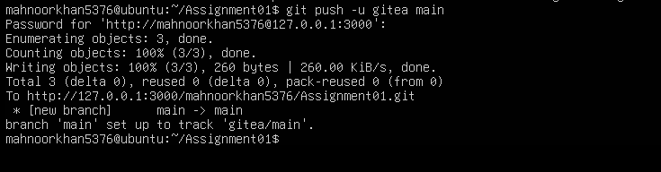
Screenshot: task1_gitea_push.png — Successful push to the Gitea remote

Step 1.3: Verify the Gitea Repository
The Assignment01 repository was opened in Gitea. The owner (mahnoorkhan5376), repository name, the Gitea URL and the rendered README.md with my name and registration number are visible.
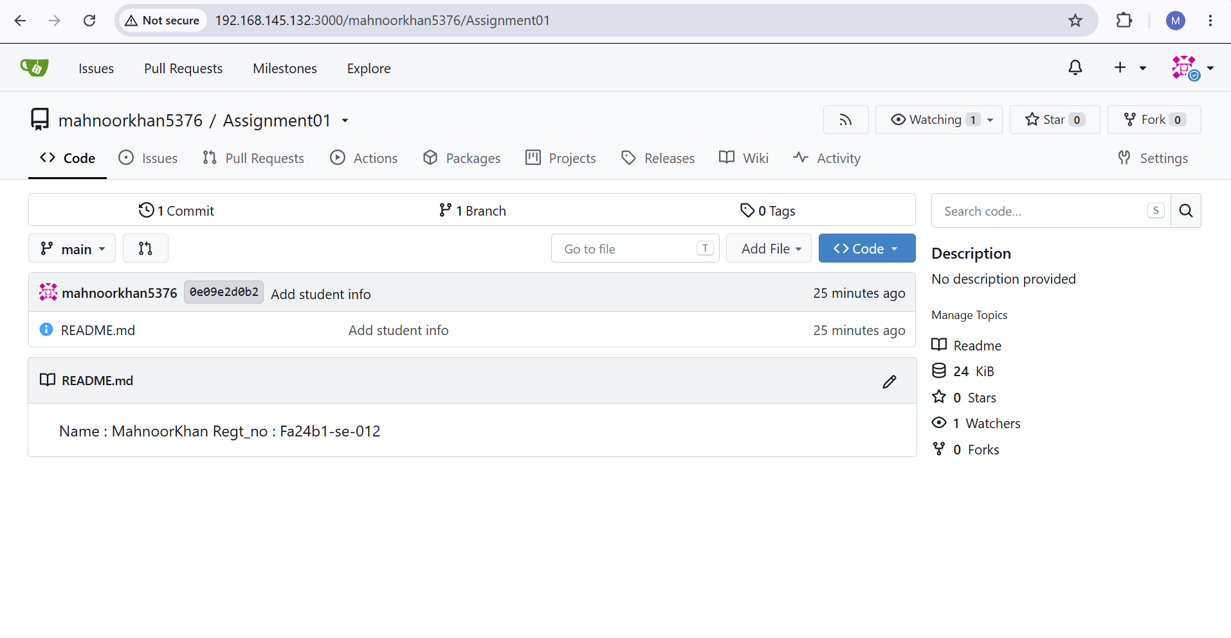
Screenshot: task1_gitea_repository.png — Gitea repository with rendered README

Task 2: Push the Same Repository to GitHub

Step 2.1: Create the GitHub Repository and Verify Both Remotes
An empty public GitHub repository named Assignment01 was created. GitHub was added as the second remote of the same local repository.
cd ~/Assignment01
git remote add github https://github.com/mahnoorkhan5376/Assignment01.git
git remote -v
Result: both gitea and github remotes are listed with fetch and push URLs; no token or password appears in any URL.
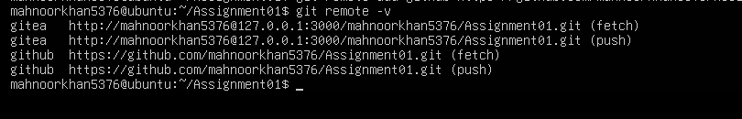
Screenshot: task2_remotes.png — git remote -v showing gitea and github remotes

Step 2.2: Push to GitHub
git push -u github main
Result: the main branch was pushed and set up to track 'github/main'.
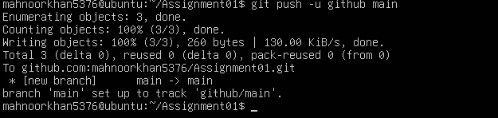
Screenshot: task2_github_push.png — Successful push to the GitHub remote

Step 2.3: Verify the GitHub Repository
https://github.com/mahnoorkhan5376/Assignment01 shows the owner mahnoorkhan5376, the name Assignment01, the Public label, and the rendered README.md with my full name and registration number.
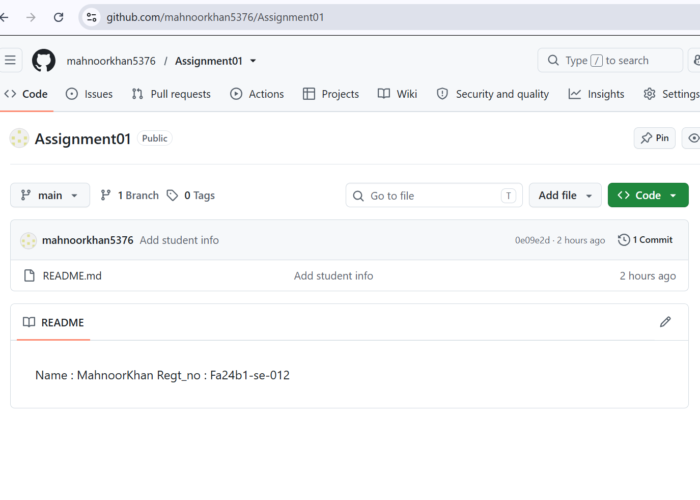
Screenshot: task2_github_repository.png — GitHub repository page with rendered README

Task 3: Track Three Large Files with Git LFS

Step 3.1: Configure Git LFS
Git LFS was initialised in the local repository, its version was confirmed, and tracking was configured for *.bin files.
cd ~/Assignment01
git lfs install
git lfs version
git lfs track "*.bin"
cat .gitattributes
Result: Git LFS initialised successfully (git-lfs/3.7.1) and .gitattributes contains the *.bin rule.
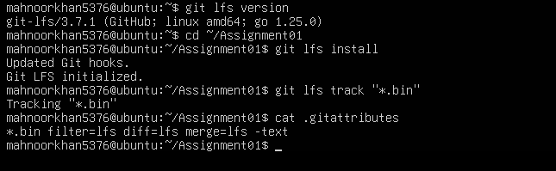
Screenshot: task3_lfs_setup.png — Git LFS setup, version and *.bin tracking rule

Step 3.2: Create and Verify Three LFS Files
Three different .bin files, each larger than 100 MiB, were created and staged together with .gitattributes.
git add .gitattributes file1.bin file2.bin file3.bin
git lfs ls-files --size
Result: all three files are tracked by Git LFS — file1.bin (106 MB), file2.bin (107 MB) and file3.bin (108 MB).
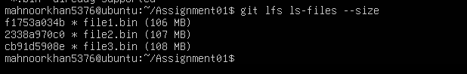
Screenshot: task3_lfs_files.png — Three files listed by git lfs ls-files --size

Step 3.3: Commit and Push the LFS Files
git commit -m "Add three files using Git LFS"
git push github main
Result: LFS objects uploaded 100% (3/3), 321 MB, and main was pushed to the GitHub Assignment01 repository.
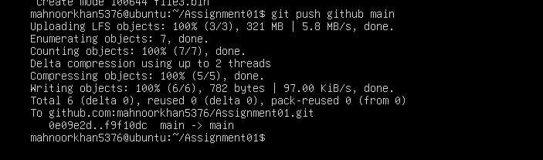
Screenshot: task3_lfs_push.png — LFS upload 100% (3/3) and successful push to GitHub

Task 4: Create a Portfolio or CV with GitHub Pages

Step 4.1: Create and Push the Portfolio Repository
A public repository named mahnoorkhan5376.github.io was created. The portfolio was built with HTML and CSS (index.html and a stylesheet) and contains the sections About Me, Education, Skills and Projects. The source files were committed and pushed to the main branch.
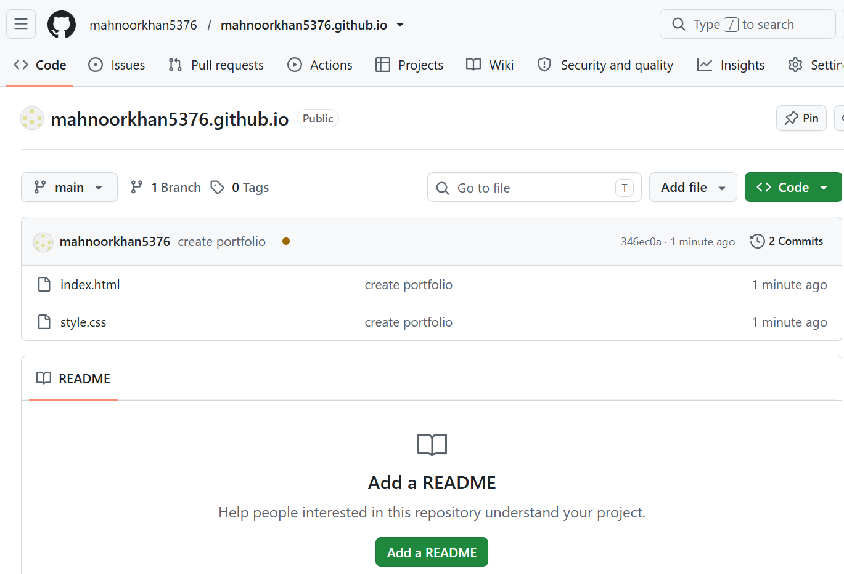
Screenshot: task4_pages_repository.png — Portfolio repository with index.html and CSS file

Step 4.2: Publish with GitHub Pages
In Settings → Pages, “Deploy from a branch” was selected with the main branch and the / (root) folder. GitHub reports that the site is live at https://mahnoorkhan5376.github.io/.
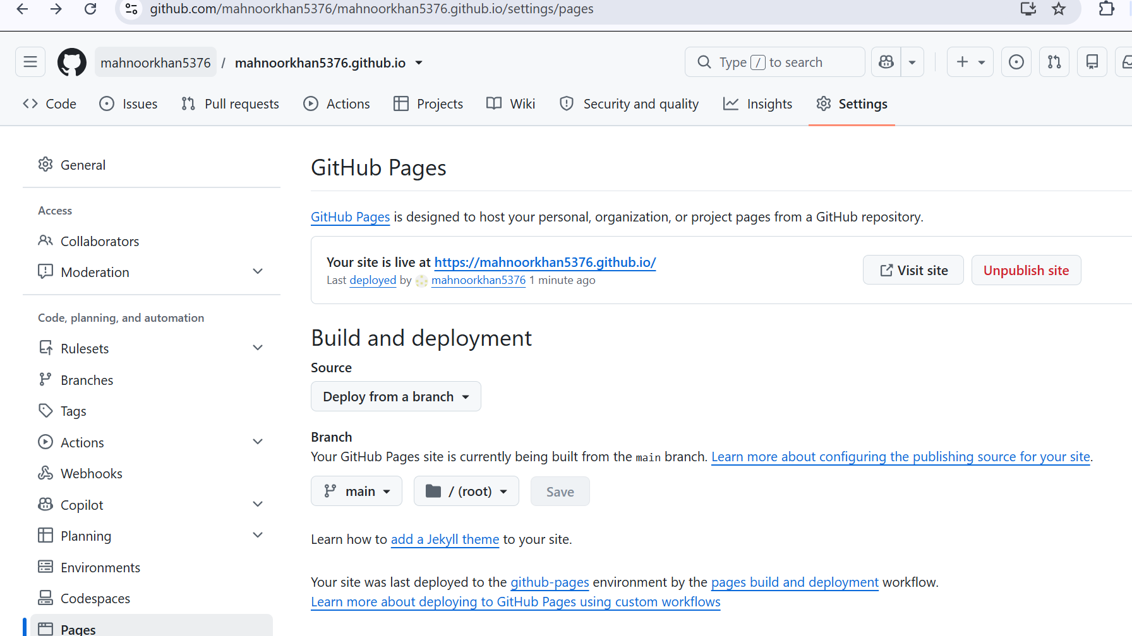
Screenshot: task4_pages_deployment.png — GitHub Pages settings showing the site is live

Step 4.3: Verify the Live Portfolio
The live site https://mahnoorkhan5376.github.io/ loads successfully and displays the About Me, Education, Skills and Projects sections.
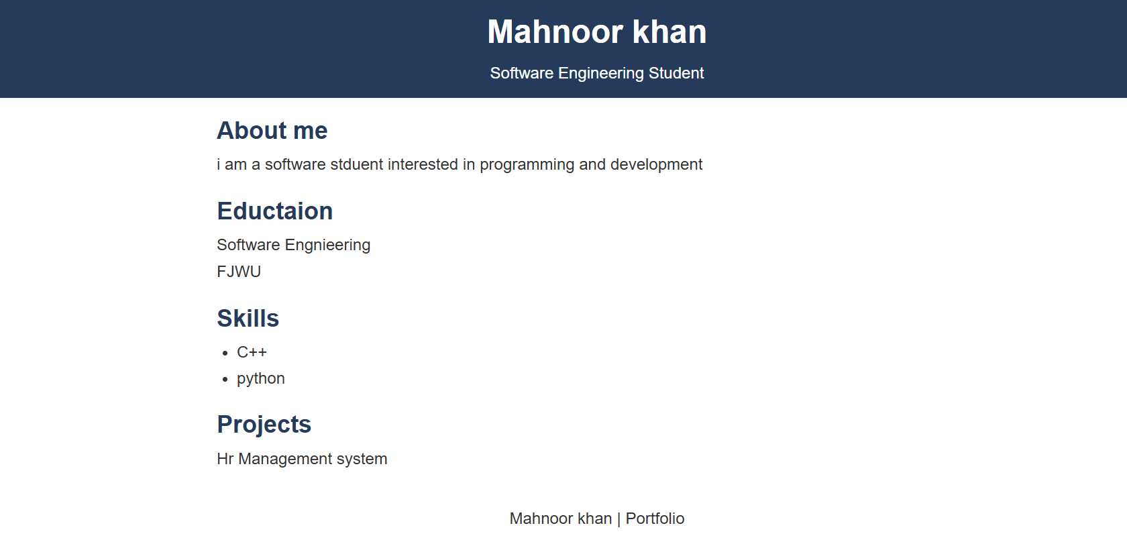
Screenshot: task4_portfolio_live.png — Live portfolio at mahnoorkhan5376.github.io

Assignment Summary
- Installed and ran Gitea with PostgreSQL on the Ubuntu server using Docker Compose.
- Created a local repository on the server and pushed it to Gitea using a personal access token without exposing it.
- Added GitHub as a second remote and pushed the same repository to both Gitea and GitHub.
- Configured Git LFS and pushed three files larger than 100 MiB to GitHub.
- Created and published a portfolio with GitHub Pages.

