System Architecture
Agile Software Engineering Capstone
Document field | Team entry
Project title | Trip Budget Planner
Team name | Hello World
Team members | Mahnoor Shahid  Oh May Ishar  Hajar Wilkes  Hafsa Ahmed
Student document owner | Hajar Wilkes  Oh May Ishar
Instructor | Shah, Syed Jawad Hussain
Sponsor or client | Commerce Bank
Version and date | V0.1, 11/06/2026
Approval status | Draft

How to use this template
Use this document to explain the system's important structures, how its parts work together, and why the team made significant technical decisions. A teammate should be able to follow a user request through the system, find where data lives, and understand the main quality and security choices.
Replace each bracketed prompt with your team's information. Remove unused example rows and all remaining prompts before submission. Keep the document current as the project changes.
Create a thin first version during Sprint 0 or Sprint 1. Update it whenever the team changes a major component, interface, data model, deployment approach, security boundary, or important technical decision.

Revision history
Version | Date | Author | Summary of change | Reviewer or approval
0.1 | 11/06/2026 | Hajar Wilkes | Initial draft | Mahnoor Shahid
[Version] | [Date] | [Name] | [What changed] | [Reviewer or decision]

Document outline
Section | Purpose
1 Architecture overview | Purpose, scope, status, and a short explanation of the system
2 Architecture drivers | Use cases, quality attributes, constraints, assumptions, and risks
3 Stakeholders and concerns | What different readers need from the architecture
4 Architecture at a glance | Selected architecture style, major elements, and rationale
5 System context view | Users, external systems, system boundary, and interactions
6 Logical view | Containers, components, responsibilities, and dependencies
7 Process and runtime view | Requests, processes, concurrency, state, and failure behavior
8 Development view | Source organization, modules, ownership, and build structure
9 Deployment view | Where software runs and how environments connect
10 Use case view | Scenarios that validate the other architecture views
11 Data architecture | Entities, relationships, ownership, validation, and migrations
12 Interfaces and APIs | Contracts, authentication, validation, errors, and versioning
13 Security and privacy | Trust boundaries, threats, secrets, identity, and data rules
14 Quality attributes | Performance, reliability, accessibility, maintainability, and testability
15 Architecture decisions | Short records of major decisions and consequences
16 Traceability and risks | Links to requirements, tests, prototypes, and unresolved concerns
17 Architecture evolution | How the team reviews and updates the architecture
18 Review and submission | Approvals and final completeness check

1 Architecture overview

1.1 Purpose and scope
This document describes the architecture of Trip Budget Planner, a web application developed by Team Hello World. The application helps users organize trips, estimate travel costs, create budgets, and track savings goals using simulated financial information.
The architecture covers the React frontend, Spring Boot REST API, MySQL database hosted on Aiven, authentication, and the main application modules. It explains how these components communicate, process requests, and store information.
This document is intended for the development team, instructor, and project stakeholders. Real banking integrations, financial transactions, payment processing, and travel booking systems are outside the project's scope.
________________________________________________________________________________

1.2 Architecture status
Item | Team entry
Architecture version | 0.1, November 6, 2026
Current status | Partly implemented
Implementation baseline | Project source code and running development application reviewed on November 6, 2026. Exact Git commit not recorded.
Known gaps | Generative AI itinerary planning, expense tracking, and trip member management remain unfinished or unverified. Trip deletion has potential database foreign-key issues. The checked-in SQL schema does not fully match the live Aiven database.

1.3 Short architecture narrative
Trip Budget Planner uses a three-tier client-server architecture consisting of a React frontend, a Java Spring Boot backend, and a MySQL database hosted on Aiven. The frontend provides the user interface and communicates with the backend through REST API requests. Spring Security uses JWT authentication to protect application endpoints. The backend organizes its functionality into controllers, services, and repositories to process requests, enforce business rules, and access stored data.
The MySQL database stores users, trips, simulated bank accounts, budgets, savings information, and itinerary activities. The application also provides rule-based travel timing and budget recommendations using predefined destination information and cost estimates. Generative AI itinerary planning is not yet implemented. The frontend-to-backend-to-database connection has been successfully demonstrated for login, trip retrieval, budget and savings display, and travel recommendations.
__________________________________________________________________

2 Architecture drivers
Architecture drivers are requirements or risks that strongly influence the system structure. Focus on the few items that change architectural choices.

2.1 Key use cases
Use case ID | Use case | Why it affects architecture | Related view or decision
UC-AUTH-01, UC-AUTH-02 | Register and sign in | Requires secure password storage, JWT authentication, and protected endpoints. | Security, Logical View
UC-TRIP-01, UC-TRIP-03, UC-TRIP-04 | Create, edit, and delete trips | Requires user-owned trip records, validation, and management of related data. | Logical, Data Views
UC-BUD-01 | Create a trip budget | Requires budget calculations, category allocations, and persistent storage. | Logical, Data Views
UC-SAV-01, UC-SAV-02 | Track and update savings | Requires savings goals, simulated contributions, and progress calculations. | Logical, Data Views
UC-BANK-01 | Connect a simulated bank account | Requires validation, account ownership checks, and secure handling of fabricated account information. | Security, Data Views
UC-AI-01 | Generate and compare AI trip options | Current rule-based recommendations use a replaceable provider interface. Generative AI functionality remains planned. | Logical View, Future Integration
UC-EXP-01 | Track actual trip expenses | Requires expense records linked to trips and comparison with planned budgets. Database table exists; application functionality remains planned. | Logical, Data Views
UC-MEM-01 | Invite and manage trip members | Would require shared-trip relationships and permission checks beyond current owner-based access. | Security, Data Views

2.2 Quality attributes
Quality ID | Quality scenario | Measure or response | Architecture effect
NFR-SEC-001 | When users register or log in, passwords must be handled securely. | Passwords are stored as salted hashes using BCrypt. | Spring Security, BCrypt password encoding, and JWT authentication.
NFR-PRIV-001 | When users connect bank accounts or record savings, only simulated financial information is used. | No real bank connections or financial transfers occur. | Simulated banking module without an external banking integration.
NFR-USE-001 | Users complete the main trip budgeting workflow. | Users can complete the workflow without a blocking error. | React interfaces, form validation, and error handling.
NFR-PERF-001 | Application pages and calculations respond under normal demonstration conditions. | Complete within 3 seconds, excluding external-service delays. | REST APIs, database queries, and backend calculations; timed verification pending.
NFR-ACC-001 | Users navigate primary workflows using a keyboard. | Core controls are keyboard accessible and form fields have clear labels. | Accessible React forms and navigation components; keyboard testing pending.
NFR-REL-001 | A user submits invalid information or a database operation fails. | Failed operations must not create incomplete records. | Backend validation and database transactions; multi-request workflows require further testing.
NFR-MNT-001 | Developers update and maintain application code. | Source code is maintained in the team's GitHub repository. | Organized frontend and backend modules with shared version control.

2.3 Constraints assumptions and architecture risks
Type | Statement | Source | Architecture effect | Owner or validation
Constraint | The project must be completed within the course schedule. | Charter C-01 | Prioritize core functionality and limit optional integrations. | Development team
Constraint | Only fabricated financial and bank account data may be used. | Hosting Charter C-02 | No real banking connections or money transfers. | Development team; repository and demonstration review
Constraint | Development time and available resources are limited. | Charter C-03, C-04 | Use existing frameworks and a manageable three-tier architecture. | Development team
Assumption | Users provide the trip, budget, and savings information needed by the application. | Charter A-02, A-04 | Forms require user input and validate submitted data. | Functional testing
Assumption | The Aiven MySQL service is accessible during development and demonstration. | Charter D-03; runtime verification | Backend availability depends on network and database access. | Backend/database team; connection testing
Risk | Database tables and the checked-in schema script are not fully synchronized. | Source and Aiven database review | Schema changes may cause deployment or setup inconsistencies. | Database team; compare and update schema
Risk | Deleting trips with associated expenses or notifications may fail because of foreign-key constraints. | Database review | Trip deletion must correctly handle dependent records. | Backend/database team; deletion tests
Risk | Trip creation and budget saving use separate API requests. | CreateTrip.jsx review | A trip may be created even when its budget fails to save. | Backend team; failure testing

3 Stakeholders and concerns
Stakeholder | Main concerns | Architecture information needed | View or evidence
Users | Usability, privacy, and reliable application functionality. | User workflows, authentication, and data protection. | Use case and logical views
Developers | Clear component responsibilities, dependencies, and maintainable code. | Frontend/backend organization, APIs, database relationships, and interfaces. | Logical and development views
Testers | Correct functionality, error handling, and testable components. | API behavior, validation rules, test environments, and failure scenarios. | Runtime and Quality Sections
Commerce Bank Mentors and Instructor | Project scope, feasibility, technical decisions, and progress. | Architecture overview, implementation status, known risks, and design decisions. | Overview, Architecture Drivers, and Traceability

4 Architecture at a glance

4.1 Selected architecture style
Trip Budget Planner uses a three-tier client-server architecture with a layered Spring Boot backend.
The three tiers are:
- Presentation Tier: A React frontend built with Vite provides the user interface and sends REST API requests.
- Application Tier: A Java Spring Boot backend handles authentication, validation, business logic, and database operations. Controllers, services, and repositories separate responsibilities.
- Data Tier: A MySQL database hosted on Aiven stores persistent application data, accessed through Spring Data JPA/Hibernate.
This architecture separates the user interface, application logic, and database responsibilities. It supports the team's division of development work and allows individual components to be maintained or updated without redesigning the entire application.
________________________________________________________________________________

4.2 Major architecture elements
Element | Responsibility | Important interface | Data owned or used | Team owner
React Web Client | Displays pages, collects user input, performs client-side validation, and communicates with the backend. | REST API using HTTP and JSON | User input, temporary interface state, and API responses | Frontend: Oh May Ishar and Hajar Wilkes
Spring Boot REST API | Processes requests, enforces business rules, checks authorization, and coordinates database operations. | REST endpoints | Users, trips, budgets, savings, simulated bank accounts, and itinerary records | Backend: Mahnoor Shahid and Hafsa Ahmed
Authentication and Security Module | Handles registration, login, BCrypt password hashing, JWT authentication, and protected requests. | Authentication endpoints and JWT Bearer tokens | User credentials, password hashes, and JWT claims | Backend team
Recommendation Module | Generates rule-based travel timing and budget estimates using destination profiles and cost assumptions. | /api/recommendations/timing and /api/recommendations/budget | Trip preferences, destination profiles, and calculated recommendations | Backend team; specific assignee unconfirmed
Aiven MySQL Database | Stores persistent records and enforces database relationships and constraints. | SQL through Spring Data JPA/Hibernate | User accounts, trips, budgets, allocations, savings, contributions, itinerary activities, and other application tables | Database: Hajar Wilkes

5 System context view

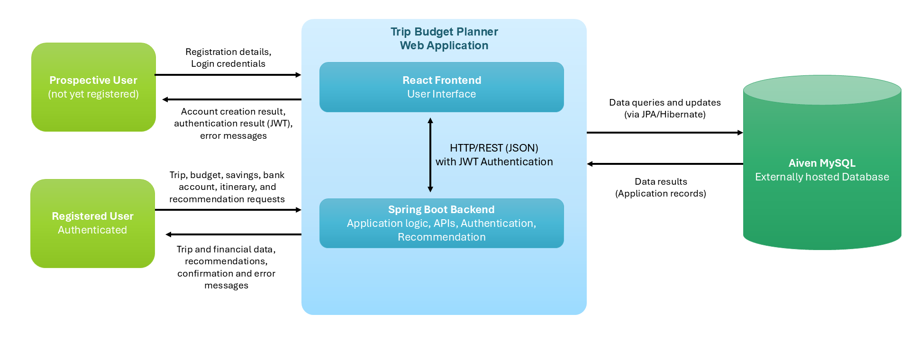
5.1 Context diagram

5.2 Context explanation
Actor or external system | Interaction with the system | Information exchanged | Trust or dependency concern
Prospective User | Creates an account or signs in through the web application. | Registration details, login credentials, authentication results, and validation errors. | Passwords are hashed using BCrypt. Protected API requests require authentication.
Authenticated User | Creates and manages trips, budgets, savings plans, simulated bank accounts, and manual itineraries. Requests travel recommendations. | Trip information, budget allocations, savings records, fictional bank-account data, itinerary activities, recommendation inputs and results. | JWT authentication and backend ownership checks restrict access to user-owned information.
Aiven MySQL | Provides persistent storage for the application through the Spring Boot backend. | SQL operations, stored application records, query results, and database operation outcomes. | Requires valid database credentials, network availability, and secure backend-to-database communication.

6 Logical view

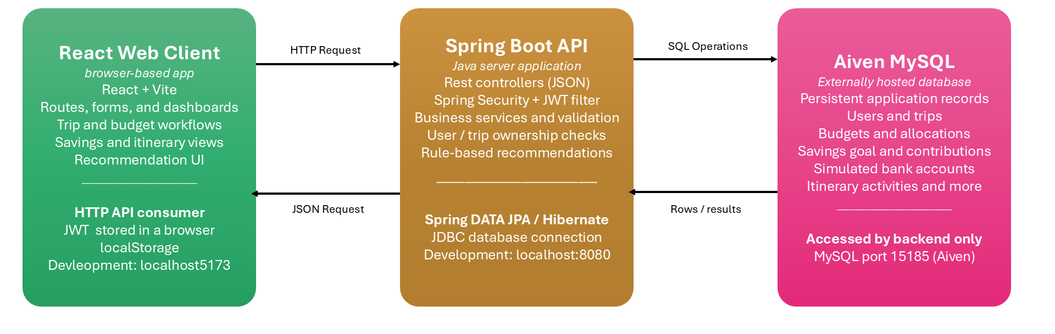
6.1 Container diagram

Trip Budget Planner consists of three main runtime containers:

React Web Client: The frontend is built using React and Vite. It provides interfaces for authentication, trip management, budgeting, savings, simulated bank accounts, itineraries, and travel recommendations. It communicates with the backend through HTTP REST requests using JSON and includes a JWT Bearer token when accessing protected endpoints.

Spring Boot REST API: The Java backend handles authentication, request processing, input validation, authorization, business rules, and database operations. Its architecture separates controllers, services, and repositories. It also contains the rule-based recommendation functionality.

Aiven MySQL Database: The database stores persistent application information, including users, trips, budgets, savings goals, contributions, simulated bank accounts, and itinerary activities. The backend accesses MySQL through Spring Data JPA/Hibernate and JDBC.

The frontend does not connect directly to MySQL. All database operations are performed through the Spring Boot backend.

In the verified development environment, the React application runs at localhost:5173, Spring Boot at localhost:8080, and MySQL is hosted remotely on Aiven. These development configurations do not establish a public production deployment.

6.2 Component view
The Spring Boot backend follows a layered structure consisting of REST controllers, service classes, and Spring Data JPA repositories.
Controllers receive HTTP requests and return responses. Services perform validation, calculations, and business operations. Repositories provide access to persistent records in MySQL.
Spring Security and JWT authentication protect backend endpoints. For user-owned resources, services verify that the authenticated user is authorized to access the requested records.

Component | Responsibility | Depends on | Provided interface | Requirement or use case
Budget service | Applies budget and category rules | Budget repository and authenticated user context | Service methods used by API routes | UC-02
[Component] | [Responsibility] | [Dependency] | [Interface] | [ID]

7 Process and runtime view

7.1 Key request or event flows
What to write: Use a sequence diagram or numbered flow for important runtime behavior. Show validation, authentication, authorization, data access, errors, and responses.
Example: Create budget flow: 1. Web client sends an authenticated POST request. 2. API validates the request body. 3. Authorization obtains the user ID from the session. 4. Budget service applies business rules. 5. Repository inserts the budget using the user ID. 6. API returns the created budget or a structured error.
[Insert sequence diagram or numbered flow here]
Create Trip and Budget Flow:
- User enters trip details : The logged-in user completes the Create Trip form, including destination, travel dates, number of travelers, travel preference, and budget.
- Frontend validates information: The react application checks required fields, travel dates, number of travelers, and budget amounts before allowing submission.
- API request is sent: react send an authenticated POST request to /api/trips with the trip information and the user’s JWT token.
- Backend verifies the request: Spring security authenticates the user , and the backend validates the submitted trip information.
- Trip is saved : The backend associates the trip with an authenticated user and saves the information in the MySql database.
- Trip ID is returned : The back returns the newly created trip information, including its unique ID.
- Budget is submitted : React sends a separate PUT request to /api/trips/{tripId}/budget containing the total budget, currency and category allocations.
- Budget is validated and saved: The backend verifies that the user owns the trip, checks the budget amounts, and saves the budget information in mySql.
- Respond is displayed : After successful request, the application redirects the user to the budget dashboard. If an error occurs, the application displays an error message. Authentication failures may require the user to log in again.

7.2 Processes concurrency state and failure
Concern | Design decision | Failure behavior | How the team will test or observe it
Session state | JWT token stored in browser localStorage. | Invalid or expired token returns 401 and redirects to login | Test login with an expired token
Concurrent update | Backend processes trip and budget updates through API requests. | Simultaneous edits may overwrite previous changes | Edit the same trip in two browsers tabs.
External dependency | Recommendation APIs use fallback values when available. | Failed request display errors: budget can be entered manually. | Simulate an API failure and check the responds

8 Development view

8.1 Source and module organization
What to write: Show how the architecture maps to repositories, folders, packages, modules, and development ownership. Keep names consistent with the logical view.
Repository or module | Purpose | Main dependencies | Build or test command | Owner
frontend/ | React user interface | React, Vite, backend, API | Npm run dev | Oh May Ishar & Hajar
backend/ | APIs, business logics, and authentication | Spring Boot, Spring security, JPA | ./mvnw test | Mahnoor & hafsa
database/ | Store users, trips, budget and expenses. | MySQL | Run schema.sql | Hajar
docs/ | Project requirements and documentation | Team documentation | N/A | All team member

8.2 Team and integration structure
What to write: Explain how team ownership, pull requests, shared interfaces, and integration practices support the architecture. Note any Conway's Law risk where team boundaries could create unwanted system boundaries.
Our team divided responsibilities into frontend, backend, database and development. We use a shared GitHub repository to commit, review, and merge code changes. The frontend and backend communicate through REST APIs, and team members coordinate to keep interfaces consistent.
A potential Conway Law risk is that separate team responsibilities may cause integration issues between components. We reduce this risk through communication, shared API agreements and integration testing,

9 Deployment view

9.1 Deployment diagram
What to write: Show development, test, and demo or production environments. Include browser, hosting, API process, database, network paths, configuration, and secrets sources.
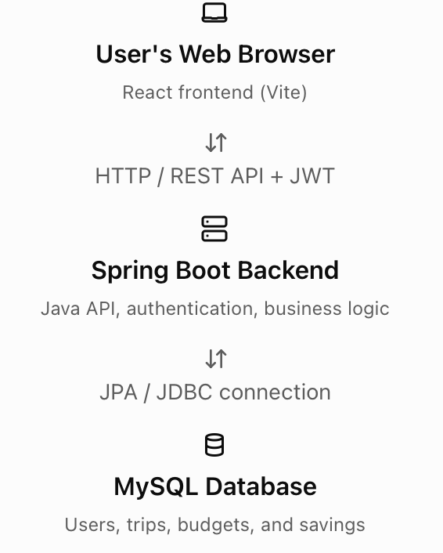
During project demonstration, the team pre-recorded the application and presented the video through zoom.

9.2 Environment inventory
Environment | Purpose | Deployed elements | Data | Configuration and secrets | Owner
Local development | Develop and test features | React, Spring Boot, MySQL connection | development data | Local configuration environment variables | Entire team
Test or demo | Test frontend and backend integration | React, Spring Boot, MySQL | Test data | Test configuration and credentials | Entire team
[Environment] | Record application demo | React, Spring Boot, MySQL | Demo trip and budget data | Local configuration and credentials | Entire team

10 Use case view
The use case view is the plus one view. It shows how the logical, runtime, development, and deployment views work together for an important scenario.
Scenario | Logical elements | Runtime flow | Deployment nodes | Evidence
Register and sign in | React forms, AUth controllers, Auth services, user repository | VAlidate authenticate, generate JWT, return results | Browser, Spring Boot, MySql | Login/signup demo and test
[Use case] | CreateTrip, Trip Controller, Budget service, repositories. | Validate, create trip, save budget, display dashboard | Browser, Spring Boot, MySql | Section 7.1 Numbered flow and recorded demo

11 Data architecture

11.1 Data model
What to write: Insert an entity relationship diagram or class model. Show key fields, primary and foreign keys, relationships, required values, and ownership boundaries.
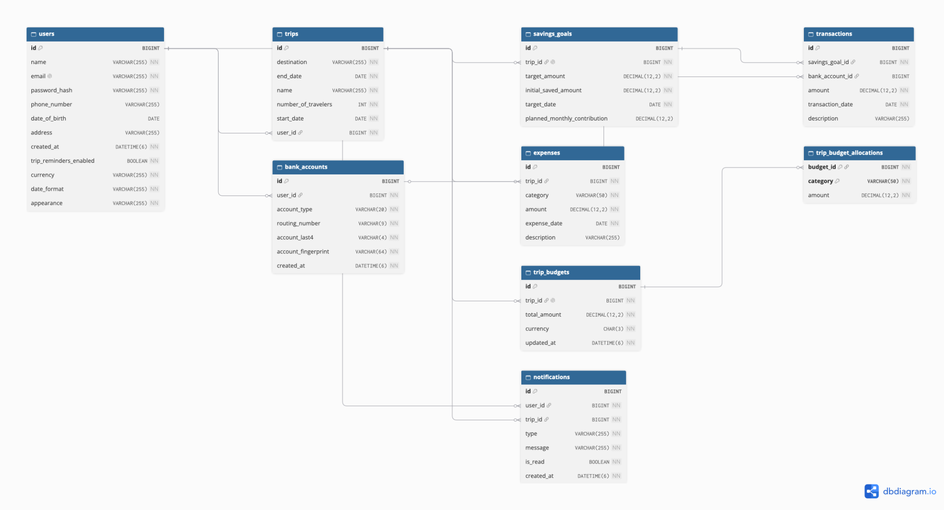

11.2 Data dictionary and ownership
Entity or data set | Purpose | Important fields | Owner or access rule | Validation retention or migration
User | Stores user accounts | ID, name, email, password hash | Users access their own profiles. | Unique email; hashes passwords.
Trips | Stores travel plans | ID, user ID, destination, dates | Users access their own trips. | Required destination and dates
Trip Budget | Stores trip spending limits | ID, trip ID, total amount, currency | Trip owner | Positive budget amount
Expenses | Track trip spending | Id, trip ID, category, amount | Trip owner | Valid expenses amount
Saving Goals | Tracks trip saving target. | Id, trip ID, target amount, date | Trip owner | Valid target amount and date

12 Interfaces and APIs

12.1 Interface catalog
Interface ID | Provider and consumer | Purpose | Protocol or format | Authentication | Version or status
API-01 | React <-> spring boot | User Login | POST /api/auth/login (JSON) | Email and password | Implemented
[API-02 | React <-> spring boot | Create trip | POST /api/trips (JSON) | JWT required | Implemented
API-03 | React <-> spring boot | Save trip budget | POST /api/trips/{tripID}/ budget (JSON) | JWT required | Implemented
API-04 | React <-> spring boot | Retrieve trips | POST /api/trips (JSON) | JWT required | Implemented

12.2 Contract details
Contract field | Team entry
Endpoint or interface | POST /api/trips
Purpose | Create a new trip for the logged-in user.
Request example | {"destination":"Chicago","name":"Chicago Trip","startDate":"2027-02-10","endDate":"2027-02-15","numberOfTravelers":2}
Success response | HTTP 201 created; return trip details and ID
Validation errors | Invalid or missing fields return an error responses
Authentication and authorization | JWT required trips belong to the authenticated user.
Compatibility or versioning | REST API; frontend and backend changes coordinate through GitHub

13 Security and privacy

13.1 Trust boundaries and threats
What to write: Mark trust boundaries on the context or deployment diagram. Identify likely misuse and failure cases without listing generic security terms.
Threat or misuse case | Affected asset | Architecture control | Verification evidence | Owner
User accesses another user trip | Private trip and budget data | JWT authentication and ownership check | Test access with another user trips ID | Backend Team
Invalid Input reaches database | Database integrity | Backend validation and JPA repositories | Test invalid trip and budget input | Backend team
Unauthorized API request | User accounts data | Spring security and JWT validation | Test missing or invalid JWT | Backend team
Database credentials exposed | Database user information | Database and user information | Keep credentials outside github | Backend team

13.2 Security and privacy decisions
Area | Team decision
Authentication | Spring Security with JWT tokens. Logout clears the stored token; expired tokens require login again.
Password handling | Passwords are hashed before database storage, not saved as plain text.
Authorization | Users can access only their own trips, budgets, and account information
Input and output protection | Backend validation and JPA repositories help protect database operations.
Secrets | Store database credentials and JWT secrets in environment configuration, outside GitHub.
Logging | Log application errors without exposing passwords, tokens, or financial details.
Financial data | Use fabricated financial data for testing and demonstrations, not real banking information.

14 Quality attributes
Quality attribute | Target or scenario | Architecture tactic | Evidence and owner
Performance | Trip and budget pages should load within 3 seconds. | React frontend and efficient database queries. | Browser performance test : Frontend team
Reliability | Application handles failed API requests without crashing. | Error handling and input validation. | API failure testing : Backend team
Accessibility | Users can navigate forms and read content easily. | Clear labels, readable contrast, and keyboard support. | UI review : All team member
Maintainability | Features can be updated without affecting unrelated components. | Separate frontend, backend, and database modules. | GitHub code review : All team members
Testability | Login, trip creation, and budgets can be tested independently. | API tests and sample data. | Unit and integration tests : Backend team
Observability | Developers can identify API and database errors. | Backend error logs and HTTP status codes. | Log review : Backend team

15 Architecture decisions
Create a short Architecture Decision Record for every decision that would be expensive or disruptive to change later. Keep rejected alternatives so future teammates understand the reasoning.

15.1 Decision index
ADR ID | Decision title | Status | Date | Owner | Related requirements
ADR-001 | Use react for frontend development | Accepted | October 2026 | Oh May & Hajar | User interface
ADR-002 | Use Spring Boot for backend APIs | Accepted | October 2026 | Mahnoor & Hafsa | Trip and budget management
ADR-003 | Use MySQL for database storage | Accepted | October 2026 | Hajar | Data Persistence
ADR-004 | Use JWT for user authentication | Accepted | October 2026 | Mahnoor & Hafsa | User security

15.2 Architecture Decision Record template
Field | Content
Decision | ADR-001: Use React for frontend development.
Status and date | Accepted- October 2026
Context | The project needs an interactive interface for managing trips, budgets, and savings.
Options considered | React, Angular, and Vue
Choice and reason | React supports reusable components and interactive user interfaces.
Consequences | Easier UI updates and component reuse, but requires JavaScript knowledge and dependency management.
Owner and reviewers | Frontend team; reviewed by project team.
Related evidence | React source code, GitHub repository, and recorded project demonstration.

16 Traceability and risks

16.1 Architecture traceability
Requirement or quality ID | Architecture element or decision | Verification evidence | Implementation status
FR-01 Registration | React sign up, AUth controller | Sign up demo and source code | Implemented
FR-01 Login | React Login, SPring security, JWT | Login demo and source code | Implemented
Trip Creation | CreateTrip, Trip service, mySql | Create trip demo | Implemented
Budget management | Budget service, mySQL | Budget dashboard demo | Implemented
UI maintainability | React components, ADR-001 | Github Source code | Implemented

16.2 Architecture risks and open questions
ID | Risk or question | Why it matters | Validation or response | Owner | Target date | Status
AR-01 | Frontend and backend integration errors | Features may not work correctly | Test API requests and responses | All member | Dec 2026 | Open
AR-02 | Database connection failure | Users cannot access saved data | Test connection and error handling | Hafsa & Mahnoor | Dec 2026 | Open
AR-03 | Unauthorized access to trips | Private user data may be exposed | Test JWT and ownership checks | Hafsa & Mahnoor | Dec 2026 | Open
AR-04 | Budget saving fails after trip creation | Trip may be saved without a budget | Test partial failures and recovery | All member | Dec 2026 | Open

17 Architecture evolution
What to write: Explain who maintains this document, when the team reviews it, how proposed and implemented elements are marked, and what events require an update.
The trip budget planner architecture documents are maintained by the entire team and reviewed during each sprint. Team members update diagrams, APIs and database details when changes are made. Major decisions are recorded in the Architecture Decision Record. Features are marked as proposed or implemented based on development progress and testing.

17.1 Diagram rules
[ ] Give each diagram a title, version or date, purpose, and legend when needed.
[ ] Label arrows with the interaction or protocol, such as HTTPS JSON request or SQL query.
[ ] Use the same component names in diagrams, source folders, interfaces, and tables.
[ ] Use one readable diagram for one main question instead of one giant diagram.
[ ] Mark proposed and implemented elements clearly and updated their status each sprint.
[ ] Do not use screenshots of code as architecture diagrams.

18 Review and submission

18.1 Review decisions
Reviewer | Role | Decision | Conditions or comments | Date
Commerce Bank | Project sponsor or mentor | Pending | Awaiting | TBD
Shah, Syed Jawad Hussain | Instructor | Pending | Awaiting | TBD
All team member | Architecture lead | Pending | Awaiting | TBD

18.2 Final submission checklist
[ ] Architecture drivers come from real use cases, nonfunctional requirements, constraints, and risks.
[ ] The document includes context, logical, runtime, development, deployment, and use case views as needed.
[ ] Diagrams use readable labels and names that agree with the implementation.
[ ] The data model protects ownership boundaries and prohibits real financial or card data.
[ ] Interfaces describe authentication, authorization, validation, success, and error behavior.
[ ] Security, secrets, logging, accessibility, reliability, performance, maintainability, and testability are addressed.
[ ] Major decisions include alternatives, rationale, consequences, owner, and date.
[ ] Architecture claims link to requirements and verification evidence.
[ ] Proposed and implemented elements are clearly distinguished.
[ ] All bracketed prompts and unused example rows have been removed.
[ ] The version, date, author list, diagram dates, and review decisions are current.
Recommended filename: TeamName_SystemArchitecture_v1.0.docx

