4.3 Perform OLAP Operations
A) Roll-Up
1. Roll up sales from Day → Month → Quarter → Year
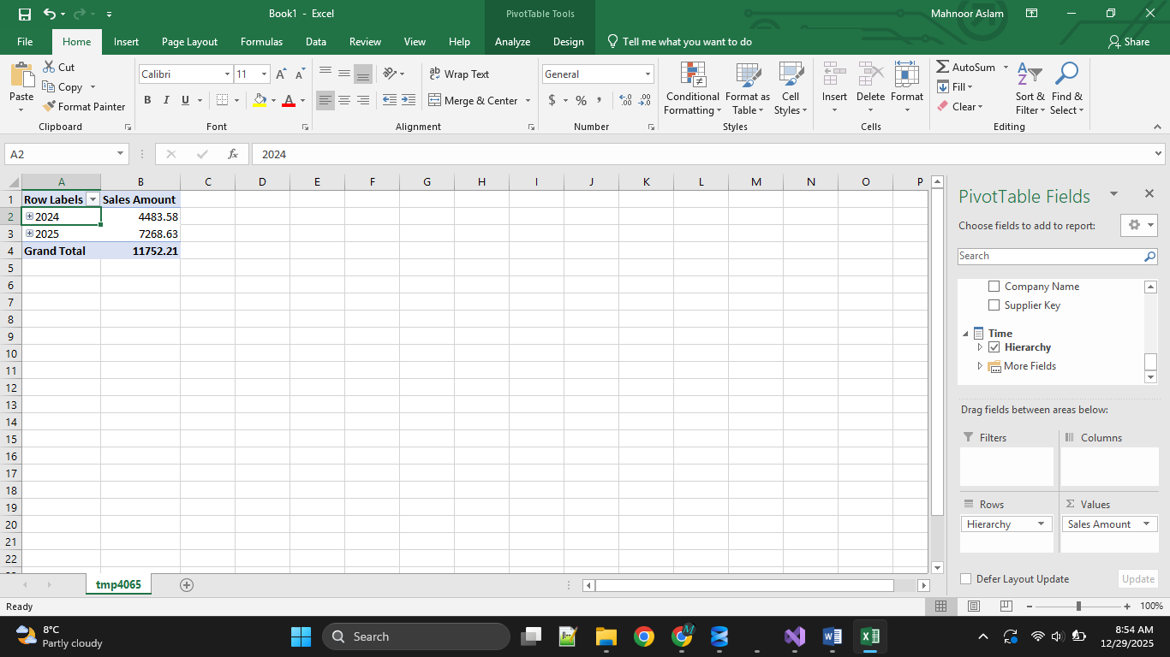

2. Roll up Product → Category 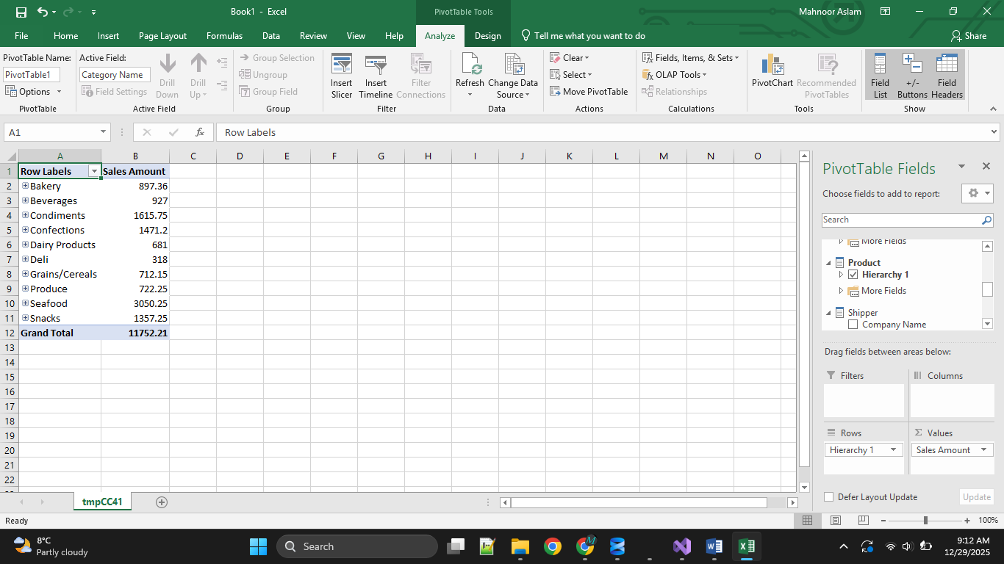

3. Roll up EmployeeCity → Country
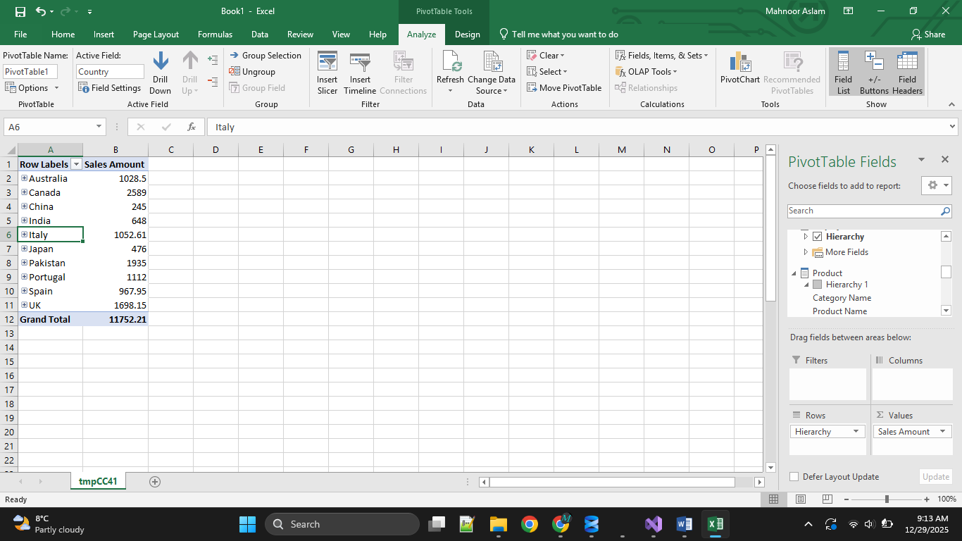

B) Drill-Down
1. Year → Quarter → Month → Day
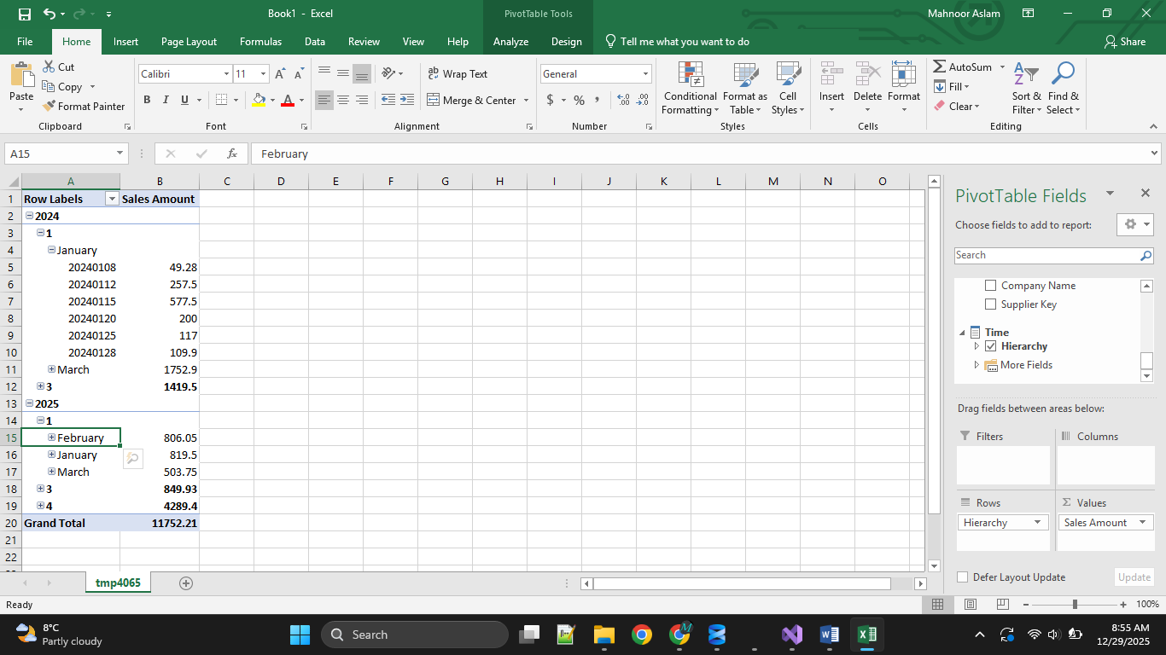

2. Category → Product
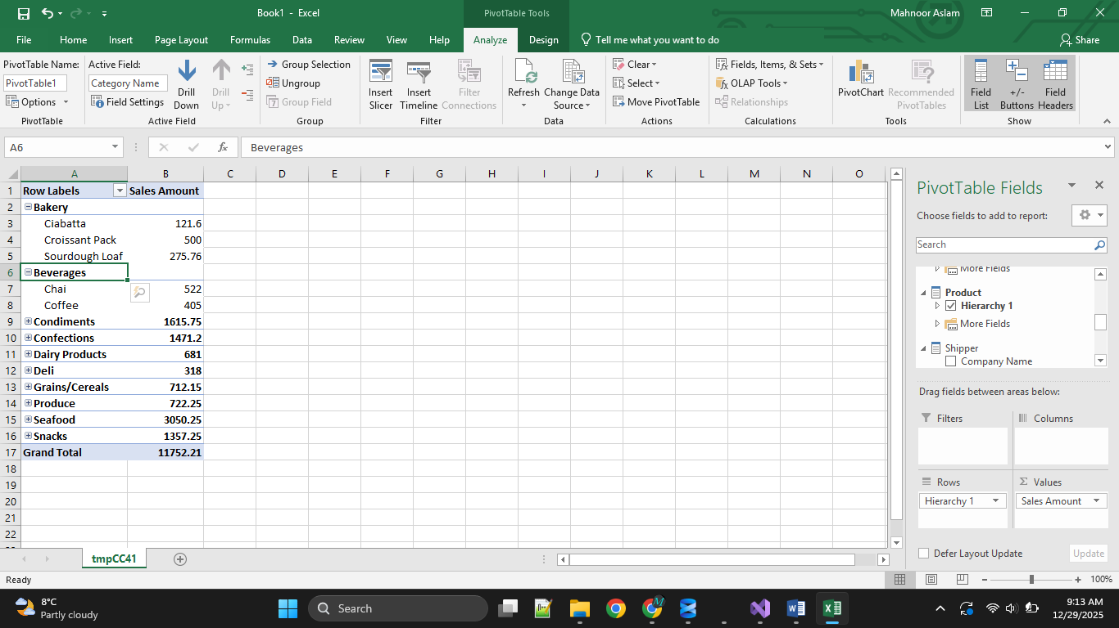
3. Country → City → Employee
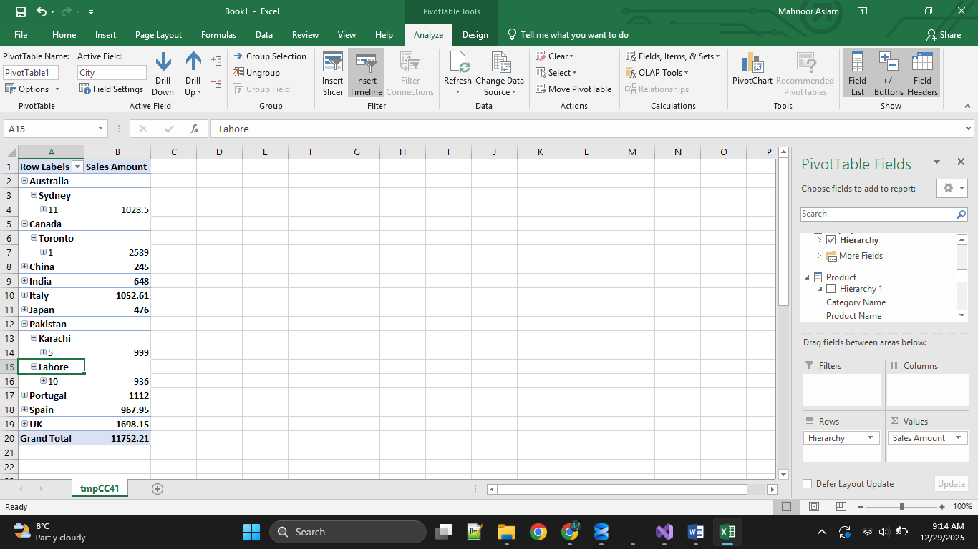

C) Slice
1. Sales where Shipper = AsiaCargo
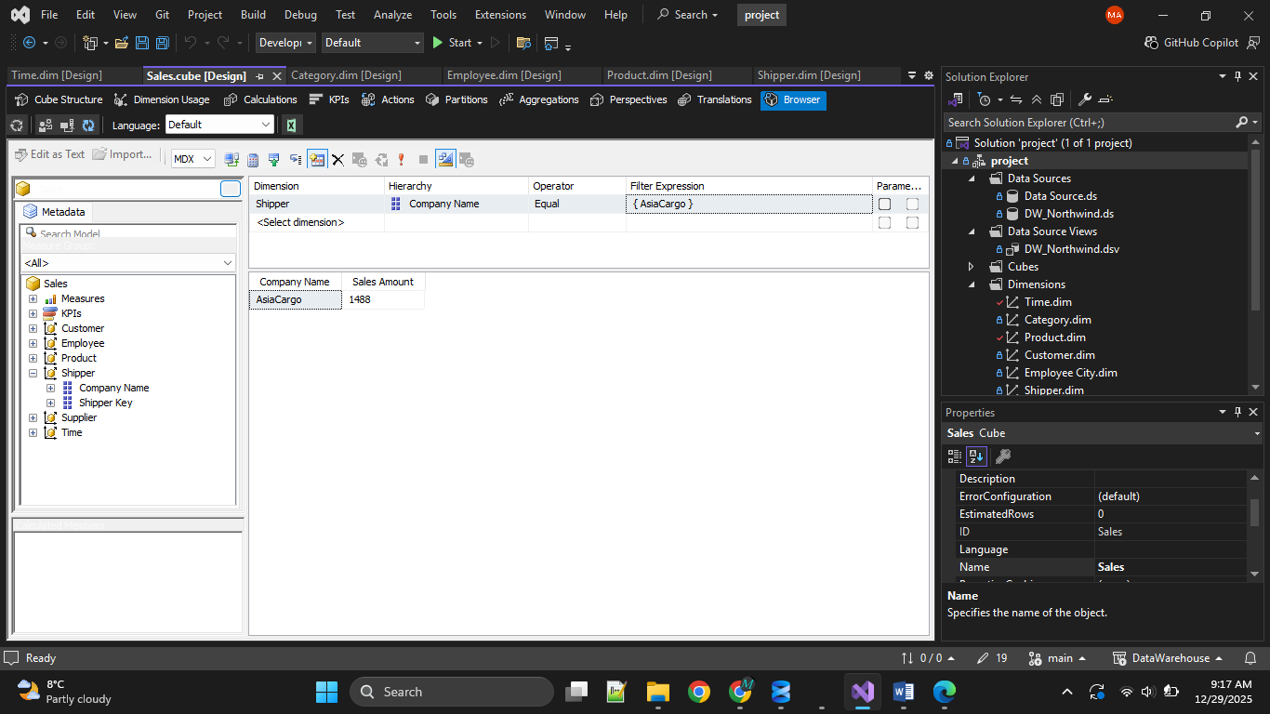
2. Sales where Category = Bakery or Seafood
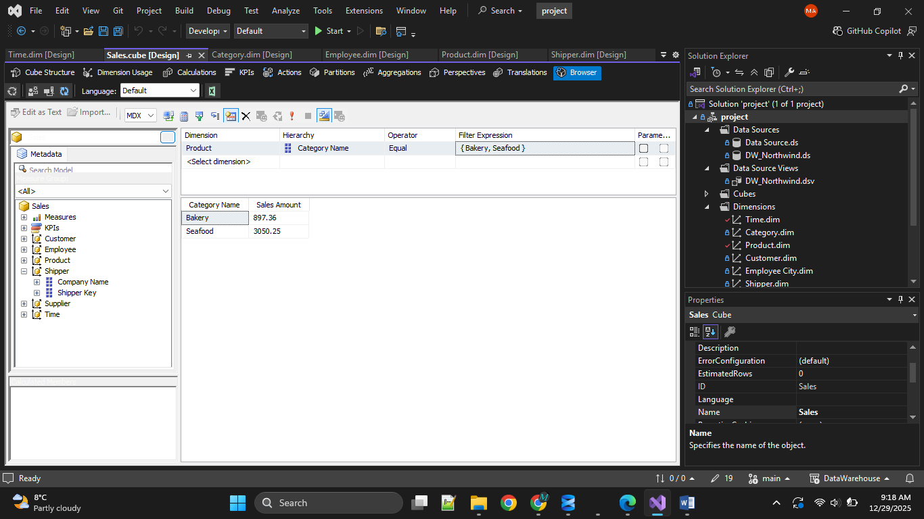

3. Sales where Gender = Female
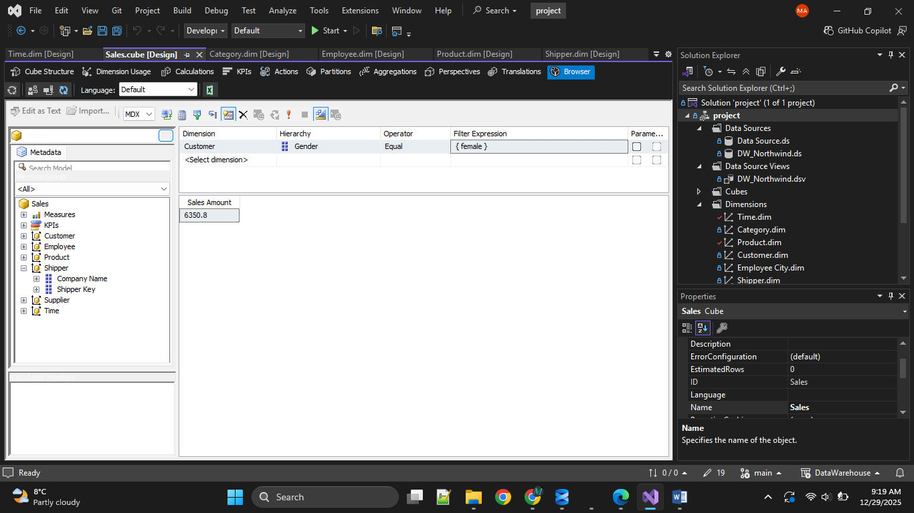
D) Dice
1. Sales in 2025 + Category = Seafood + Employee Country = Canada 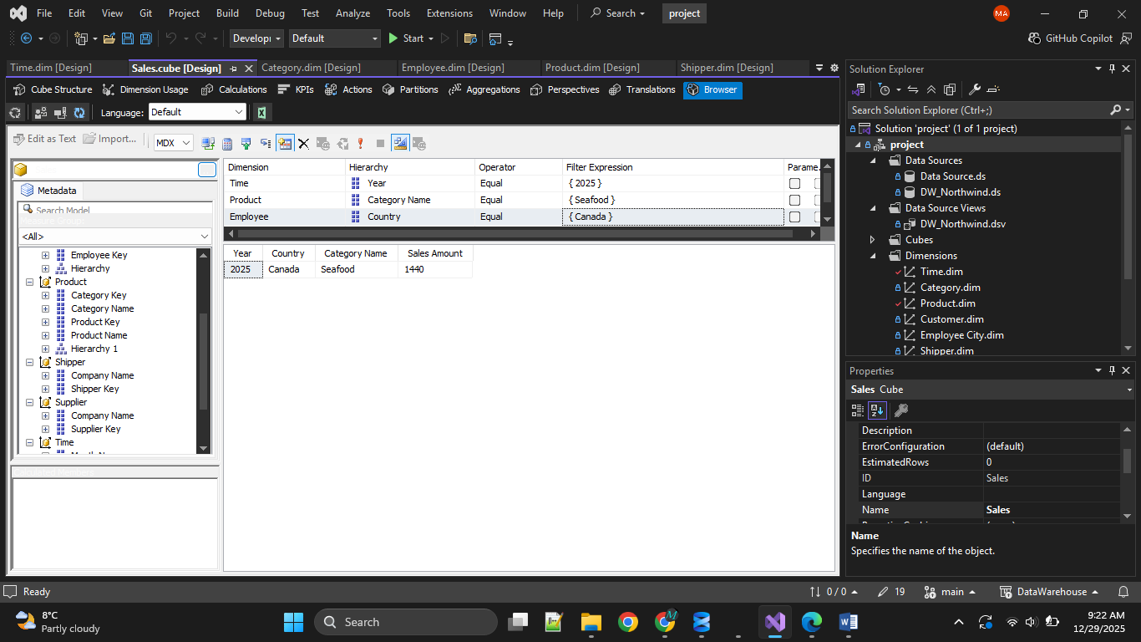
2. Sales for Products with Quantity > 20 in October
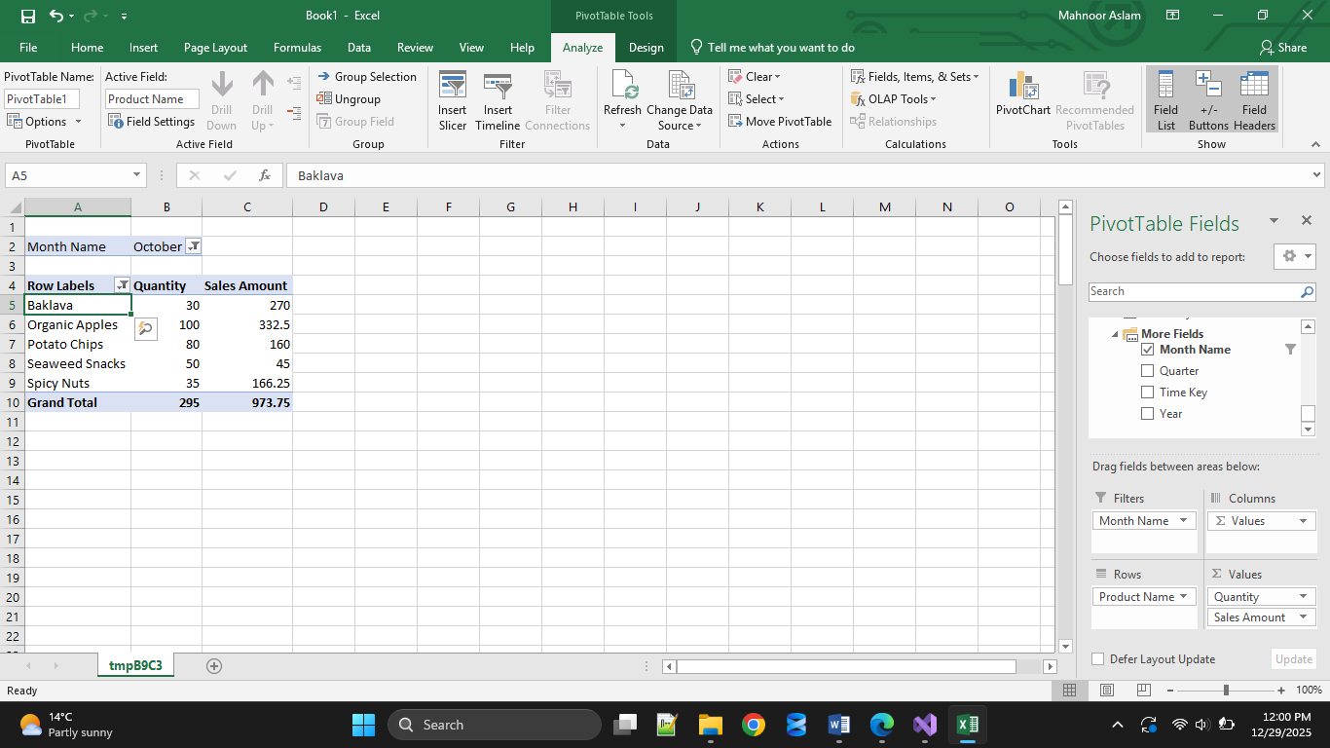

3. Compare two Employees across two Categories
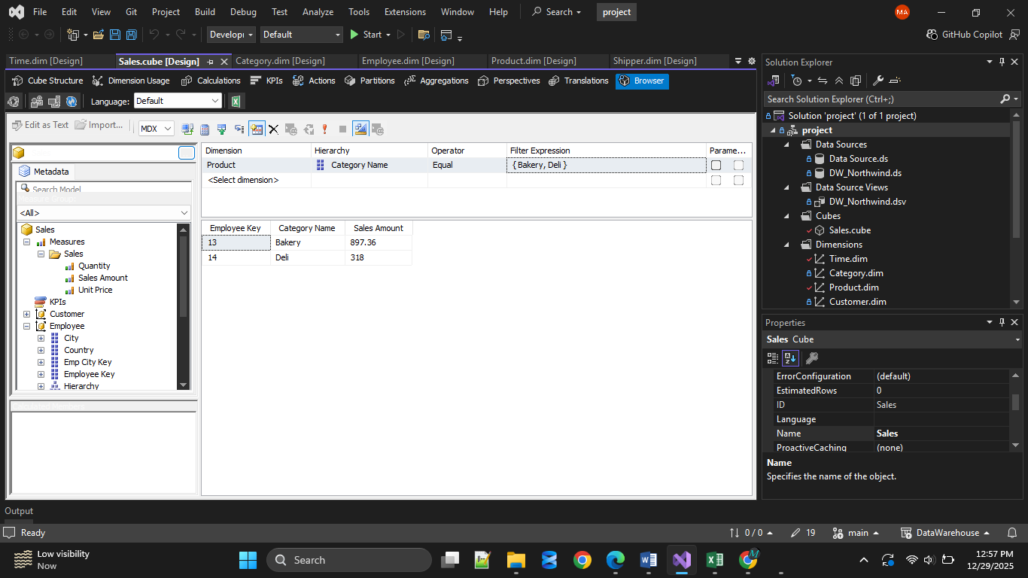
4.4 Analytical Questions (Must Answer Using Cube)
- Which employee generated the highest revenue in 2025?
Employee id : 12
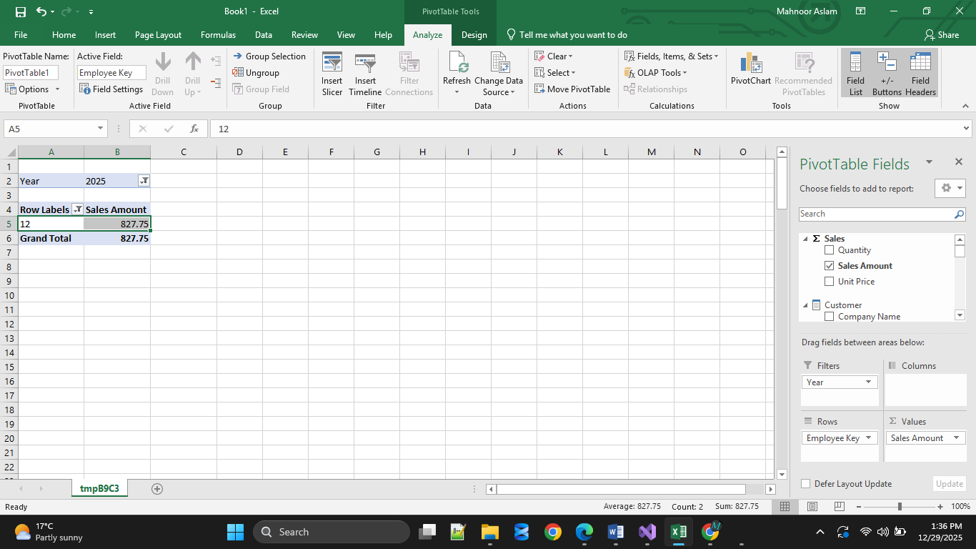
- Which category performed best each quarter?
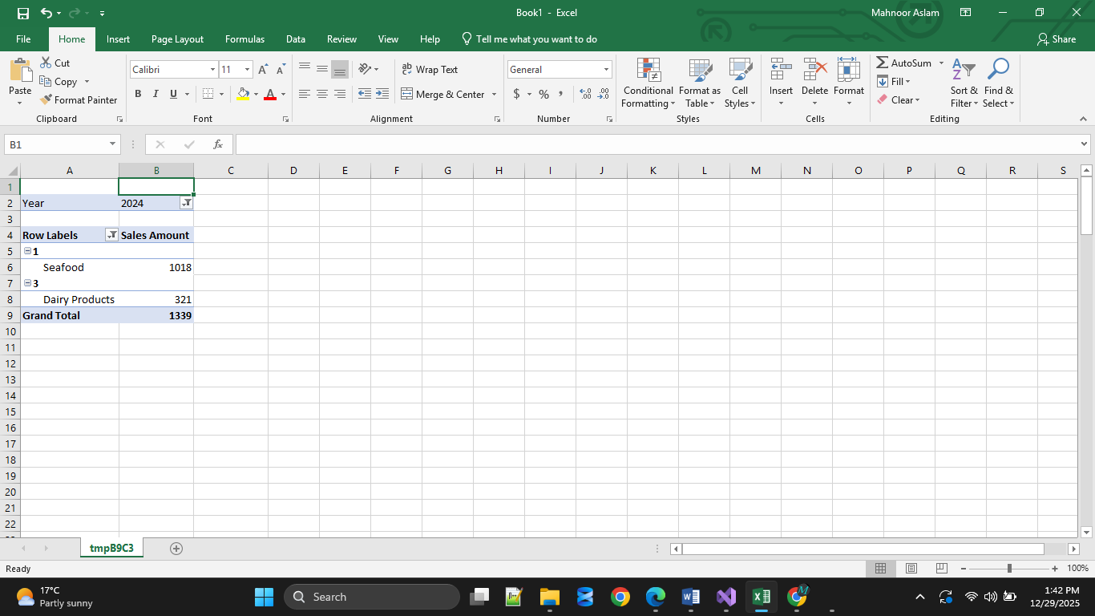
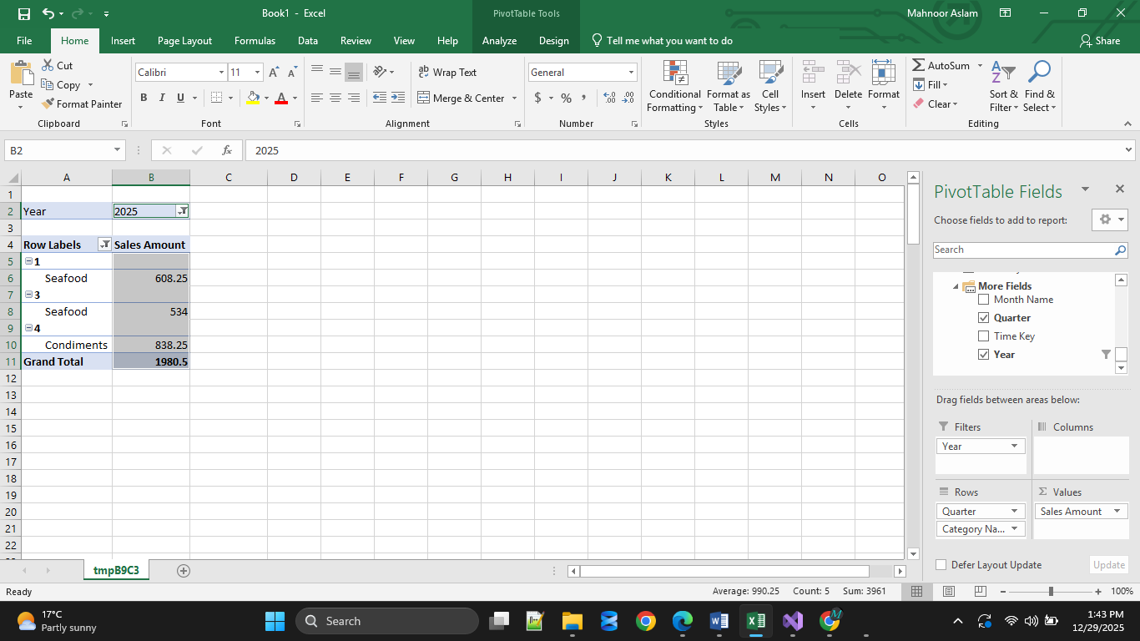

- Which supplier contributes most revenue within each category?
Northern Catch in Seafood.
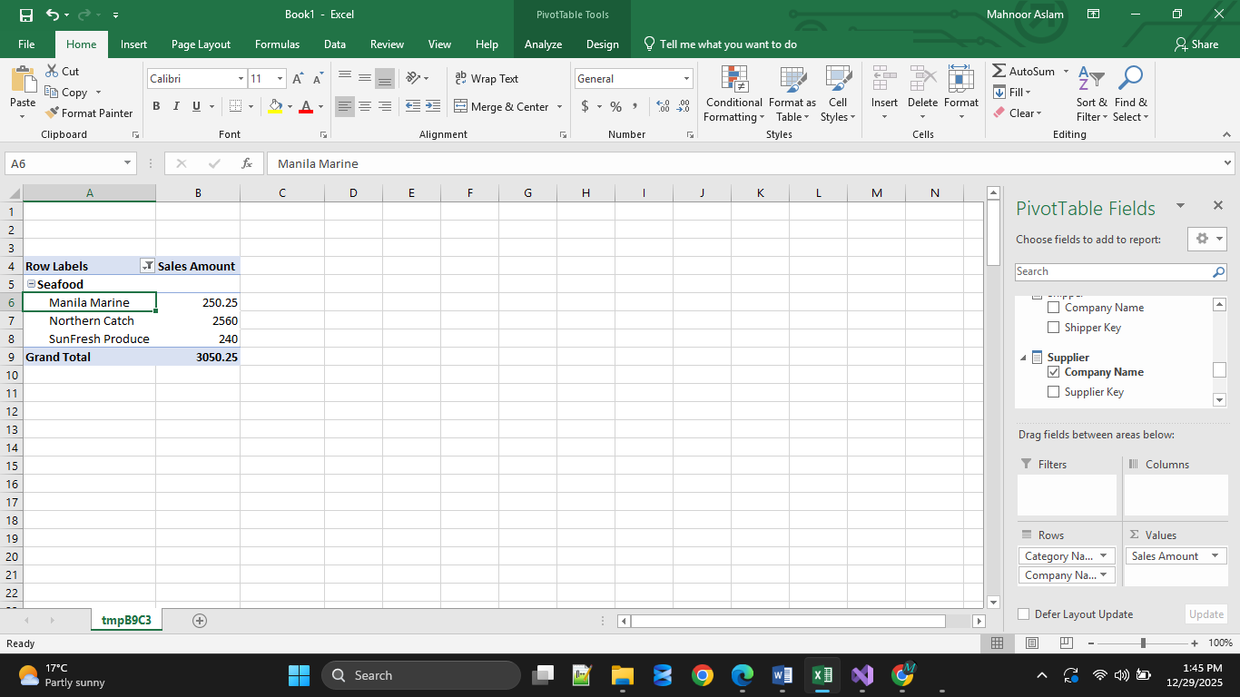
- Which shipper handles the most high-value orders?
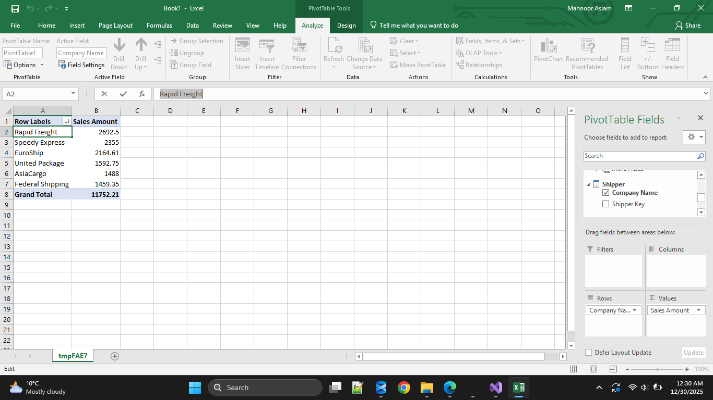
- Which product has the highest average order size?
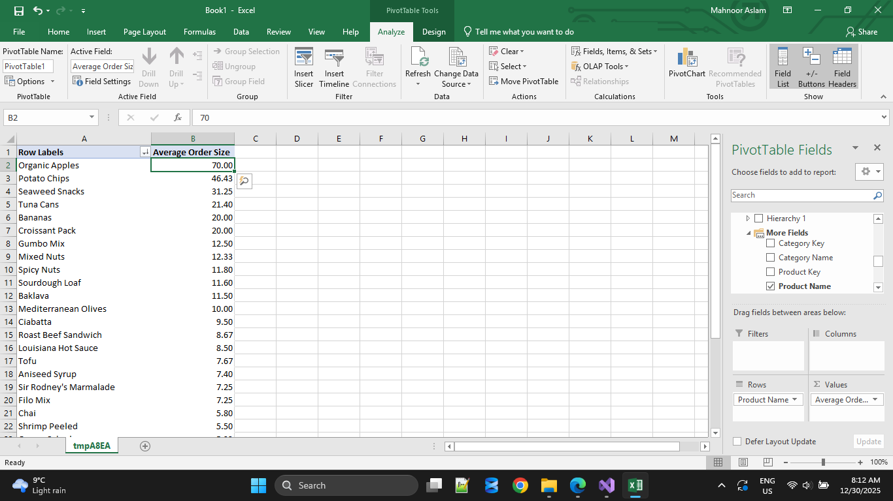

- Are male or female customers more profitable?
Female Customers
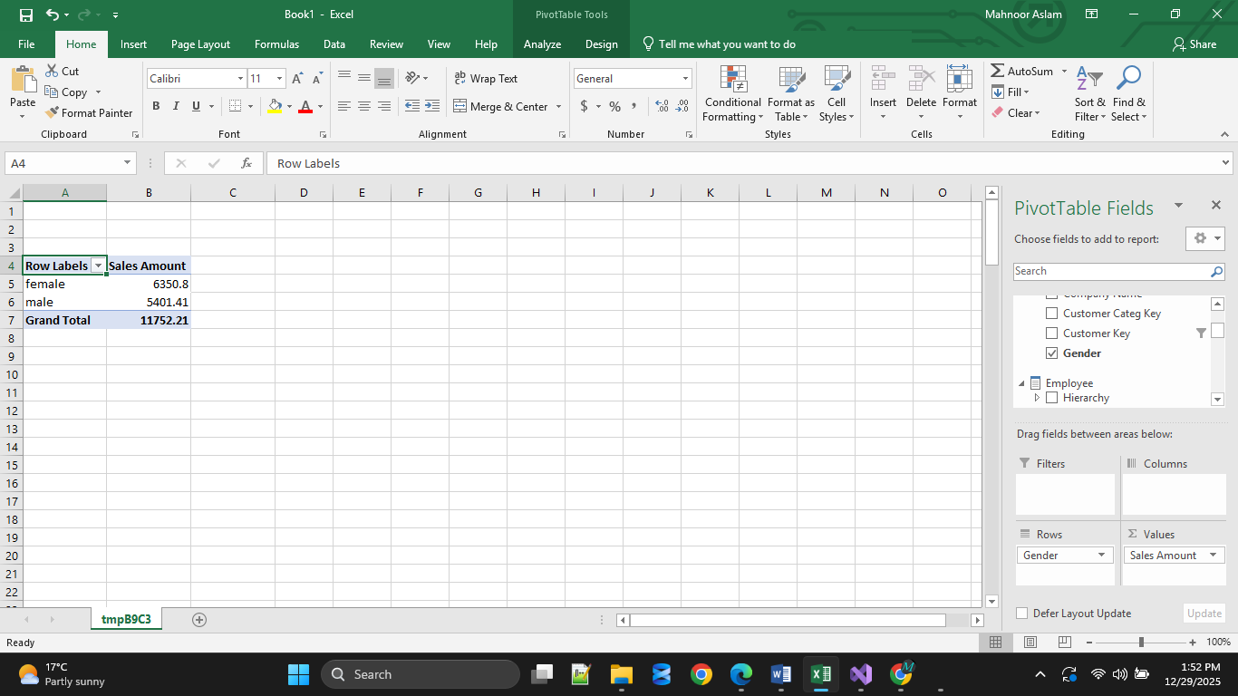
- Which months show unusual drops in sales?

March in 2025
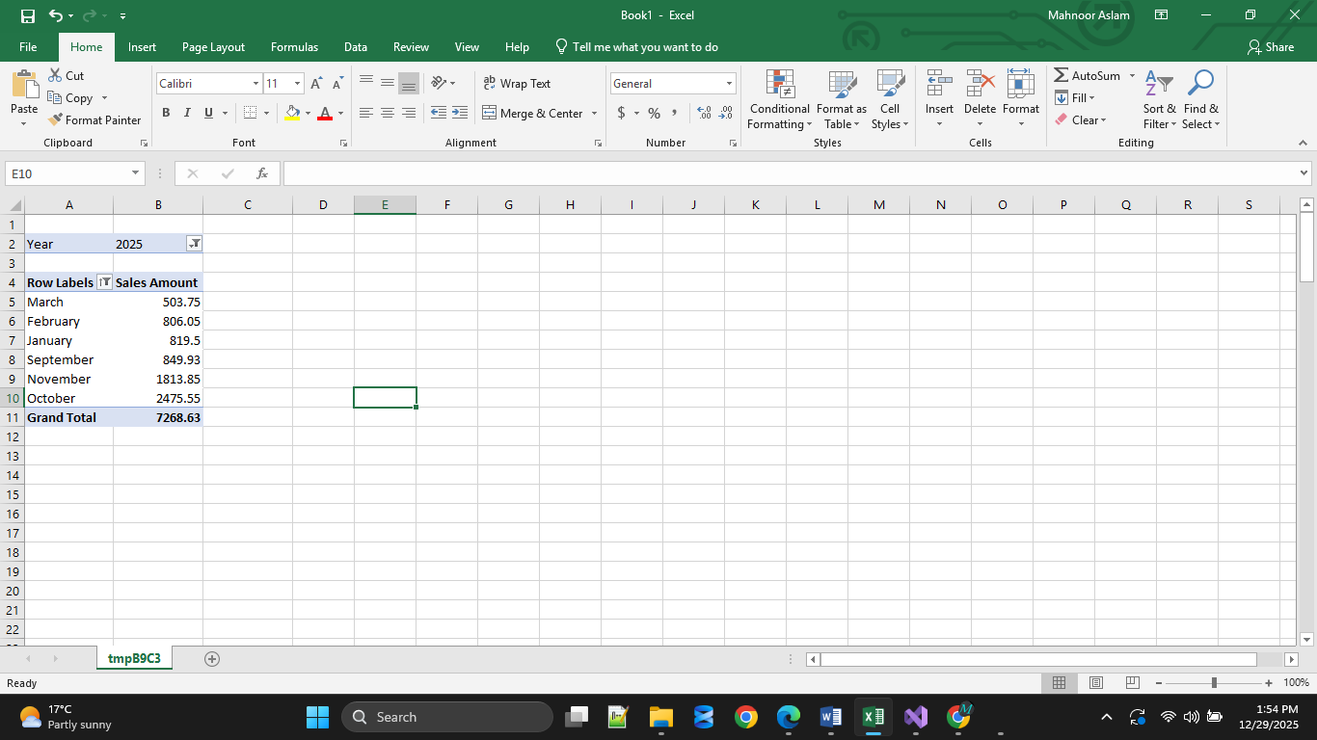
Aug in 2024
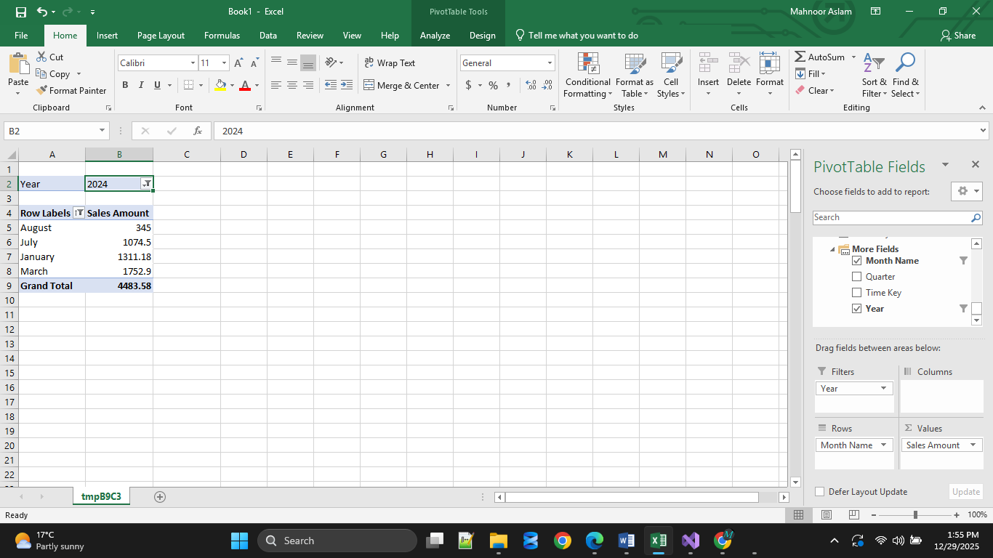

- Top 5 customers by revenue.
