A New Platform for Analysis of 5D Image and Meta data
Johan Henriksson*, Jurgen Hench, Thomas Burglin
Department of Biosciences and Nutrition, Karolinska Institute
* To whom correspondence should be directed, johan.henriksson@biosci.ki.se

There are several problems with the way imaging and analysis is done today. Our tools cannot handle the dimensionality of the data, files cannot easily be communicated, associated data like recording parameters gets lost and the repeatability of recordings can be questioned. Analyzing data is very labour intensive as it is still hard to batch process large amount of images or data without extensive programming. We have developed a platform consisting of open formats and new software that aims to solve these issues.

Introduction
During our work, we found ourselves spending more effort on getting the software and hardware to work rather than producing results. The problems were numerous; there was no agreement on how spatio-temporal recordings was to be made and the result were ad-hoc storage schemes and poor documentation of recording procedures. The defacto standard software for image analysis, ImageJ [IMAGEJ], could not easily be extended to handle our type of metadata and only 3 dimensional image data (with 3 channels) was supported. We started making our own very specialized solution but after realizing how common the problem was, we decided to produce something more general.

Design Criterias
The following requirements were set up:
- Ability to cope with at least 50GB imagesets or as large as can be fit on media (uncompressed)
- Full support for data and metadata
- Minimal restrictions on what type of images can be stored (DIC, fluorescence)
- Communicating data must be easy
- Extensible solution
- Simple storage and backup
- Easy processing of large amounts of data
- Lean solution in the sense that the sparsely available computer scientific resources in the biology/medical community should be enough to maintain and use the system

Solution
We came up with the following:
- A new open file format ”OST”
- A plugin framework and image analysis program ”EV”
- Utilities to record OST-images from proprietary microscopy programs
EV is designed to use OST but also supports proprietary formats. Likewise, adding OST support to new software is simple. Upgrading old microscopes to work with newer formats can be both simple and hard; we have simplified the process but there is more to be done. We give an example on how this can be done.

The OST imageset format
The problems with current imageset formats is that they are
- non-trivial to implement
- not scaling to very large imagesets
- unable to handle missing or left out images
- not meant to handle large amounts of non-image data
- lacking compression and strategies for incorporating future compression methods
- proprietary, limiting extensibility or utility
This left us with the only option to make our own format. It has been created based on our experience and we describe here the latest official version. All technical details have been left out; see the OST whitepaper for implementation technical details [OST].
An alternative to making a new file format is to create a database, using for example SQL [CITE OME HERE]. This approach has several problems; databases can be hard to install. It is not hard to produce several terabytes of data and these have to span several disks or be stored externally. This is not trivial to set up and doing backups of this amount of data is tricky. Furthermore, communicating data can be involved. With firewalls and limited bandwidth, it is in many cases easier to just send a DVD or upload entire datasets over night. This again creates a need for an intermediate format. Still, databases might be a good idea in the future but we judge that the disadvantages weigh over at the moment.
The requirement for a lean solution has forced us to use standards as far as possible. Images are stored one-by-one in a loosely specified file format. Directories are used to denote which channel, frame and slice (Z) an image belongs to, for example ”imageset-DIC/1/2.png” means slice 2 in frame 1 in channel DIC. Individual files means flexibility, speed and support for very large imagesets. If new better file formats come along that are widely supported, then standard libraries will be able to read them and the formats will be supported automatically. Suitable formats are as of writing PNG and JPEG, depending on if lossy or lossless compression is wanted.
For storage and backup purposes, support for lossy compression is a need. Our recordings are uncompressed in the range 30-40GB. As we make these on a daily basis, even 500GB-disks (normal size as of writing) would fill up in no time. By applying lossy compression images we do not intend to use for quantitative analysis such as DIC, we gain a factor 10x in size. This also means we now can fit a recording on a single DVD, currently one of the cheapest external medias for backup.
COMPRESSION BENCHMARKS?
General data is stored in an XML-file as libraries are widely available. There are clear rules on how additional data (and new types of data) are added to the imagesets. If there is only general data (not image data), then the single XML-file can make up the entire dataset without additional directory structure.

Adding OST Support to Proprietary Software
We first tried to access our microscope camera directly (Hamamatsu ORCA C4742-95-12ER with an Active Silion Snapper framegrabber) using the drivers but failed because of the very poor documentation. This seems to be a common situation and we will thus share our experience in how we worked around this.
Our lab uses Improvision OpenLab 4 but it crashes very often and the automation language is severely limited (our complaints about this have so far been ignored). It does however access the hardware and so we figured that we could use OpenLab itself as the driver (see figure PATH). The trick is to make an automation to 1. input all parameters 2. capture a single stack based on these 3. store stack in a well-defined location. Because of the crashes and limitations in the language, it is not feasibly to have OpenLab do anything more sophisticated than this. Instead, we wrote a script (using AppleScript and ...) that sends virtual key presses to OpenLab. Parameters can easily be fed into the dialogs using a key press-emulator. If a crash is detected, OpenLab is restarted by the script and work resumed. Since OST was made to allow gaps, these dropped images have minimal impact. Once the stack has been written to disk, it is carefully moved to another directory and renamed. Here we have another utility, the ”OST Daemon”, that asynchronously fetches image stacks (OpenLab TIFF) over the network, and saves them down in an OST-file with suitable compression level. Metadata is passed the same way, but written by the script; this way recording parameters are never lost.
It is unfortunate but from our experience this seems to be the easiest/only way to go if we wish to use common open formats. Getting drivers and specifications for existing hadware has proven to be hard, probably because there is no economic benefit once the hardware already has been sold. We therefore urge anyone considering to buy a new microscope to immediately require drivers and low-level specifications as this will make life much easier for all of us in the future.
FIG PATH: The microscope pathway
Microscope
OpenLab
AppleScript
OST Daemon
Disk

The Plugin Framework EV
The defacto standard image analysis program today, ImageJ, was not designed to handle the amounts of data and complexity considered here. For example, data may at most be 3D and not have more than 3 channels. ImageJ was never designed to handle metadata. Some plugins exist that partially removes these limitations but we have found them to integrate poorly [reference visbio etc here?]. It seemed to us that refactoring the fundamental design would be more work than rewriting the program from scratch. Hence we created EV.
Portability and ease of programming forced us to choose Java as the programming language. Standard tools and libraries like Swing, JAI, JNI, JavaCC, JDBC, JOGL, POI/HSSF, JFreeChart and JDOM were used in addition. The choice of language might make porting of plugins from ImageJ rather easy but this has not been verified yet.
The flexibility and batch processing requirement made us create plugin framework as opposed to a normal static program. Whenever a new type of data is added, it is easy to extend EV with custom data editors and render overlay information. An example of this is shown in figure [SHELLS] where embryo shells have been annotated with position and size.
[SHELLS PICTURE]
Data support was taken very seriously. EV treats image data the same way as generic data; images are supported by a plugin (albeit a very fundamental one). There are two ways of processing large amounts of data; either the built-in scripting language is used or EV is used as a library. The scripting language is suitable for simple jobs of the type ”apply F to all X” while the library approach is for heavy duty work, giving access to the entire Java language.
Several plugins have been made, but the collection is far from complete yet. For example, it is possible to generate QuickTime movies out of recordings, which are useful as summaries. Proprietary formats are supported through a plugin which in turn uses LOCI Bioformats [BIOF]. Custom data (data without a specified plugin) can be viewed and edited with a built-in XML tree and table editor.

Lineaging
Our current work relates to the cell lineage of C.elegans and we have made extensive plugins for this. This will serve as an example of what can be done with the plugin framework.
C.elegans is an earth-living nematode and has become a very successful model organism. One key feature is that cell division and differentiation is very [PUBLICATION ORDER] consistent between individuals. For this reason, a lot of effort has been spent on mapping which cells divide, when and what they become [SULSTON]. To map an expression or phenotype to a specific cell, extensive work is required to indentify the cell in question. The act of following cells during development is called lineaging and the complexity of doing this calls for software aid.
To the knowledge of the authors, the only existing program for (manual) lineaging is SIMI BioCell [SIMI]. It is however a rather costly proprietary program, growing old as it is made for Windows 3.1. The inability to modify the code as well as to run it on a modern system has forced us to make our own lineaging system. The EV lineaging plugin consists of the following parts:
- Basic data definition. This converts XML-data to an efficient data structure that is used internally by the rest of the plugin.
- Image window extension. The user performs lineaging by fitting circles to images and then moving them around. The data is hence both modified and presented in another plugin (the image window plugin) [FIG1].
- Model window extension. This is a 3D view and the plugin allows display and selection of the nuclei coordinates [FIG2].
- A new window, the Lineaging window. Here the division pattern is displayed as a tree. Name and parental relations can be modified [FIG3].
The process of adding new data type support is now rather linear and would probably be done in the order above. If data is only to be presented, then it all boils down to a few calls to the Java Swing library, commonly taught in a first course on programming. This gives us hope that even the biology community will be able to extend EV without too much effort and learning.

Migrating to OST and EV
Moving to OST is simpler the more structured your current data is. Unfortunately, the gain is higher the less structured it is. There are three ways of going; if the data is unstructured then it can be manually imported and converted in EV. If the image data is structured then the OST Daemon is a faster choice. Metadata can be added during or after conversion the same ways. If the data is written in CSV- and XLS-files, then there is a plugin that can be used. The potentially faster way is to use EV as a library for Java and make a custom importer but this of course requires a bit of programming.
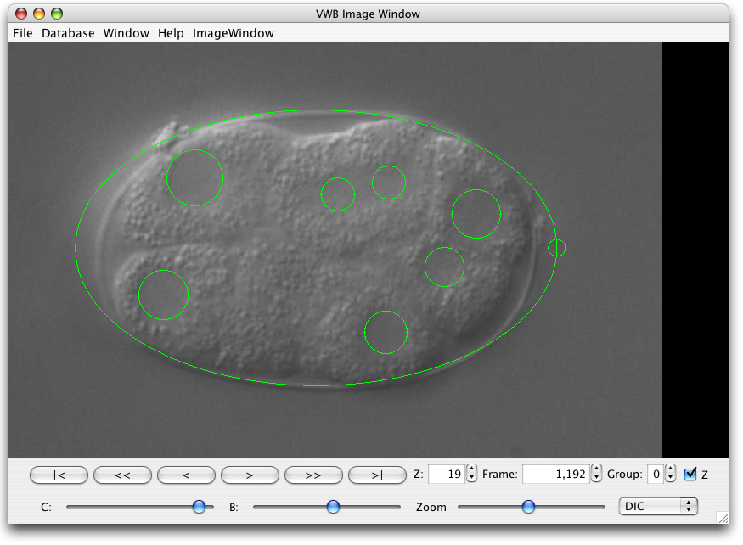FIG1 Cell outlines show on top of images
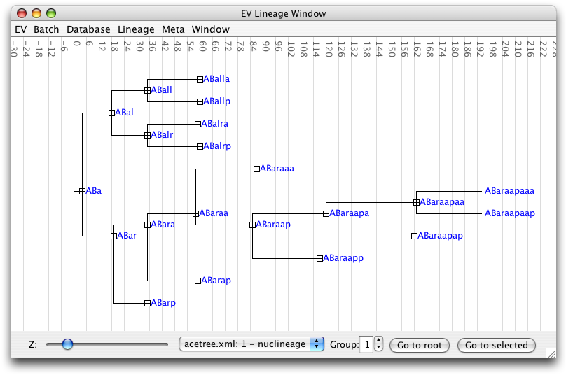FIG3 The lineage shown as a tree
REDO IMAGES
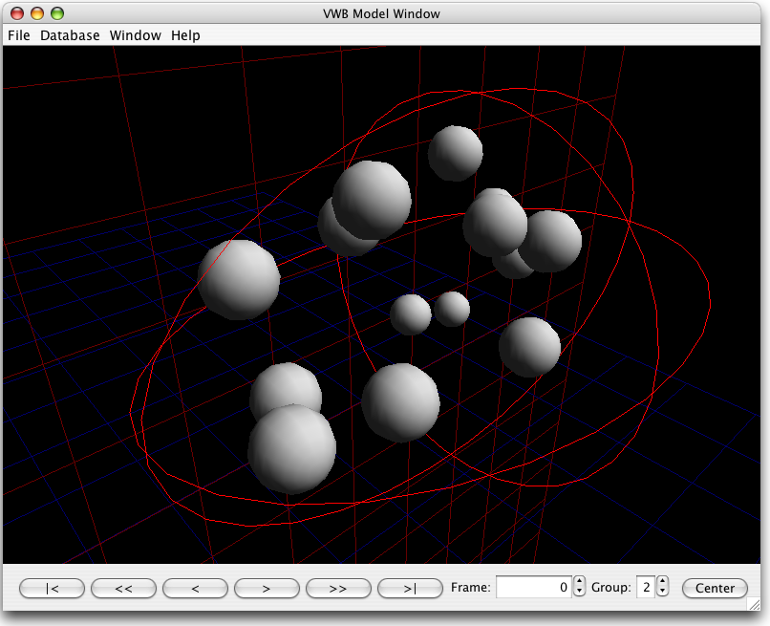FIG2 Cells displayed in 3D

Discussion
We have presented some key issues in microscopy and image analysis. These have been addressed through the introduction of a new file format and a framework for working with these files. We have proposed a method for adding support for OST to old microscopes when no drivers are available. As an example of how new types of data can be introduced, we have written an entirely new system to do lineaging of embryos, replacing an expensive special-purpose commercial program.
Our experience with the new system so far is very promising. A successful recording of a C.elegans embryo through-out development could take as long as a week to produce before we implemented our framework; now it is routine work and takes a day. Old data was stored in OpenLab PICT/TIFF-stacks and could barely be viewed. Since it was not compressed, data spanned several DVD's and in practice no one ever looked at the data. Quantitative analysis was difficult since recording settings were needed to understand the data and the storage format was not standardized. Now this data always follows the images and the convenient format combined with our software has turned viewing into a pleasure.
The lineaging plugin has turned out to be very easy to use and allows non-linear interaction. This is very important as several strategies are required to do efficient lineaging; adapting the process to fit a program is not an option; now most of the time is spent on learning to identifying the cells rather than learning the software itself.

Support
The success of a new system does not only depend technical merit but also if it is endorsed by enough users. We have collected some names for the latter:
Thomas Burglin, Staffan Strömblad?, Andrew Fire?, nov2k people? Ponti?

Division of Work
EV, as well as the current OST-format, was developed by J.Henriksson, who also wrote the article. J.Hench made substantial contributions to the specification of OST and EV, not to mention the pain-staking work of interfacing OpenLab to OST. T.Burglin initiated the project and acquired funding.

Acknowledgements
Martin ... has used numerous early versions and given very valuable feedback. Later on Konstantin ... also joined as a user. We have gained some valuable experience on lineaging user interface design from an early prototype developed by J.Koch and L.Meng.

References
[EV-web] Henriksson J, Burglin T (2007) VWB and EV Website, Karolinska Institutet, Sweden, http://celegans.sh.se
[OST] Hench J, Henriksson J, Burglin T (2007) The OST whitepaper http://celegans.sh.se:8020/yawiki/wiki.jz?page=yawiki:DocsImagesetSpec
[IMAGEJ] Rasband, W.S., ImageJ, (1997-2007) U. S. National Institutes of Health, Bethesda, Maryland, USA, http://rsb.info.nih.gov/ij/
[SIMI] Schnabel R, Hutter H, Moerman D & Schnabel H (1997) Assessing normal embryogenesis in Caenorhabditis elegans using a 4D microscope: variability of development and regional specification. Dev. Biol. 184, 234–265
[SULSTON]
[BIOF] LOCI Bioformats

PLOS Blurb
The lack of standardization in imaging is a major obstacle to research. We present new formats, new software and ways of upgrading your old microscope software.

PLOS Author Summaries
We ask that authors submitting revised manuscripts include a 150-200 word non-technical summary of the work as as a separate file, uploaded as Supporting Information, with the title "Author Summary". Subject to editorial review, this short text is published with all research articles as a highlighted text box.
Distinct from the scientific abstract, the author summary is included in the article to make findings accessible to an audience of both scientists and non-scientists. Ideally aimed to a level of understanding of an undergraduate student, the significance of the work should be presented simply, objectively, and without exaggeration.
Authors should avoid the use of acronyms and complex scientific terms and write the text using a first person voice. Authors may benefit from consulting with a science writer or press officer to ensure they effectively communicate their findings to a general audience. We encourage you to look at two examples of summaries currently online in PLoS Biology. These examples should help you determine the level we are aiming for:

CHECK
OME comparison?
ROIs, some image plugins
should we add recording strings?
MicroDaemon => OST Daemon?
- mention openlab OST hack, but not so much the details. light comes in next paper.
- this paper is the first; rotation follows later

