A New Platform for Analysis of 5D Image and Meta data
Johan Henriksson*, Jurgen Hench, Thomas Burglin
Department of Biosciences and Nutrition, Karolinska Institute
* To whom correspondence should be directed, johan.henriksson@biosci.ki.se

There are several problems with the way imaging and analysis is done today. Our tools cannot handle the dimensionality of the data, files cannot easily be communicated, associated data like recording parameters gets lost and the repeatability of recordings can be questioned. Analysing data is very labour intensive as it is still hard to batch process large amount of images or data without extensive programming. We have developed a platform consisting of open formats and new software that aims to solve these issues.

Introduction
During our work, we found ourselves spending more effort on getting the software and hardware to work rather than producing results. The problems were numerous; there was no agreement on how spatio-temporal recordings was to be made and the result were ad hoc storage schemes and poor documentation of recording procedures. The de-facto standard software for image analysis, ImageJ [IMAGEJ], could not easily be extended to handle our type of meta data and only 3 dimensional image data (with 3 channels) was supported. We started making our own very specialized solution but after realizing how common the problem was, we decided to produce something more general.

Design Criteria
The following requirements were set up:
- Ability to cope with at least 50GB image sets or as large as can be fit on media (uncompressed)
- Full support for data and meta data
- Minimal restrictions on what type of images can be stored (DIC, fluorescence)
- Communicating data must be easy
- Extensible solution
- Simple storage and backup
- Easy processing of large amounts of data
- Lean solution in the sense that the sparsely available computer scientific resources in the biology/medical community are enough to maintain and use the system.

Solution
We developed the following:
- A new open file format ”OST”
- A plug-in framework and image analysis program ”EV”
- Utilities to record OST-images through proprietary microscopy programs
EV is designed to use OST but also supports proprietary image and data formats. Likewise, adding OST support to new software is simple. Upgrading old microscopes to work with newer formats can be both simple and hard; we have simplified the process but there is more to be done. We give an example on how this can be done.

The OST image set format
Currently available image set formats are
- non-trivial to implement
- not scaled to very large image sets
- unable to handle missing or left out images
- not meant to handle large amounts of non-image data
- lacking compression and strategies for incorporating future compression methods
- proprietary, limiting extensibility or utility
This left us with the only option to create our own format. It has been developed based on our experience and we describe here the latest official version. All technical details have been left out; see the OST white-paper for implementation technical details [OST].
An alternative to making a new file format is to create a database, using e.g. SQL [CITE OME HERE]. This approach has several problems; databases can be hard to install. We currently generate several terabytes of data within short time. These amounts of data will span several physical disks and are likely to be stored externally. This is not trivial to set up and doing backups of large data volumes can be tricky. Furthermore, communicating data can be involved. With firewalls and limited bandwidth, it is in many cases easier to just send a DVD or upload entire datasets over night. This again creates a need for an intermediate format. Still, databases might be a good idea in the future but we judge that the disadvantages weigh over at the moment.
The requirement for a lean solution has forced us to use standards as far as possible. Images are stored one-by-one in a loosely specified file format. Directories are used to denote which channel, time frame and focal pane (Z-slice) an image represents, for example ”imageset-DIC/1/2.png” means Z-slice 2 in frame 1 of channel DIC. Individual files increase flexibility, speed and support for very large image sets. If new, more efficient file formats come along that are widely supported, then standard libraries will be able to read them and those formats will be supported automatically. Suitable formats are as of writing PNG and JPEG, depending on if lossy or lossless compression is preferred.
For storage and backup purposes, support for lossy compression is a need. Our current time lapse recordings are uncompressed in the range 30-40GB. As we obtain these on a daily basis, even 500GB-disks (normal size as of writing) would fill up in a short time time. By applying lossy compression to images we do not intend to use for quantitative analysis such as DIC, we gain a factor 10x in size. This also means we now can fit a recording on a single DVD, currently one of the cheapest external media for backup.
COMPRESSION BENCHMARKS?
General data is stored in an XML-file as libraries are widely available. There are clear rules on how additional data (and new types of data) are added to the imagesets. Others have successfully used the XML format to store meta data [REFERENCE OTHER COMMERCIAL Software]. In case of data sets that only contain general data without images then the single XML-file makes up the entire dataset without an additional directory structure.

Adding OST Support to Proprietary Software
We first tried to access our microscope camera directly (Hamamatsu ORCA C4742-95-12ER with an Active Silion Snapper framegrabber DIG-16) using the drivers but failed because of very poor documentation. This seems to be a common situation and we will thus share our experience in how we worked around this.
Our lab uses Improvision OpenLab 4 for microscope control. This software crashes very often and the automation language is severely limited. Our complaints to the manufacturer have mostly been ignored so far. However OpenLab contains bundled “black box type” drivers to access the hardware. We decided that we could use OpenLab itself as the driver (see figure PATH). Our workaround is to use an automation to input all parameters, to capture a single stack based on these and then to store stack in a well-defined location. Because of the crashes and limitations in the language, it is not possible and reliable to have OpenLab do anything more sophisticated than this. Instead, we wrote a light-weight script application that controls OpenLab through virtual key presses. If a crash is detected, OpenLab is restarted by the script and the time lapse recording is resumed. Since OST was made to allow gaps, dropped images due to software and hardware faults have minimal impact. Once an image stack has been written to disk, it is carefully moved to another directory and renamed. This task is performed by another utility, the ”OST Daemon”, that asynchronously fetches image stacks (OpenLab TIFF) over the network, and saves them in an OST-file with suitable compression level. Meta data is transferred the same way, the OST XML file is written by the our script. This ensures that recording parameters are never lost.
FIG PATH: The microscope pathway
Microscope
OpenLab
Script Appl.
OST Daemon
Disk
Our solutions may look unfortunate from a technical point of view. Yet, from our experience this seems to be the easiest and sometimes the only way if we wish to use common open formats. Retrieving drivers and specifications for existing proprietary hardware has proven to be hard, probably sue to the lack of economic benefits once the hardware has been sold. We can therefore urge anyone considering to buy a new microscope to immediately require drivers and low-level specifications as this will make life much easier for all of us in the future. [THIS SHOULD GO INTO THE DISCUSSION]

The Plugin Framework EV
The de-facto standard image analysis program today, ImageJ, was not designed to handle large amounts of data and the complexity considered here. For example, data may at most be 3D and not have more than 3 channels. ImageJ was never designed to handle meta data. Some plug-ins exist that partially bypass these limitations but we have found them to integrate poorly [reference visbio etc here?]. It seemed to us that changing the fundamental design would be more work than writing a program from scratch. Hence we created EV.
Portability and ease of programming forced us to choose Java as the programming language. Standard tools and libraries like Swing, JAI, JNI, JavaCC, JDBC, JOGL, POI/HSSF, JFreeChart and JDOM were used in addition. The choice of language might make porting of plugins from ImageJ rather easy but this has not been verified yet.
The flexibility and batch processing requirement made us create plug-in framework as opposed to a normal static program. Whenever a new type of data is added, it is easy to extend EV with custom data editors and render overlay information. An example of this is shown in figure [SHELLS] where embryo shells have been annotated with position and size.
[SHELLS PICTURE]
Data support was taken very seriously. EV treats image data the same way as generic data; images are supported by a plug-in (albeit a very fundamental one). There are two ways of processing large amounts of data; either through the built-in scripting language or EV is used as a library. The scripting language is suitable for simple jobs of the type ”apply F to all X” while the library approach is for heavy duty work, giving access to the entire Java language.
Several plug-ins have been made, but the collection is far from complete yet. For example, it is possible to generate QuickTime movies from of recordings, which are useful as previews and summaries. Proprietary formats are supported through a plug-in which in turn uses LOCI Bioformats [BIOF]. Custom data (data without a specified plug-in) can be viewed and edited with a built-in XML tree and table editor.

Lineaging
Our current work relates to the cell lineage of Caenorhabditis elegans and we have made extensive plug-ins for this. This will serve as an example of what can be done with the plugin framework.
C. elegans is an earth-living nematode which has become a very successful model organism in developmental biology and biomedical research. One key feature is that cell divisions and differentiation are rather [PUBLICATION ORDER] consistent between individuals. For this reason, a lot of effort has been put into mapping cell divisions, when and what they become [DEPPE 1977, SULSTON 1983, SCHNABEL 1996, Bao 2006]. To describe gene expression or phenotype occurring in a specific cell, extensive work is required to identify the cell in question. The act of tracking cells throughout development was termed lineaging and it's complexity calls for software aid.
To the knowledge of the authors, several manual lineaging tools have been created during the past decades such as Angler, 4Dviewer TBU, and SIMI BioCell [SIMI]. All have incommon that they are limited to nowadays unsupported image formats (e.g. Apple's PICT stacks) and updates for current desktop computer systems are not available. The latter program, is a rather costly proprietary program, designed to run under Windows 3.1. The inability to modify the code as well as to run it on a modern system has forced us to make our own lineaging system. The EV lineaging plug-in consists of the following parts:
- Basic data definition. This converts XML-data to an efficient data structure that is used internally by the rest of the plug-in.
- Image window extension. The user performs lineaging by fitting circles to images and then moving them around as cell positions and sizes change. The data is hence both modified and presented in another plugin (the image window plugin) [FIG1].
- Model window extension. This is a 3D view and the plug-in allows display and selection of the cell coordinates [FIG2].
- Lineaging window. Here the division pattern is displayed as a tree. Name and parental relations can be modified [FIG3].
The process of adding new data type support is rather linear and would probably be done in the order above. If data is only to be presented, then it all boils down to a few calls to the frequently used Java Swing library [References how commonly this lib. is used!]. This enables the community of biomedical research to extend EV without too much effort and learning.

Migrating to OST and EV
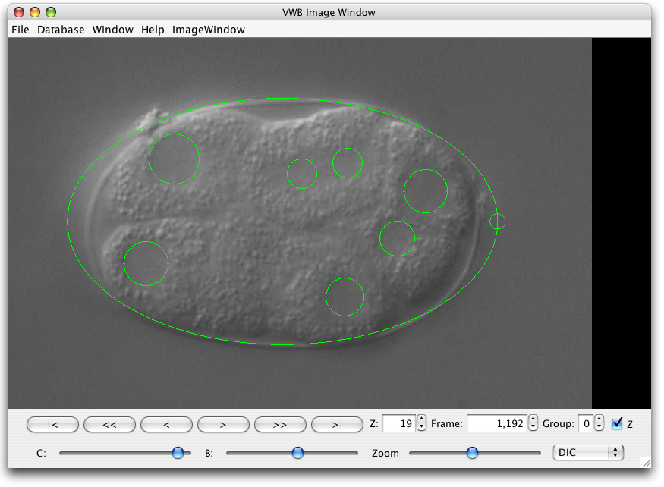FIG1 Cell outlines show on top of images
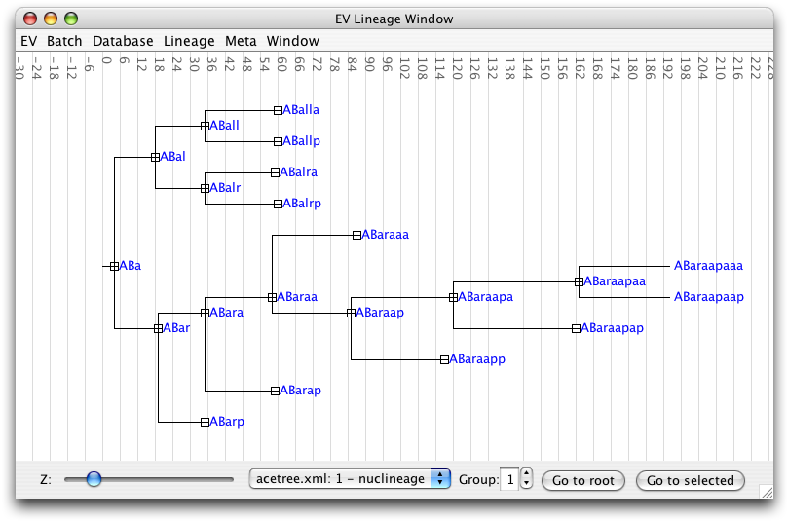FIG3 The lineage shown as a tree
REDO IMAGES
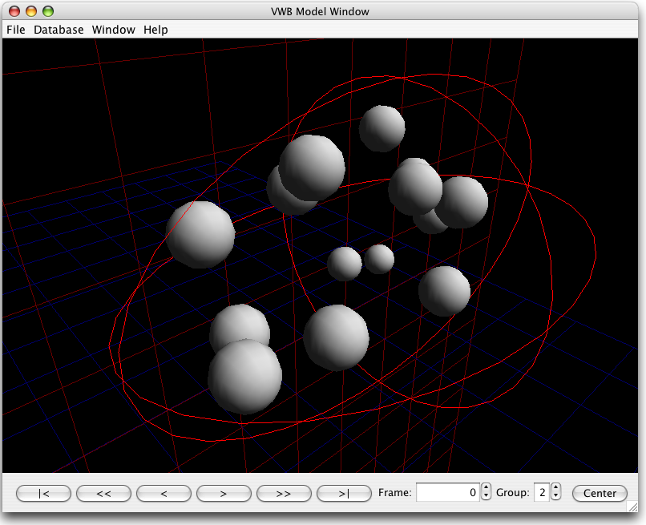FIG2 Cells displayed in 3D
Moving to OST is simpler the more structured your current data is. Unfortunately, the gain is higher the less structured it is. There are three ways of going; if the data is unstructured then it can be manually imported and converted in EV. If the image data is structured then the OST Daemon is the faster choice. Meta data can be added during or after conversion the same ways. We provide a plug-in for data stored in CSV- and XLS-files. The potentially faster way is to use EV as a library for Java and make a custom importer.

Discussion
We have presented key problems in automated multi-channel time lapse microscopy and image analysis. These have been addressed through the introduction of a new file format and a framework for working with these files. We have proposed a method for adding OST support to microscope setups for which no custmoizable drivers are available. As an example of how new types of data can be introduced, we have written a system to manually trace the lineage of C. elegans embryos, replacing an expensive special-purpose commercial program.
Our experience with the our new system is very promising. A successful recording of a C.elegans embryo through-out development could take as long as a week to produce and analyse before we implemented our framework; now it is routine work and takes a day. Previously recorded data was stored in OpenLab PICT/TIFF-stacks and could barely be viewed. Since it was uncompressed, data spanned several DVDs which made viewing tedious, impractical and slow. Quantitative analysis was difficult since recording settings are needed to evaluate the data. The storage format for image and meta data was not standardized. Our current automated approach saves the recording instructions for future use, all meta data and the images autonomously. We, the researchers, can now fully concentrate on the data interpretation and analysis rather than on data conversion and storage management.
The lineaging plug-in has turned out to be very easy to use and allows non-linear interaction. This is very important as several strategies are required to do efficient lineaging. Adapting the process to fit a program is not an option. Most of the time is spent on training to identify specific cells rather than learning to use the software itself.

Support
The success of a new system does not only depend technical merit but also if it is endorsed by a community of users. We have collected some names for the latter:
Thomas Burglin, Staffan Strömblad?, Andrew Fire?, nov2k people? Ponti?

Division of Work
EV, as well as the current OST-format, was developed by J. Henriksson, who also wrote the article. J. Hench made substantial contributions to the specification of OST and EV and wrote the OST interface script application to control the microscope through OpenLab. T. Burglin initiated the project and acquired funding.

Acknowledgements
M. Lüppert has used numerous early versions and given very valuable feedback. K. Cesnulevicius and K. Meemon also joined as a users. J. Dethlefsen helped maintaining nematode stocks and gave valuable feed-back regarding the user interface. We have gained some valuable experience on lineaging user interface design from prototype software developed by T. Bürglin, J. Koch and L. Meng.

References
[EV-web] Henriksson J, Burglin T (2007) VWB and EV Website, Karolinska Institutet, Sweden, http://celegans.sh.se
[OST] Hench J, Henriksson J, Burglin T (2007) The OST whitepaper http://celegans.sh.se:8020/yawiki/wiki.jz?page=yawiki:DocsImagesetSpec
[IMAGEJ] Rasband, W.S., ImageJ, (1997-2007) U. S. National Institutes of Health, Bethesda, Maryland, USA, http://rsb.info.nih.gov/ij/
[SIMI] Schnabel R, Hutter H, Moerman D & Schnabel H (1997) Assessing normal embryogenesis in Caenorhabditis elegans using a 4D microscope: variability of development and regional specification. Dev. Biol. 184, 234–265
[SULSTON]
[Deppe 1977]
[Bao 2006]
[BIOF] LOCI Bioformats
[OME] Goldberg I, C Allan J M Burel, D Creager, A Falconi, H Hochheiser, J Johnston, J Mellen, P K Sorger, and J R Swedlow (2005) The Open Microscopy Environment (OME) Data Model and XML File: Open Tools for Informatics and Quantitative Analysis in Biological Imaging. Genome Biol. 6:R47.

PLOS Blurb
The lack of standardization in imaging is a major obstacle to research. We present new formats, new software and ways of upgrading your old microscope software.

PLOS Author Summaries
We ask that authors submitting revised manuscripts include a 150-200 word non-technical summary of the work as as a separate file, uploaded as Supporting Information, with the title "Author Summary". Subject to editorial review, this short text is published with all research articles as a highlighted text box.
Distinct from the scientific abstract, the author summary is included in the article to make findings accessible to an audience of both scientists and non-scientists. Ideally aimed to a level of understanding of an undergraduate student, the significance of the work should be presented simply, objectively, and without exaggeration.
Authors should avoid the use of acronyms and complex scientific terms and write the text using a first person voice. Authors may benefit from consulting with a science writer or press officer to ensure they effectively communicate their findings to a general audience. We encourage you to look at two examples of summaries currently online in PLoS Biology. These examples should help you determine the level we are aiming for:

FOR NATURE
Nature biotech has a section on computational biology, otherwise Nature methods.
format: article. 150w abstract, 2500-3500w abstract+body
less than 30 references

CHECK
OME comparison?
ROIs, some image plugins
should we add recording strings?
MicroDaemon => OST Daemon?
- mention openlab OST hack, but not so much the details. light comes in next paper.
- this paper is the first; rotation follows later

