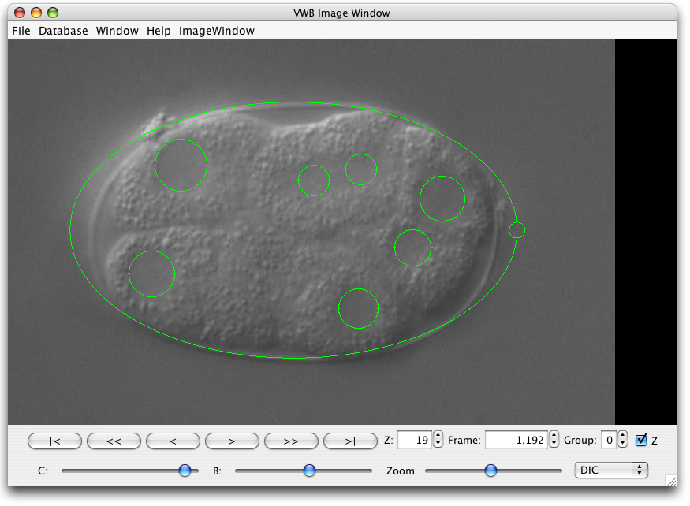FIG1 Cell outlines show on top of images
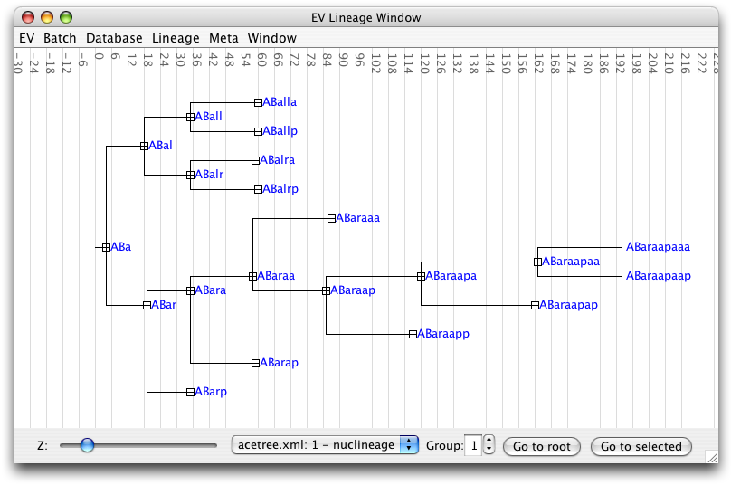FIG3 The lineage shown as a tree
REDO IMAGES
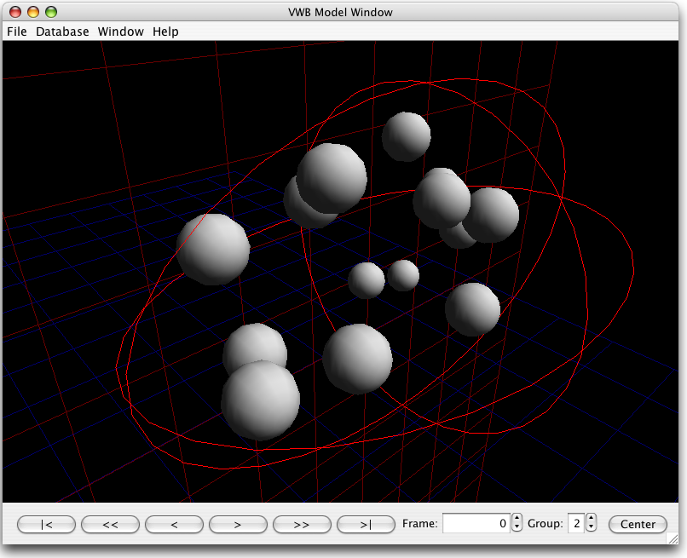FIG2 Cells displayed in 3D

Filters NEW SECTION
There is an elaborate system for image processing. A module that performs an operation on an image is usually called a “filter” (not to be confused with the mathematical notion of a filter). EV comes with for example edge detecting filters. Several filters can be linked into a “Filter Sequence” which can be stored and batch applied to several images. Making a new filter is simple and the shortest filter is only 40 lines of Java. Filters are strongly separated from the user interface, making it easy to invoke them from code or scripts. Images can be viewed with filters enabled without modification; hence there is no need to apply a filter to all images before browsing them which saves time. We know no other imaging software that offers this flexibility.

