nopCommerce邮件发送改造
nopCommerce系统的邮件发送,很多人都经常发不出去,比如腾讯邮箱,很难发送出去
将nopCommerce使用的.NET自带的邮件发送改为开源的MailKit,问题可以解决

本文使用的nopCommerce版本为3.6

首先在Nop.Services 引用MailKit

PM> Install-Package MailKit

修改 Nop.Services.Messages下EmailSender.cs文件为

using System;
using System.Collections.Generic;
using System.IO;
using System.Linq;
using Nop.Core.Domain.Messages;
using Nop.Services.Media;
using MimeKit;
using MailKit.Net.Smtp;

namespace Nop.Services.Messages
{
/// <summary>
/// Email sender
/// </summary>
public partial class EmailSender : IEmailSender
{
private readonly IDownloadService _downloadService;

public EmailSender(IDownloadService downloadService)
{
this._downloadService = downloadService;
}

/// <summary>
/// Sends an email
/// </summary>
/// <param name="emailAccount">Email account to use</param>
/// <param name="subject">Subject</param>
/// <param name="body">Body</param>
/// <param name="fromAddress">From address</param>
/// <param name="fromName">From display name</param>
/// <param name="toAddress">To address</param>
/// <param name="toName">To display name</param>
/// <param name="replyTo">ReplyTo address</param>
/// <param name="replyToName">ReplyTo display name</param>
/// <param name="bcc">BCC addresses list</param>
/// <param name="cc">CC addresses list</param>
/// <param name="attachmentFilePath">Attachment file path</param>
/// <param name="attachmentFileName">Attachment file name. If specified, then this file name will be sent to a recipient. Otherwise, "AttachmentFilePath" name will be used.</param>
/// <param name="attachedDownloadId">Attachment download ID (another attachedment)</param>
public virtual void SendEmail(EmailAccount emailAccount, string subject, string body,
string fromAddress, string fromName, string toAddress, string toName,
string replyTo = null, string replyToName = null,
IEnumerable<string> bcc = null, IEnumerable<string> cc = null,
string attachmentFilePath = null, string attachmentFileName = null,
int attachedDownloadId = 0)
{
var message = new MimeMessage();
//from, to, reply to
message.From.Add(new MailboxAddress(fromName, fromAddress));
message.To.Add(new MailboxAddress(toName, toAddress));
if (!string.IsNullOrEmpty(replyTo))
{
message.ReplyTo.Add(new MailboxAddress(replyToName, replyTo));
}

//密件抄送
if (bcc != null)
{
foreach (var address in bcc.Where(bccValue => !string.IsNullOrWhiteSpace(bccValue)))
{
message.Bcc.Add(new MailboxAddress("", address.Trim()));
}
}

//抄送
if (cc != null)
{
foreach (var address in cc.Where(ccValue => !String.IsNullOrWhiteSpace(ccValue)))
{
message.Cc.Add(new MailboxAddress("",address.Trim()));
}
}

var html = new TextPart("html")
{
Text = body
};

var alternative = new Multipart("alternative");
alternative.Add(html);
var multipart = new Multipart("mixed");
multipart.Add(alternative);

//添加邮件的附件
if (!string.IsNullOrEmpty(attachmentFilePath) &&
File.Exists(attachmentFilePath))
{

//附件
var attachment = new MimePart()
{
ContentObject = new ContentObject(File.OpenRead(attachmentFilePath), ContentEncoding.Default),
ContentDisposition = new ContentDisposition(ContentDisposition.Attachment),
ContentTransferEncoding = ContentEncoding.Default
};

if (!string.IsNullOrEmpty(attachmentFileName))
{
//attachment.FileName = attachmentFileName;
attachment.ContentDisposition.Parameters.Add("GB2312", "FileName", attachmentFileName);
}

#region 解决附件中文名称乱码情况
//var index = attachment.Headers.IndexOf(HeaderId.ContentDisposition);
//var disposition = attachment.Headers[index];
//disposition.SetValue("GB2312", disposition.Value);
#endregion

multipart.Add(attachment);
}

//another attachment?
if (attachedDownloadId > 0)
{
var download = _downloadService.GetDownloadById(attachedDownloadId);
if (download != null)
{
//we do not support URLs as attachments
if (!download.UseDownloadUrl)
{
string fileName = !String.IsNullOrWhiteSpace(download.Filename) ? download.Filename : download.Id.ToString();
fileName += download.Extension;

var attachment = new MimePart()
{
ContentObject = new ContentObject(new MemoryStream(download.DownloadBinary), ContentEncoding.Default),
ContentDisposition = new ContentDisposition(ContentDisposition.Attachment),
ContentTransferEncoding = ContentEncoding.Default
};

#region 解决附件中文名称乱码情况
//var index = attachment.Headers.IndexOf(HeaderId.ContentDisposition);
//var disposition = attachment.Headers[index];
//disposition.SetValue("GB2312", disposition.Value);
attachment.ContentDisposition.Parameters.Add("GB2312", "FileName", fileName);
#endregion

multipart.Add(attachment);
}
}
}
//content
message.Subject = subject;
message.Body = multipart;

//send email

using (var client = new SmtpClient())
{
client.Connect(emailAccount.Host, emailAccount.Port, emailAccount.EnableSsl);
client.AuthenticationMechanisms.Remove("XOAUTH2");
client.Authenticate(emailAccount.Username, emailAccount.Password);
client.Send(message);
client.Disconnect(true);
}
}
}
}

经测试腾讯企业邮箱和腾讯个人邮箱没有问题,其他的请自行测试
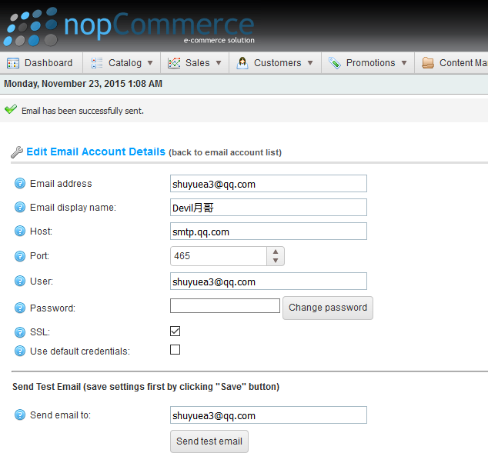
MailKit的资料大家可以去下面连接看看
网址 http://www.mimekit.net/
开源地址 https://github.com/jstedfast/MailKit

附件名称乱码https://github.com/jstedfast/MailKit/issues/264
2015年11月22日
Devil月哥

