Java Extra Practice 3

Name: Soham Mokashi

Roll no: 9919

Batch: C

Div: SE COMPS A

Q1)

Code:

import java.lang.\*;

import java.util.\*;

class valNum{

float num;

void chkNum(float x)

{

if(Math.abs(x)<1)

{

System.out.println("SMALL");

}

else

{

if(x>0)

{

if(x>1000000)

{

System.out.println("LARGE");

}

else

{

System.out.println("POSITIVE");

}

}

else

{

System.out.println("NEGATIVE");

}

}

}

}

class numChk

{

public static void main(String [] args)

{

Scanner sc=new Scanner(System.in);

System.out.println("Enter number :");

float n=sc.nextFloat();

valNum v1=new valNum();

v1.chkNum(n);

}

}

Output:

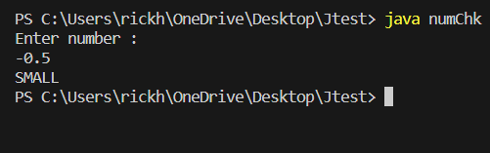

Q2)

Code:

import java.lang.\*;

import java.util.\*;

class Rose

{

float x,y,z;

void Test(float x, float y, float z)

{

if(y>x)

{

if(z>y)

{

System.out.println("ASCENDING ORDER");

}

else

{

System.out.println("RANDOM ORDER");

}

}

else

{

if(z<y)

{

System.out.println("DESCENDING ORDER");

}

else

{

System.out.println("RANDOM ORDER");

}

}

}

}

class chkOrder

{

public static void main(String [] args)

{

Scanner sc=new Scanner(System.in);

Rose r1=new Rose();

System.out.println("ENTER THREE NUMBERS");

float n1=sc.nextFloat();

float n2=sc.nextFloat();

float n3=sc.nextFloat();

r1.Test(n1,n2,n3);

}

}

Output:

