Maths1

Intro To Modular Arithmetic

Count Pair whose sum%m is 0

GCD

GCD(a, b)

Delete one to maximize GCD of all array elements

# Intro To Modular Arithmetic

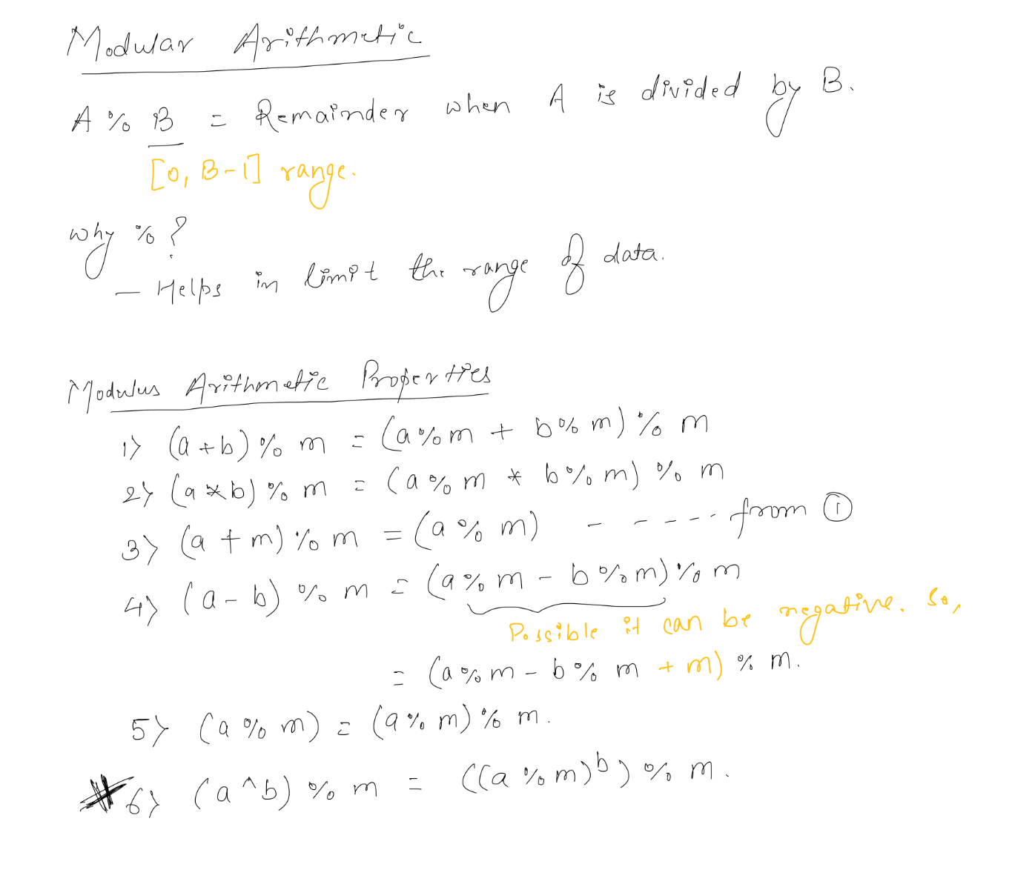

# 

# Count Pair whose sum%m is 0

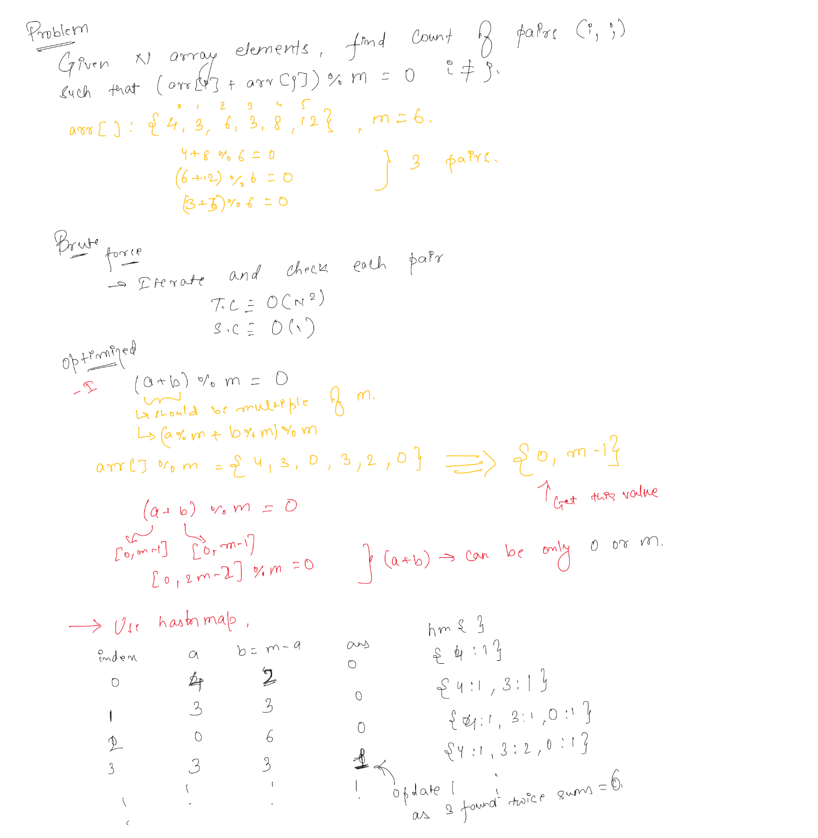

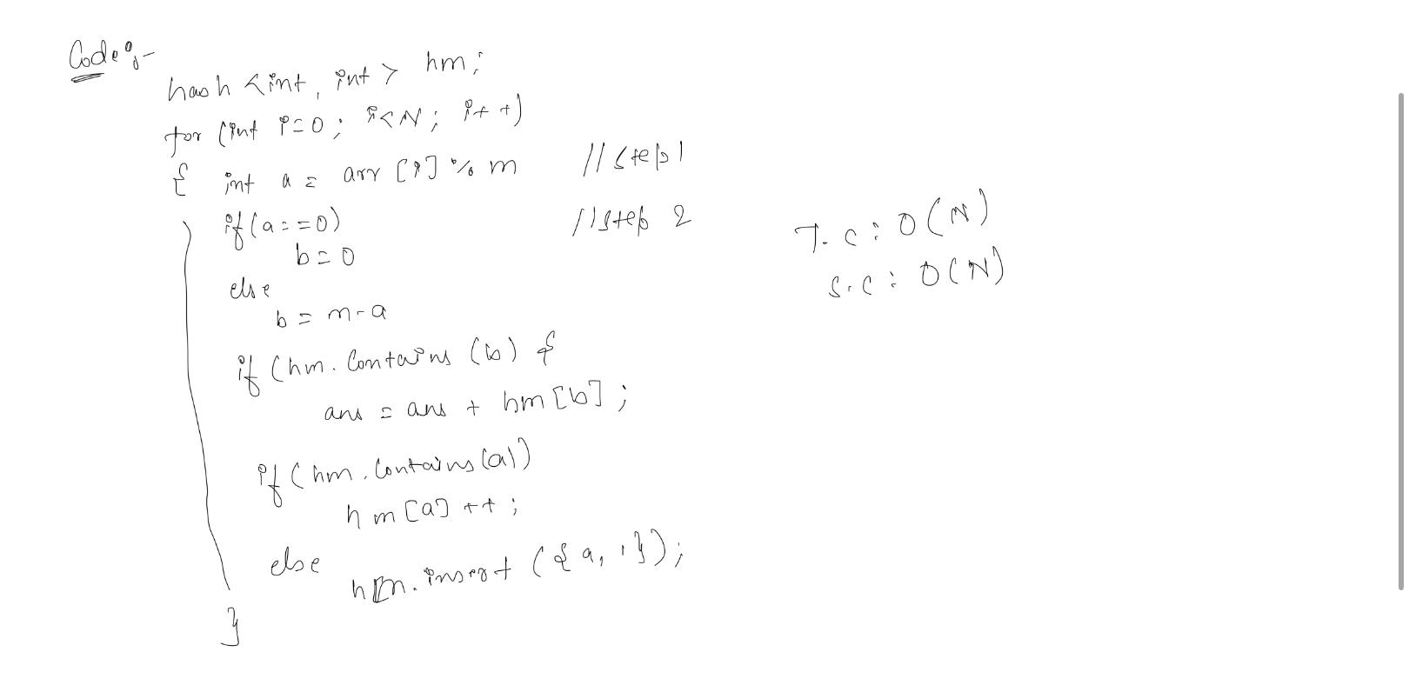

# GCD

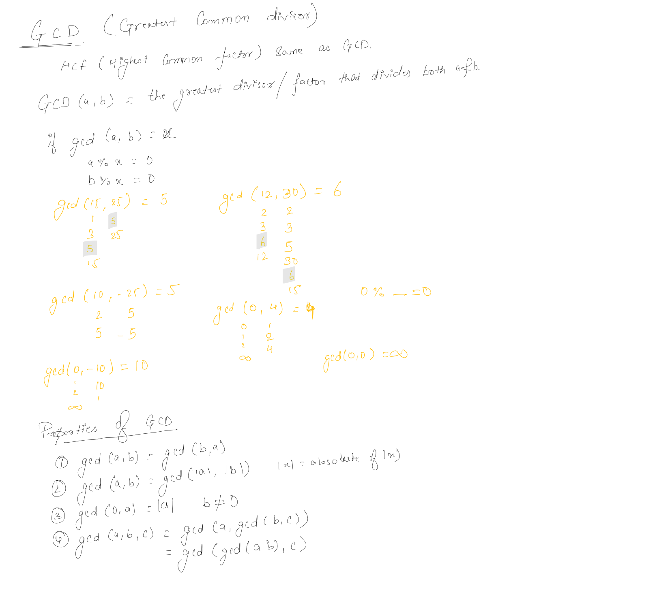

# GCD(a, b)

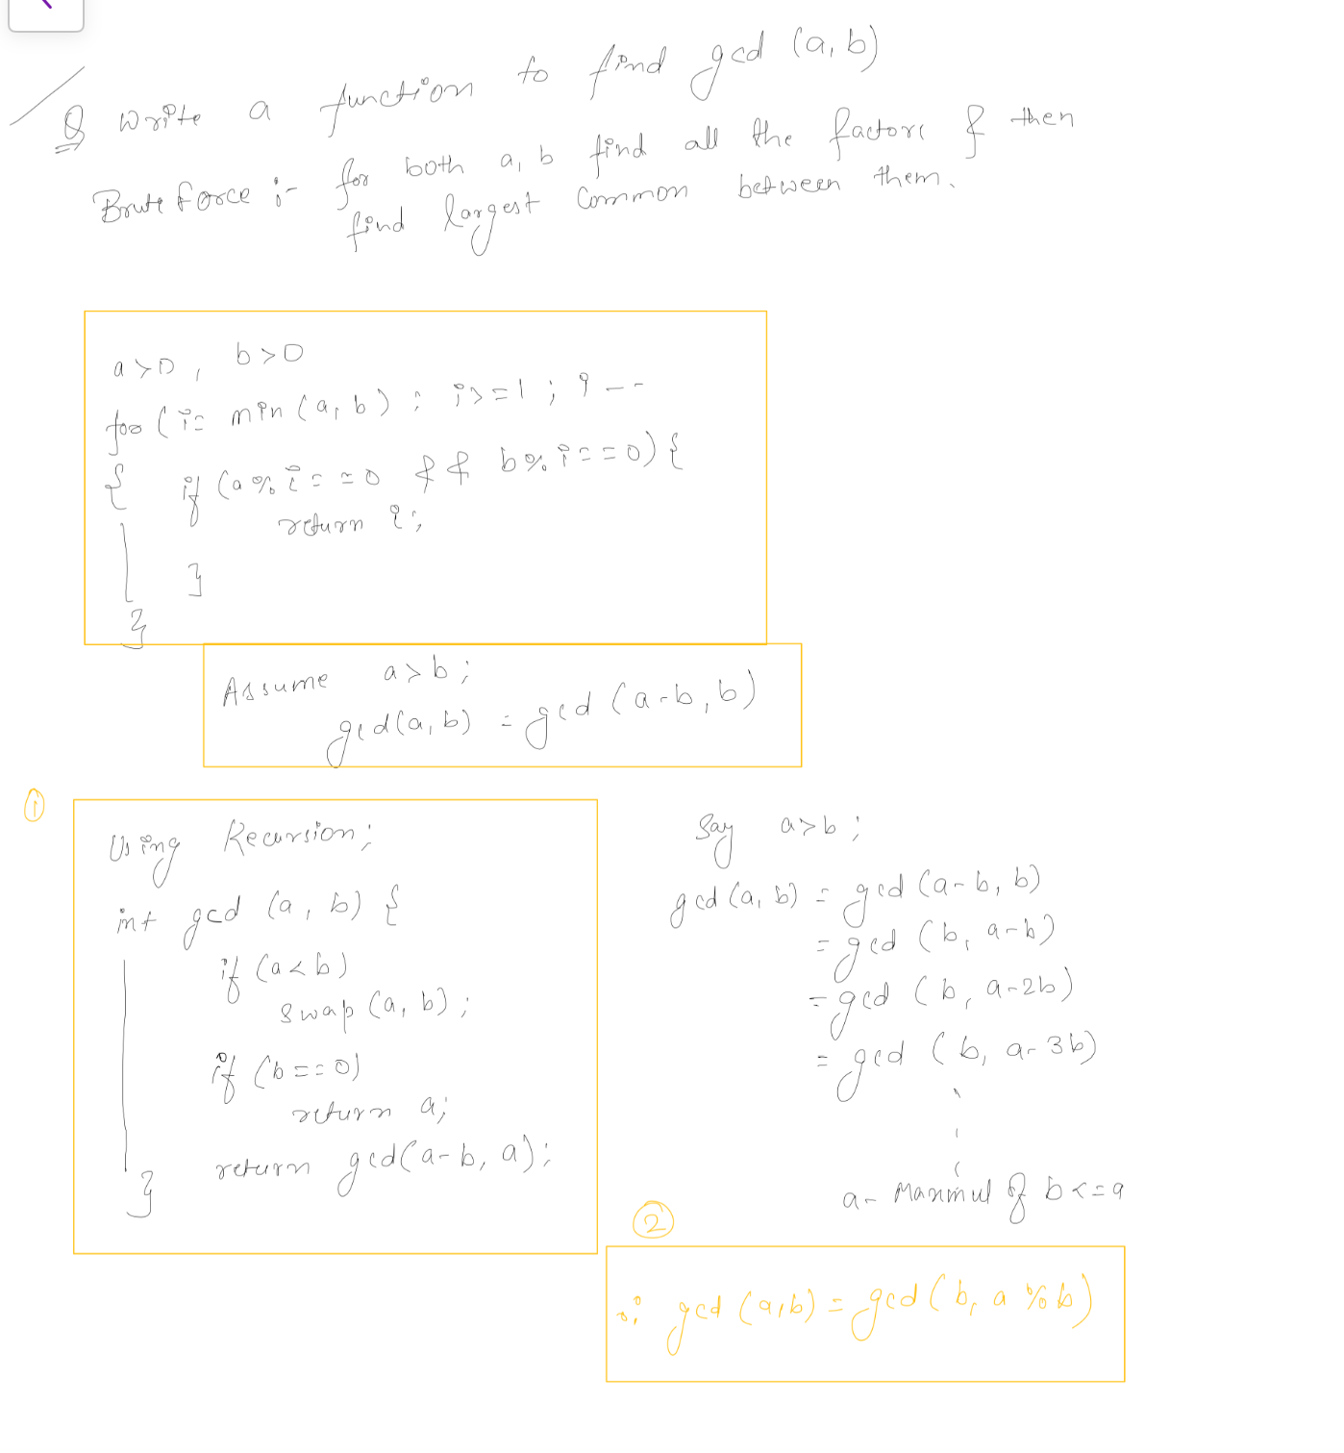

# 

# Delete one to maximize GCD of all array elements

