Addition and Multiplication Rule

Permutation

Combination

Pascal Triangle

Finding Nth column title in the excel sheet

# Addition and Multiplication Rule

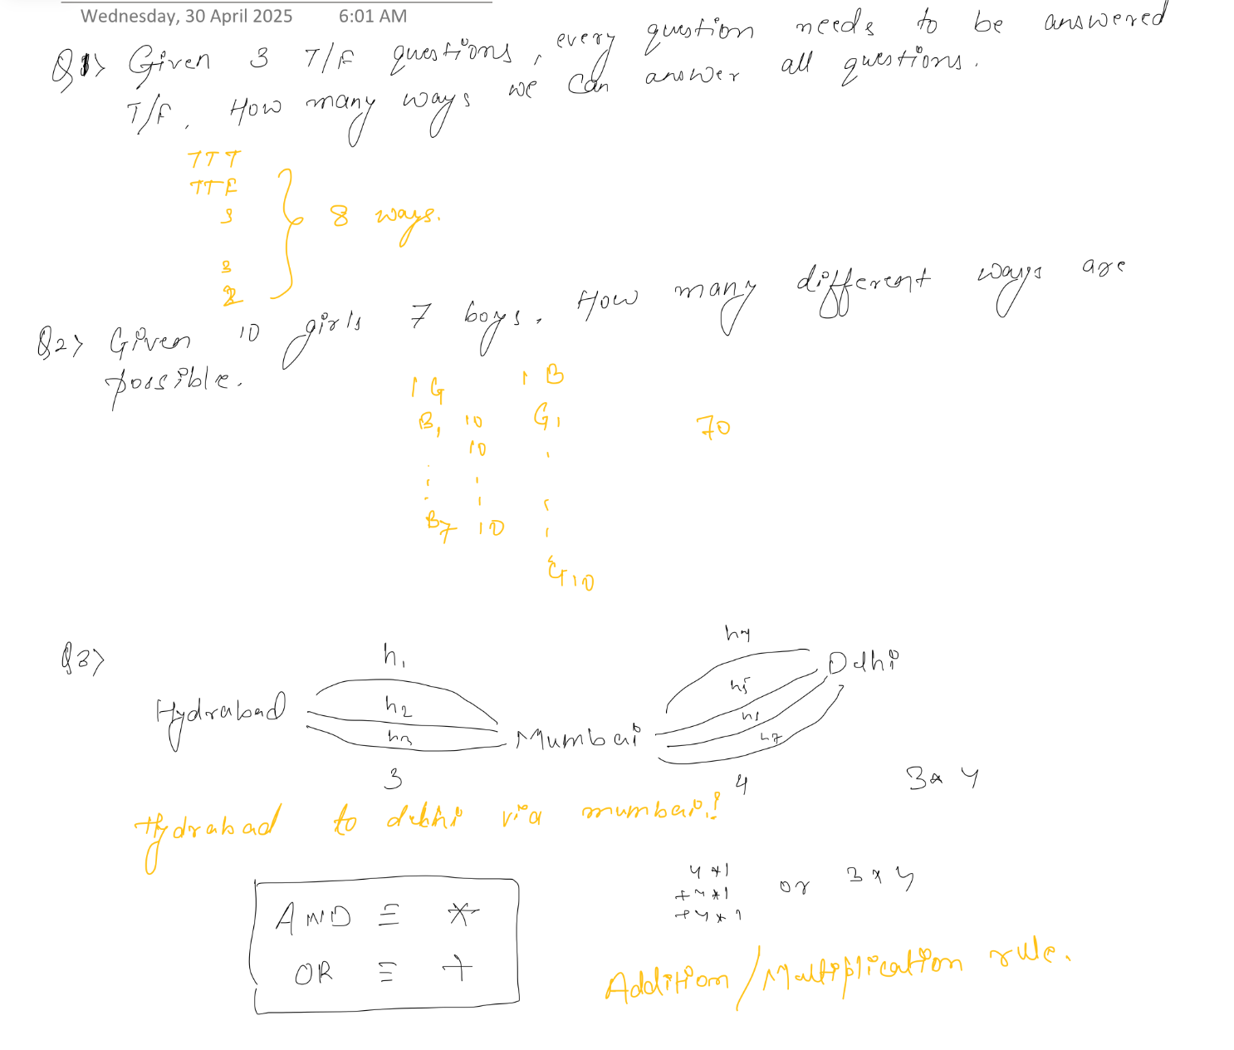

# Permutation

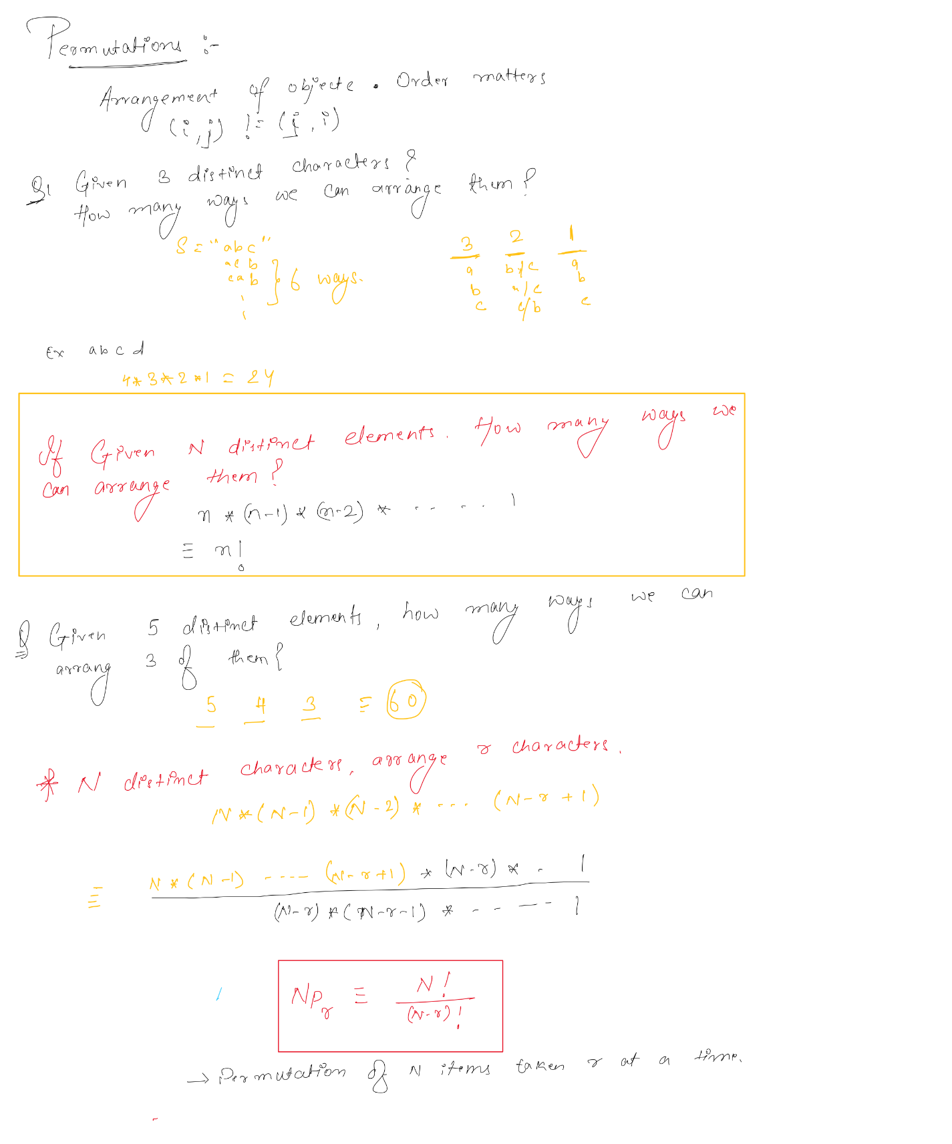

# Combination

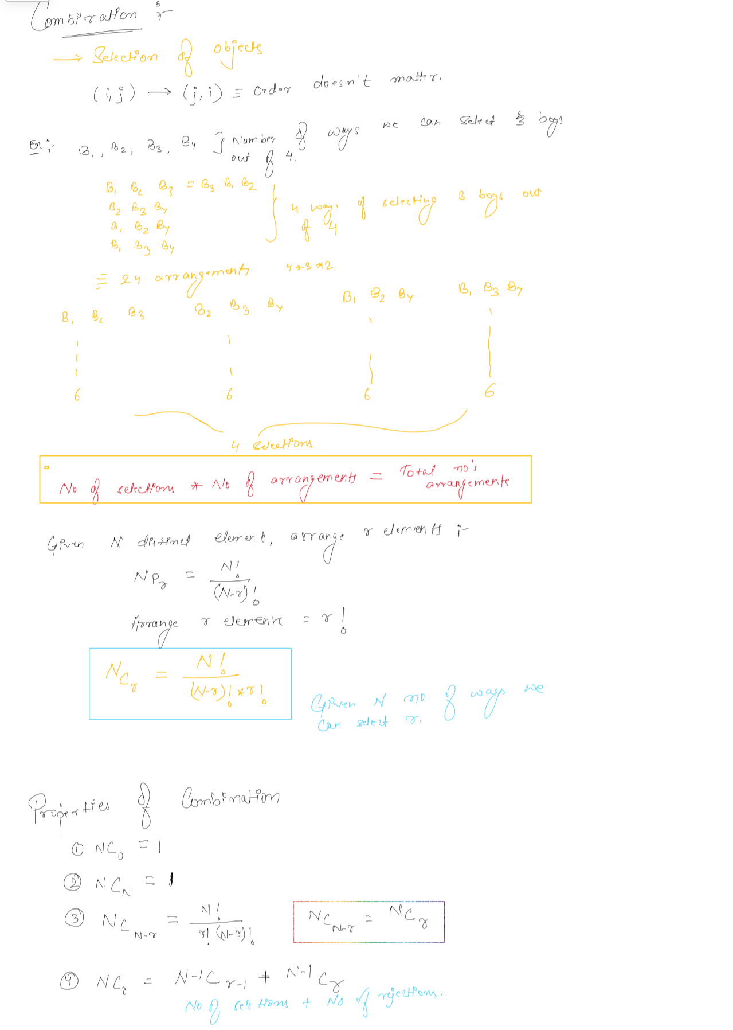

# Pascal Triangle

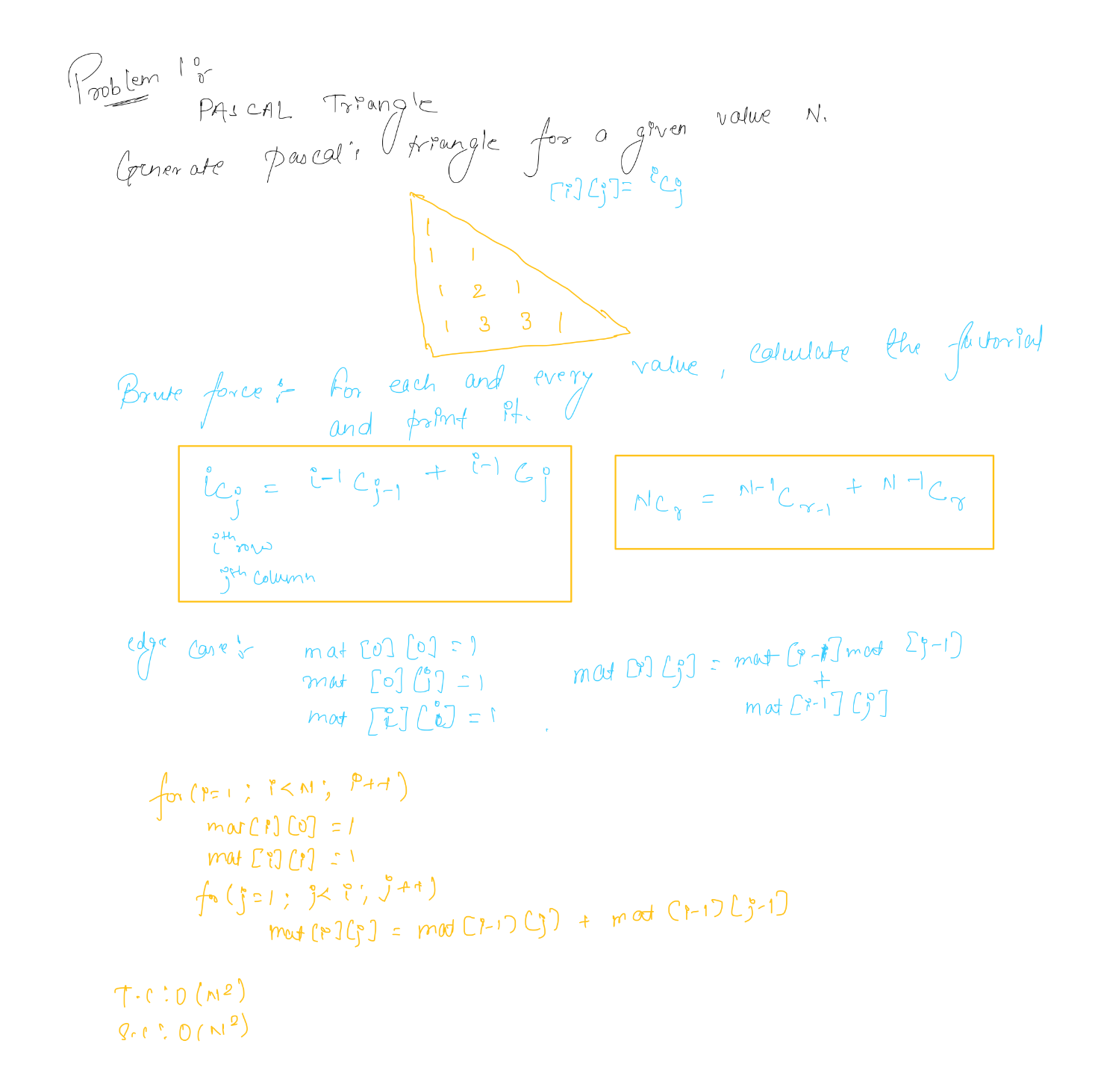

# Finding Nth column title in the excel sheet

