Recursion

Recursion - Introduction

Function Call Tracing

Problems

Time Complexity For Recursive Function

# Recursion - Introduction

* A function calling itself.
* Solving a problem using a smaller version of the same problems (subproblem).

3 Steps to implement Recursive code

* **Assumption:** Decide what your function does and assume that it does.
* **Main Logic:** Break down and solve problems using sub problems.
* **Base Condition:** Decide when your function should stop.

### Function Call Tracing

| Int add(N, M){  return (N+M)  }  Int Square(N){  Return N*N  }  Int twice(N){  Return 2*N  } | main(){  Int x = add(10, 20)  Int y = Square(x);  Int z = twice(y);  print(z);  }  main(){  print(twice square(add(10, 20)))  } |
| --- | --- |

**Add -> square -> twice**

**30 -> 900 -> 1800**

# Problems

**Problem 1:** Given N, find the factorial of N!

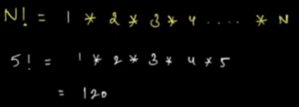

Assumption:

Int factorial(int N){

…..

}

Main Logic: Try to break the problem

N! = 1*2*3*4*5*6*7*.............*(N-1)*N

Base Condition:

When N==1, return 1;

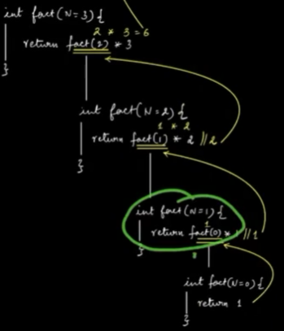 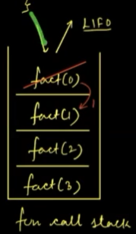

**Problem 2: Fibonacci Series / Sequence   
 Write a function to compute Nth Fibonacci**

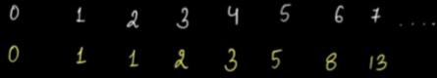

1. **Given N,** the function will calculate Nth Fib and return

int fib(int N){

………..

}

1. **Main Logic,**

return fib(N-1)+fib(N-2);

1. **Base Condition**

If (N == 0 || N == 1){

return N;

}

Function Call Trace:

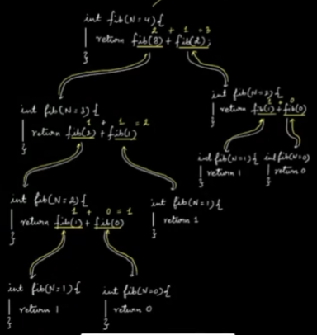

**Problem 3:**

**Given 2 integers a and N. Find a^N using Recursion.**

1. **Assumption:** given a and N, the function will calculate and return a^N.

Int pow(int a, int N){

…….

}

1. **Main Logic:**

a^N = a*a*a*.......................*a (N times)

Approach 1) a*pow(a, N-1);

Approach 2)

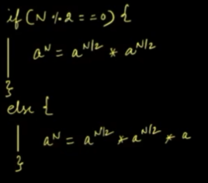

1. **Base Condition:**

if(N == 0){

return 1;

}

**Function Call Stack:**

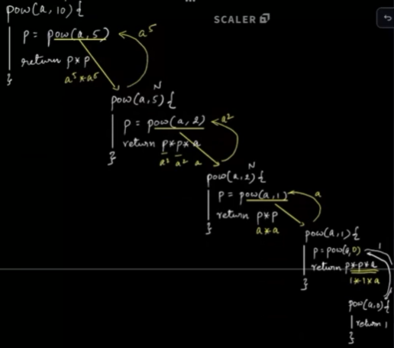

# Time Complexity For Recursive Function

* Use the substitution method to find the recursive Functions.

1. **For Factorial:**

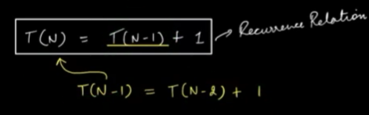

T(N) = T(N-1) + 1

T(N-1) = T(N-2) + 2

…………….

…………….

T(N) = T(N-K) + K

T(0) = 1

N-K = 0

**K=N**

**T.c = O(N)**

1. **For Pow Function**



T(N) = **2[T(N/2)] + 1;**

T(N/2) = 2[2T(N/4) + 1] + 1 = **4T(N/4) + 3**

…………………… = **8T(N/8) + 7**

………………….

Generalized Eqn : **T(N) = 2^K[T(N/2^K) + (2^K-1)]**

**N/2^K = 1**

**N = 2^K**

**K = logN**

**T.c = O(logN)**

* **Generalized Definition Of Time Complexity**

Time Complexity = No of Function Calls * Time Taken in a Single Function Call.