Trees 3

Intro To BST

Searching In BST

Insertion In BST

Deletion In BST

Construct A BST from Sorted Array

Check If given tree is a BST

# Intro To BST

# Searching In BST

# 

# Insertion In BST

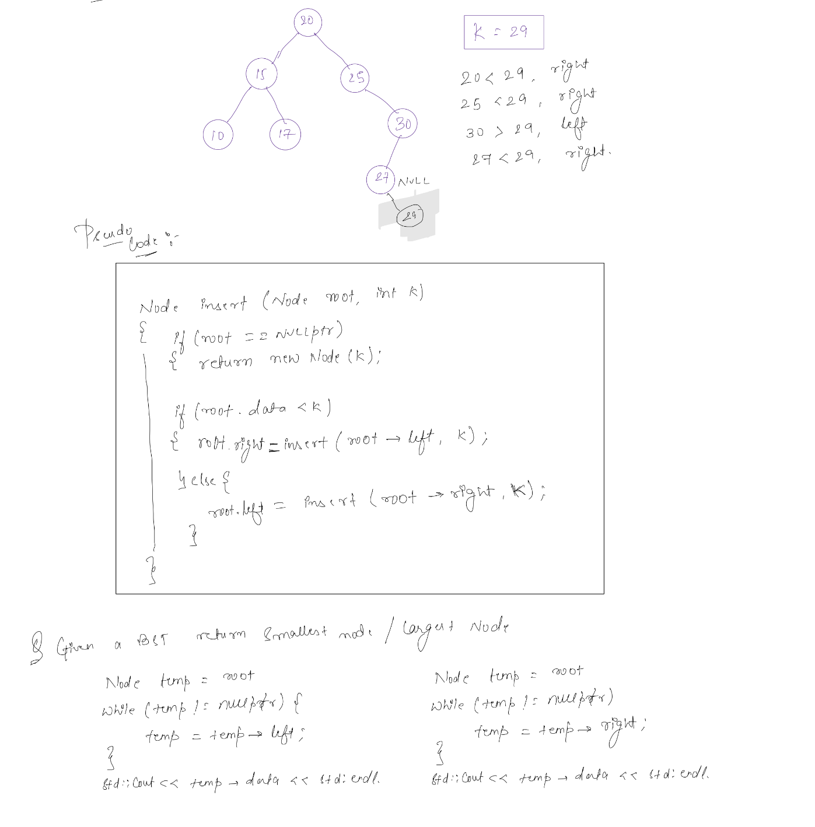

# Deletion In BST

# 

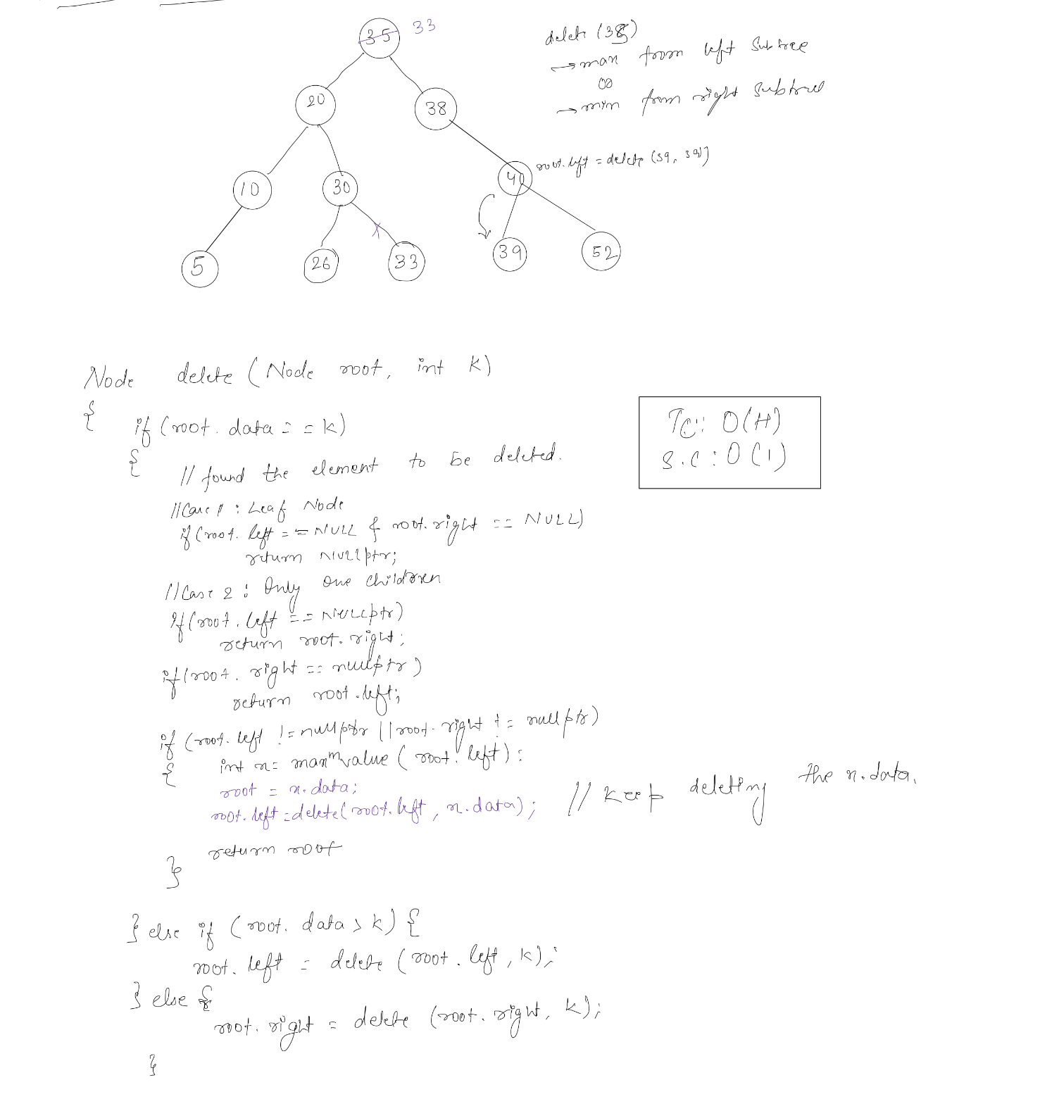

# Construct A BST from Sorted Array

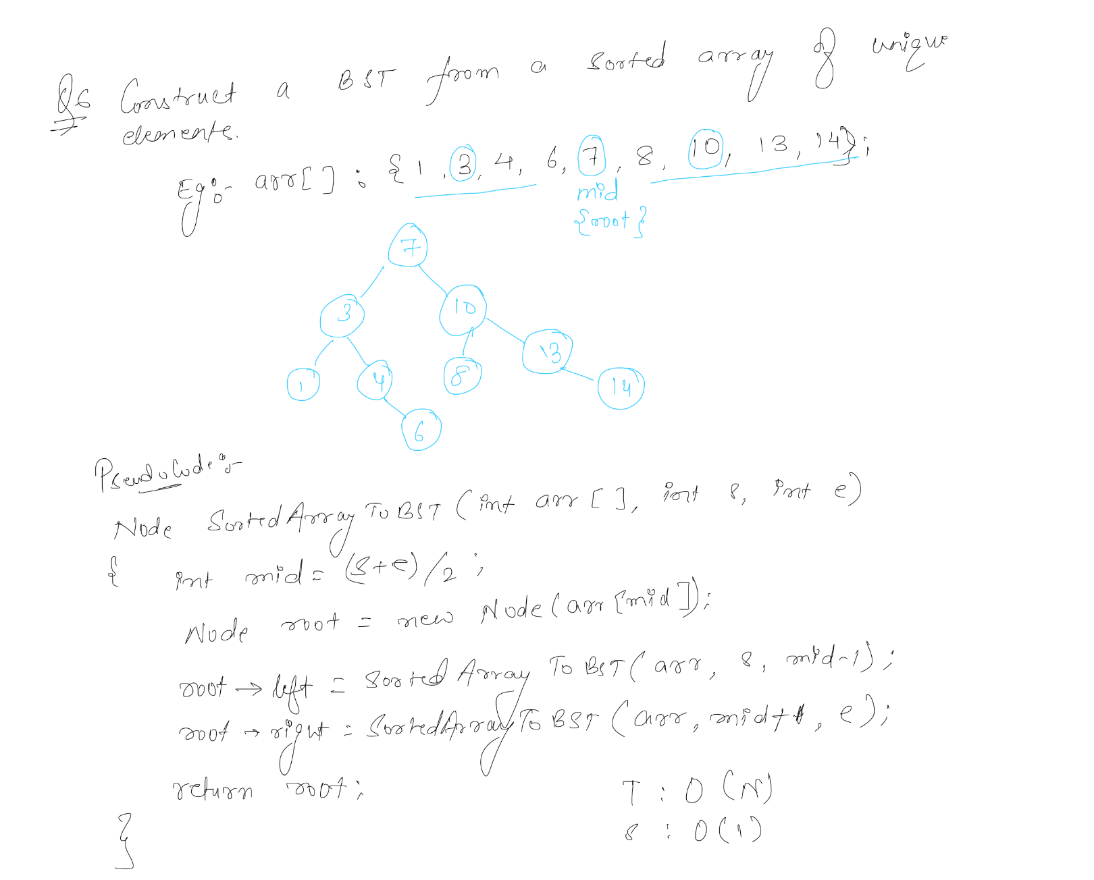

# Check If given tree is a BST

