Trees 4

Find Kth Smallest Element

Morris Traversal

Path from root to element’s node

LCA in B tree

In Time and Out time in a B tree

LCA(a, b) for multiple Queries

# Find Kth Smallest Element

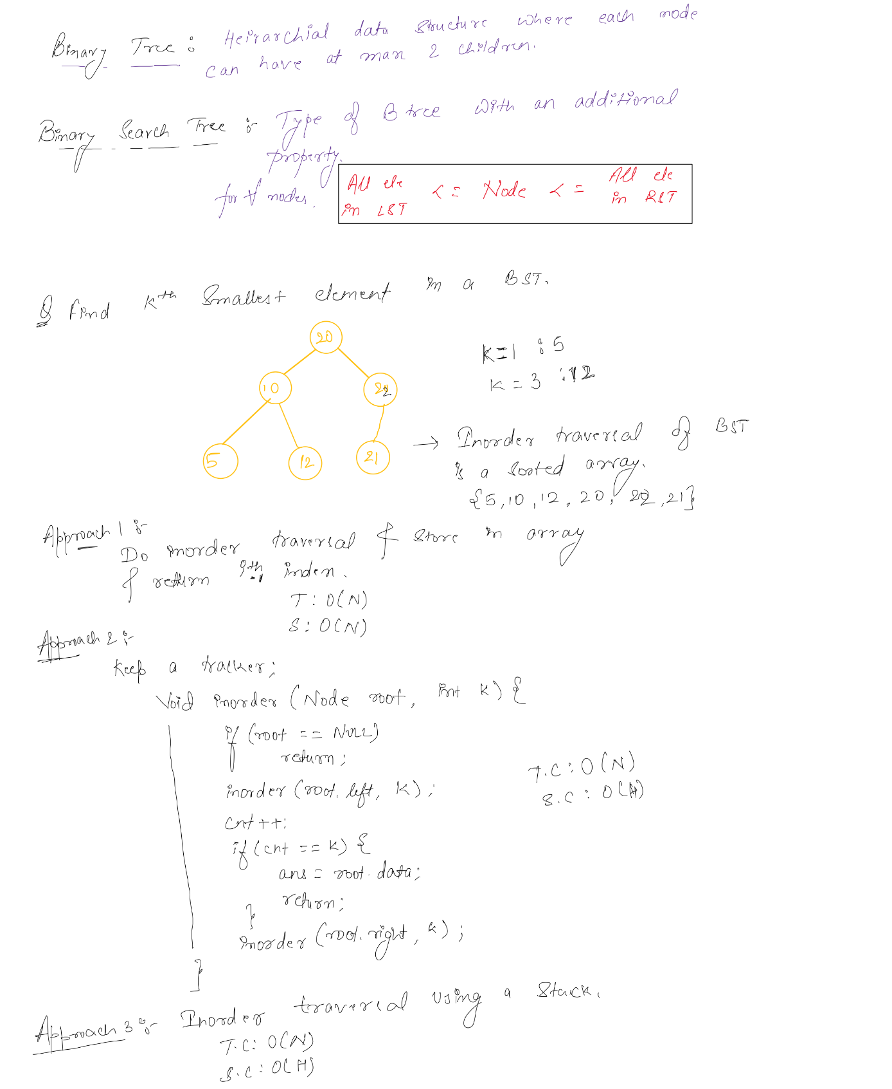

# Morris Traversal

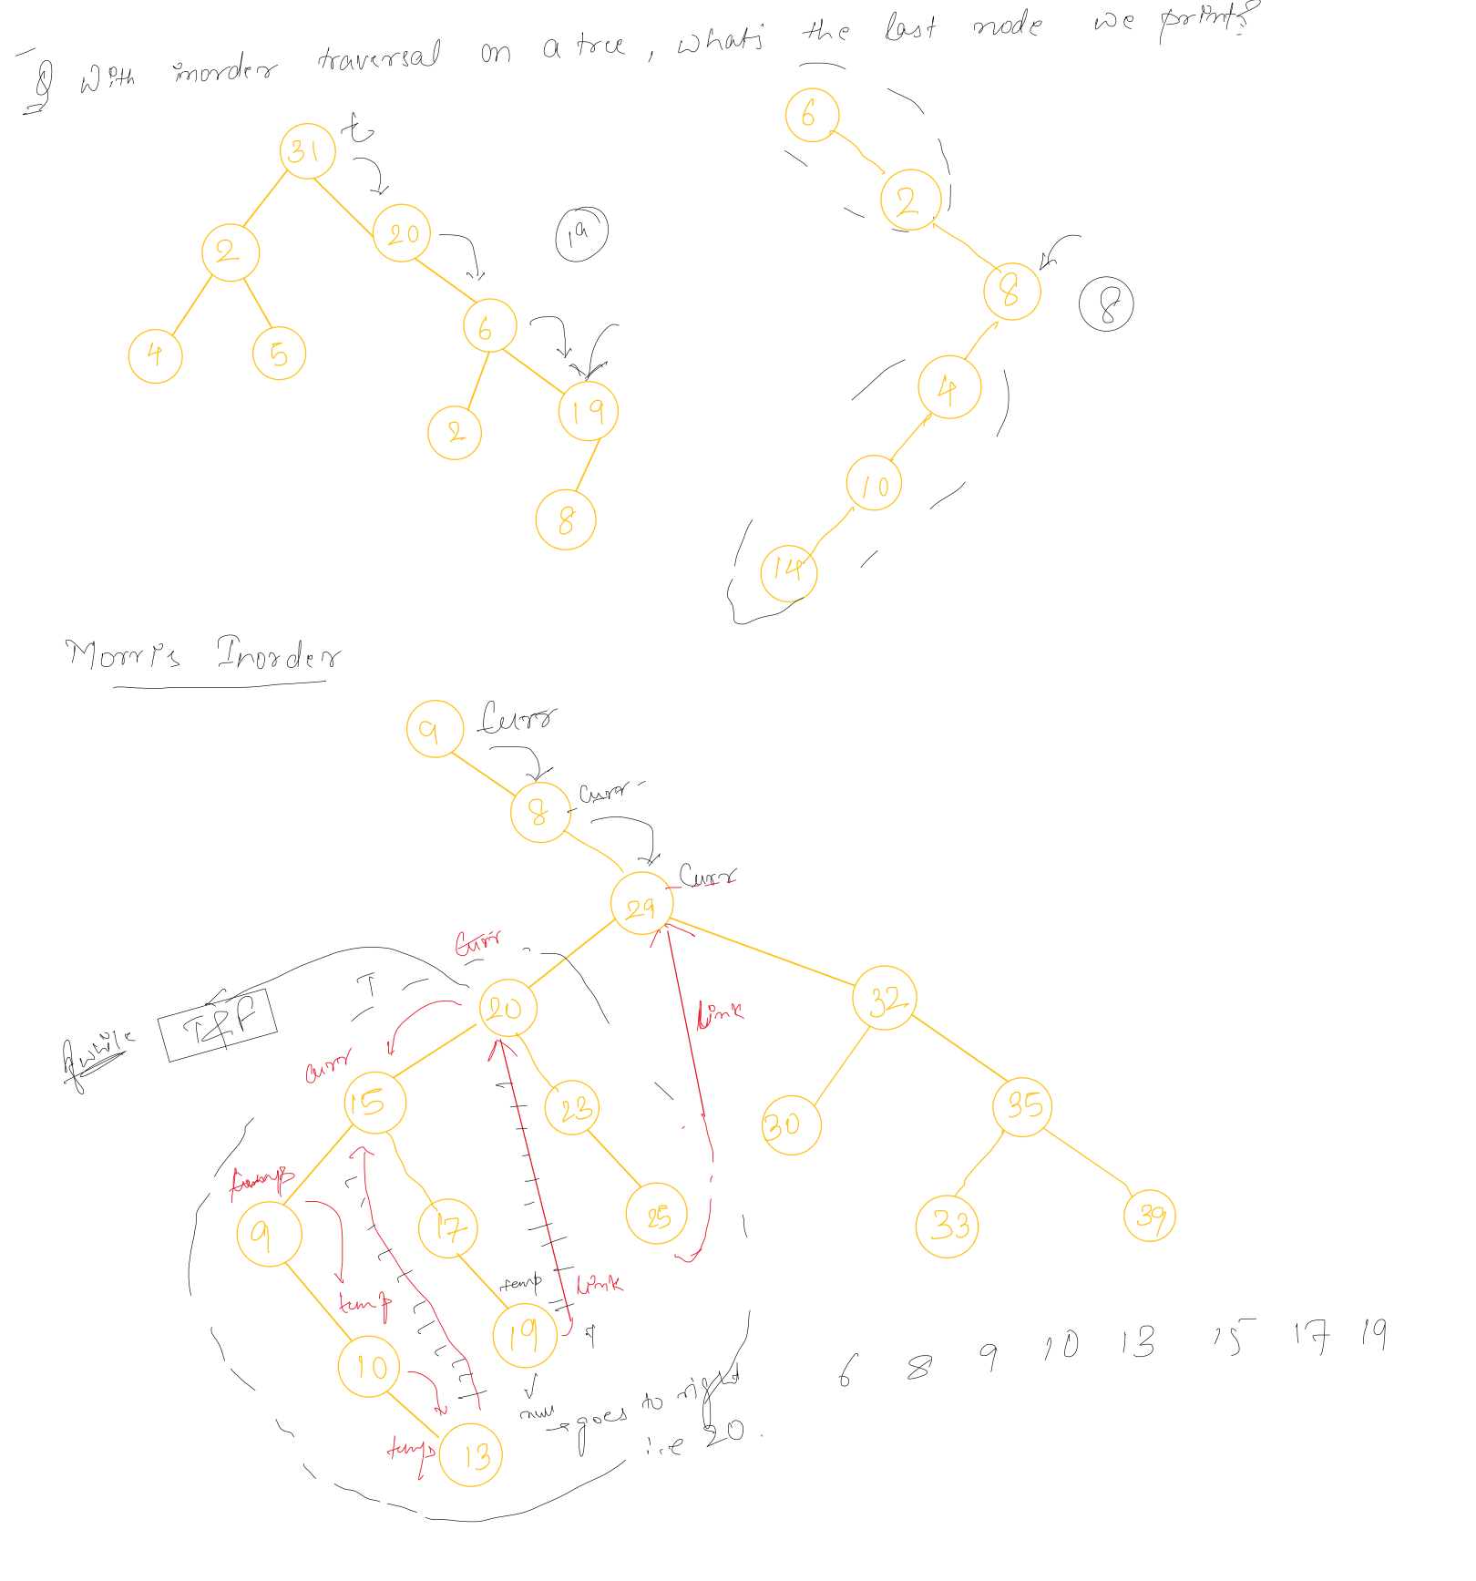

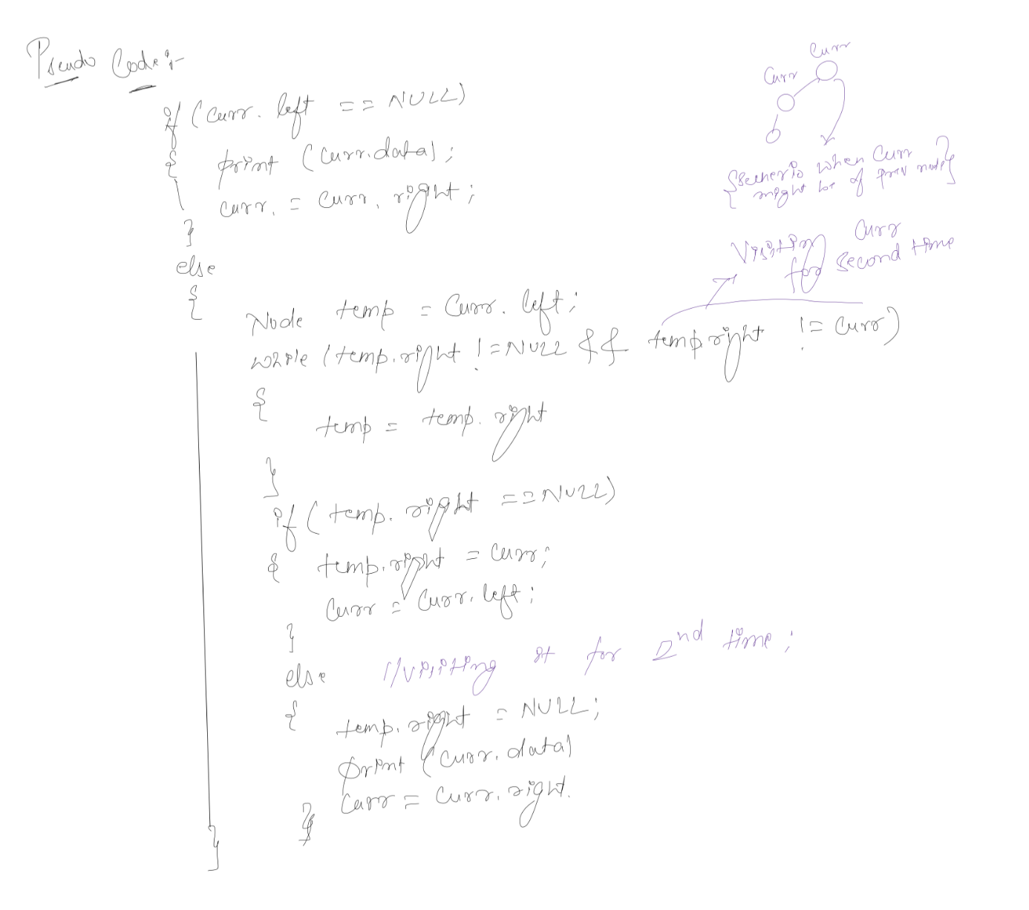

# Path from root to element’s node

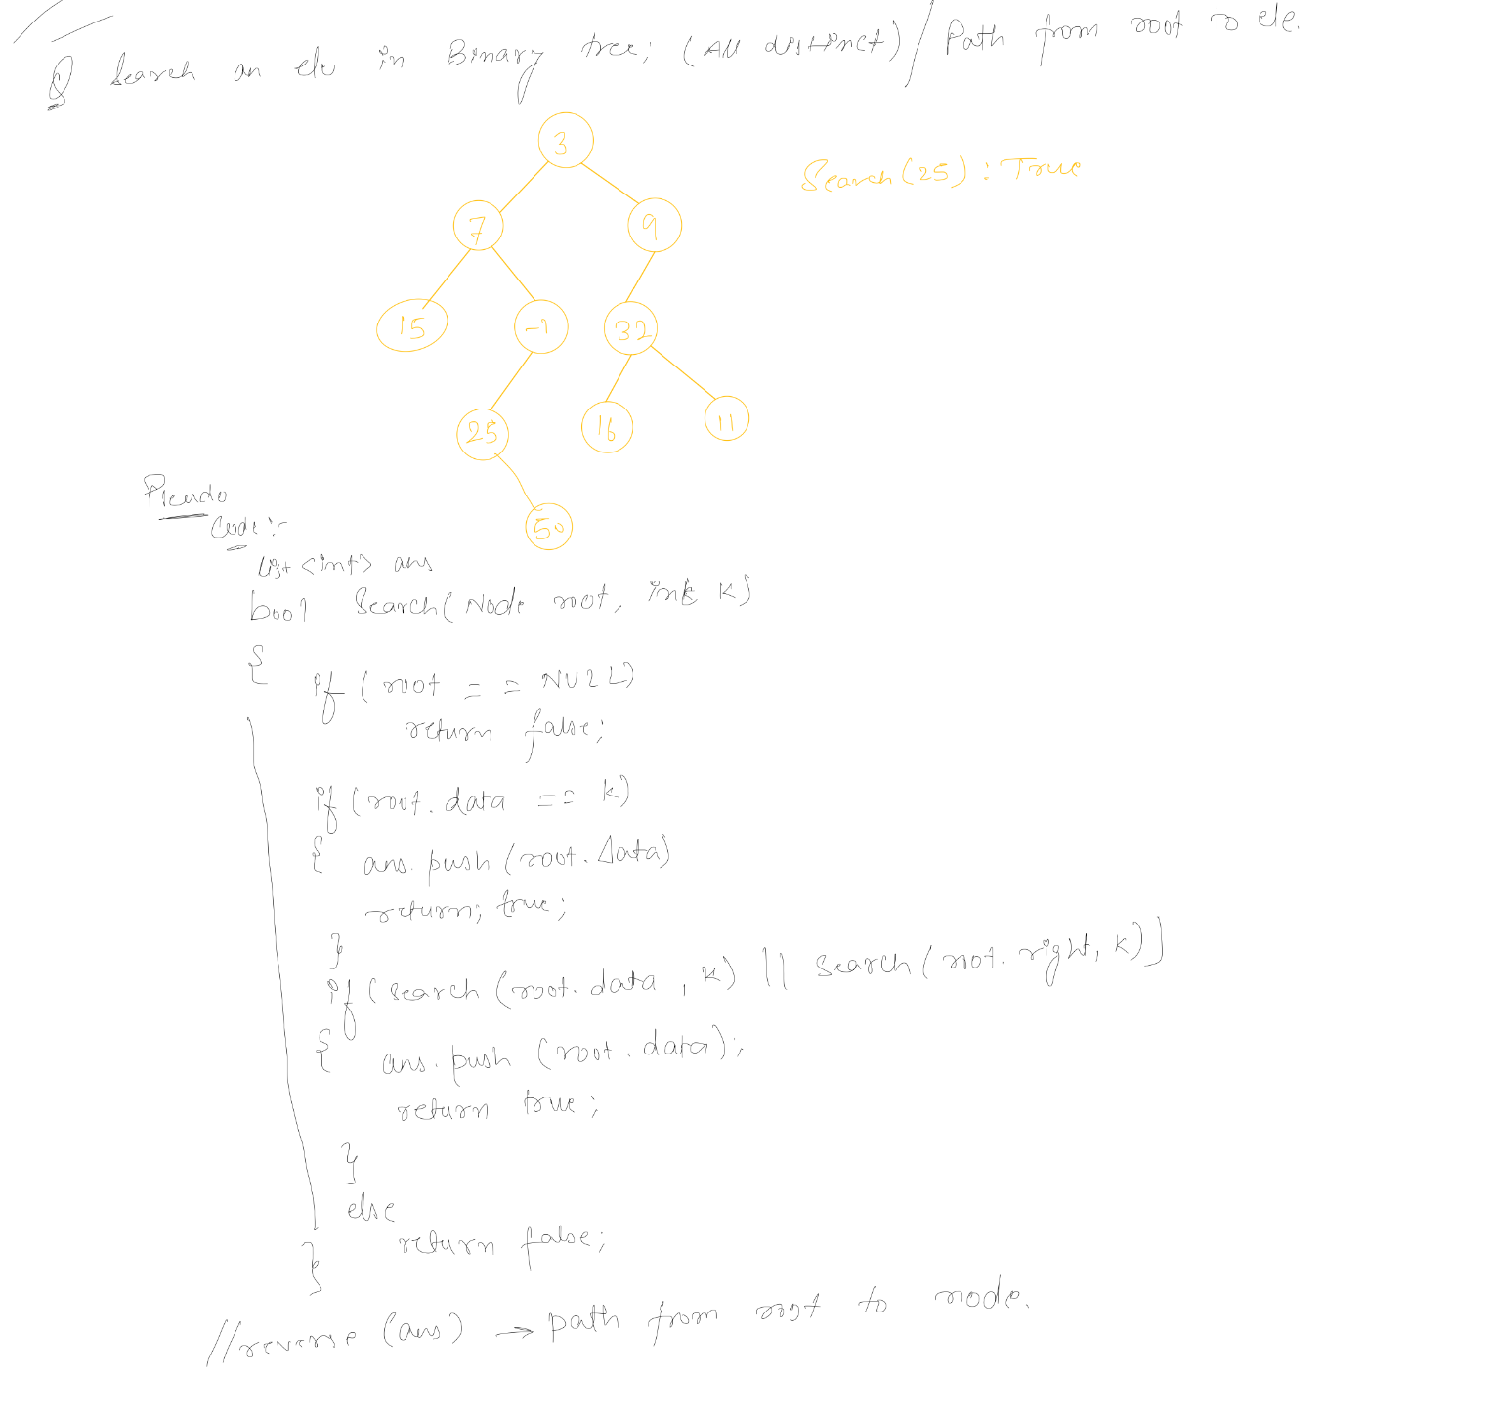

# 

# LCA in B tree

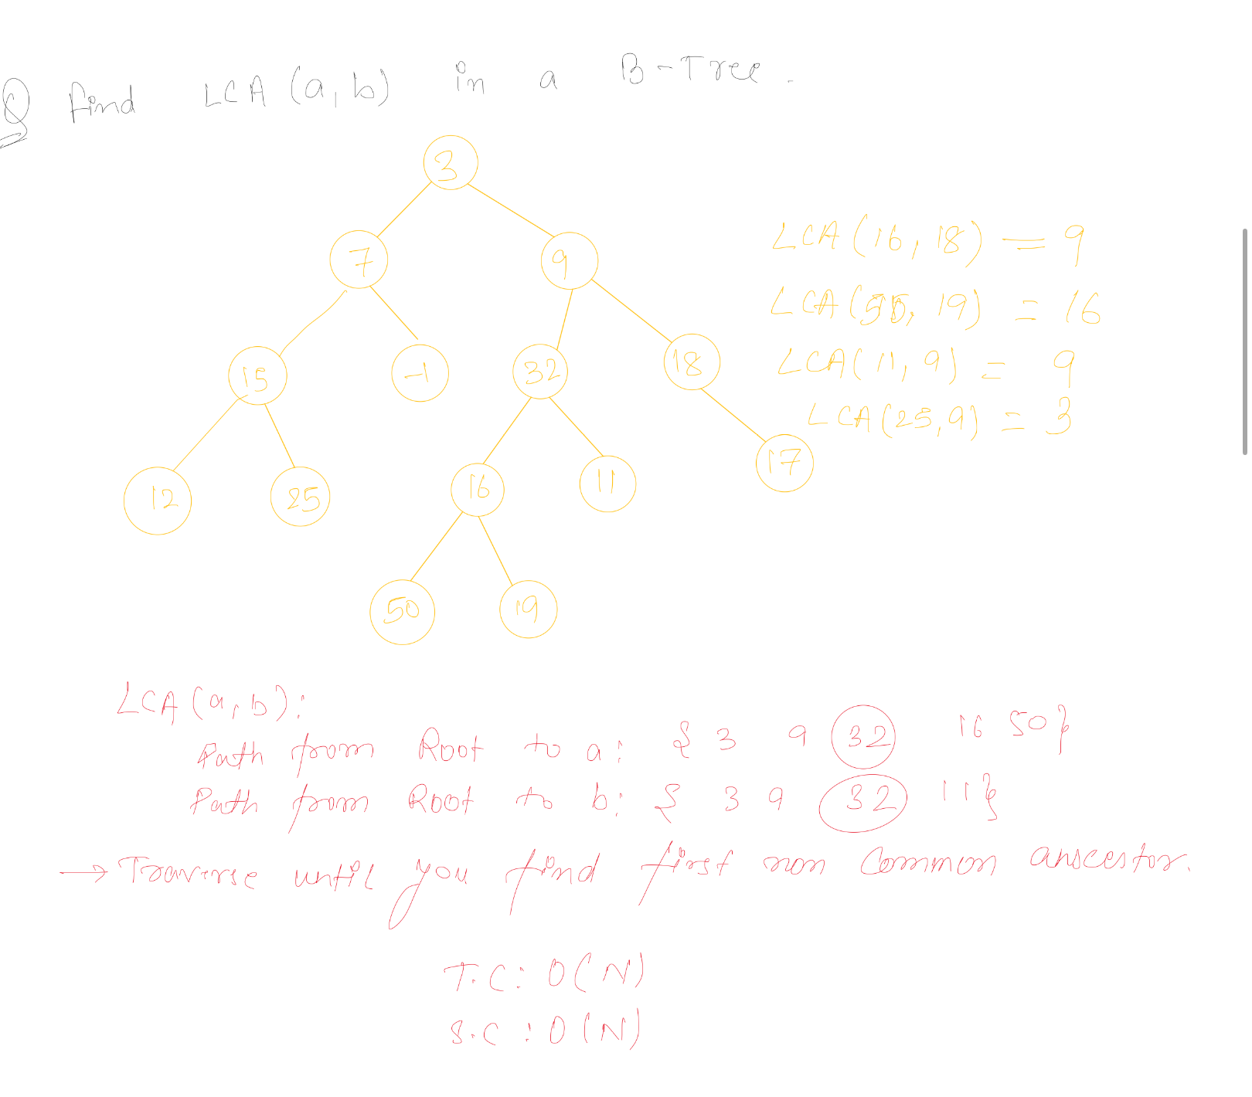

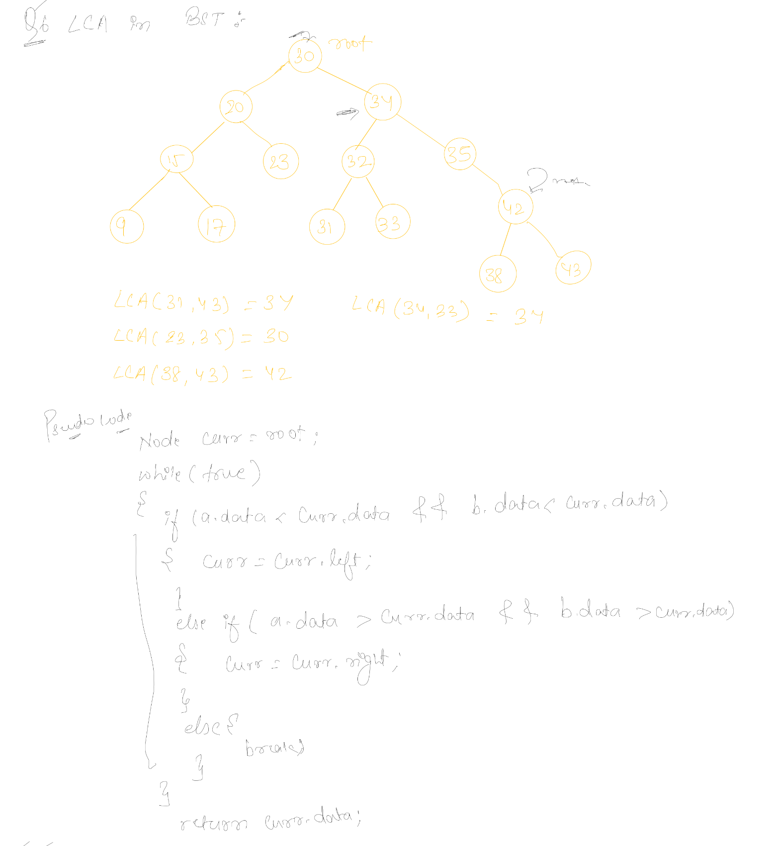

# In Time and Out time in a B tree

# 

# LCA(a, b) for multiple Queries

