Trees 5

Invert Binary tree

Equal Tree Partition

Next pointer in binary tree

Path sum equal k

Diameter of a tree

# Invert Binary tree

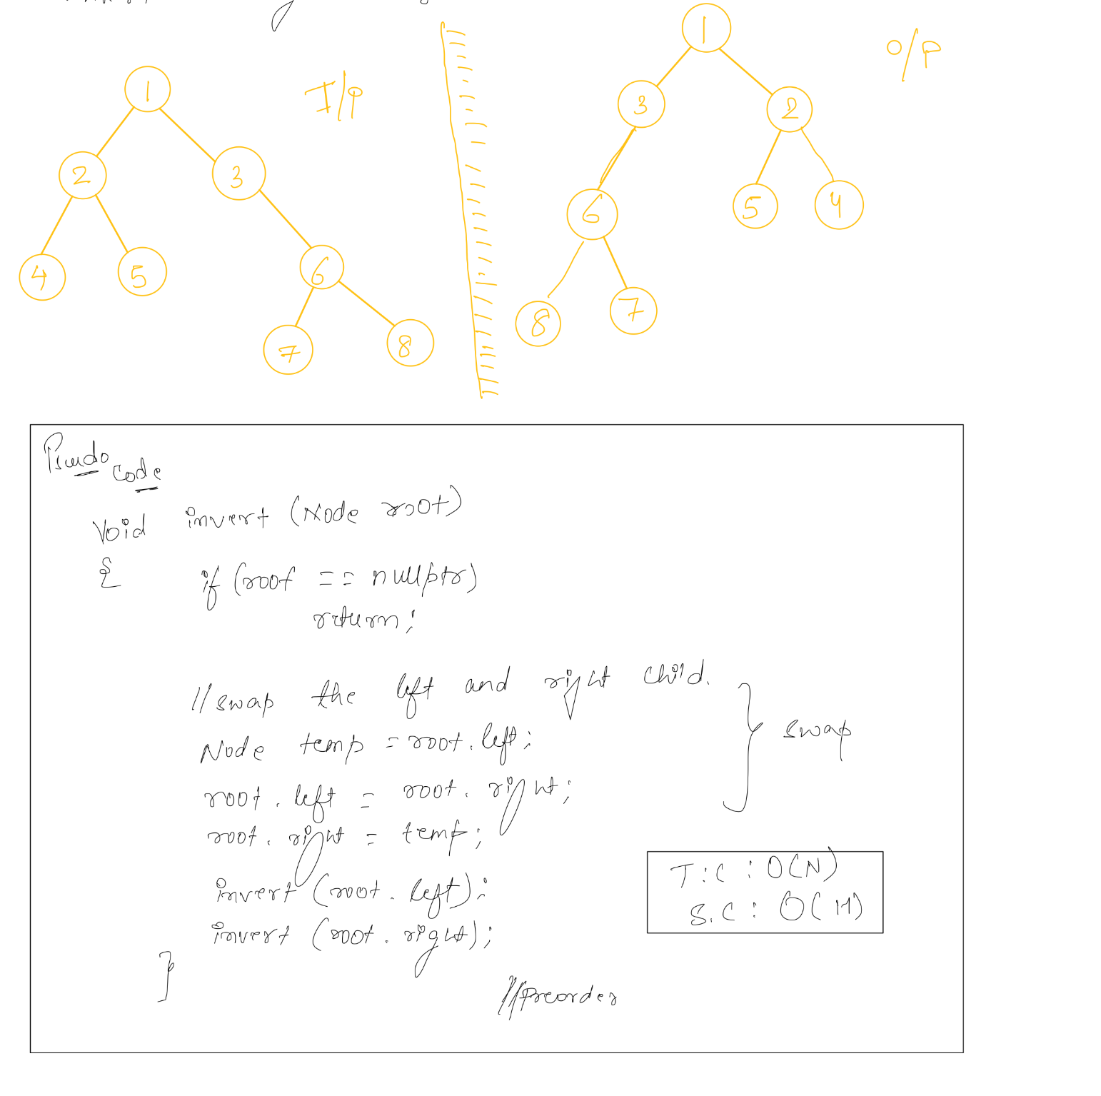

# Equal Tree Partition

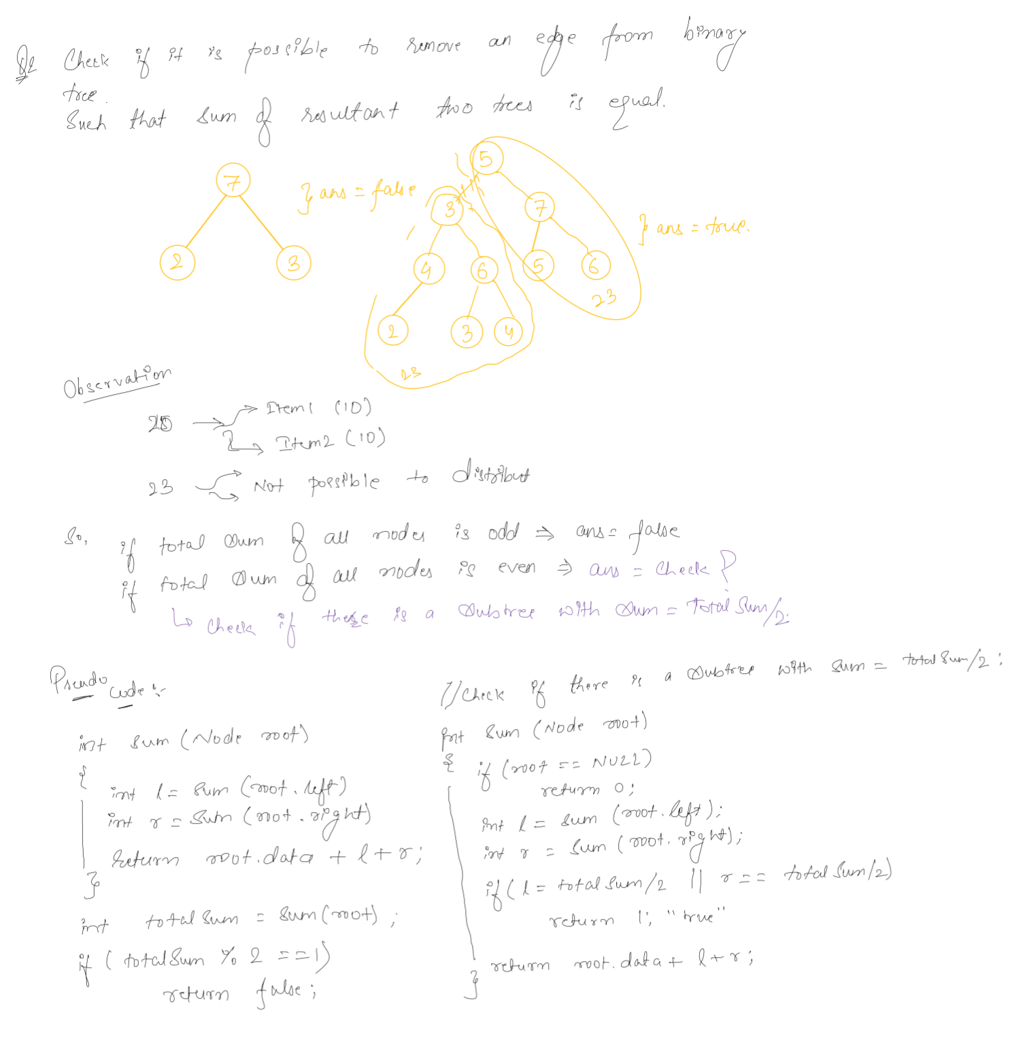

check what is returned by sum function…..

# Next pointer in binary tree

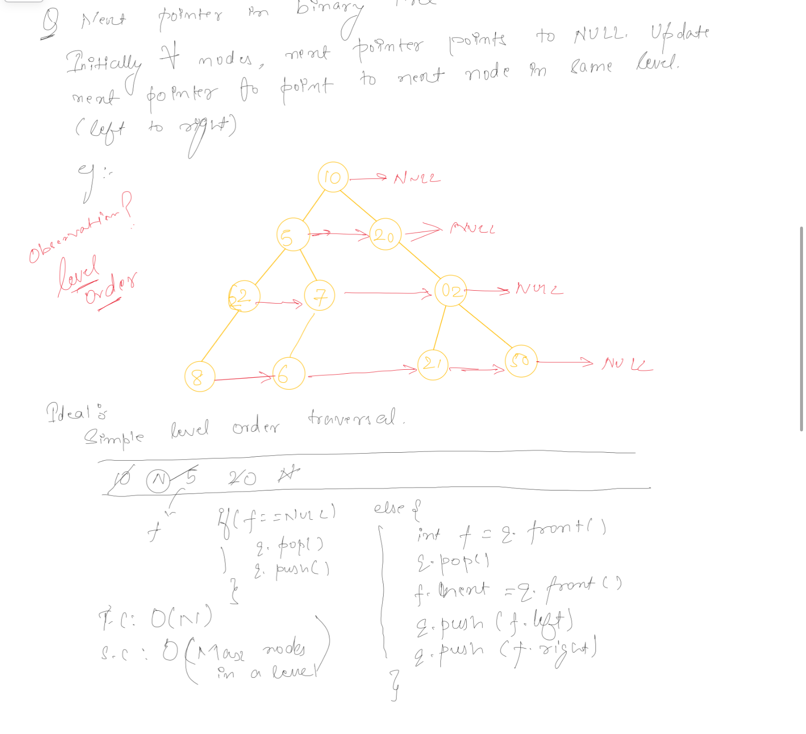

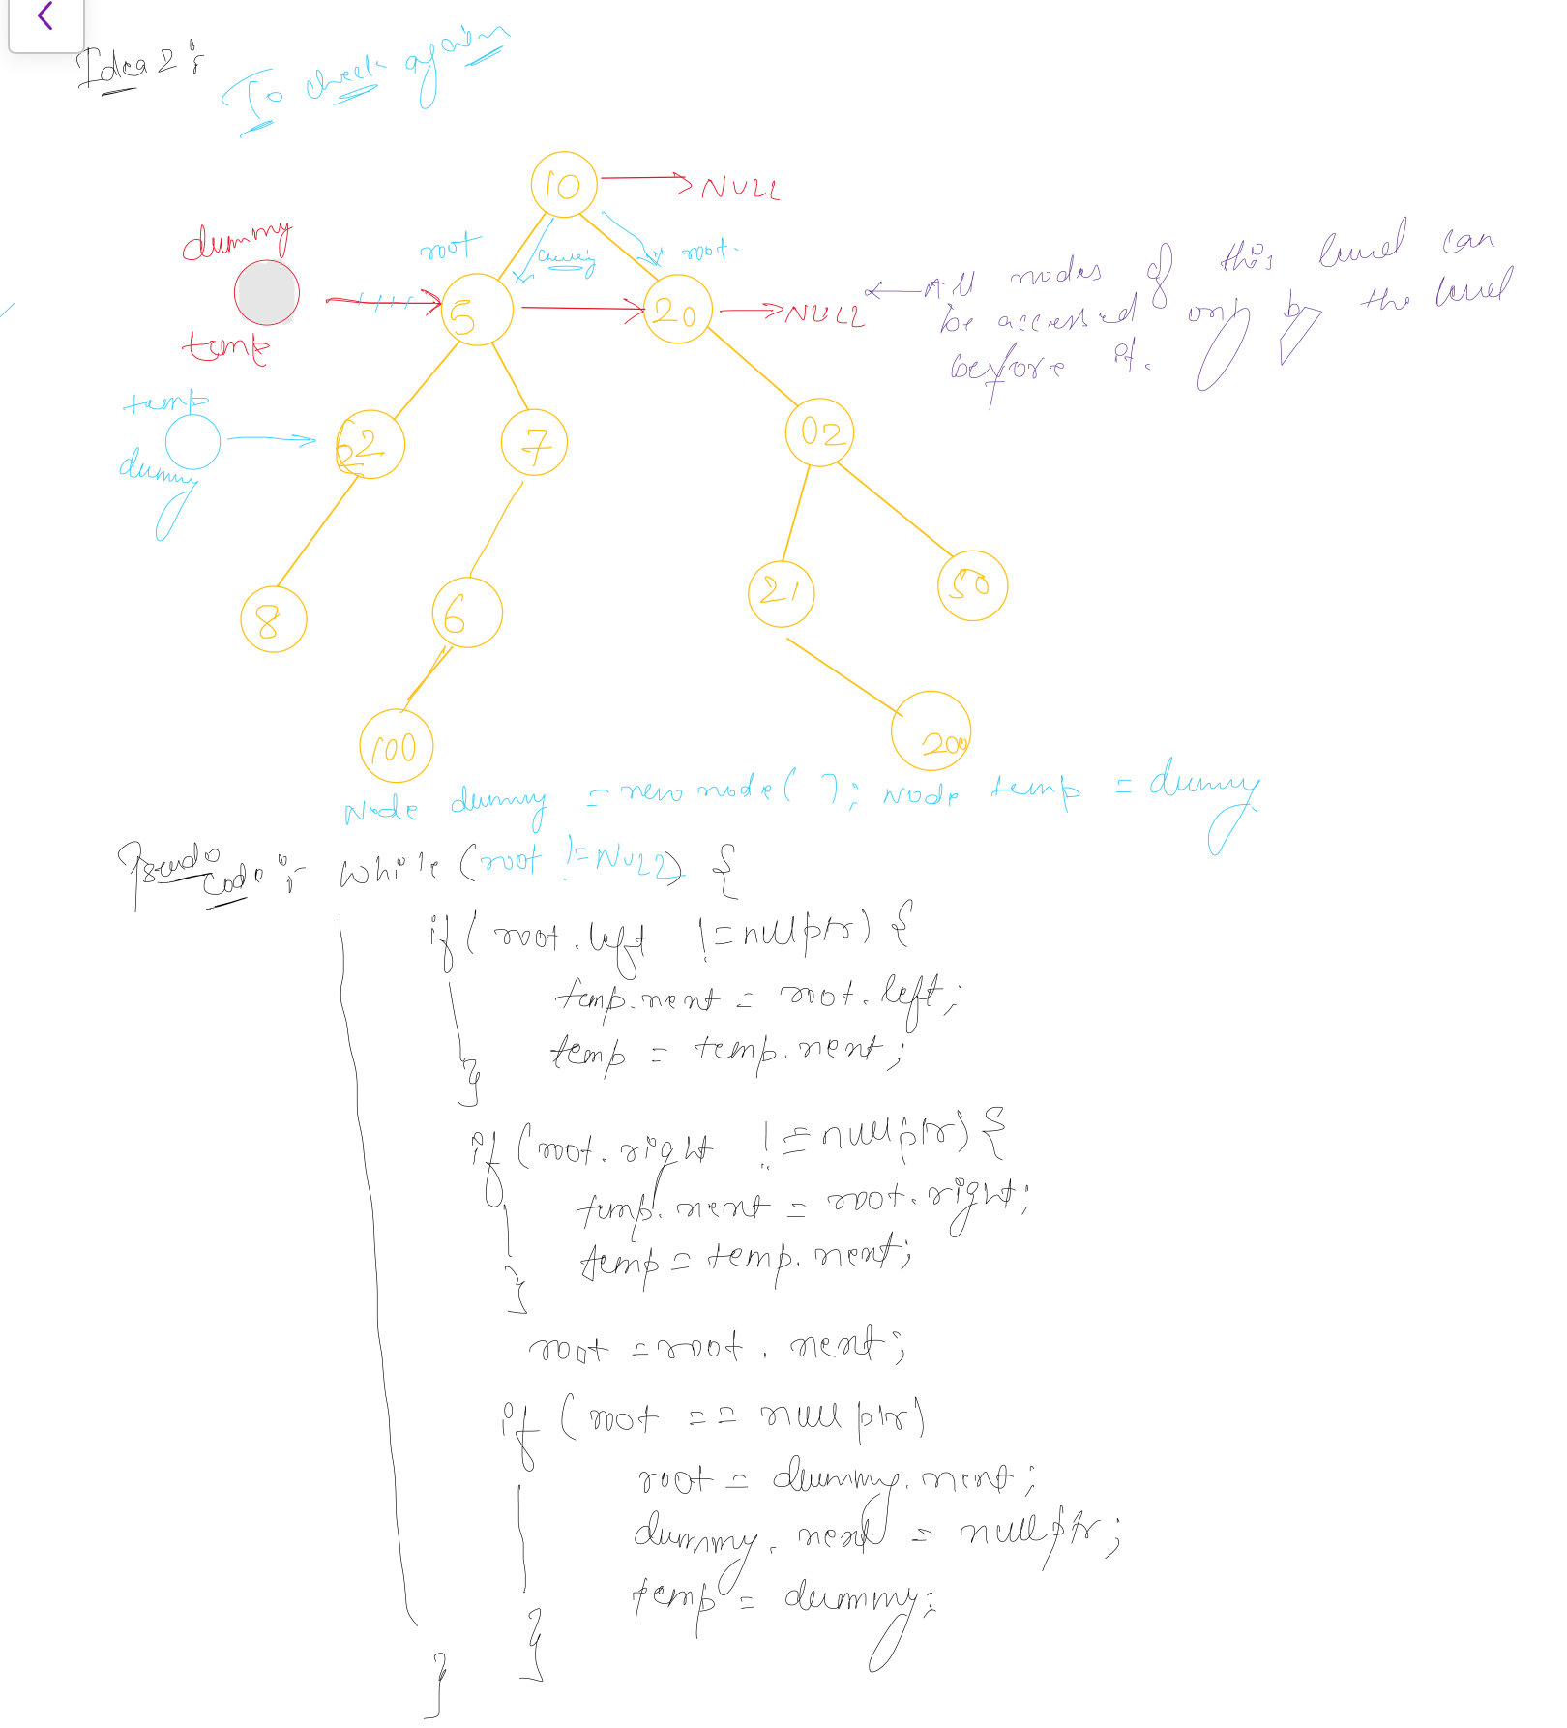

# Path sum equal k

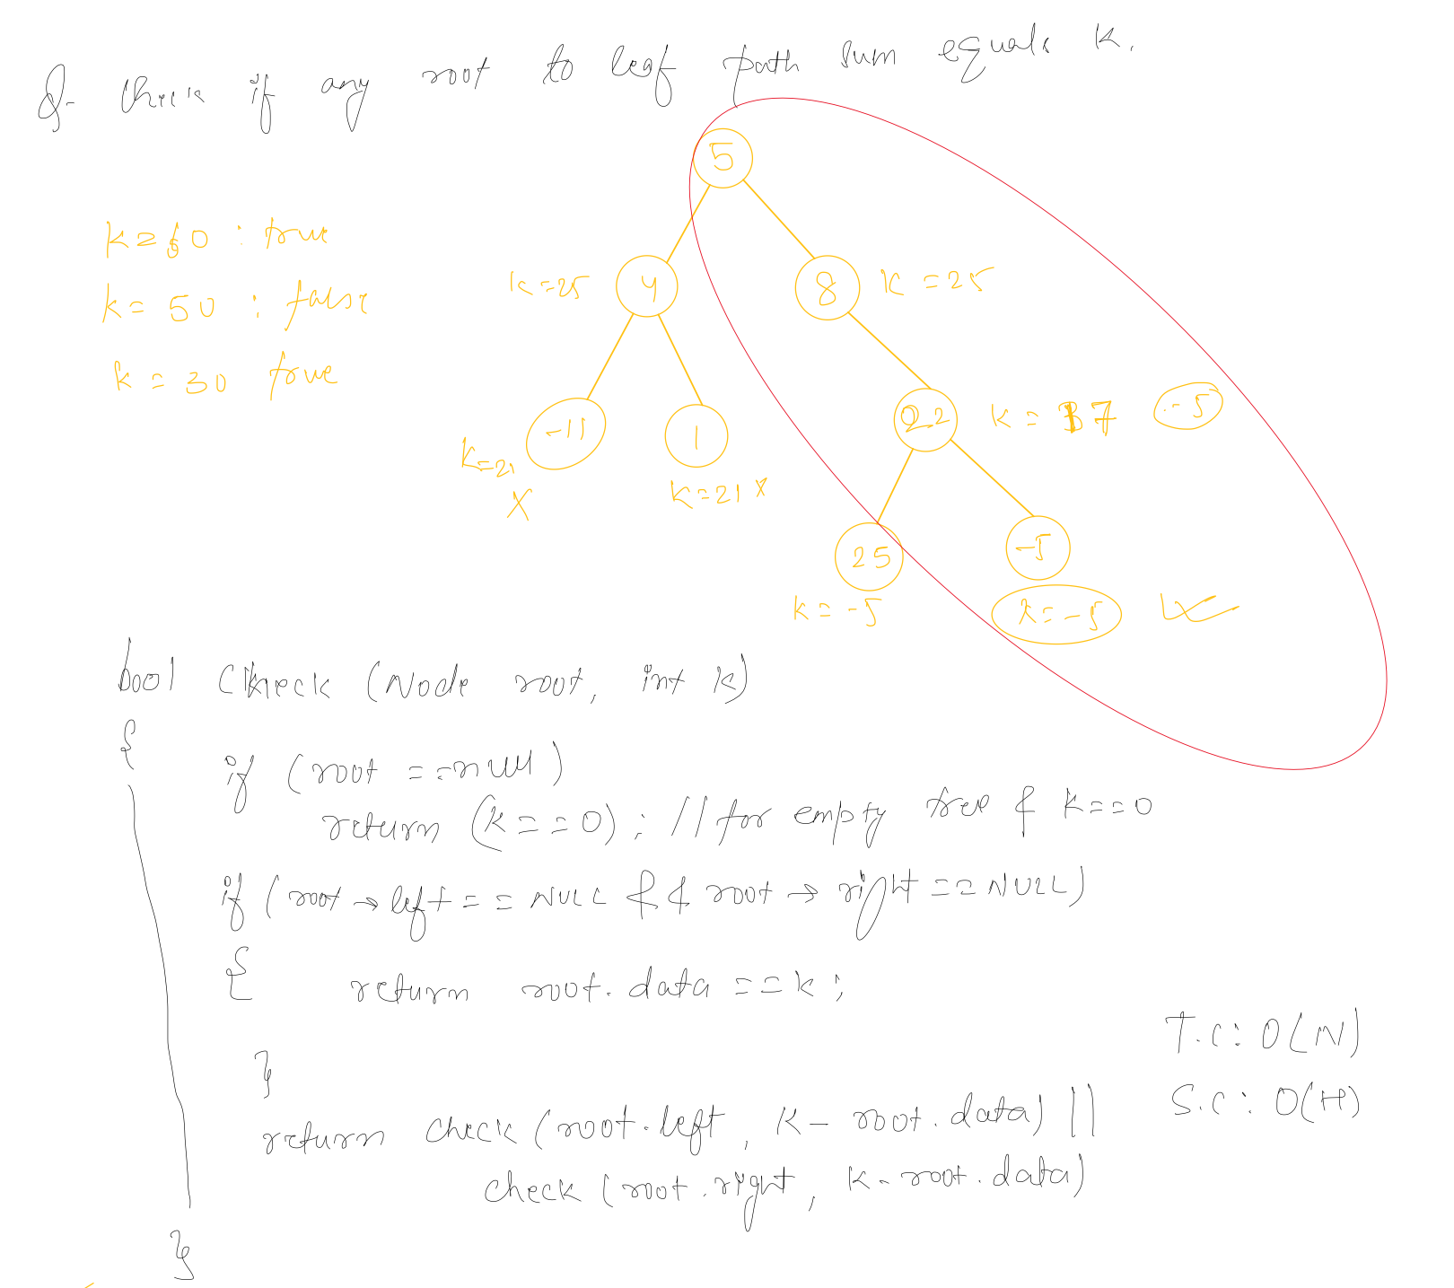

# 

# Diameter of a tree

