Linked List 2

Find middle of the Linked List

Merge 2 sorted LL

Sort LL using Merge Sort

Detect Cycle in a LL

Find start of a cycle

# Find middle of the Linked List

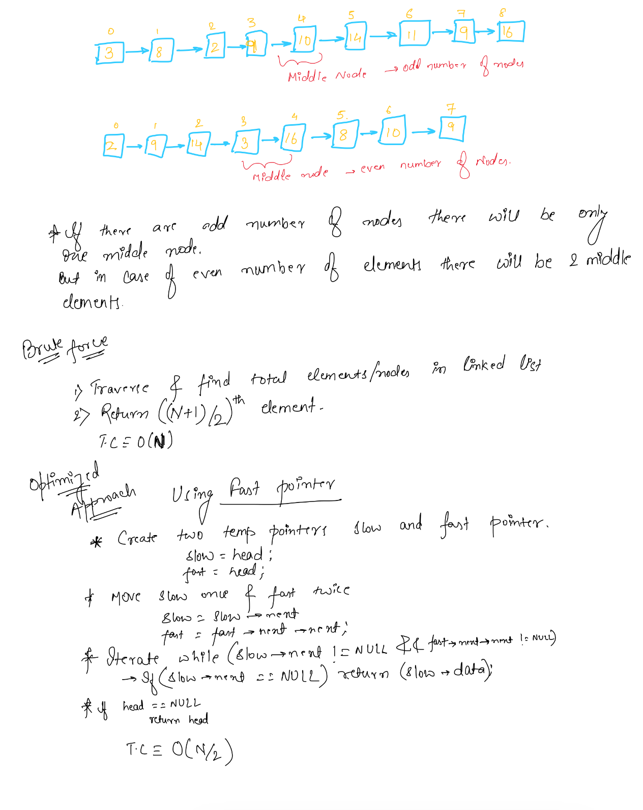

# Merge 2 sorted LL

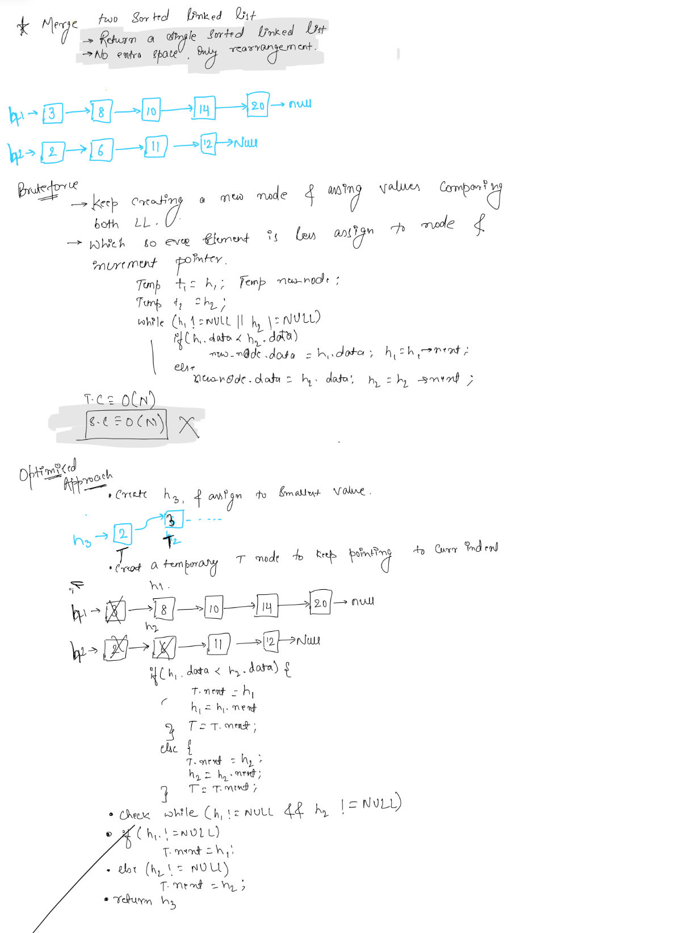

# Sort LL using Merge Sort

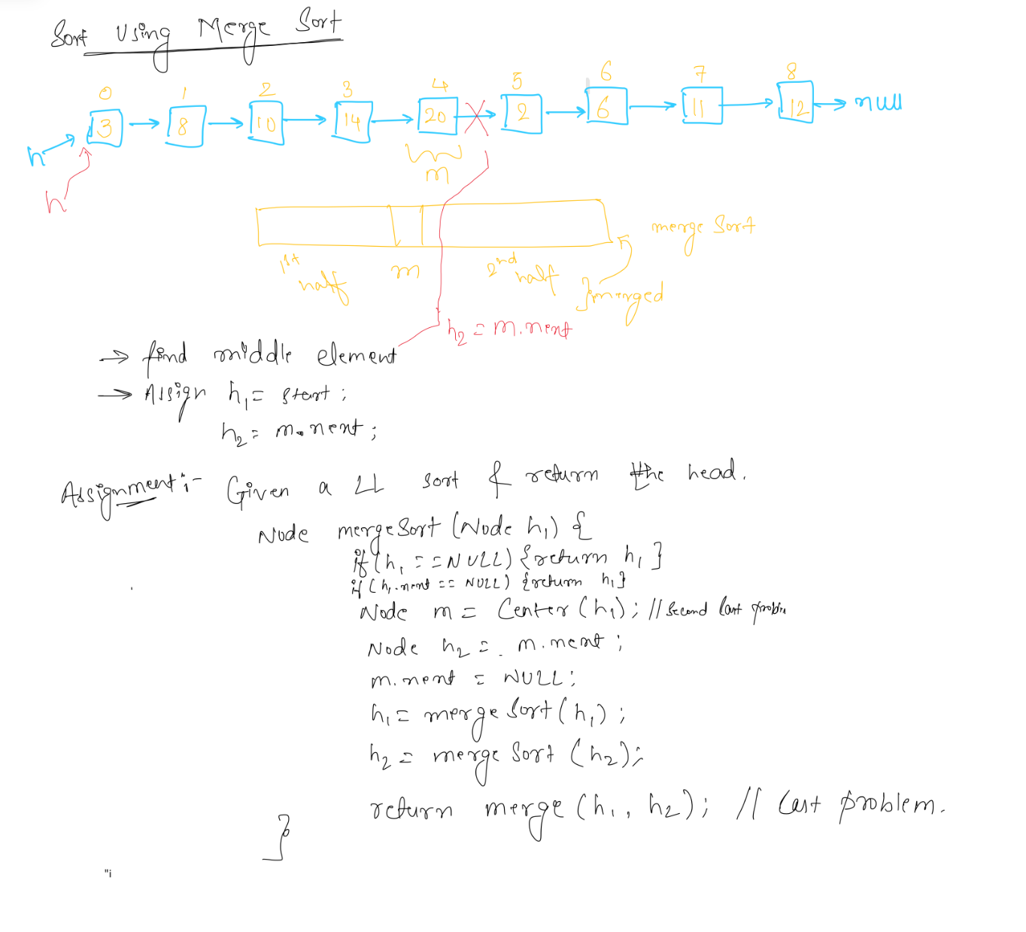

# Detect Cycle in a LL

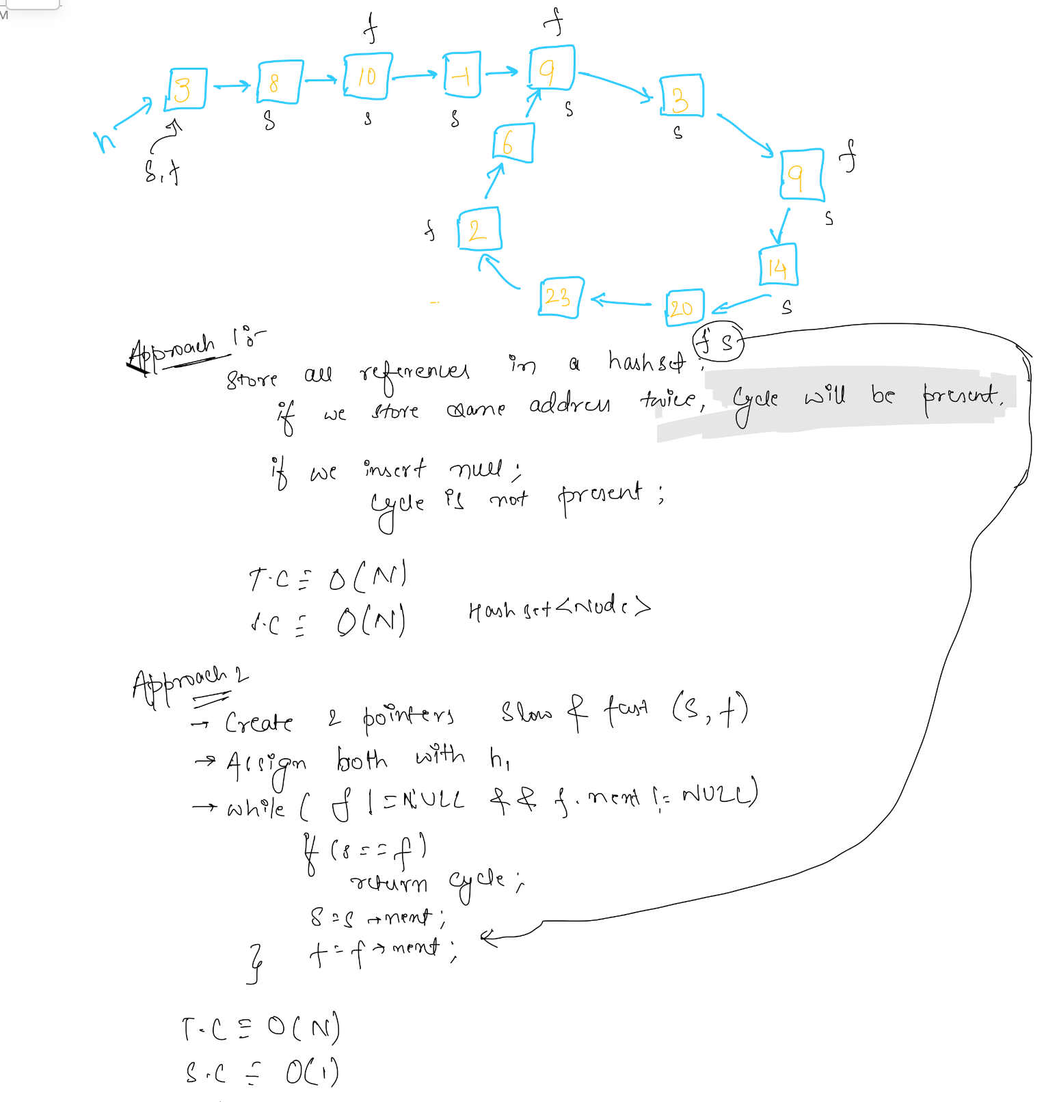

# 

# Find start of a cycle

