Stack Problems

Nearest Smaller / Nearest Greater

Largest Rectangle in Histogram

Sum of (max-min) of all subarrays

# 

# Nearest Smaller / Nearest Greater

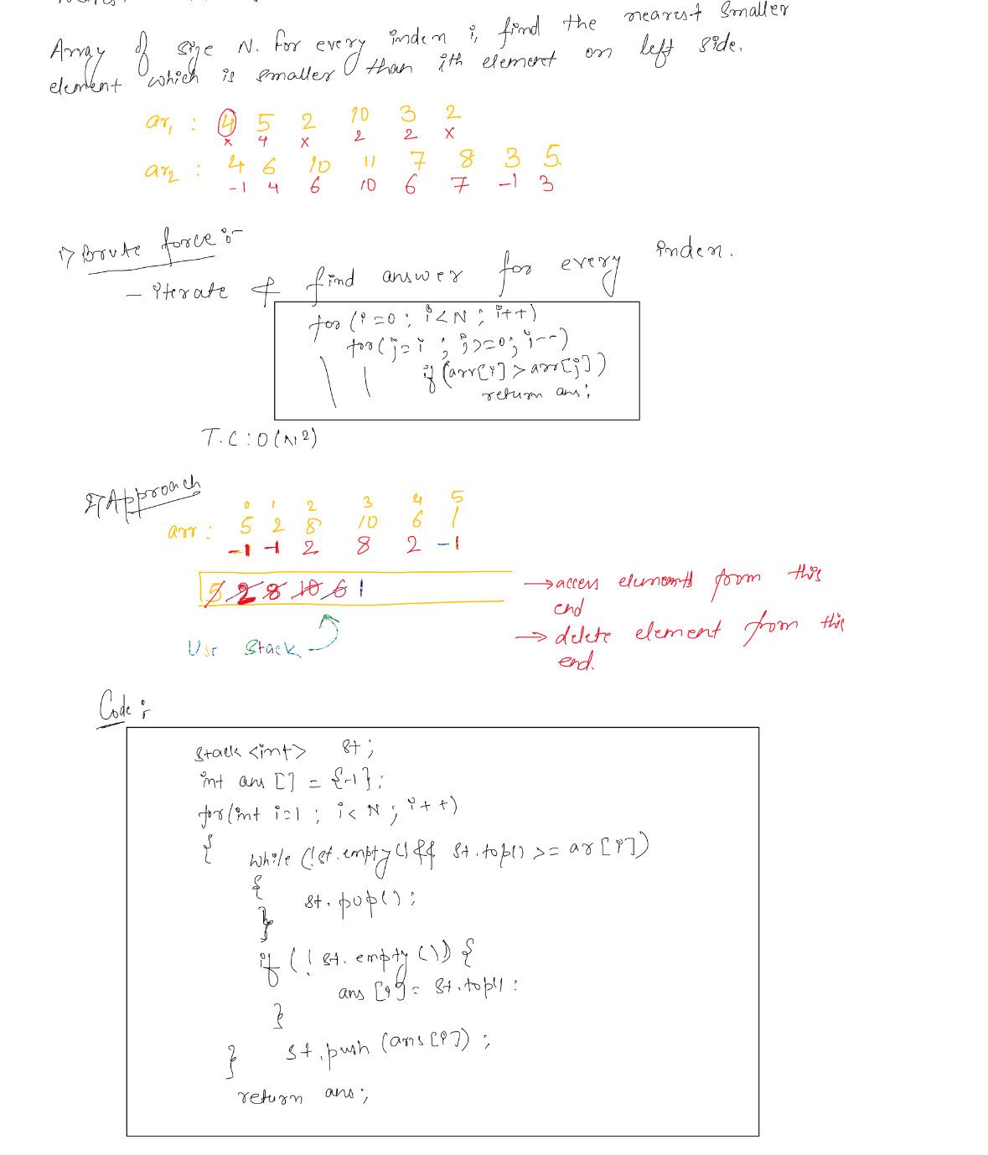

Check for all different variants of this problem.

# Largest Rectangle in Histogram

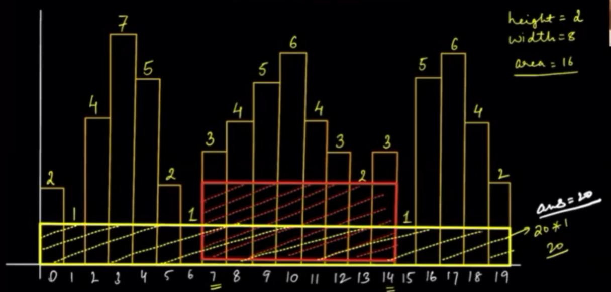

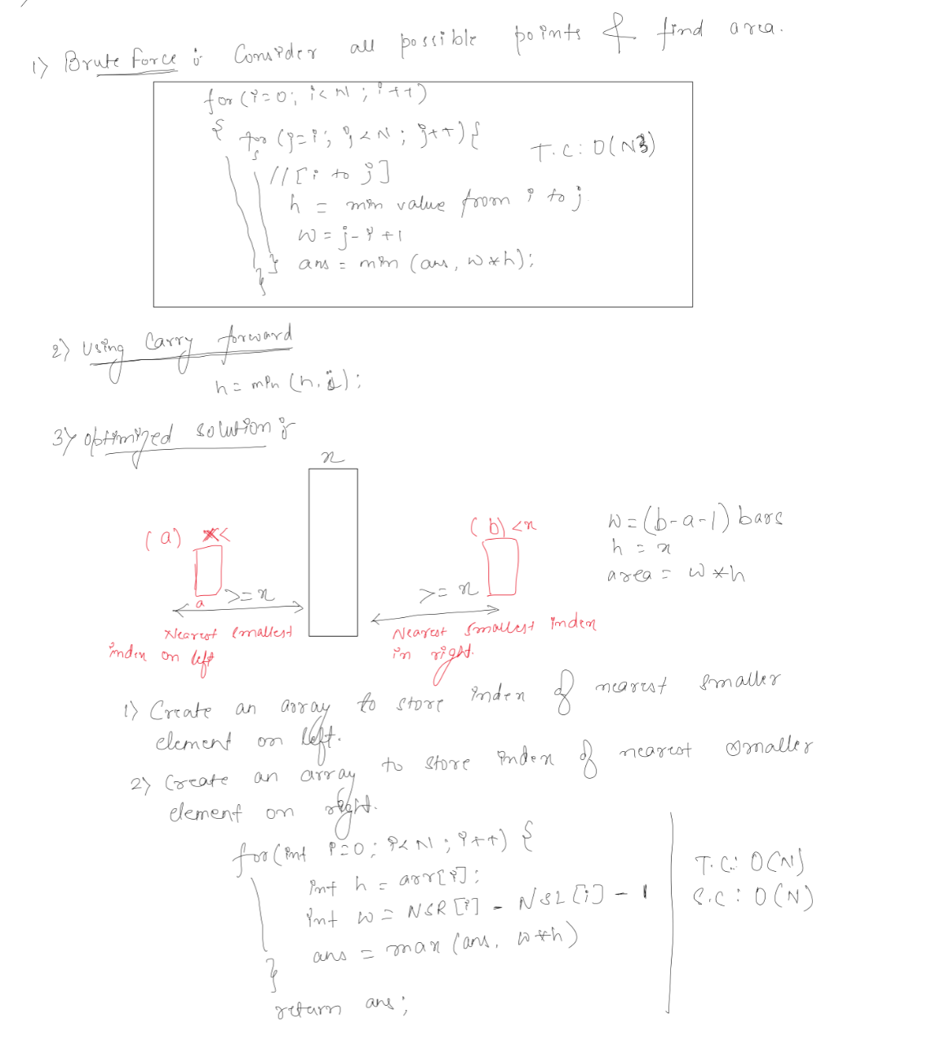

# Sum of (max-min) of all subarrays

