Queues

Intro To Queues

Queues Using Arrays

Queues Using Stack

Queues Using LL

Nth perfect Number

Dequeues

Sliding Window Maximum of size k

# Intro To Queues

Queues are a type of container adaptors that operate in a first in first out (FIFO) type of arrangement. Elements are inserted at the back (end) and are deleted from the front. Queues use an encapsulated object of **deque or list** (sequential container class) as its underlying container, providing a specific set of member functions to access its elements.

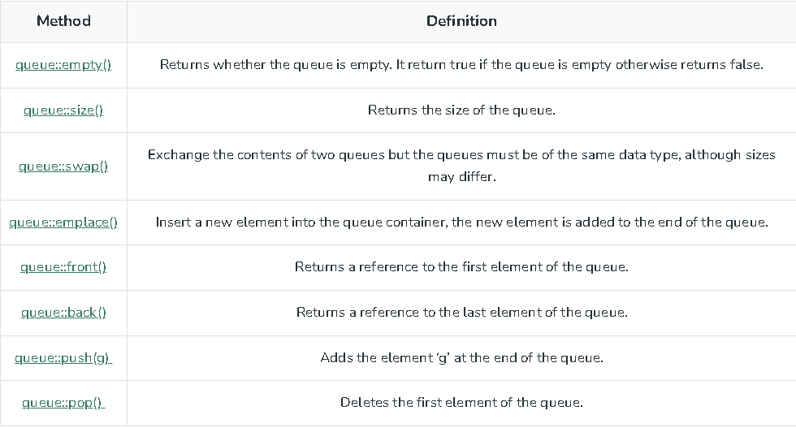

To use a queue, you have to include the <queue> header file

# 

# Queues Using Arrays

# Queues Using Stack

# 

# 

# Queues Using LL

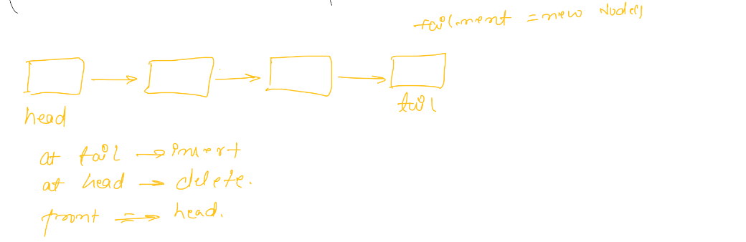

# Nth perfect Number

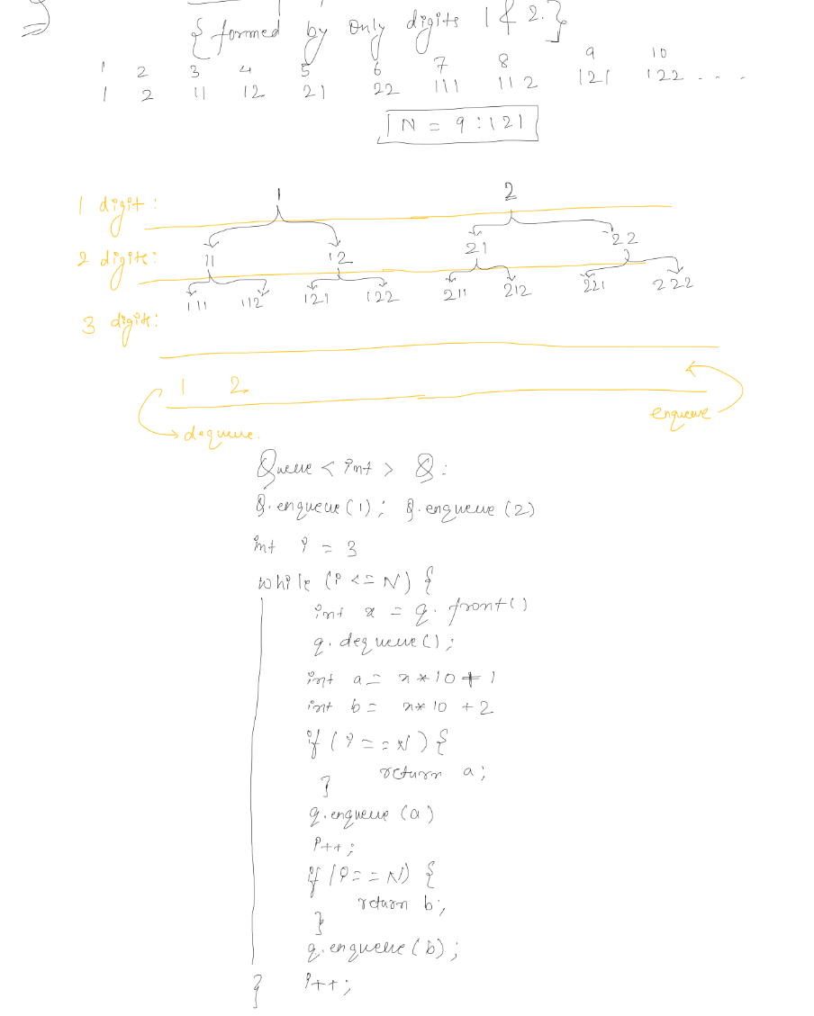

# Dequeues

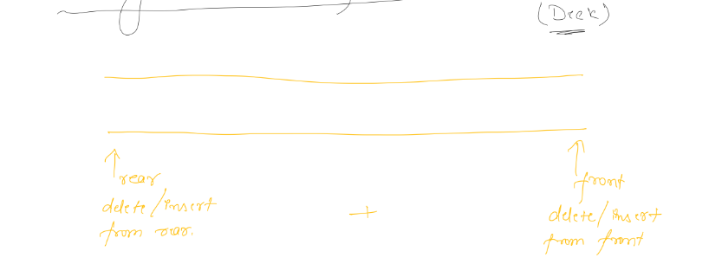

# 

# Sliding Window Maximum of size k

