Trees 1

Introduction To Trees

Binary Trees

Traversals In a Tree

Iterative Inorder Traversal

Construct Binary Tree from Inorder And Postorder

# 

# 

# 

# 

# 

# 

# 

# Introduction To Trees

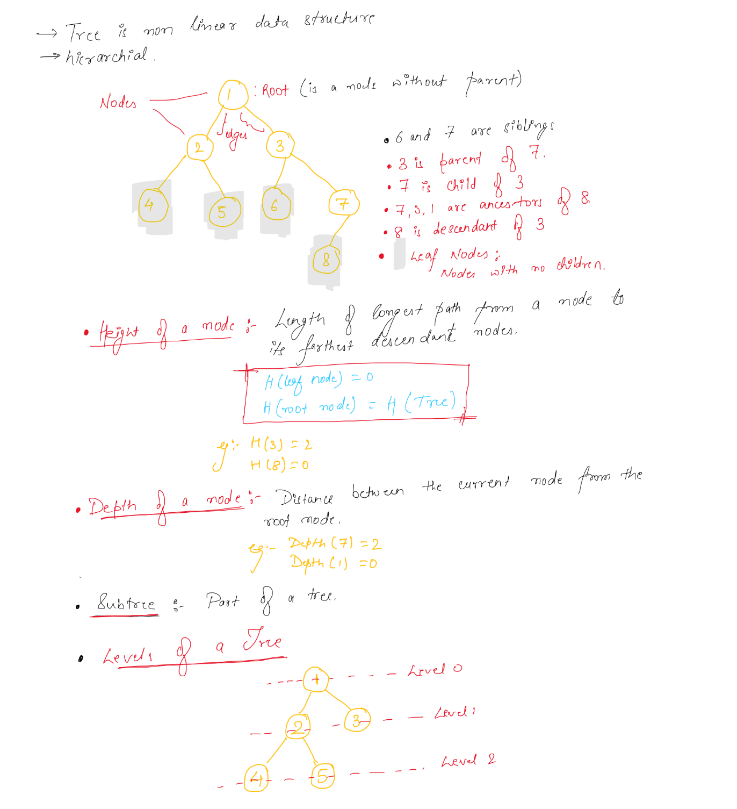

# Binary Trees

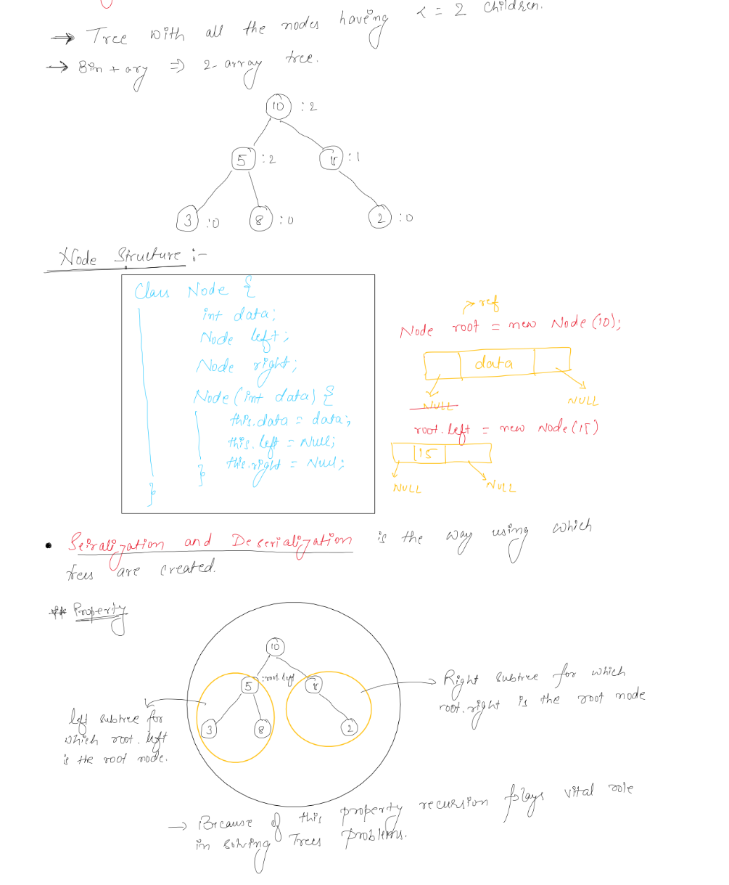

# Traversals In a Tree

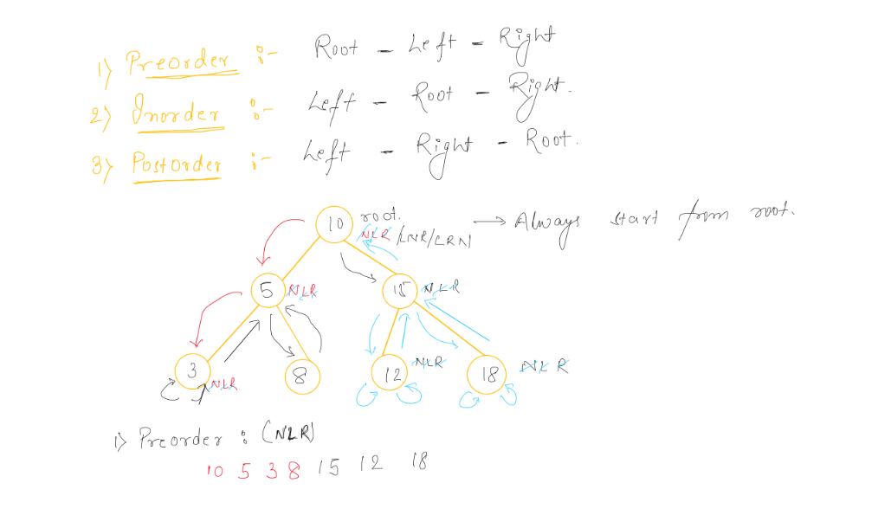

# Iterative Inorder Traversal

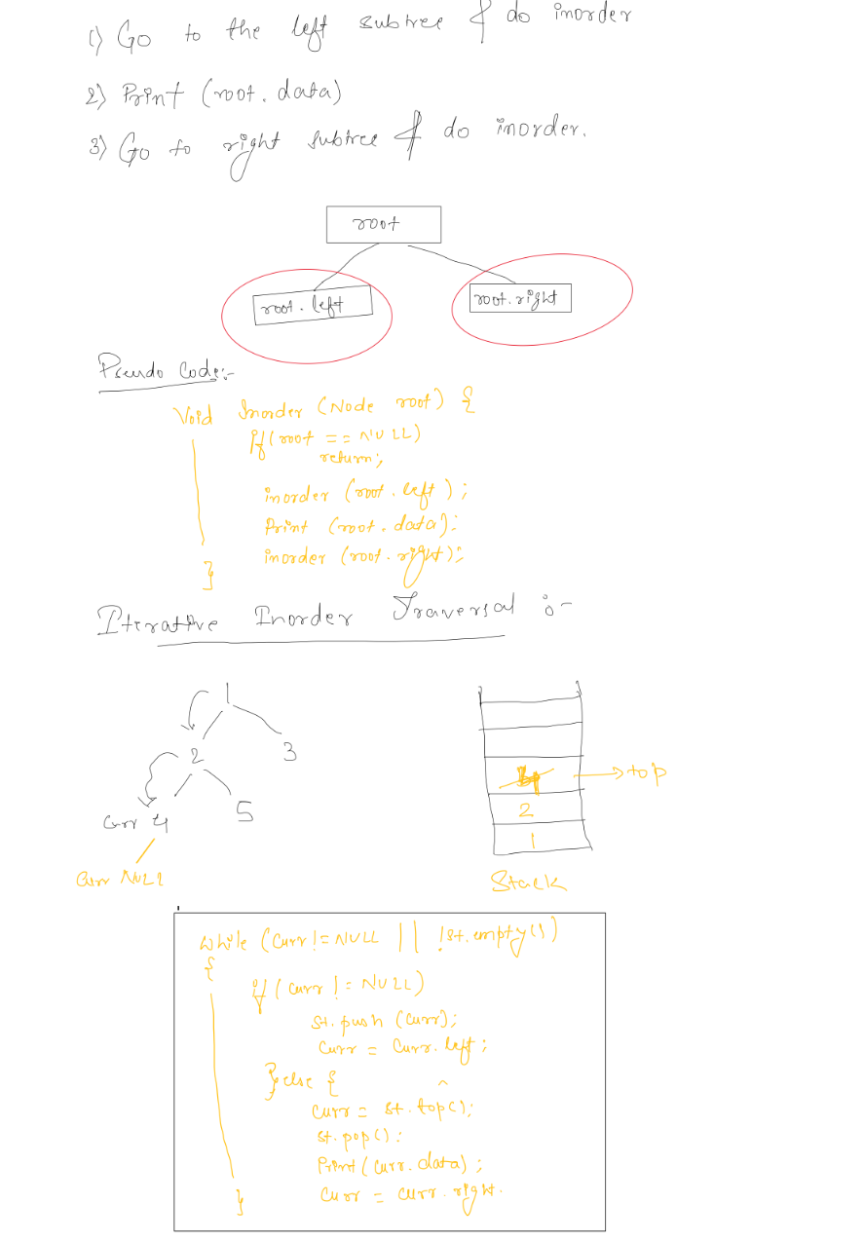

# Construct Binary Tree from Inorder And Postorder

