Trees 2

Level Order Traversal (R - L)

Left View And Right View

Vertical Order Traversal

Top And Bottom View

Types Of Binary Tree

Height Balanced Tree

# Level Order Traversal (R - L)

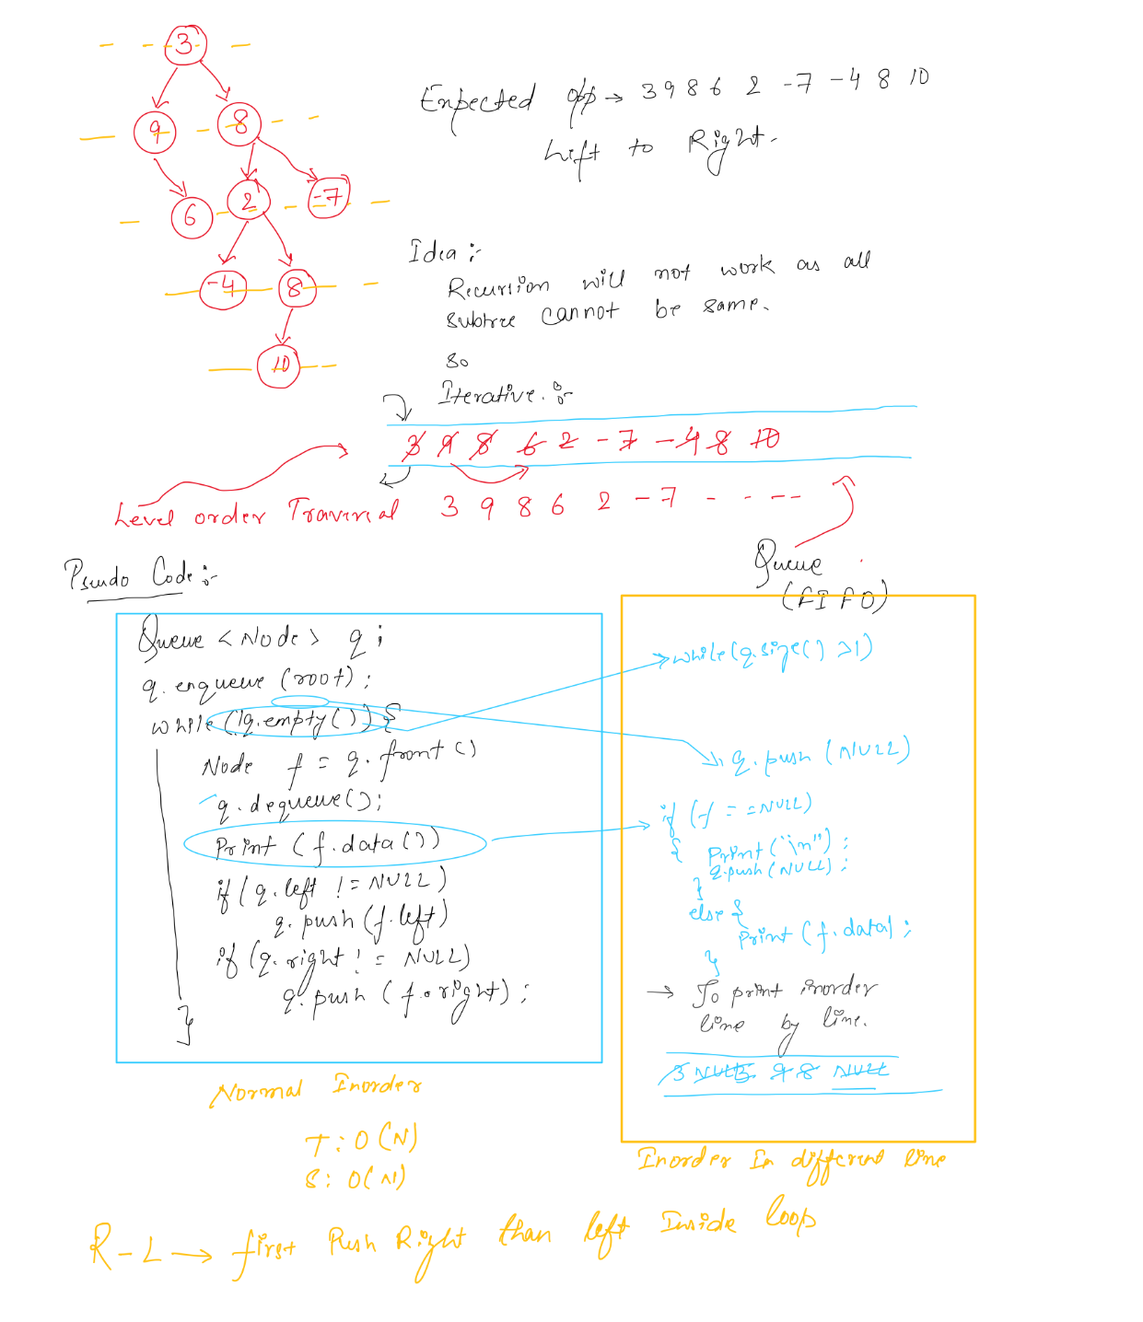

# Left View And Right View

# 

# 

# 

# Vertical Order Traversal

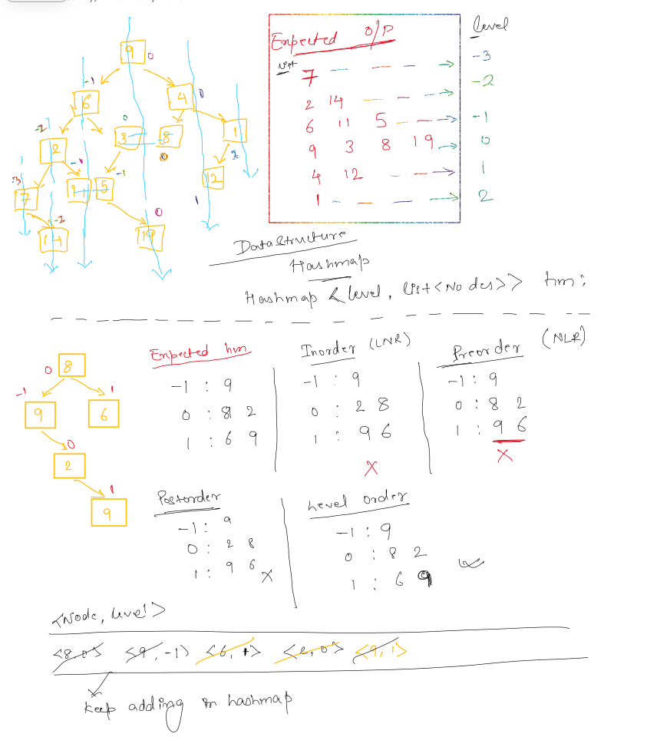

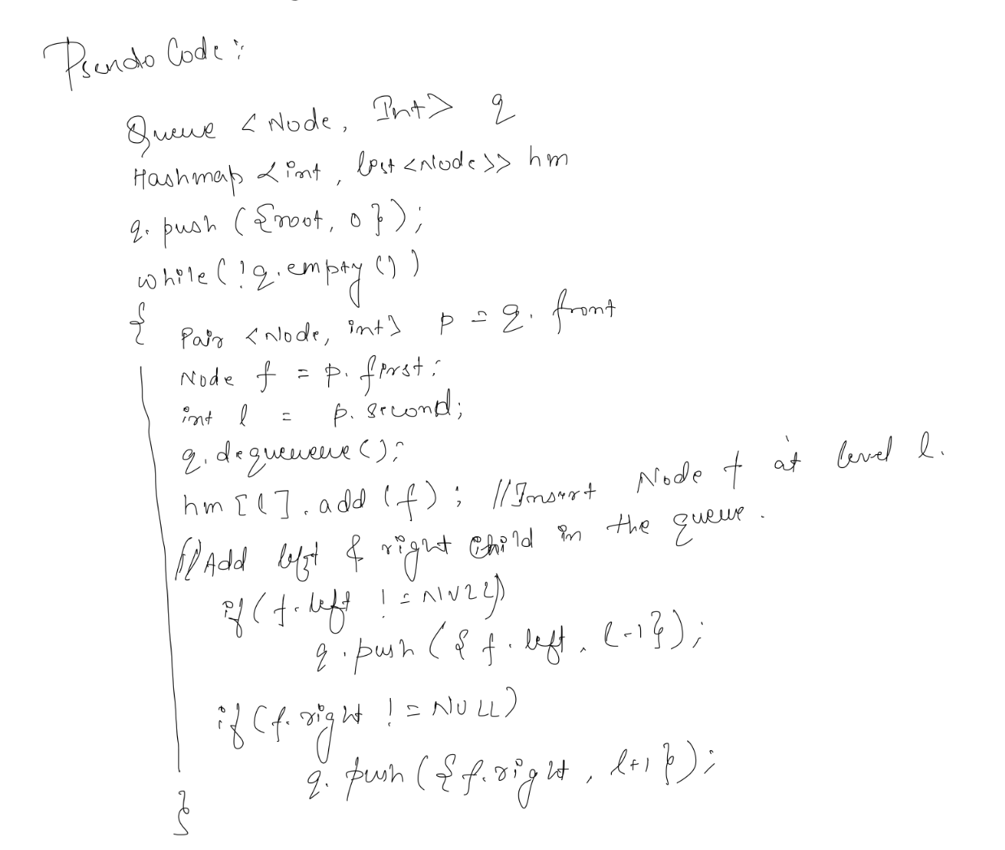

# Top And Bottom View

# 

# Types Of Binary Tree

# 

# Height Balanced Tree

