Greedy

Intro To Greedy

Car Sale

Maximum Candies

Maximum Job

# Intro To Greedy

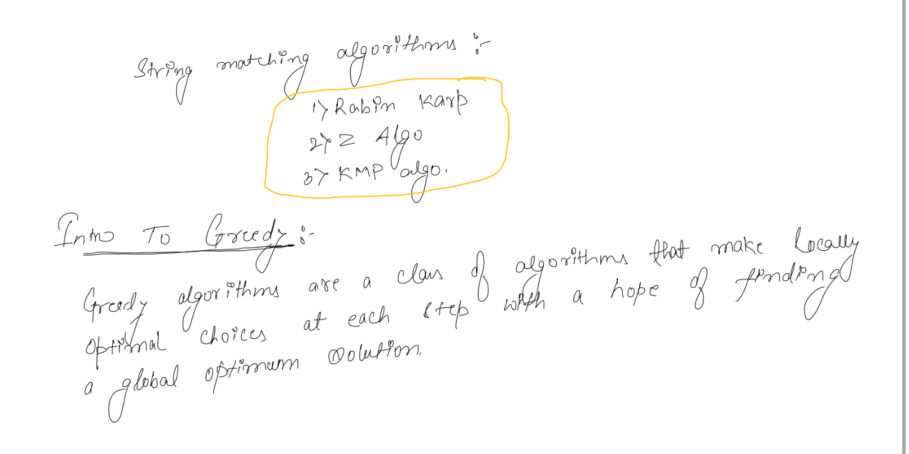

# Car Sale

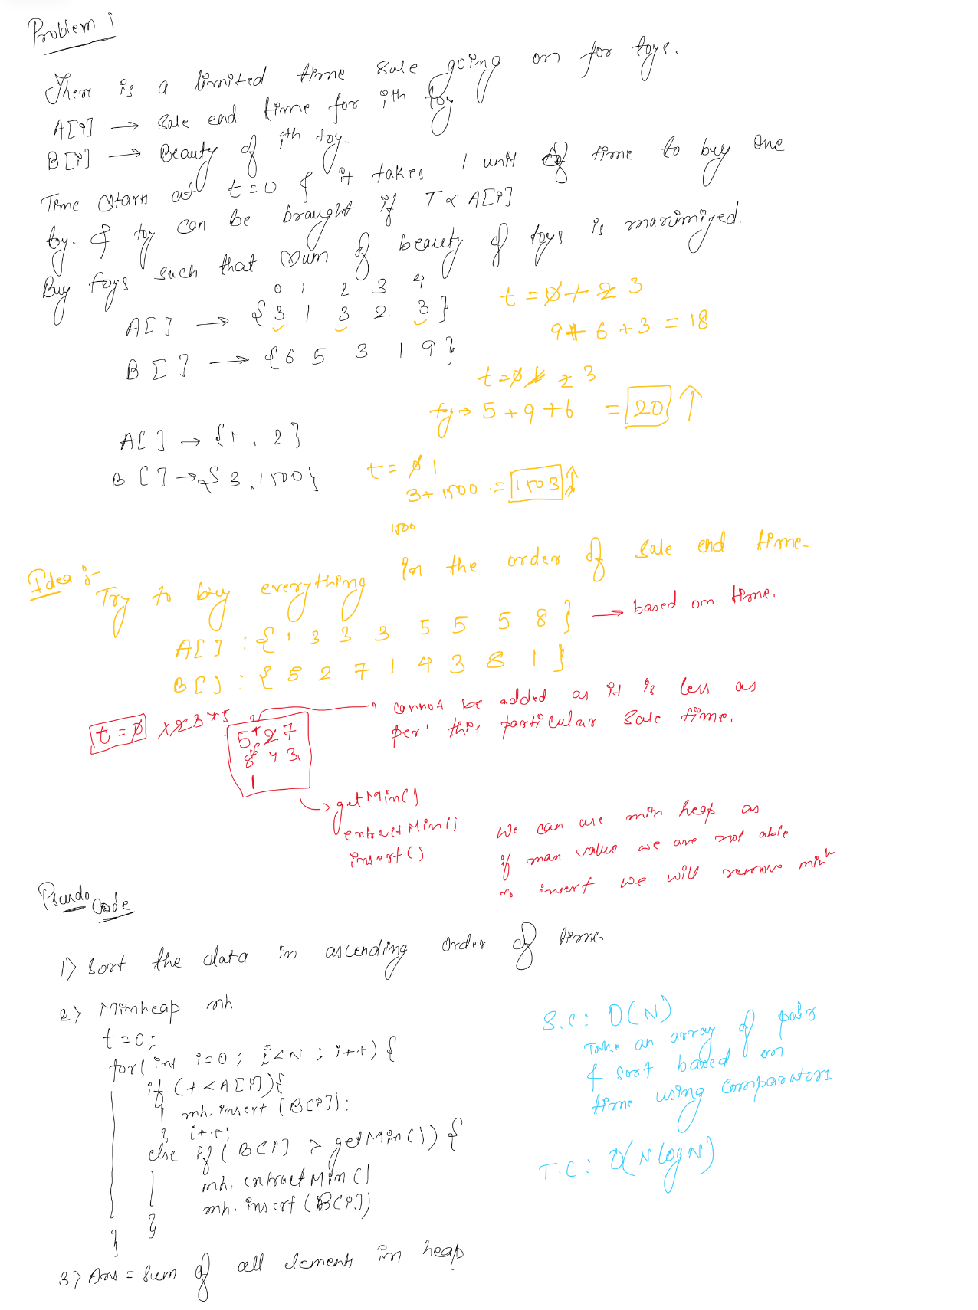

# Maximum Candies

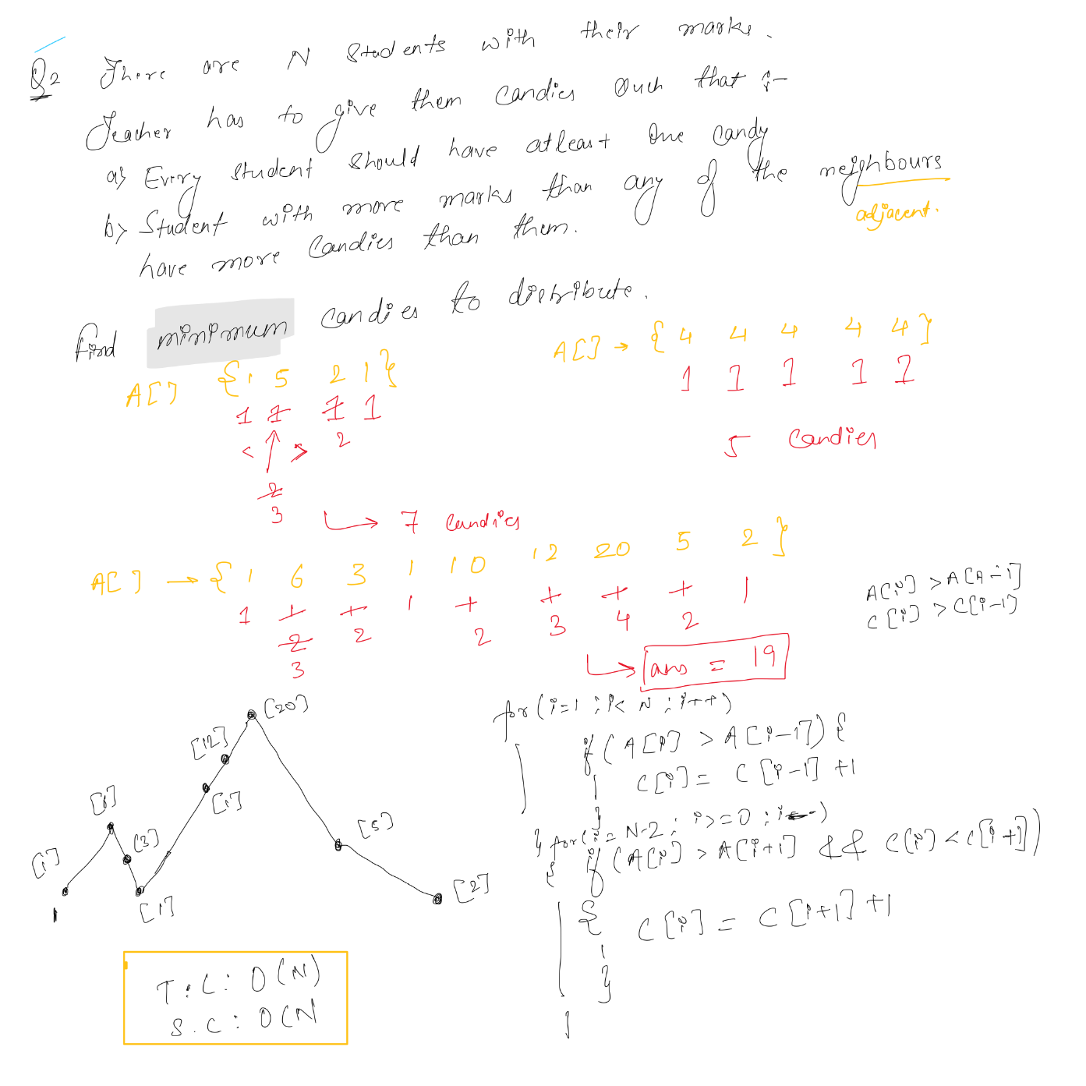

# Maximum Job

