Backtracking 1

Introduction

Rat In a Maze

Generate All Permutations (Unique Chars)

Generate All permutations (Duplicate Chars)

Generate All Subsets

# 

# Rat In a Maze

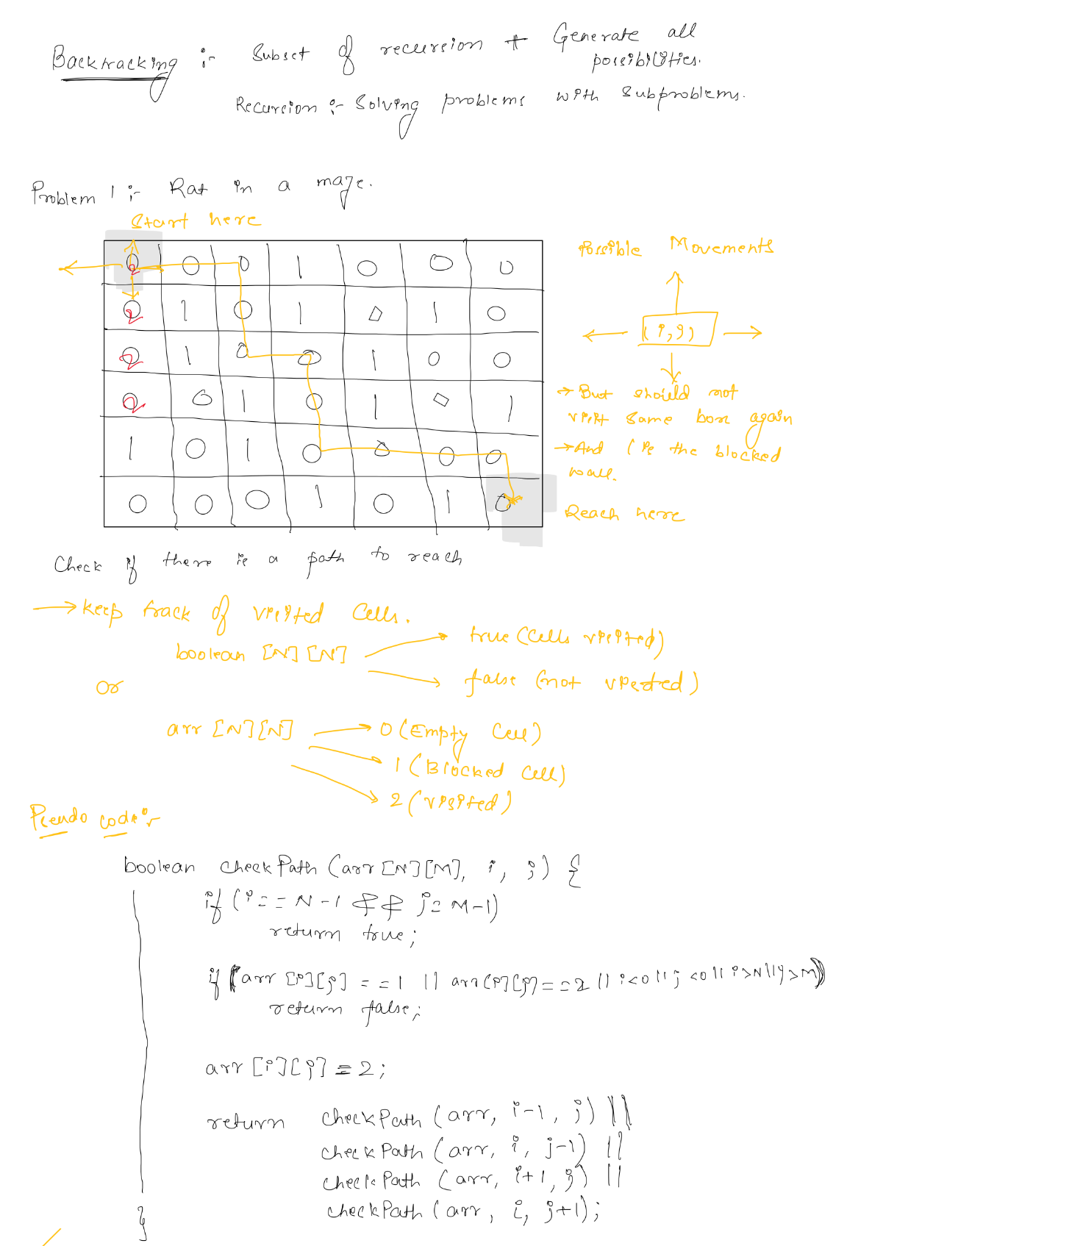

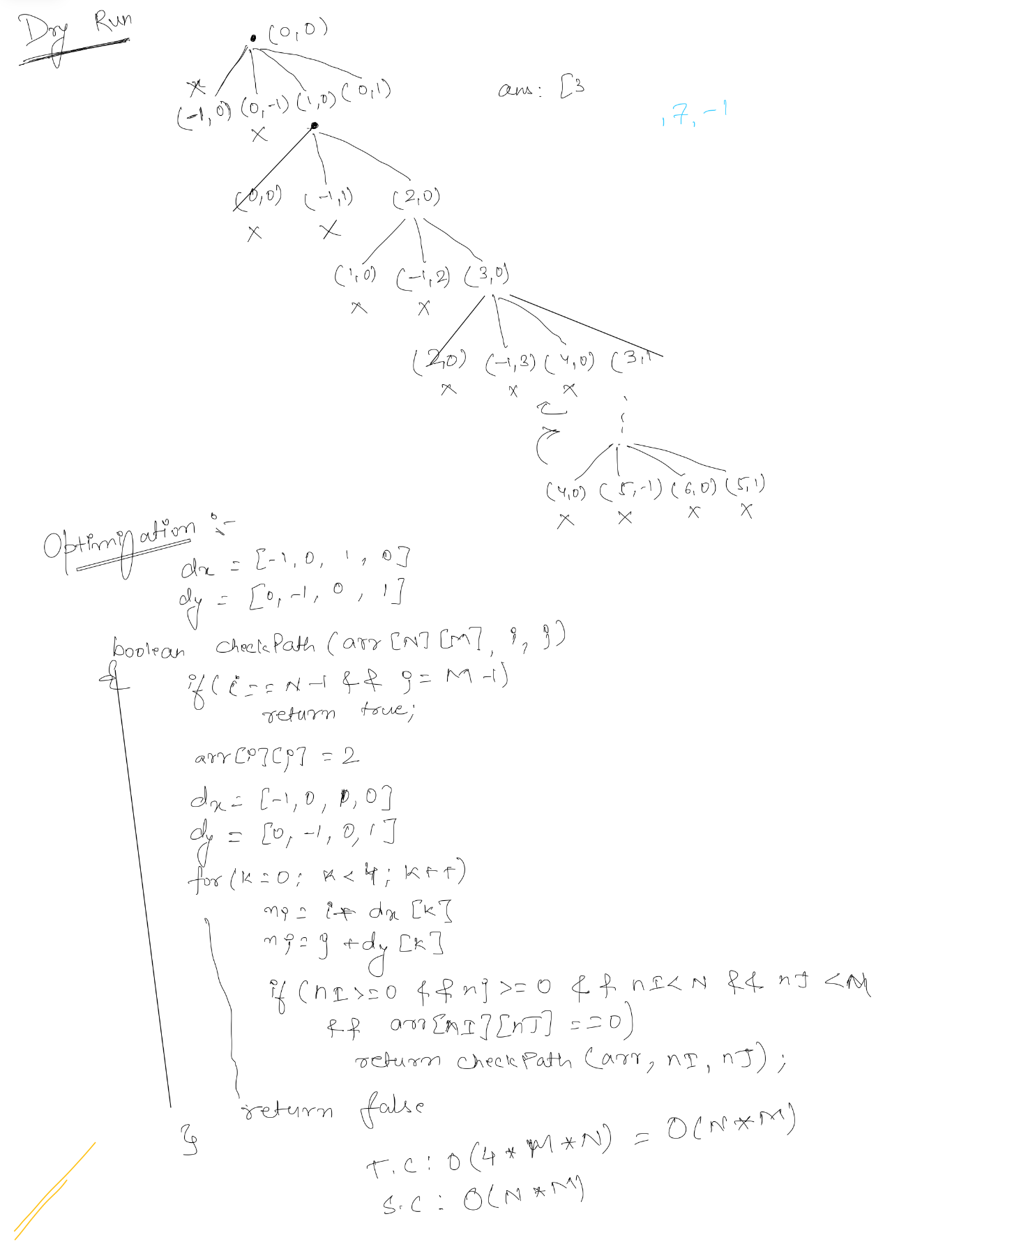

# Generate All Permutations (Unique Chars)

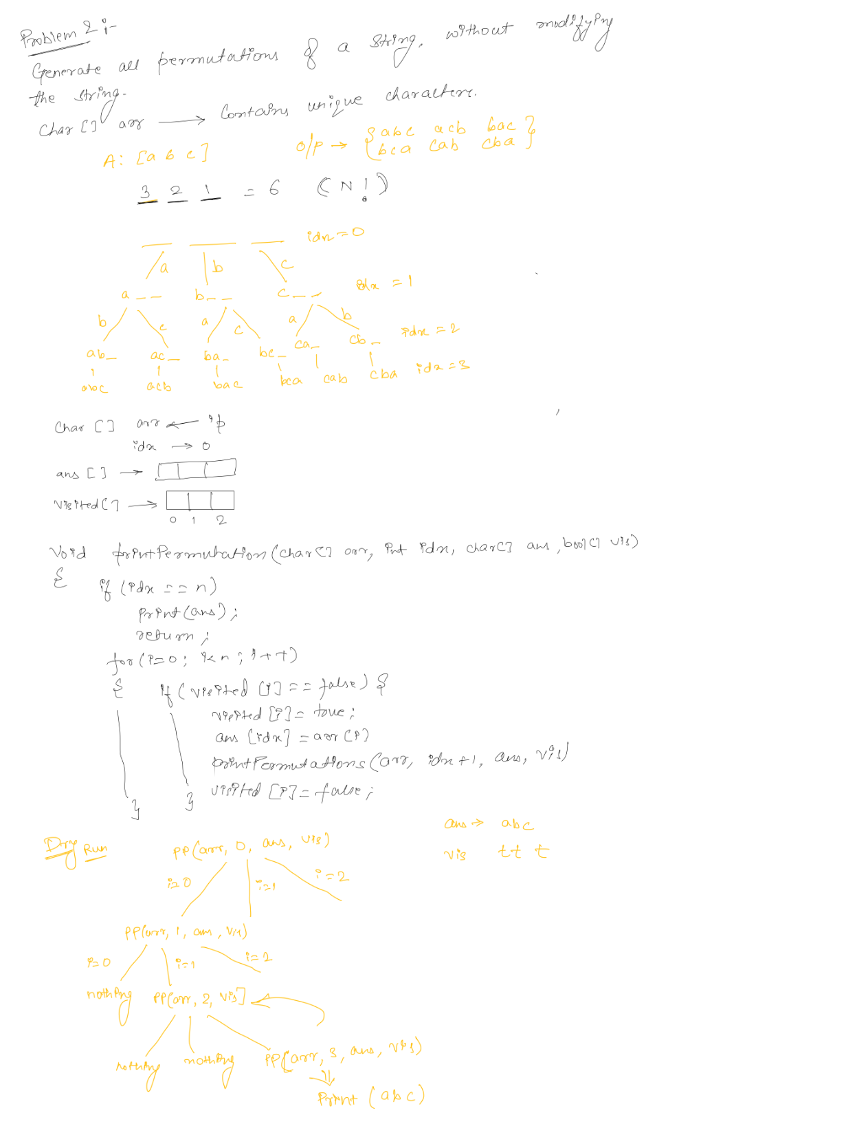

# Generate All permutations (Duplicate Chars)

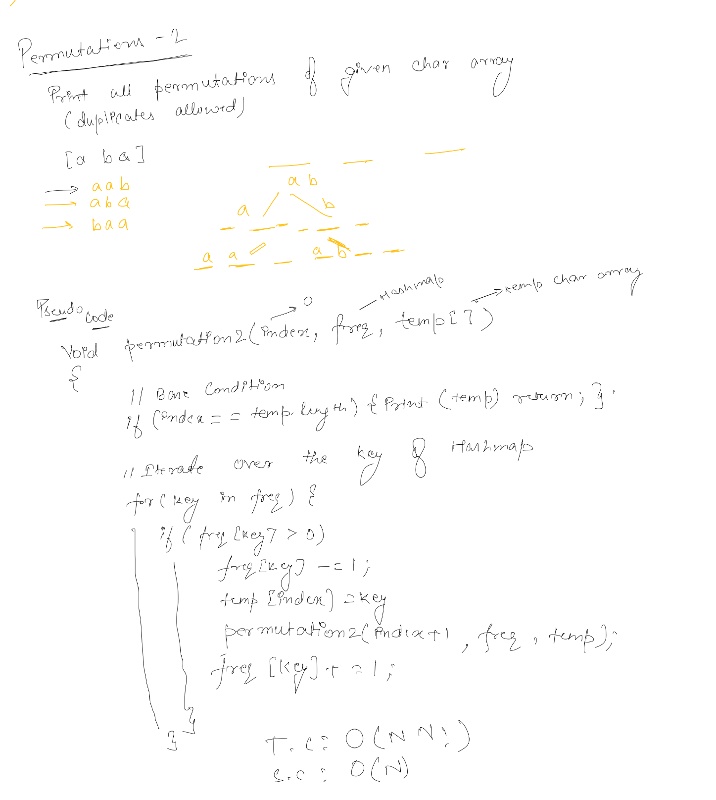

# Generate All Subsets

