DP - 1D

Problem 1

Types of DP and Steps

Problem 2

Problem 3

# Problem 1

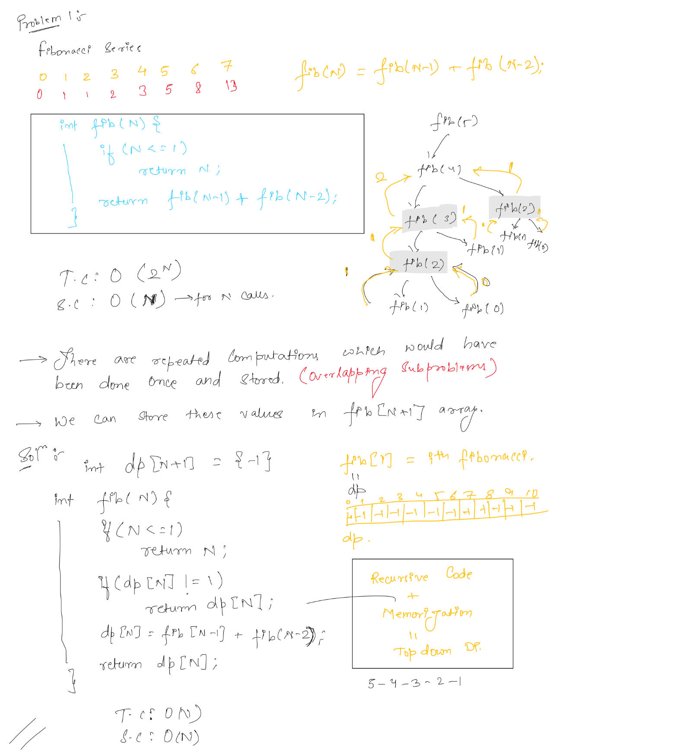

# Types of DP and Steps

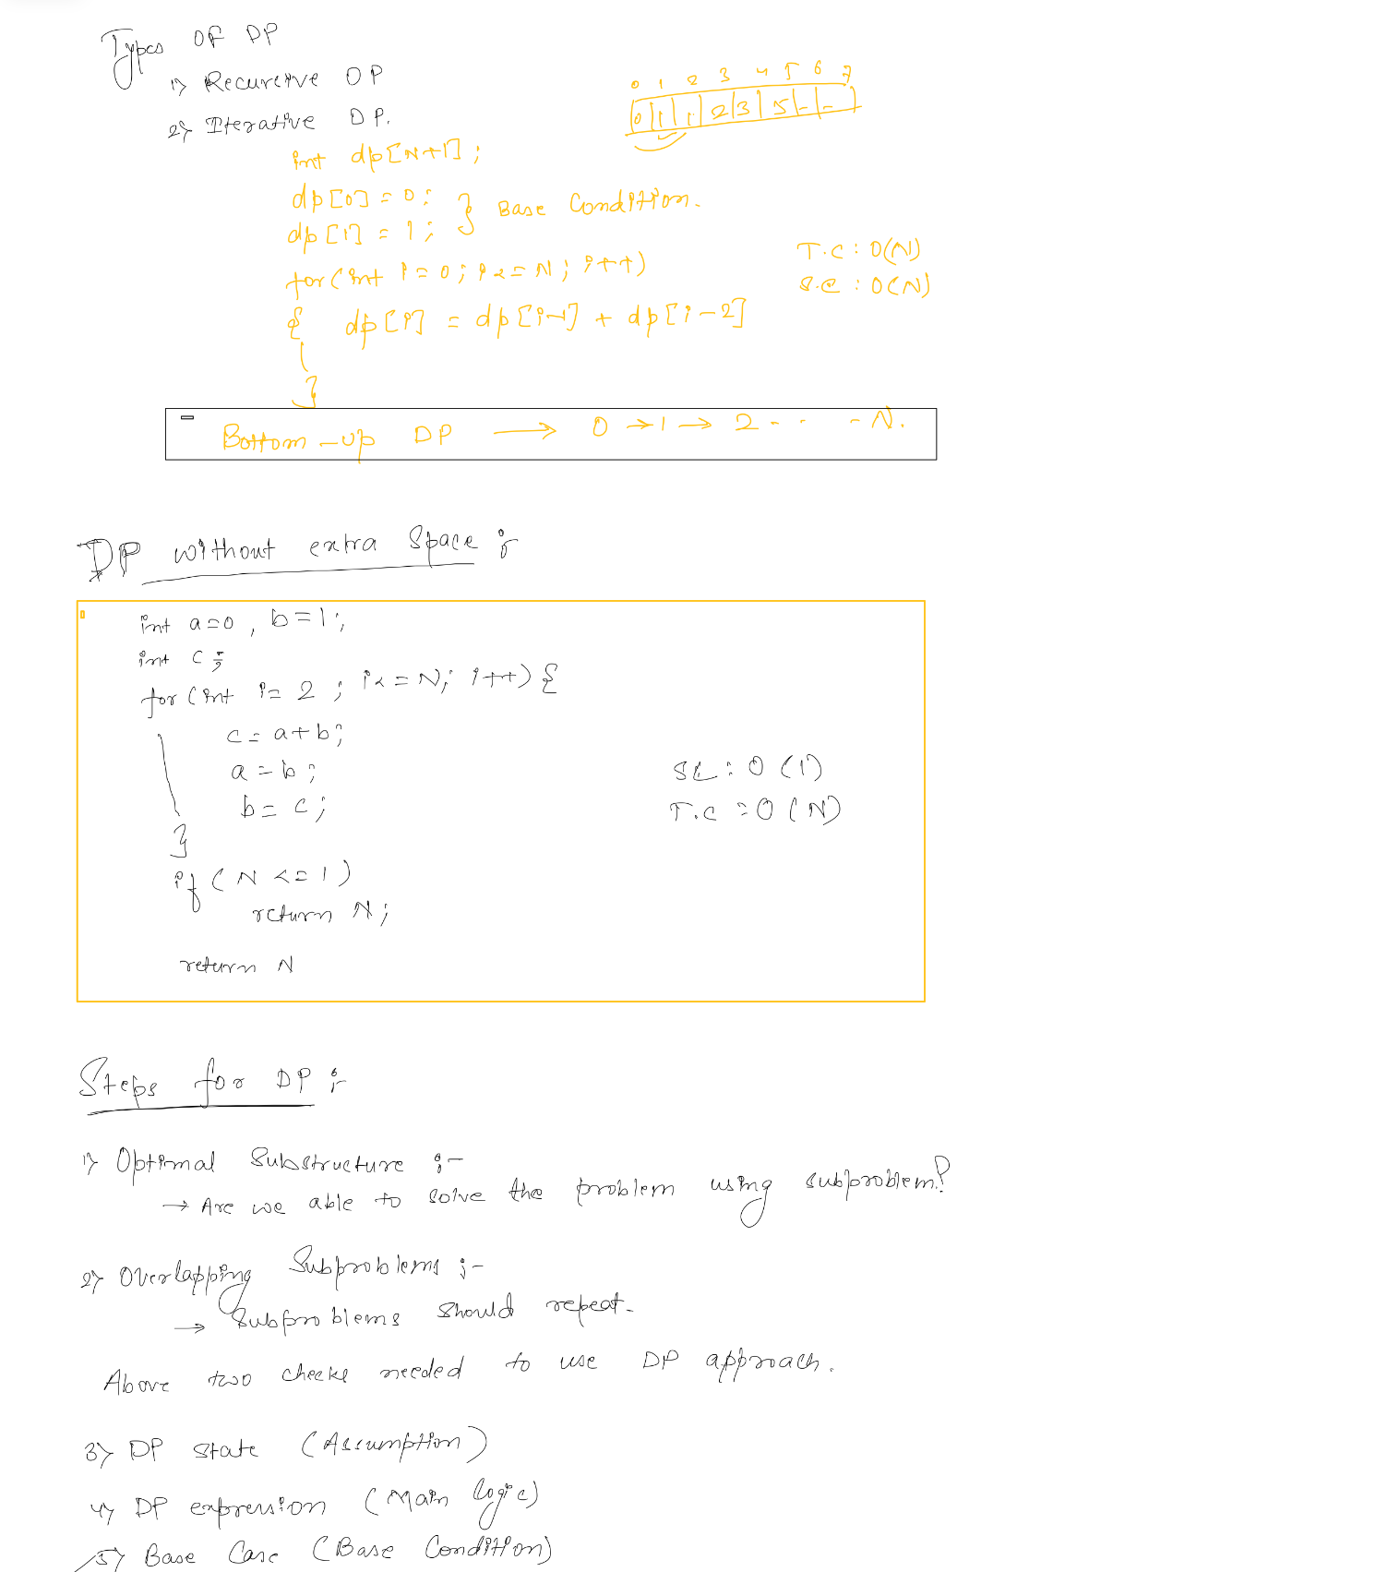

# Problem 2

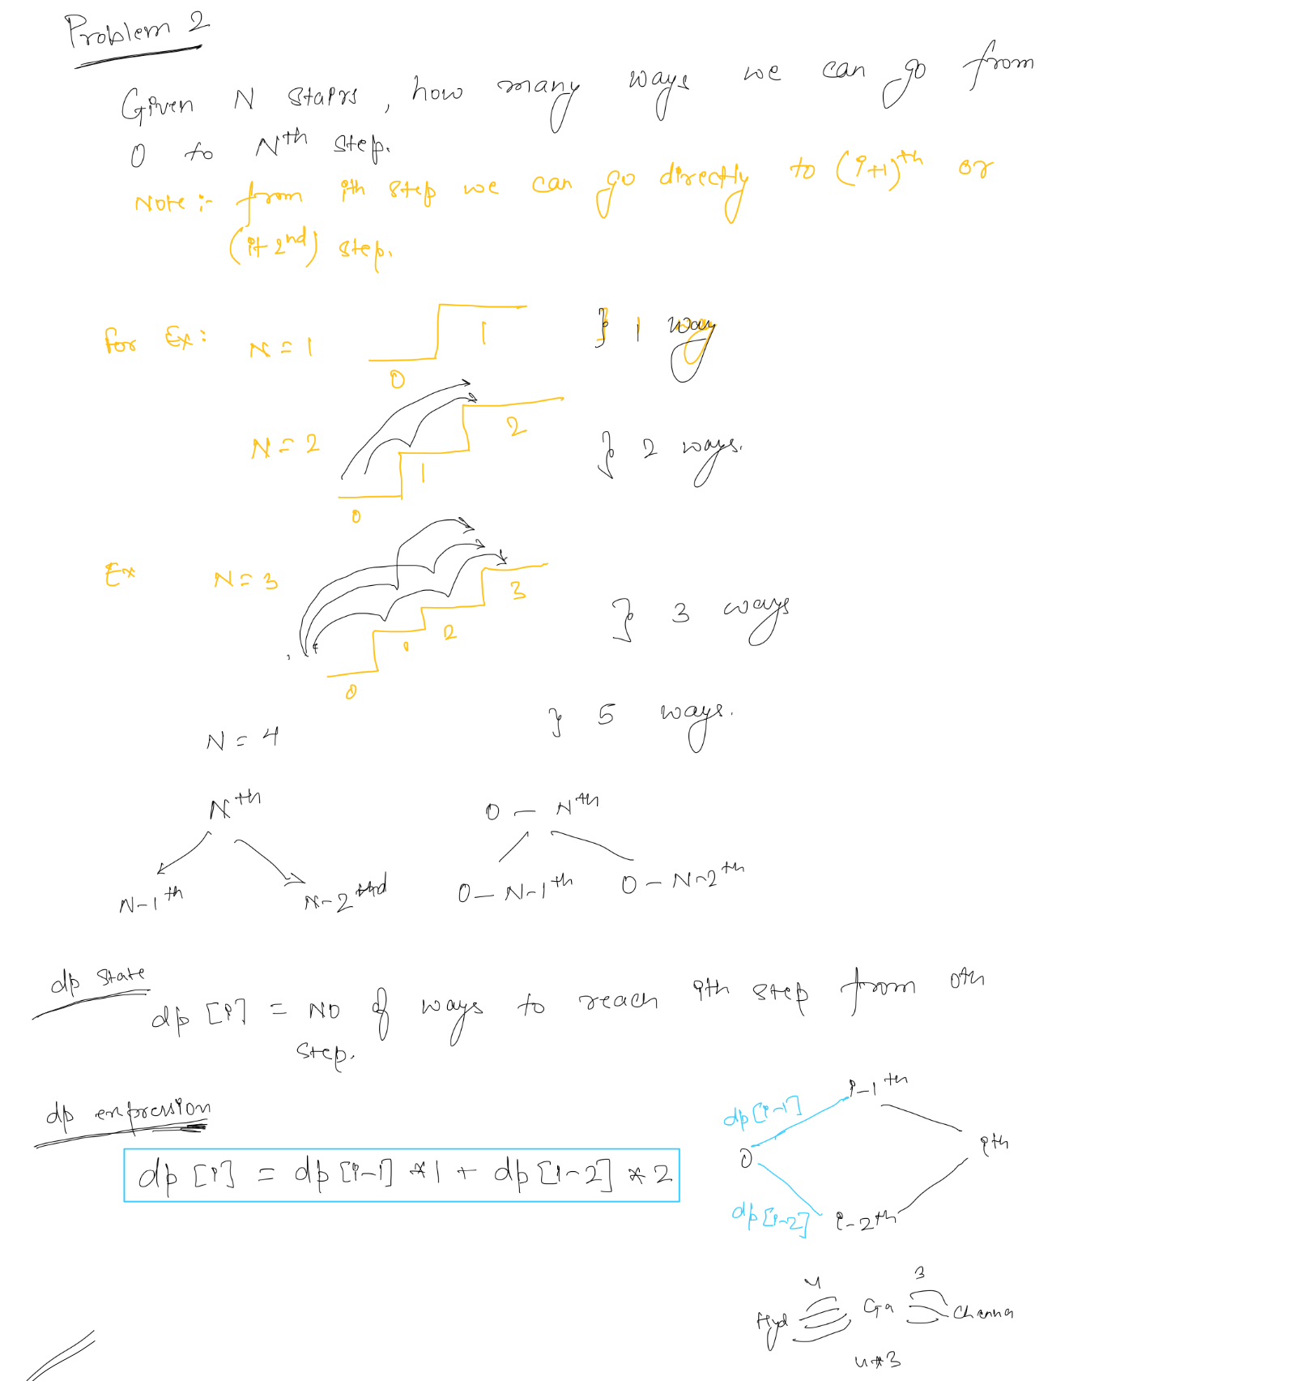

# Problem 3

